Project | IEEE 802.16 Broadband Wireless Access Working Group <http://ieee802.org/16>
Title | Event DrivenNetwork Entry
Date Submitted | 2011-09-22
Source(s) | Erik Colban, Bin Chen, George Calcev, Ronald Mao  Huawei Technologies Co., Ltd.  Jaesun Cha, ETRI  Jinsoo Choi, LGE  Lei Zhou, Samsung | E-mail: ecolban@huawei.com  jscha@etri.re.kr  js.choi@lge.com  l.zhou@samsung.com  *<http://standards.ieee.org/faqs/affiliationFAQ.html>
Re: | Call for Comments on the new 802.16p Amendment Working Document <IEEE 802.16p-11/0021> [based on 802.16Rev3/D1].
Abstract | This contribution proposes the use of a minimum access window to avoid large number of devices accessing the network in a short time interval.
Purpose | Discuss and adopt
Notice | This document does not represent the agreed views of the IEEE 802.16 Working Group or any of its subgroups. It represents only the views of the participants listed in the “Source(s)” field above. It is offered as a basis for discussion. It is not binding on the contributor(s), who reserve(s) the right to add, amend or withdraw material contained herein.
Copyright Policy | The contributor is familiar with the IEEE-SA Copyright Policy <http://standards.ieee.org/IPR/copyrightpolicy.html>.
Patent Policy | The contributor is familiar with the IEEE-SA Patent Policy and Procedures:  <http://standards.ieee.org/guides/bylaws/sect6-7.html#6> and <http://standards.ieee.org/guides/opman/sect6.html#6.3>.  Further information is located at <http://standards.ieee.org/board/pat/pat-material.html> and <http://standards.ieee.org/board/pat>.

Event Driven Network Entry
Erik Colban, George Calcev, Bin Chen et al.
Huawei
Jaesun Cha, ETRI
Jinsoo Choi, LGE
Lei Zhou, Samsung

Abstract
This contribution proposes the use of a minimum access window to avoid large number of devices accessing the network in a short time interval.

Background

M2M devices may be programmed to respond to certain events by reporting the event to the network (e.g. to a M2M server). For instance, an M2M device may be programmed to access the network regularly and transmit some measurement reports (in which case it is triggered by a timer event). It may also be programmed to report certain events when they occur (e.g. excessive heat, humidity, or other sensor data). If too many devices access the network in a too short time period, too many collisions occur during the ranging procedure. This results in the devices re-trying to access the network, creating even more traffic on the ranging channels. As a result, the access time can get very long, the success rate drops critically and there is excessive ranging to no avail.

The number of devices that access the network at any given time depends on the applications that run on the devices, which is outside the scope of the standard. It is under the control of the application programmer. However, the application programmer cannot be assumed to understand or take into considerations the constraints of the particular air interface transmission technology. An application programmer could, for instance, program all devices to enter the network every night at 2 a.m. sharp, or to program the devices to attempt to re-enter the network as soon as power is restored after a power outage.

In the next section we have performed some simulations that show that there is a maximum sustainable access rate, which is such that, if the access rate is kept below this rate, the success rate is high and the number of ranging retries is low, but when the access rate goes above this rate the success rate drops very suddenly. It is therefore essential that the access rate be kept below this maximum sustainable access rate. To ensure that this rate is not exceeded, we suggest applying a Minimum Access Window. The size of this window is based on an estimate on the maximum number of devices that could potentially access the network within a very short time interval. By ensuring that the devices randomly select a network re-entry time in the Minimum Access Window, we guarantee a sufficiently low access rate, and thereby a high success rate and low average number of ranging retries. The total time for all devices to enter the network is also lower than if the devices were required to perform multiple access attempts. The minimal access window provides a simple criterion for the application programmer and could even be ensured by an API.

Simulation
We used simulation assumptions described in IEEE C802.16p-11/0126 “Evaluation Guideline for Comparison of Network Entry Solutions”, produced by the 802.16 WG, M2M TG, Network Entry ad-hoc group. In particular,
- Number of devices = 12000
- Reporting period = 1 through 5 minutes in increments of 15 seconds
- 1 ranging opportunity per frame
- Initial backoff window size = 2
- Max backoff window size = 65536
- Max number of retries = 8
- T3 timer set to 60 ms
- 0% misdetection and false alarm probability

The results of two independent runs are shown in Figure 1.

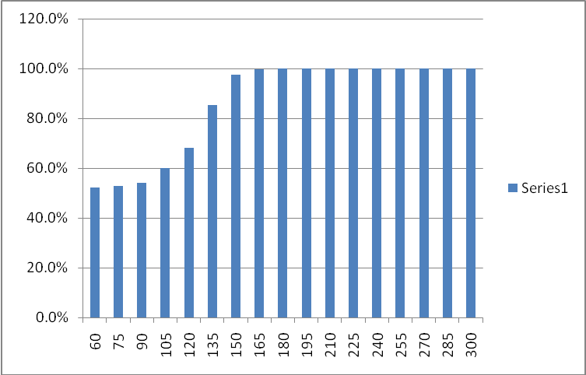
Figure 1: Success rate for 12000 devices accessing the network in a given interval of time.
We note that when the accesses are distributed over 3 minutes or more, the success rate is high. The few devices that possibly fail to access the network (because they have exhausted the number of ranging retries) may restart the procedure. The number of ranging trials is shown in Figure 2.

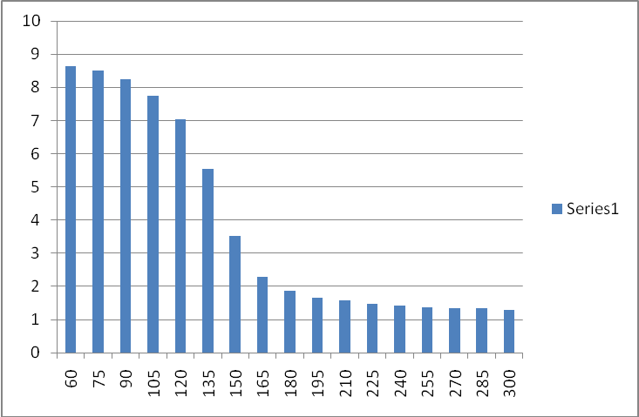
Figure 2: Average number of ranging trials
We note that when the accesses are distributed over 3 minutes or more, the number of ranging trials is low.
The success rate, although already close to 100% continues to increase and the number of trials continues to decrease when the window over which the access attempts are distributed increases. However, the time for 90% (or 95%) of the devices to gain access increases as well, so there is a tradeoff success rate and average ranging trials versus time to access the network.

Proposed Changes

Change 1: Modify page 7, lines 1 – 20 as follows:
>>>>>>>>>>>>>>>>>>>> Start of Change <<<<<<<<<<<<<<<<<<<<<<<<<<<<<<<

6.3.2.3.10 DSA-REQ message

Add the following new texts to the end of 6.3.2.3.10

When the DSA-REQ message is sent to an M2M device, the following TLV may be included:

MGID Tuple (see 11.13.46)
MGID that is added

Minimal Access Window Size (see 11.13.47)
The minimal size of a window within which the M2M device shall select the start time for the network entry procedure.

6.3.2.3.11 DSA-RSP message

When the DSA-RSP message is sent to an M2M device, the following TLV may be included:

Minimal Access Window Size (see 11.13.47)
The minimal size of a window within which the M2M device shall select the start time for the network entry procedure.

6.3.2.3.13 DSC-REQ (DSC request) message

Add the following new texts to the end of 6.3.2.3.13

When the DSC-REQ message is sent to an M2M device, the following TLV may be included:
MGID Tuple (see 11.13.46)
MGID that is changed

Minimal Access Window Size (see 11.13.47)
The minimal size of a window within which the M2M device shall select the start time for the network entry procedure.

6.3.2.3.14 DSC-RSP (DSC response) message

When the DSC-RSP message is sent to an M2M device, the following TLV may be included:

Minimal Access Window Size (see 11.13.47)
The minimal size of a window within which the M2M device shall select the start time for the network entry procedure.

>>>>>>>>>>>>>>>>>>>> End of Change <<<<<<<<<<<<<<<<<<<<<<<<<<<<<<<

Change 2: On page 9, modify section 6.3.9.5.1 as follows:

>>>>>>>>>>>>>>>>>>>> Start of Change <<<<<<<<<<<<<<<<<<<<<<<<<<<<<<<

6.3.9.5.1 Contention-based initial ranging and automatic adjustments
First, an SS shall synchronize to the DL and learn the UL channel characteristics through the UCD MAC
management message. At this point, the SS shall scan the UL-MAP message to find an initial ranging
interval. The BS shall allocate an initial ranging interval consisting of one or more transmission
opportunities. For SC and OFDM PHY, the size of each transmission opportunity shall be as specified by the
UCD TLV, Ranging Request Opportunity Size.
For SC and OFDM PHY, the SS shall put together a RNG-REQ message to be sent in an initial ranging
interval. The duration of the burst carrying the RNG-REQ message shall be as specified in the Ranging
Request Burst Size TLV (see 11.3.1). The CID field shall be set to the noninitialized SS value (zero). For the
OFDM PHY, the initial ranging process may include a subchannelized mechanism specified in 8.3.7.2. For
the OFDMA PHY, the initial ranging process shall begin by sending initial ranging CDMA codes on the UL
allocation dedicated for that purpose (for more details see 6.3.10.3), instead of RNG-REQ messages sent on
contention slots. When an M2M device attempts to enter or re-enter the network and the network entry or re-entry is not in response to paging (e.g., it may be triggered by an event), it shall apply a uniform random process to select the start time of network entry procedure from a window whose size is greater than or equal to the Minimum Access Window Size. The Minimum Access Window Size does not apply to the abnormal power down procedure, see 6.3.35.
An M2M device may perform ranging process using the initial ranging backoff window assigned by a MOB_PAG-ADV. The duration of this initial backoff window may be different from one assigned by UCD. This initial backoff window shall be only applied to the ranging process that is in response to the MOB_PAG-ADV message.
>>>>>>>>>>>>>>>>>>>> End of Change <<<<<<<<<<<<<<<<<<<<<<<<<<<<<<<

Change 3: Add the following lines to page 23, line 28.
>>>>>>>>>>>>>>>>>>>> Start of Change <<<<<<<<<<<<<<<<<<<<<<<<<<<<<<<

11.13.47 Minimal Access Window Size

The Minimal Access Window Size is the size of a window within which the M2M device shall select the start time for the network entry procedure. The M2M device shall use a uniform random selection process to select the network entry start time.

Name | Type | Length | Value | Scope
Minimal Access Window Size | 146.TBD | 2 | The size in units of 1 second of the Minimal Access Window | DSA-REQ/RSP  DSC-REQ/RSP
>>>>>>>>>>>>>>>>>>>> End of Change <<<<<<<<<<<<<<<<<<<<<<<<<<<<<<<

