Project | IEEE 802.16 Broadband Wireless Access Working Group <http://ieee802.org/16>
Title | Event Driven Network Entry
Date Submitted | 2011-11-06
Source(s) | Erik Colban  Huawei | Voice: +1-858-775-2494  E-mail: ecolban@huawei.com  erik.colban@drawmetry.com  *<http://standards.ieee.org/faqs/affiliationFAQ.html>
Re: | IEEE 802.16 Working Group Letter Ballot #34: Announcement, see IEEE 802.16-11/0028
Abstract | This contribution proposes the use of a minimum access window to avoid large number of devices accessing the network in a short time interval.
Purpose | Discuss and adopt
Notice | This document does not represent the agreed views of the IEEE 802.16 Working Group or any of its subgroups. It represents only the views of the participants listed in the “Source(s)” field above. It is offered as a basis for discussion. It is not binding on the contributor(s), who reserve(s) the right to add, amend or withdraw material contained herein.
Copyright Policy | The contributor is familiar with the IEEE-SA Copyright Policy <http://standards.ieee.org/IPR/copyrightpolicy.html>.
Patent Policy | The contributor is familiar with the IEEE-SA Patent Policy and Procedures:  <http://standards.ieee.org/guides/bylaws/sect6-7.html#6> and <http://standards.ieee.org/guides/opman/sect6.html#6.3>.  Further information is located at <http://standards.ieee.org/board/pat/pat-material.html> and <http://standards.ieee.org/board/pat>.
Event Driven Network Entry
Erik Colban
Huawei Technologies

Abstract
This contribution proposes the use of a minimum access window to avoid large number of devices accessing the network in a short time interval.

Background

M2M devices may be programmed to respond to certain events by reporting the event to the network (e.g. to a M2M server). For instance, an M2M device may be programmed to access the network regularly and transmit some measurement reports (in which case it is triggered by a timer event). It may also be programmed to report certain events when they occur (e.g. excessive heat, humidity, or other sensor data). If too many devices access the network in a too short time period, too many collisions occur during the ranging procedure. This results in the devices re-trying to access the network, creating even more traffic on the ranging channels. As a result, the access time can get very long, the success rate drops critically and there is excessive ranging to no avail.

The number of devices that access the network at any given time depends on the applications that run on the devices, which is outside the scope of the standard. It is under the control of the application programmer. However, the application programmer cannot be assumed to understand or take into considerations the constraints of the particular air interface transmission technology. An application programmer could, for instance, program all devices to enter the network every night at 2 a.m. sharp, or to program the devices to attempt to re-enter the network as soon as power is restored after a power outage.

In the next section we have performed some simulations that show that there is a maximum sustainable access rate, which is such that, if the access rate is kept below this rate, the success rate is high and the number of ranging retries is low, but when the access rate goes above this rate the success rate drops very suddenly. It is therefore essential that the access rate be kept below this maximum sustainable access rate. To ensure that this rate is not exceeded, we suggest applying a Minimum Access Window. The size of this window is based on an estimate on the maximum number of devices that could potentially access the network within a very short time interval. By ensuring that the devices randomly select a network re-entry time in the Minimum Access Window, we guarantee a sufficiently low access rate, and thereby a high success rate and low average number of ranging retries. The total time for all devices to enter the network is also lower than if the devices were required to perform multiple access attempts. The minimal access window provides a simple criterion for the application programmer and could even be ensured by an API.

Simulation
We used simulation assumptions described in IEEE C802.16p-11/0126 “Evaluation Guideline for Comparison of Network Entry Solutions”, produced by the 802.16 WG, M2M TG, Network Entry ad-hoc group. In particular,
- Number of devices = 12000
- Reporting period = 1 through 5 minutes in increments of 15 seconds
- 1 ranging opportunity per frame
- Initial backoff window size = 2
- Max backoff window size = 65536
- Max number of retries = 8
- T3 timer set to 60 ms
- 0% misdetection and false alarm probability

The results of two independent runs are shown in Figure 1.

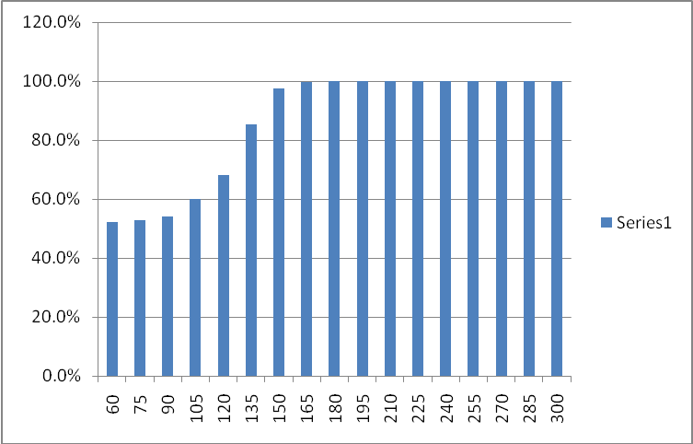
Figure 1: Success rate for 12000 devices accessing the network in a given interval of time.
We note that when the accesses are distributed over 3 minutes or more, the success rate is high. The few devices that possibly fail to access the network (because they have exhausted the number of ranging retries) may restart the procedure. The number of ranging trials is shown in Figure 2.

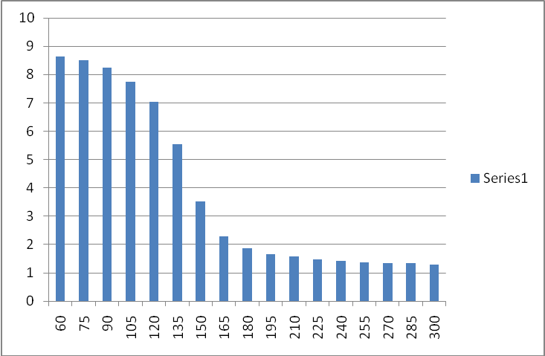
Figure 2: Average number of ranging trials
We note that when the accesses are distributed over 3 minutes or more, the number of ranging trials is low.
The success rate, although already close to 100% continues to increase and the number of trials continues to decrease when the window over which the access attempts are distributed increases. However, the time for 90% (or 95%) of the devices to gain access increases as well, so there is a tradeoff success rate and average ranging trials versus time to access the network.

Proposed Changes

Change 1
On page 28, line 11, add an extra row to Table 83:

Table 83—AAI-DSA-REQ message field description

Minimal Access Window Size | 10 | The minimal size of a window within which the M2M device shall select the start time for the network entry procedure in units of 1 second. | May be present if this message is sent by the BS and is for an uplink service flow related with M2M

Change 2

Add an extra row to Table 84:

Table 84—AAI-DSA-RSP message field description

Minimal Access Window Size | 10 | The minimal size of a window within which the M2M device shall select the start time for the network entry procedure in units of 1 second. | May be present if this message is sent by the BS and is for an uplink service flow related with M2M

Change 3

Add an extra row to Table 86:

Table 86—AAI-DSC-REQ message field description

Minimal Access Window Size | 10 | The minimal size of a window within which the M2M device shall select the start time for the network entry procedure in units of 1 second. | May be present if this message is sent by the BS and is for an uplink service flow related with M2M

Change 4

Add Table 87 into the draft and add:

Add new parameter at the end of Table 87 as indicated

Table 87—AAI-DSC-RSP message field description

Minimal Access Window Size | 10 | The minimal size of a window within which the M2M device shall select the start time for the network entry procedure in units of 1 second. | May be present if this message is sent by the BS and is for an uplink service flow related with M2M

Change 5
On page 33, line 64, insert:

Add the following text after the first paragraph of 6.2.15.3 as indicated

6.2.15.3 Initial ranging and automatic adjustments

After DL synchronization, the AMS shall attempt to perform initial ranging with the ABS. If the ranging
procedure is successfully completed, the AMS is UL synchronized with the ABS and obtains TSTID from
the ABS. The TSTID is used until the ABS assigns the AMS an STID through registration procedure.

When an M2M device attempts to enter or re-enter the network and the network entry or re-entry is not in response to paging (e.g., it may be triggered by an event), it shall apply a uniform random process to select the start time of network entry procedure from a window whose size is greater than or equal to the Minimum Access Window Size. The Minimum Access Window Size does not apply to the abnormal power down procedure, see 6.2.29.

