Project | IEEE 802.16 Broadband Wireless Access Working Group <http://ieee802.org/16>
Title | Seamless MS transfer to the nearest neighboring BS or any serving point based on the system type
Date Submitted | 2007-11-08
Source(s) | Vikas Mehrotra, Apurv Mathur, Simon Jing, Rishi Arora  Motorola* | Voice: 8472816757  E-mail: Vikas.Mehrotra@motorola.com  *<http://standards.ieee.org/faqs/affiliationFAQ.html>
Re: | Letter Ballot 26
Abstract | A method to support smooth transition of the subscriber at the time of network entry, idle mode reentry, or MSS initiated flow creation to another base station when the serving base station is at full capacity.
Purpose | Approve for inclusion in Revision 2.
Notice | This document does not represent the agreed views of the IEEE 802.16 Working Group or any of its subgroups. It represents only the views of the participants listed in the “Source(s)” field above. It is offered as a basis for discussion. It is not binding on the contributor(s), who reserve(s) the right to add, amend or withdraw material contained herein.
Release | The contributor grants a free, irrevocable license to the IEEE to incorporate material contained in this contribution, and any modifications thereof, in the creation of an IEEE Standards publication; to copyright in the IEEE’s name any IEEE Standards publication even though it may include portions of this contribution; and at the IEEE’s sole discretion to permit others to reproduce in whole or in part the resulting IEEE Standards publication. The contributor also acknowledges and accepts that this contribution may be made public by IEEE 802.16.
Patent Policy | The contributor is familiar with the IEEE-SA Patent Policy and Procedures:  <http://standards.ieee.org/guides/bylaws/sect6-7.html#6> and <http://standards.ieee.org/guides/opman/sect6.html#6.3>.  Further information is located at <http://standards.ieee.org/board/pat/pat-material.html> and <http://standards.ieee.org/board/pat>.
Seamless MS transfer to the nearest neighboring BS or any serving point based on the system type
Vikas Mehrotra,
Apurv Mathur
Simon Jing,
Rishi Arora,
Motorola Inc.

Problem definition:
Current WiMax networks do not support a smooth transition of the subscriber at the time of network entry, idle mode reentry, and MSS initiated flow creation to another base station when the serving base station is at full capacity. At any time, there could be other neighboring Base stations that are not as loaded and have the available resources for MS or its flows to be admitted.
- Initial Network Entry
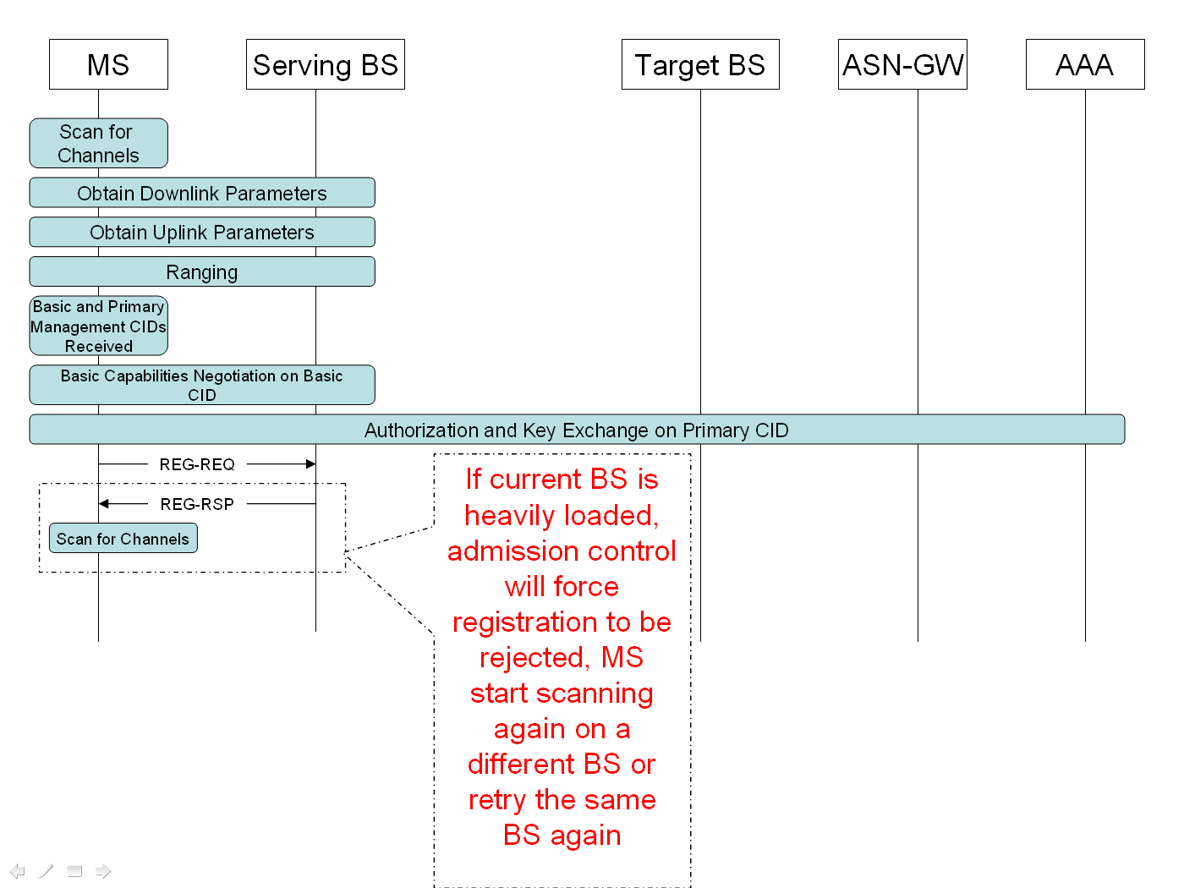
- Idle Mode Re-entry
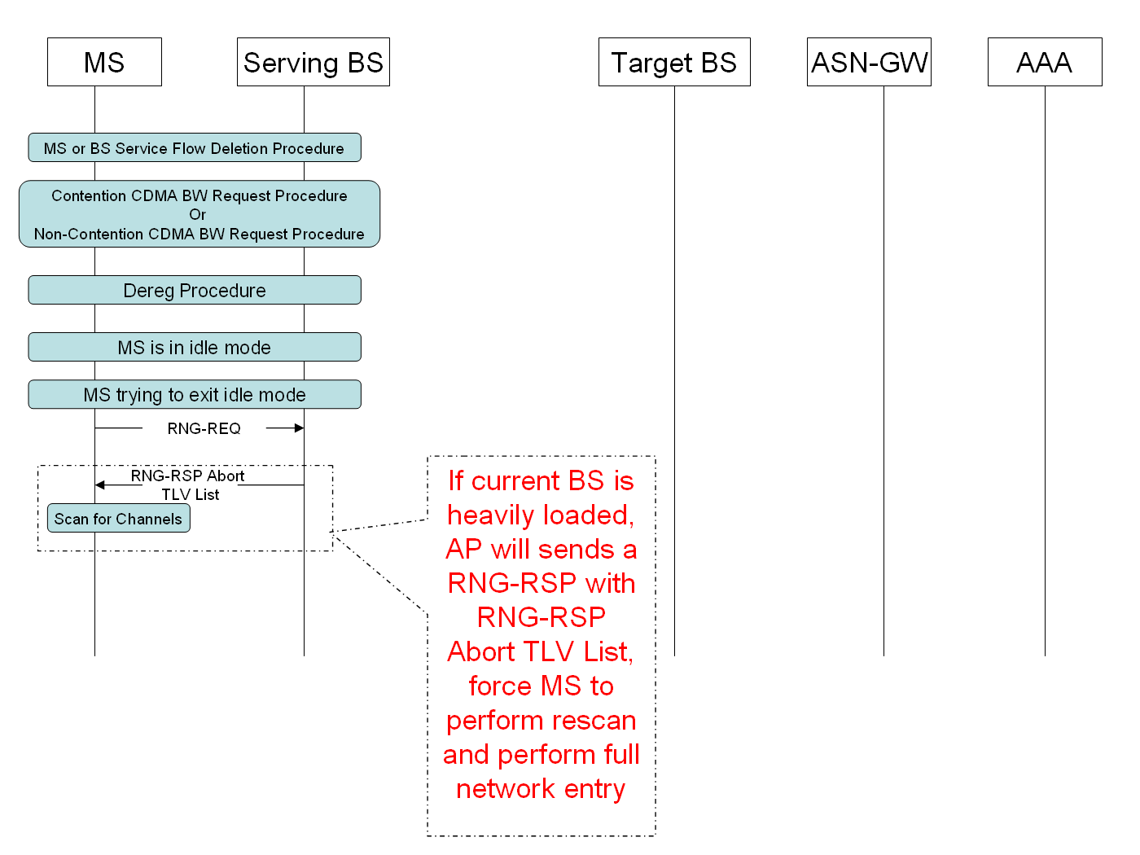
- MSS Initiated data flow
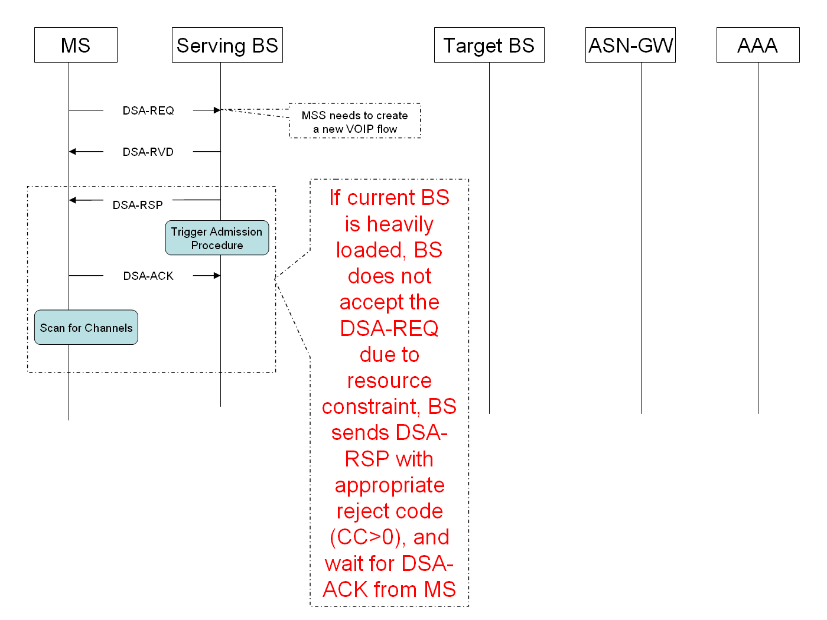

Suggested remedy:

Initial Network Entry

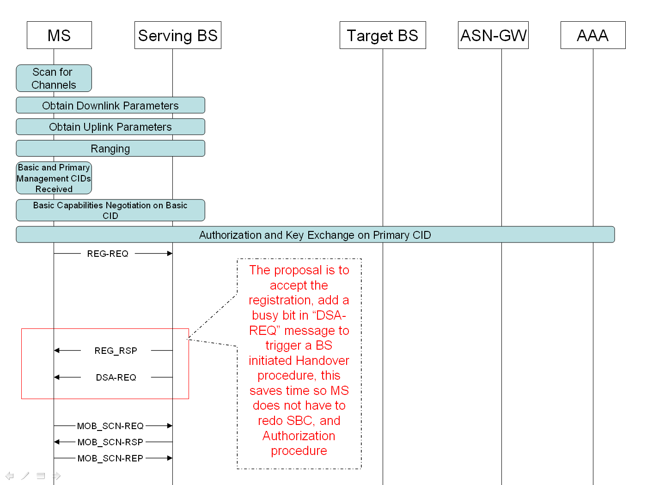
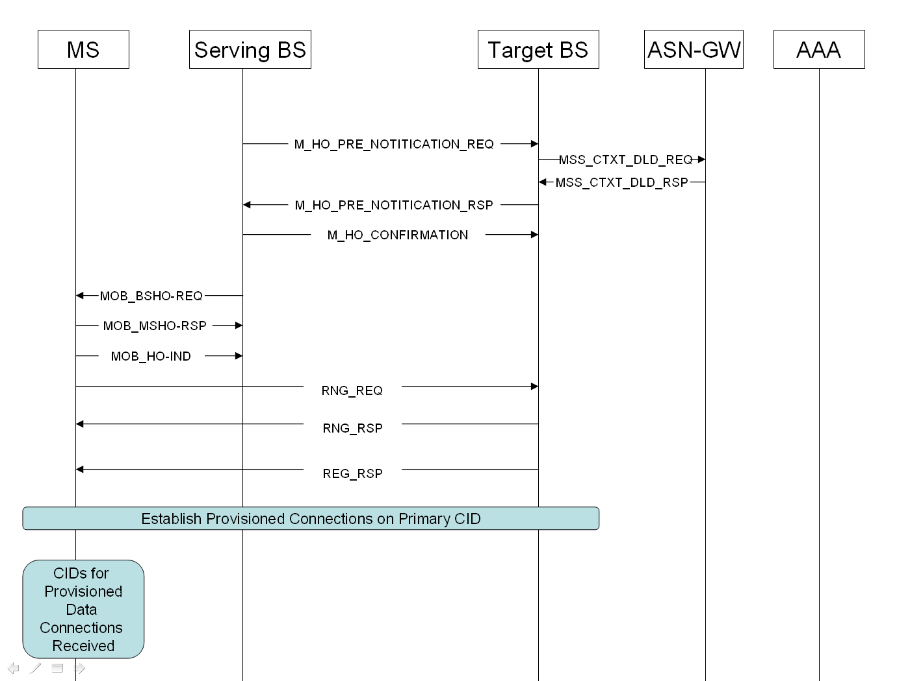

Idle Mode Re-entry

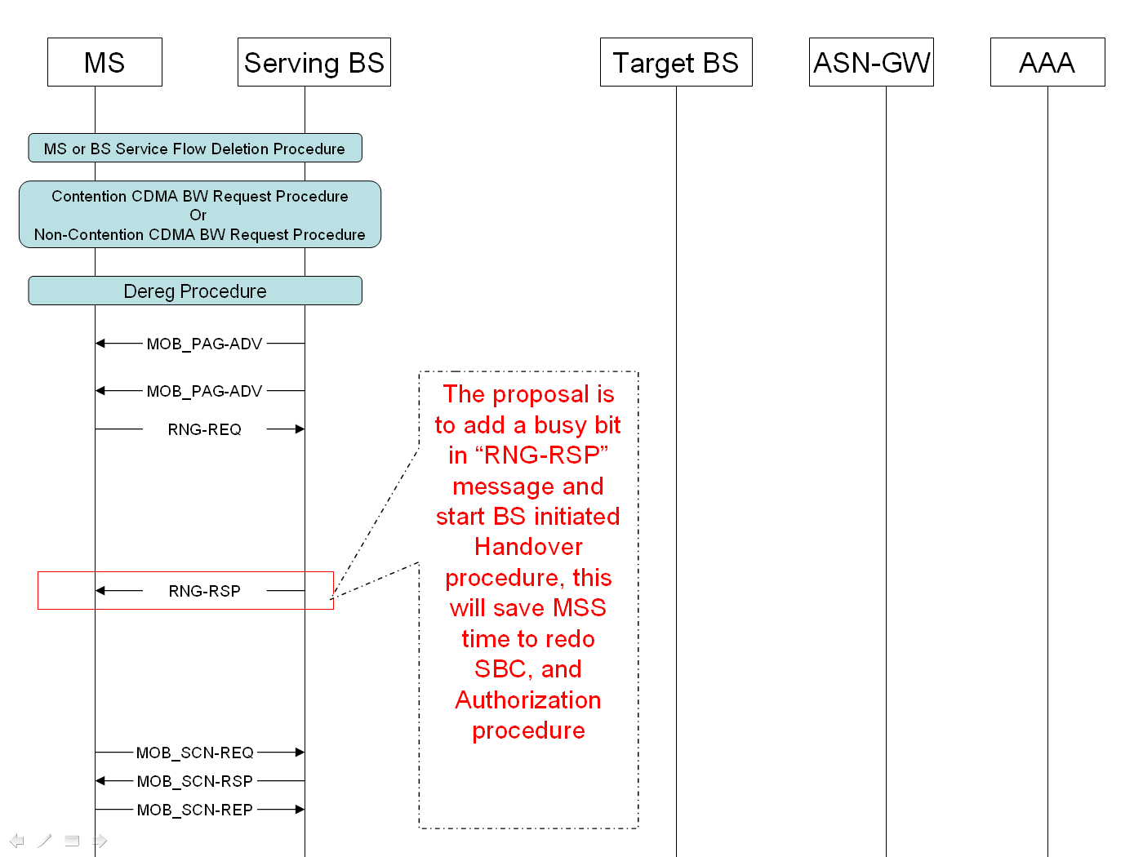

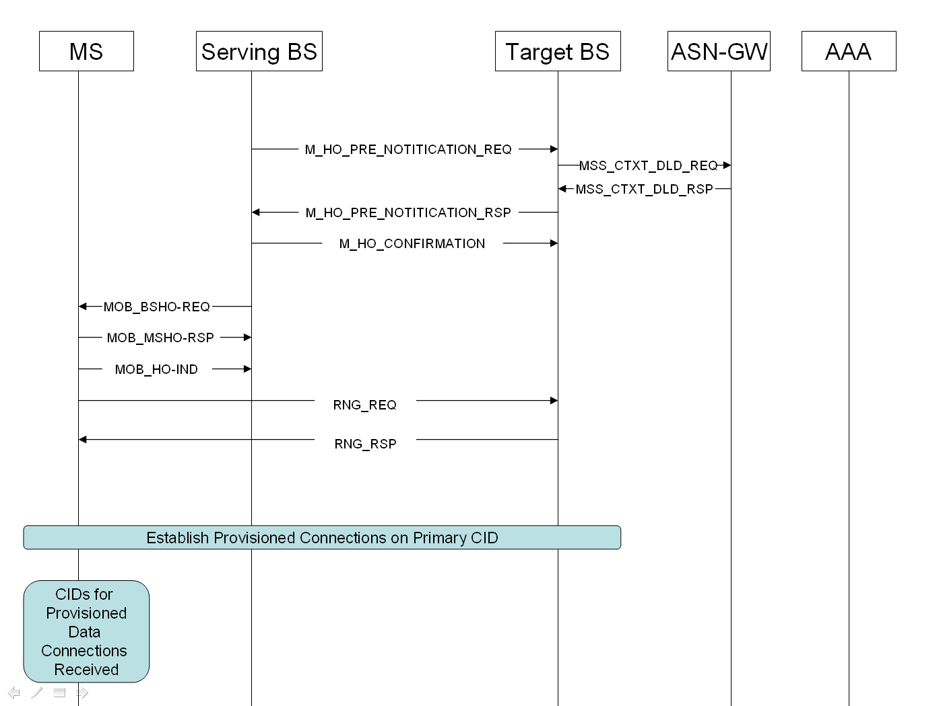

MSS Initiated Data Flow
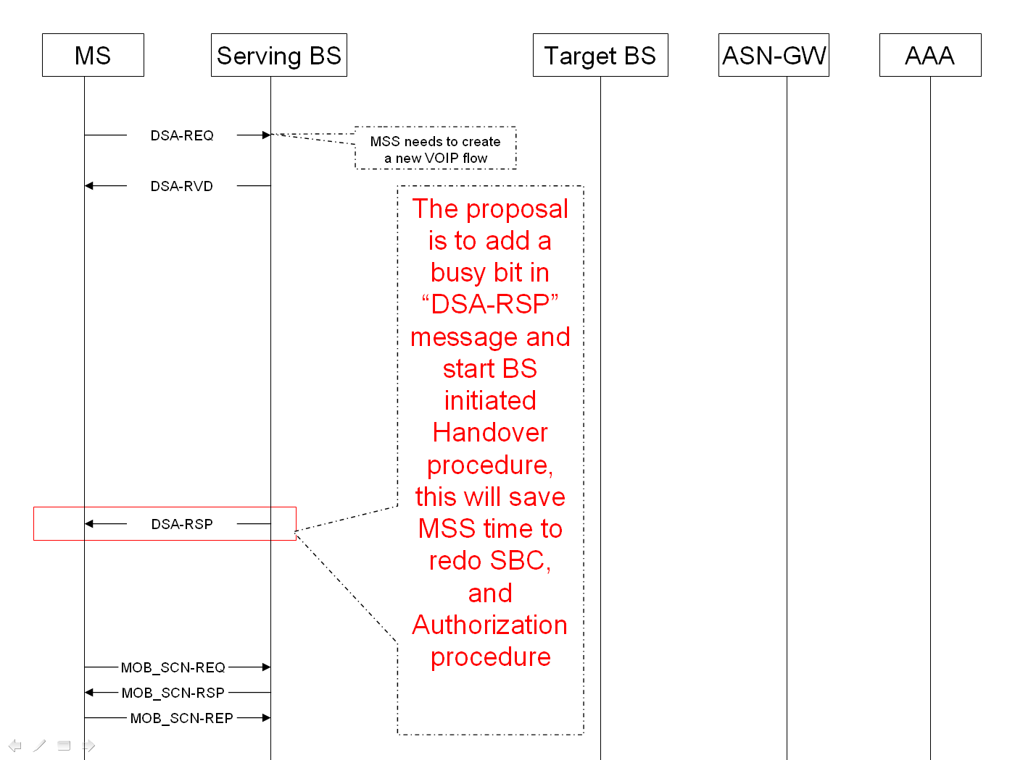

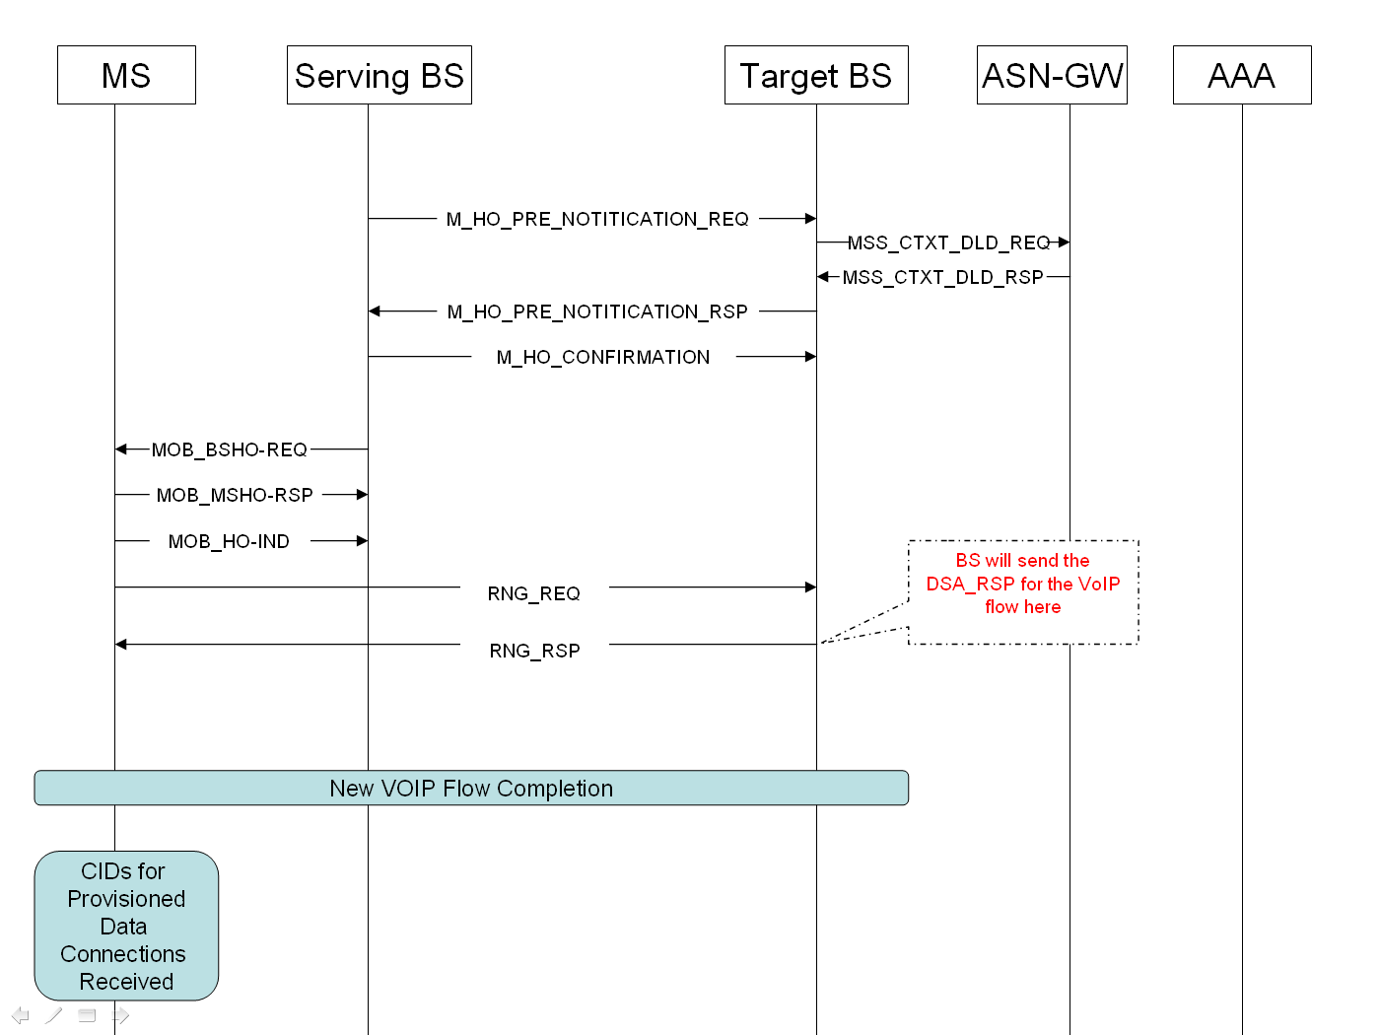

Suggest adding Section 11.13.38 “Busy Bit Indicator” in 802.16e-2005

11.13 Service flow management encodings
.
.
.
.
11.13.38 Busy Bit Indicator

This parameter is used by BS to indicate lack of resources to support this flow in the Base Station. If this parameter is set and mobility is supported, MS is requested to perform Scanning procedure and send a MOB_SCN-REP to the BS. If another candidate BS is available, and can admit the flows from this subscriber, then BS will initiate a BS initiated Handover for this MS. BS may provide the new Flow parameters for this MS in the RNG_RSP sent to the MS at the new target BS.

Type | Length | Value | Scope
x | 1 | 0-BS can admit this user’s flow  1- BS has reached maximum capacity and cannot admit this current flow | DSx-REQ  DSx-RSP  DSx-ACK  REG-RSP

