Project | IEEE 802.16 Broadband Wireless Access Working Group <http://ieee802.org/16>
Title | Persistent allocation method for reducing MAP overhead
Date Submitted | January 14, 2008
Source(s) | June Moon  Hoon Chang  Kwanhee Rho  Seho Kim  Jaehee Cho  Heewon Kang  Changyoon Oh | Voice: +82-31-279-7529  E-mail: changyoon.oh@samsung.com  *<http://standards.ieee.org/faqs/affiliationFAQ.html>
Re: | [Cite the specific document number of the appropriate Call for Contributions, the ballot number, etc. Contributions that are not responsive to this section of the template, may be refused or assigned a low priority for review.]
Abstract | The resource allocation scheme of 802.16e is extended to enable persistent allocations (also referred to as periodic allocations).
Purpose | Accept the proposed specification changes on IEEE P802.16Rev2/D2.
Notice | This document does not represent the agreed views of the IEEE 802.16 Working Group or any of its subgroups. It represents only the views of the participants listed in the “Source(s)” field above. It is offered as a basis for discussion. It is not binding on the contributor(s), who reserve(s) the right to add, amend or withdraw material contained herein.
Release | The contributor grants a free, irrevocable license to the IEEE to incorporate material contained in this contribution, and any modifications thereof, in the creation of an IEEE Standards publication; to copyright in the IEEE’s name any IEEE Standards publication even though it may include portions of this contribution; and at the IEEE’s sole discretion to permit others to reproduce in whole or in part the resulting IEEE Standards publication. The contributor also acknowledges and accepts that this contribution may be made public by IEEE 802.16.
Patent Policy | The contributor is familiar with the IEEE-SA Patent Policy and Procedures:  <http://standards.ieee.org/guides/bylaws/sect6-7.html#6> and <http://standards.ieee.org/guides/opman/sect6.html#6.3>.  Further information is located at <http://standards.ieee.org/board/pat/pat-material.html> and <http://standards.ieee.org/board/pat>.
Persistent allocation method for reducing MAP overhead

1. Introduction
When there are many small-sized bursts within a frame, e.g. VoIP traffic, MAP overhead can significantly be increased, limiting system capacity. Persistent allocation can reduce MAP overhead remarkably since allocation MAP message only appears once and retaining allocation afterward. This contribution proposes complete solution for supporting persistent allocation.

2. Proposed Solution
The periodicity of VoIP packet transmissions enables persistent resource allocation where the resource assignment signaling needs not to be sent for each packet transmission. In persistent allocation, MAP IEs including new resource assignments are sent to corresponding MSs in the beginning of periodic allocation, and for given persistent allocation period, resource assignments such as allocated resource size and MCS are assumed to be fixed and used by the corresponding MSs without explicit signaling.
However, resource for a VoIP MS needs to be deallocated when the MS goes into the silence state where the voice coder either transmits or suppresses lowest-rate voice packets, or should be reallocated when the MS’s MCS is changed to counteract channel variations.
Deallocation makes the allocated resource unused, creating a lot of fragmented unused resource, called resource hole if it is not replaced with other persistent allocation. It may be filled with another small-sized burst with non-persistent allocation, but when data traffic is multiplexed with VoIP traffic, this seriously degrades efficiency of the resource utilization as well as voice capacity. As a result, efficient management mechanism of persistent resource is required to alleviate this problem. We propose efficient persistent resource allocation method in order to reduce the overhead of explicit signaling and improve the resource utilization.
In the proposed method, a new persistent allocation IE is designed to represent a group region and its resource allocation. It has its own Group ID, indicating a specified group as depicted in Fig. 1. The group consists of a set of users which have persistent resource within the Persistent IE. The users in same group shall have same allocation period (e.g. 4 frames for 20ms period VoIP). Assigning persistent subburst in a group region to an MS implicitly makes the MS belong to the group. Resources in a region are addressed by a pair of (slot offset, duration). The MSs in a group have a unique identification, called ‘order’, representing the order of the MSs’ resources in the group region.

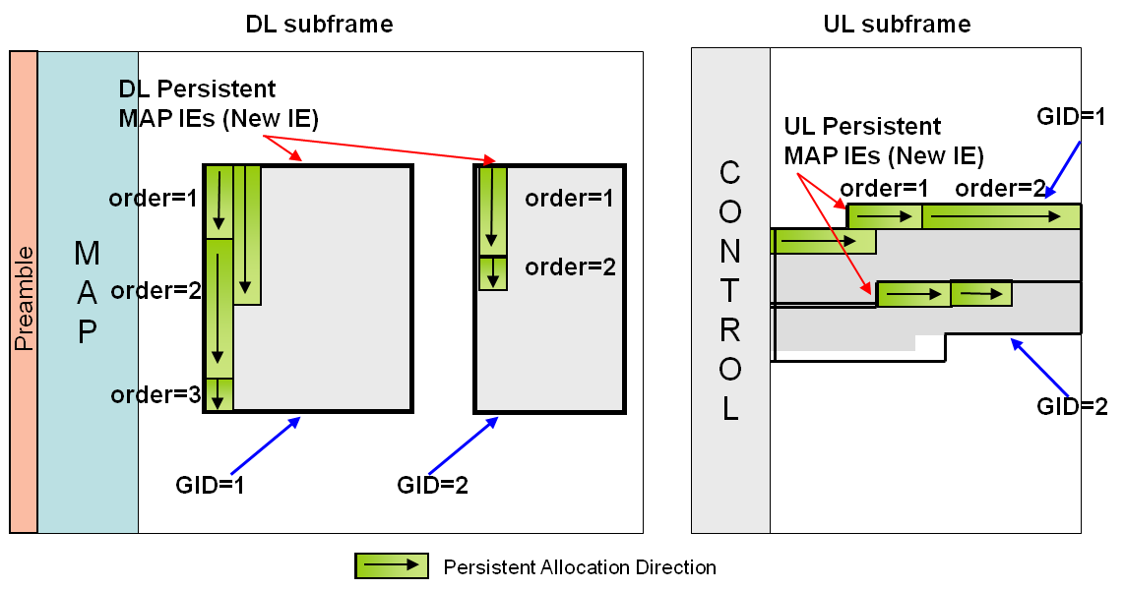
Figure 1. Persistent resource allocation and group regions

When new persistent users enter the cell or the users in silence state move to talk state, new persistent allocation is needed. New persistent allocations in the group region are appended to the previously allocated slots as illustrated in Fig. 2. The slot offset for the first new allocation is given in the IE, and subsequent allocated resources are implicitly arranged in sequential order. For newly allocated persistent MSs, {CID, duration, MCS} fields are included.

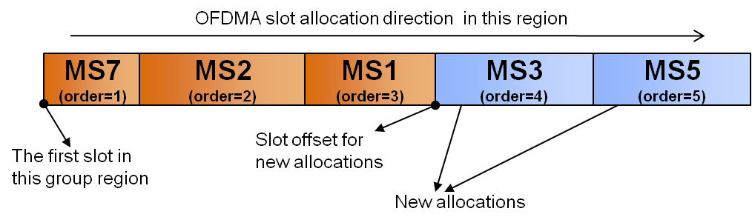
Figure 2. Allocating new resource for persistent resource allocation

When the users in talk state move to the silence state, the resources assigned to them should be de-allocated. Then, as illustrated in Fig. 3, all the MSs with order value higher than specified order value within deallocation message shall decrease their order value by one and their start slot positions of persistent resource are also shifted by the amount of duration of deallocating resource

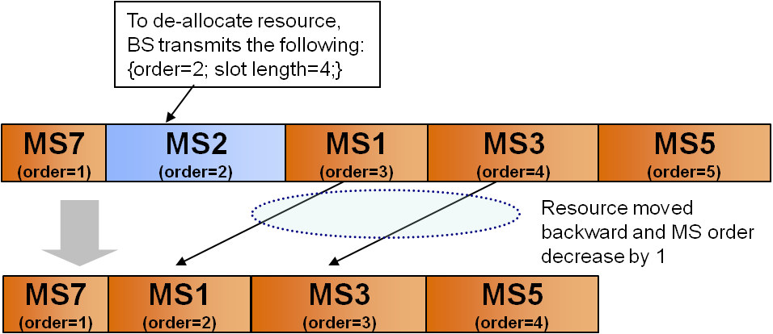
Figure 3. Deallocating assigned resource in persistent resource allocation

If a resource is resized due to MCS change, voice codec rate change, or possibly MIMO mode change (SM/STC), the persistent resources after in resource order are moved forward or backward, depending on the change of the size. For example as shown in the Fig. 4, when the MCS is changed, a MCS change sub-IE is transmitted, and all MSs after the MCS changed MS use their resource at a new slot location, shifted by the length of the delta duration which is defined as the slot number difference between the previous assignment and the new assignment. When the MCS is changed to a higher MCS level, the delta duration is negative since the MS needs fewer slots to transmit fixed-sized VoIP packets and the following resources are shifted backward. On the other hand, when the MCS is changed to a lower MCS level, the delta duration becomes positive and the following resources are shifted forward.

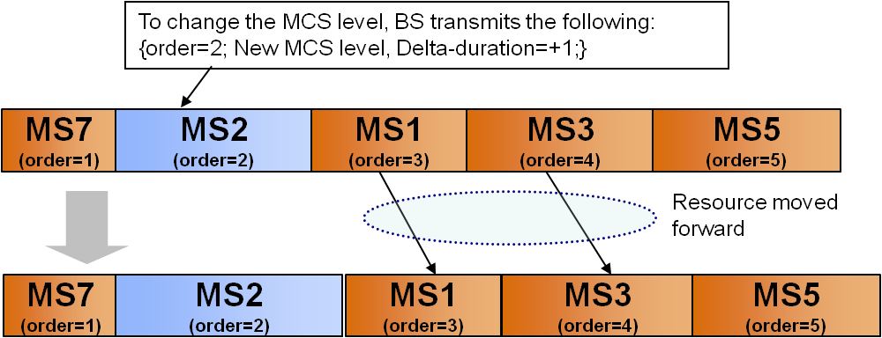
Figure 4. Changing allocated resource size when the MCS level is adjusted.

In the proposed method, resource rearrangements for de-allocation and resize are executed in first and automatically fill the unassigned holes in the group region. Newly allocated resources are appended after that. Therefore, unused resource holes cannot exist in our method.
When missing a MAP in resizing or de-allocating persistent resources, the MSs with persistent allocation may not be aware of the new locations of their resources in use. To cope with this problem, which can occur in any other persistent allocation schemes, we introduce a change counter based approach. A persistent change counter (PCC) is increased for each occurrence of deallocation and MCS change event. Each group has its own PCC. For example, assume that allocation period of group-A is 4 and PCC value is 1 at the N-th frame. At the (N+4)-th frame, there are 2 deallocation events and 1 MCS change event. Then, PCC value of Group-A at the (N+4)-th frame should be 4 in this case. Whenever Deallocation or MCS change events for persistent resource occur, the BS sends PCC value in order to indicate possible change of persistent resource. When an MS with persistent allocation losses MAP message due to decoding failure, the MS shall transmit a specific CQICH codeword to the BS in order to indicate its MAP loss. The BS, in respond to reception of the specific CQICH codeword from MSs, should send only the PCC value when there is no deallocation or MCS change event at the previous frame. MSs monitor the PCC value and it can figure out there are no changes of persistent resource at the previous frame. If deallocation and MCS change events occur at the previous frame, the BS should send both PCC value and persistent resource change information so that the MS can keep track of its own persistent resource. The persistent resource change information can be either explicit persistent allocation message or just resource change information; for example, deallocation and MCS change information at the previous frame. Since the PCC value is increased for each occurrence of deallocation or MCS change event, each deallocation and MCS change event has its own PCC identification. Therefore, the MSs that missing MAP at the previous frame, can recover its own persistent resource position by monitoring the PCC value and resource change information.

3. Proposed Text

[Add new section to 8.4.5.3.21.2]

8.4.5.3.21.2 Downlink Persistent Allocations

Downlink persistent allocations are used by the base station to make downlink time-frequency resource assignments which repeat periodically. The logical time-frequency resource assigned by persistent allocation repeats at a periodic interval. For downlink persistent allocations, the base station transmits the Persistent HARQ DL MAP IE.

The Persistent HARQ DL MAP IE defines one two-dimensional data region (a number of symbols by a number of subchannels). These allocations are further partitioned into subbursts by allocating a specified number of slots to each burst. Subbursts can be allocated either in persistent manner, or in non-persistent manner. The number of slots for each subburst is indicated by duration fields. The slots are allocated in a frequency-first order, starting from the slot with the smallest symbol number and smallest subchannel, and continuing to slots with increasing subchannel number. When DL Slot Offset IE appears in the Persistent HARQ DL MAP IE, subsequent subbursts starts from the slot indicated by Slot offset field, and continuing to slots with increasing subchannel number. When the edge of the allocation is reached, the symbol number is increased by slot duration, as depicted in Figure xxx. Each subburst is separately encoded.
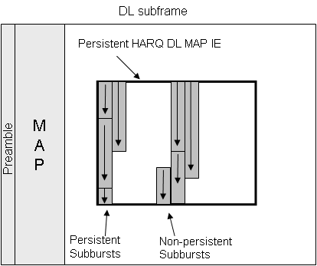
Figure xxx. Persistent HARQ DL Allocation

Table xxx defines detailed message format for Persistent HARQ DL MAP IE. Each Persistent HARQ DL MAP IE has its own Group ID, indicating a specified group. The Group consists of a set of users which have persistent resource within the Persistent HARQ DL MAP IE and have same allocation period. Assigning persistent subburst in a group region to an MS implicitly makes the MS belong to the group.

Several Sub-IEs are defined within the Persistent Subburst IE. DL Allocation sub-IE is used for subburst allocation, which can be either persistent, or non-persistent. Persistently allocated subbursts will repeatedly be allocated with a period indicated by Group allocation period until explicit deallocation message is sent. Deallocation sub-IE is used for deallocating persistently allocated surburst. DL MCS change sub-IE is used for changing allocation information (e.g. MCS level and slot length) for persistently allocated subburst. DL slot offset sub-IE is used for indicating slot start pointer for non-persistent subburst allocation. Subbursts allocated by DL allocation sub-IEs with non-persistent option appearing after DL slot offset sub-IE starts from the slot indicated by Slot offset field, and continuing to slots with increasing subchannel number.

Persistent subburst allocation starts from the slot right after previously allocated persistent resource. All the users within a group shall have persistent allocated resource, and also shall have their order value, which is used as user identifier for DL deallocation IE and DL MCS change IE. Order value is allotted only for persistent allocation, representing MSs’ allocated resource order. For DL Allocation sub-IE with persistent allocation first appearing in the Persistent HARQ DL MAP IE, the MS shall find its order value by referring the Number of persistent allocations field. For the subsequent DL Allocation sub-IEs with persistent allocation, the MSs shall find its order value by counting number of preceding DL Allocation sub-IEs.

When DL deallocation sub-IE is sent, all the MSs with order value higher than specified order value within this sub-IE shall decrease their order value by one and their start slot position of persistent resource is also decreased by the amount of duration (DL deallocation sub-IE). When DL MCS change sub-IE is sent, all the MSs with order value higher than specified order value within this sub-IE shall adjust their start slot position by the amount of delta duration (DL MCS change sub-IE).

ACK channel start offset is specified for each group. MSs shall calculate their ACK channel indices for persistent allocation by the sum of ACK channel start offset and the order value of each MS. For non-persistent allocation specified within Persistent DL MAP IE, explicit ACK channel index is specified within DL allocation sub-IE.

HARQ retransmission packet for persistent allocation shall be assigned by non-persistent allocation

Table xxx - Persistent HARQ DL MAP IE
Syntax | Size (bit) | Notes
Persistent HARQ DL MAP IE() {
Extended-2 DIUC | 4
Length | 8
RCID type | 2
Group ID | 4 | Group identifier for this Persistent IE
Number of persistent allocations | 4 | Used for obtaining 'order' information for persistent allocation
Duration type | 2 | Bit size of duration field:  10bits (0b00), 8bits (0b01)  6bits (0b10)
DL Persistent Control IE() | variable
While (data remains) {
Mode | 4
If (mode == 0000)
Persistent DL HARQ Chase Sub-Burst IE () | variable
If (mode == 0011)
Persistent MIMO DL Chase HARQ Sub-Burst IE () | variable
}
}

Number of persistent allocations
Indicates number of persistent allocations in this group. This can be used for obtaining 'order' value for persistent allocation

Duration type
Specifies bit size of duration field used in the Persistent HARQ DL MAP IE

Table xxx – DL Persistent control IE
Syntax | Size (bit) | Notes
DL Persistent control IE() {
Persistent control indicator | 4
if (LSB#0 of Persistent control indicator == 1) { |  | Group Region indicator
OFDMA symbol offset | 8
Subchannel offset | 7
Number of OFDMA symbols | 7
Number of subchannels | 7
Rectangular burst indication | 1
Reserved | 2
}
if (LSB#1 of Persistent control indicator == 1) { |  | Group Period indicator
Group allocation period | 4
}
if (LSB#2 of Persistent control indicator == 1) { |  | ACK channel start offset indicator for persistent allocation
ACK CH Start Offset | 8
}
if (LSB#3 of Persistent control indicator == 1) { |  | PCC indicator
Persistent Change Counter | 8
}
}

Group allocation period
The group allocation period shall be set to the period of the persistent allocation, in units of frames. If the allocation period is set to n, the time-frequency resource assignment repeats every n frames. For example, as illustrated below, if n=4, the time-frequency resource assignment is valid in frames N, N+4, N+8, etc.

ACK channel start offset
It is specified for each group. MSs shall calculate their ACK channel indices for persistent allocation by the sum of ACK channel start offset and the order value of each MS.

Persistent Change Counter (PCC)
For each group, PCC is increased for each occurrence of new MCS change or deallocation event. For example, assume that allocation period of group-A is 4 and PCC value is 1 at the N-th frame. At the (N+4)-th frame, there are 2 deallocation events and 1 MCS change event. PCC value of Group-A at the (N+4)-th frame should be 4 in this case. When an MS with persistent allocation losses MAP message due to decoding failure, an MS shall transmit a specific CQICH codeword to the BS in order to inform its MAP loss. The BS shall send PCC value when there is any deallocation or MCS change event at the current frame, or when there are any reception of the specific CQICH codeword from the MS.

Table xxx –Persistent DL HARQ Chase Sub-burst IE
Syntax | Size (bit) | Notes
Persistent DL HARQ Chase Sub-Burst IE () {
N sub-IE | 4 | Number of Sub-IEs
For (j=0; j<N_sub-IE; j++) { | 3
Sub-IE type | 3
Reserved | 1
If (Sub-IE type==0)
DL Deallocation sub-IE() | Variable | Persistent deallocation
If (Sub-IE type==1)
DL MCS Change sub-IE() | 16 | MCS change for persistent resource
If (Sub-IE type==2)
DL Allocation sub-IE() | Variable | Non-persistent or persistent allocation
If (Sub-IE type==3)
DL Slot Offset sub-IE() | 12 | Indicates the start pointer in OFDMA slots, with respect to the lowest numbered OFDM symbol and the lowest numbered subchannel in the time-frequency resource. When this IE appear before DL_allocation_IE, it indicates allocation start position.
}
}

Table xxx – Persistent MIMO DL Chase HARQ Sub-Burst IE ()
Syntax | Size (bit) | Notes
Persistent MIMO DL Chase HARQ Sub-Burst IE () {
N sub-IE | 4 | Number of Sub-IEs
For (j=0; j<N_sub-IE; j++) { | 3
Sub-IE type | 3
Reserved | 1
If (Sub-IE type==0)
DL Deallocation sub-IE() | variable | Persistent deallocation
If (Sub-IE type==1)
MIMO DL MCS Change sub-IE() | variable | MCS change for MIMO persistent resource
If (Sub-IE type==2)
MIMO DL Allocation sub-IE() | variable | Non-persistent or persistent MIMO allocation
If (Sub-IE type==3)
DL Slot Offset sub-IE() | 12 | Indicates the start pointer in OFDMA slots, with respect to the lowest numbered OFDM symbol and the lowest numbered subchannel in the time-frequency resource. When this IE appear before DL_allocation_IE, it indicates allocation start position.
}
}

Table xxx – DL Deallocation sub-IE
Syntax | Size (bit) | Notes
DL deallocation sub-IE() {
Order | 5
Duration | Variable | 10/8/6 bits
Padding | Variable | Padding to nibble; shall be set to 0
}

Table xxx – DL MCS change sub-IE
Syntax | Size (bit) | Notes
DL MCS Change sub-IE() {
Order | 5
DIUC | 4
Repetition Coding Indication | 2
Delta duration | 5 | Difference in slots between previously occupied subburst size and current subburst size
}

Table xxx - DL Allocation sub-IE
Syntax | Size (bit) | Notes
DL Allocation sub-IE() {
RCID | Variable
Allocation flag | 1 | 0: Non-persistent allocation  1: Persistent allocation
Duration | Variable | 10 bit in case of Duration type=00  8 bit in case of Duration type=01  6 bit in case of Duration type=10
DIUC | 4
Repetition Coding Indication | 2
if (Allocation flag==1) {
Number of ACID | 4 | Number of HARQ channels associated with this persistent assignment. It enables ACID cycling
}
ACID | 4
AI-SN | 1
ACK disable | 1
If (ACK_disable==0 and Allocation_flag==0) {
ACK channel | 8 | ACK channel index
}
Dedicated DL control Indicator | 2
If LSB#0 of dedicated DL control indicator ==1){
Duration (d) | 4
If (Duration !=0b0000 ){
Allocation index | 6
Period (p) | 3
Frame offset | 3
}
}
If (LSB #1 of dedicated DL control indicator ==1){
Dedicated DL control IE | Variable
}
}

Allocation flag
Indicates whether this subburst allocation is persistent or not

ACID
The ACID field shall be set to the beginning ACID as described below.

Number of ACID
The Number of ACID (N_ACID) shall be set to the number of HARQ channel identifiers for persistent allocation. The Number of ACID and ACID fields are used together to establish an implicit cycling of ACID as follows. If N_ACID is greater than 1, and if the allocation period is greater than 0, the ACID corresponding to the first occurrence of the persistent allocation corresponds to the ACID field, and the ACID corresponding to the second occurrence of the persistent allocation corresponds to the ACID field + 1, etc. The ACID corresponding to the N_ACIDth occurrence of the persistent allocation corresponds to the ACID field + N_ACID – 1, and the ACID corresponding to the (N_ACID + 1)^{th} occurrence of the persistent allocation corresponds to the ACID field. This process is repeated for additional occurrences of the persistent allocation. As illustrated below, if the allocation period equals 4, if N_ACID = 4, and if ACID = 2, the ACID follows the pattern 2, 3, 4, 5, 2, 3, 4, 5, etc.

ACK channel index
The ACK channel shall be set to the number of the ACK channel within the HARQ ACK Region. The mobile station shall use the indicated ACK channel for transmitting acknowledgment information for each packet received using the time-frequency resource referred to by non-persistent allocation.

AI_SN
The AI_SN shall be set to the initial AI_SN for each ACID in the sequence of ACID values. The AI_SN shall toggle from 1 to 0 or 0 to 1 for each occurrence of a particular ACID. For example, if the allocation period equals 4, if N_ACID = 4, if ACID = 2, and if AI_SN = 0, the ACID follows the pattern 2, 3, 4, 5, 2, 3, 4, 5, etc, and the AI_SN follows the pattern 0, 0, 0, 0, 1, 1, 1, 1, etc.

Table xxx – DL slot offset sub-IE
Syntax | Size (bit) | Notes
DL slot offset sub-IE {
Slot offset | 10
Reserved | 2
}

Slot offset
Indicates the start pointer in OFDMA slots, with respect to the lowest numbered OFDM symbol and the lowest numbered subchannel in the time-frequency resource. When this IE appears before DL allocation sub-IE with non-persistent option, it indicates allocation start position. This does not affect persistent allocation

Table xxx – MIMO DL MCS change sub-IE
Syntax | Size (bit) | Notes
MIMO DL MCS Change sub-IE() {
Order | 5
Dedicated MIMO DL Control Indicator | 1
if (Dedicated MIMO DL Control Indicator==1) {
Dedicated MIMO DL Control IE() | Variable
}
Delta_duration | 5 | Difference in slots between previously occupied subburst size and current subburst size
For (i=0; i<N_layer; i++) {
DIUC | 4
Repetition Coding Indication | 2
}
}

Table xxx - MIMO DL Allocation sub-IE
Syntax | Size (bit) | Notes
MIMO DL Allocation sub-IE() {
MU_indicator | 1 | Indicates whether this DL burst is intended for multiple SS
Dedicated MIMO DL Control Indicator | 1
ACK disable | 1
if (MU_indicator==0) {
RCID | Variable
}
if (Dedicated MIMO DL Control Indicator==1) {
Dedicated MIMO DL Control IE() | Variable
}
Allocation flag | 1 | 0: Non-persistent  1: Persistent alloc
Duration | Variable | 10/8/6 bits
For (i=0; i<N_layer; i++) {
if (MU_indicator==1) {
RCID | Variable
}
DIUC | 4
Repetition Coding Indication | 2
if (ACK_diable==0) {
if (Allocation flag==1) {
Number of ACID | 4 | Number of HARQ channels associated with this persistent assignment. It enables ACID cycling
}
ACID | 4
AI-SN | 1
If (ACK_disable==0 and Allocation_flag==0) {
ACK channel | 8 | ACK channel index
}
}
}
Padding | Variable | Padding to nibble; shall be set to 0
}

[Add new section to 8.4.5.4.24.3]

8.4.5.4.24.3 Uplink Persistent Allocations
Uplink persistent allocations are used to make uplink time-frequency resource assignments which repeat periodically. The logical time-frequency resource assigned by persistent allocation repeats at a periodic interval. For uplink persistent allocations, the base station transmits the Persistent HARQ UL MAP IE.

The Persistent HARQ UL MAP IE defines data region by the starting symbol and subchannel. Subbursts defined within the Persistent HARQ UL MAP IE can be allocated either in persistent manner, or in non-persistent manner. The number of slots for each subburst is indicated by duration fields. The slots are allocated in a time-first order. When UL Slot Offset IE appears in the Persistent HARQ UL MAP IE, subsequent subbursts starts from the slot indicated by Slot offset field, and continuing to slots with increasing symbol number. When the edge of the allocation is reached, the subchannel number is increased. Each subburst is separately encoded.

Table yyy - Persistent HARQ UL MAP IE
Syntax | Size (bit) | Notes
Persistent HARQ UL MAP IE() {
Extended-2 UIUC | 4
Length | 8
RCID type | 2
Group ID | 4
Number of persistent allocations | 4
Duration type | 2 | Bit size of duration field:  10bits (0b00), 8bits (0b01)  6bits (0b10)
UL Persistent Control IE() | variable
While (data remains) {
Mode | 3
Reserved | 1
If (mode == 000)
Persistent UL HARQ Chase Sub-Burst IE () | variable
If (mode == 011)
Persistent MIMO UL Chase HARQ Sub-Burst IE () | variable
}
}

Number of persistent allocations
Indicates number of persistent allocations in this group. This can be used for obtaining 'order' value for persistent allocation

Duration type
Specifies bit size of duration field used in the Persistent HARQ UL MAP IE

Table yyy – UL Persistent Control IE
Syntax | Size (bit) | Notes
UL Persistent Control IE () {
Persistent control indicator | 3
Reserved | 1
if (LSB#0 of Persistent control indicator == 1) { |  | Group Region indicator
OFDMA symbol offset | 8
Subchannel offset | 7
Reserved | 1
}
if (LSB#1 of Persistent control indicator == 1) { |  | Group Period indicator
Group allocation period | 4
}
if (LSB#2 of Persistent control indicator == 1) { |  | PCC indicator
Persistent Change Counter | 8
}

Group allocation period
The group allocation period shall be set to the period of the persistent allocation, in units of frames. If the allocation period is set to n, the time-frequency resource assignment repeats every n frames. For example, if n=4, the time-frequency resource assignment is valid in frames N, N+4, N+8, etc.

Persistent Change Counter (PCC)
For each group, PCC is increased for each occurrence of new MCS change or deallocation event. For example, assume that allocation period of group-A is 4 and PCC value is 1 at the N-th frame. At the (N+4)-th frame, there are 2 deallocation events and 1 MCS change event. PCC value of Group-A at the (N+4)-th frame should be 4 in this case. When an MS with persistent allocation losses MAP message due to decoding failure, an MS shall transmit a specific CQICH codeword to the BS in order to inform its MAP loss. The BS shall send PCC value when there is any deallocation or MCS change event at the current frame, or when there are any reception of the specific CQICH codeword from the MS.

Table yyy –Persistent UL HARQ Chase Sub-burst IE
Syntax | Size (bit) | Notes
Persistent UL HARQ Chase Sub-Burst IE () {
N sub-IE | 4 | Number of Sub-IEs
For (j=0; j<N_sub-IE; j++) { | 3
Sub-IE type | 3
Reserved | 1
If (Sub-IE type==0)
UL Deallocation sub-IE() | variable | Persistent deallocation
If (Sub-IE type==1)
UL MCS Change sub-IE() | 16 | MCS change for persistent resource
If (Sub-IE type==2)
UL Allocation sub-IE() | variable | Non-persistent or persistent allocation
If (Sub-IE type==3)
UL Slot Offset sub-IE() | 12
}
}

Table yyy – Persistent MIMO UL Chase HARQ Sub-Burst IE
Syntax | Size (bit) | Notes
Persistent MIMO UL Chase HARQ Sub-Burst IE () {
N sub-IE | 4 | Number of Sub-IEs
For (j=0; j<N_sub-IE; j++) { | 3
Sub-IE type | 3
Reserved | 1
If (Sub-IE type==0)
UL Deallocation IE() | Variable | Persistent deallocation
If (Sub-IE type==1)
MIMO UL MCS Change IE() | 16 | MCS change for MIMO persistent resource
If (Sub-IE type==2)
MIMO UL Chase Allocation IE() | Variable | Non-persistent or persistent MIMO allocation
If (Sub-IE type==3)
UL Slot Offset IE() | 16
}
}

Table yyy – UL Deallocation sub-IE
Syntax | Size (bit) | Notes
UL deallocation sub-IE() {
Order | 5
Duration | Variable | 10/8/6 bits
Padding | Variable | Padding to nibble; shall be set to 0
}

Table yyy – UL MCS change Sub-IE
Syntax | Size (bit) | Notes
UL MCS Change sub-IE() {
Order | 5
UIUC | 4
Repetition Coding Indication | 2
Delta duration | 5 | Difference in slots between previously occupied subburst size and current subburst size
}

Table yyy - UL Allocation sub-IE
Syntax | Size (bit) | Notes
UL Allocation sub-IE() {
RCID | Variable
Allocation flag | 1 | 0: Non-persistent allocation  1: Persistent allocation
Dedicated UL control Indicator | 1
If (Dedicated UL control indicator ==1){
Dedicated UL control IE | Variable
}
UIUC | 4
Repetition Coding Indication | 2
Duration | Variable | 10 bit in case of Duration type=00  8 bit in case of Duration type=01  6 bit in case of Duration type=10
if (Allocation flag==1) {
Number of ACID | 4 | Number of HARQ channels associated with this persistent assignment. It enables ACID cycling
}
ACID | 4
AI-SN | 1
ACK disable | 1
}

Allocation flag
Indicates whether this subburst allocation is persistent or not

ACID
The ACID field shall be set to the beginning ACID as described below.

Number of ACID
The Number of ACID (N_ACID) shall be set to the number of HARQ channel identifiers for persistent allocation. The Number of ACID and ACID fields are used together to establish an implicit cycling of ACID as follows. If N_ACID is greater than 1, and if the allocation period is greater than 0, the ACID corresponding to the first occurrence of the persistent allocation corresponds to the ACID field, and the ACID corresponding to the second occurrence of the persistent allocation corresponds to the ACID field + 1, etc. The ACID corresponding to the N_ACIDth occurrence of the persistent allocation corresponds to the ACID field + N_ACID – 1, and the ACID corresponding to the (N_ACID + 1)^{th} occurrence of the persistent allocation corresponds to the ACID field. This process is repeated for additional occurrences of the persistent allocation. If the allocation period equals 4, if N_ACID = 4, and if ACID = 2, the ACID follows the pattern 2, 3, 4, 5, 2, 3, 4, 5, etc.

AI_SN
The AI_SN shall be set to the initial AI_SN for each ACID in the sequence of ACID values. The AI_SN shall toggle from 1 to 0 or 0 to 1 for each occurrence of a particular ACID. For example, if the allocation period equals 4, if N_ACID = 4, if ACID = 2, and if AI_SN = 0, the ACID follows the pattern 2, 3, 4, 5, 2, 3, 4, 5, etc, and the AI_SN follows the pattern 0, 0, 0, 0, 1, 1, 1, 1, etc.

Table yyy – UL Slot Offset sub-IE
Syntax | Size (bit) | Notes
UL slot offset sub-IE {
Slot offset | 10
Reserved | 2
}

Slot offset
Indicates the start pointer. When this IE appears before UL allocation sub-IE with non-persistent option, it indicates allocation start position. This does not affect persistent allocation

Table yyy – MIMO UL MCS Change sub-IE
Syntax | Size (bit) | Notes
MIMO UL MCS Change sub-IE() {
Order | 5
Dedicated MIMO UL Control Indicator | 1
if (Dedicated MIMO UL Control Indicator==1) {
Dedicated MIMO UL Control IE() | Variable
}
Delta_duration | 5
For (i=0; i<N_layer; i++) { |  | N_layer=2 when MU indicator is set to 1
UIUC | 4
Repetition Coding Indication | 2
}
}

Table yyy - MIMO UL Allocation sub-IE
Syntax | Size (bit) | Notes
MIMO UL Allocation sub-IE () {
MU_indicator | 1 | Indicates whether this UL burst is intended for multiple SS
Dedicated MIMO UL Control Indicator | 1
ACK disable | 1
if (MU_indicator==0) {
RCID | Variable
if (Dedicated MIMO UL Control Indicator==1) {
Dedicated MIMO UL Control IE() | Variable
}
} else
Matrix
}
Allocation flag | 1 | 0: Non-persistent  1: Persistent alloc
Duration | Variable | 10/8/6 bits
For (i=0; i<N_layer; i++) { |  | N_layer=2 when MU indicator is set to 1
if (MU_indicator==1) {
RCID | Variable
}
UIUC | 4
Repetition Coding Indication | 2
if (ACK_diable==0) {
if (Allocation flag==1) {
Number of ACID | 4 | Number of HARQ channels associated with this persistent assignment. It enables ACID cycling
}
ACID | 4
AI-SN | 1
}
}
Padding | Variable | Padding to nibble; Shall be set to 0
}

