Project | IEEE 802.16 Broadband Wireless Access Working Group <http://ieee802.org/16>
Title | Support of Load Balancing with Preamble Index
Date Submitted | 2008-01-22
Source(s) | Jaejeong(Brian) Shim,  KiBack Kim,  Aeri Lim  Samsung Electronics* | Voice:  E-mail: brian.shim@samsung.com  *<http://standards.ieee.org/faqs/affiliationFAQ.html>
Re: | LB26a
Abstract | This contribution proposed a load balancing scheme during initial network entry, HO, or re-entry from idle mode.
Purpose | Accept the proposed specification changes on IEEE P802.16Rev2/D2.
Notice | This document does not represent the agreed views of the IEEE 802.16 Working Group or any of its subgroups. It represents only the views of the participants listed in the “Source(s)” field above. It is offered as a basis for discussion. It is not binding on the contributor(s), who reserve(s) the right to add, amend or withdraw material contained herein.
Release | The contributor grants a free, irrevocable license to the IEEE to incorporate material contained in this contribution, and any modifications thereof, in the creation of an IEEE Standards publication; to copyright in the IEEE’s name any IEEE Standards publication even though it may include portions of this contribution; and at the IEEE’s sole discretion to permit others to reproduce in whole or in part the resulting IEEE Standards publication. The contributor also acknowledges and accepts that this contribution may be made public by IEEE 802.16.
Patent Policy | The contributor is familiar with the IEEE-SA Patent Policy and Procedures:  <http://standards.ieee.org/guides/bylaws/sect6-7.html#6> and <http://standards.ieee.org/guides/opman/sect6.html#6.3>.  Further information is located at <http://standards.ieee.org/board/pat/pat-material.html> and <http://standards.ieee.org/board/pat>.
Load balancing scheme using ‘Preamble Index’
Samsung Electronics

Problem description

When a BS cannot support an MS trying initial network entry, handover, or reentry from idle mode, it has to move the MS to other BS which can support the MS. However, current specification does not support the operation.

BS can use RNG-RSP (with ranging status=abort) or DREG-CMD (with action code = 00), but they cannot designate specific target BS to the MS.

BS can use the ‘Downlink frequency override’ TLV. But the TLV cannot designate a specific target BS and it is not available when reuse factor = 1.

Even though MS can obtain the Service level prediction of each target BS during handover, the system load of target BS may change when the MS moves to the BS.

MS could get the loading information (Available DL/UL Radio Resources) in DCD/UCD during network entry. But the information is only for the serving BS. Generally, the TX period of NBR-ADV message is much larger than that of DCD/UCD. Thus, MS may not get the NBR-ADV message during network entry. MS cannot perform load balancing based on the loading information of only the serving BS. In case of re-entry from idle-mode, MS may not obtain latest DCD, UCD, and NBR-ADV. The Configuration Change Count of DCD and UCD does not count in the Available DL Radio Resource and Available UL Radio Resource respectively. That means MS mostly have loading information which is not valid any more during re-entry from idle mode.

Proposed Changes

Change #1: Add a TLV and its description in “RNG-RSP message”:

Adopt the following changes in pp.92, line 12:

SS MAC Address (48-bit)
A required parameter when the CID in the MAC header is the Initial Ranging CID.
Frequency Adjust Information
AAS Broadcast Permission
Preamble Index override
Preamble Index(es) of new target BS(s) where the MS should redo ranging. If the TLV includes two or more Preamble Indexes, the first one in the list is the most preferable and the second is the next preferable. When the TLV is used with Downlink frequency override TLV, the MS should redo ranging on the new DL channel with the Preamble Index(es).

Change #2: Add a TLV in Table 552 - RNG-RSP message encodings:

Add the following TLV into Table 552:

Table 552—RNG-REQ message encodings

Name | Type  (1 byte) | Length | Value | PHY scope
Preamble Index override | 39 | Length is defined as: (Num of Preamble Index) * 1 | Preamble Index(es) of new target BS(s) where the MS should redo ranging.  If this TLV is used, the Ranging Status value shall be set to 2. Shall be used for licensed bands only. | All

[Informative] - Example of operation (handover case)

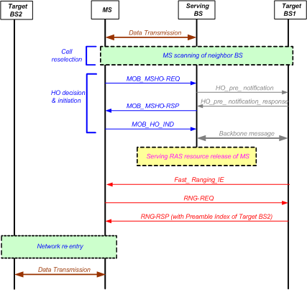

References

[IEEE802.16-Rev2/D2] IEEE Computer Society and IEEE Microwave Theory and Techniques Society, “DRAFT Standard for Local and Metropolitan Area Networks Part 16: Air Interface for Broadband Wireless Access Systems”, P802.16Rev2/D2 (December 2007). Revision of IEEE Std 802.16-2004 and consolidates material from IEEE Std 802.16e-2005, IEEE Std 802.16-2004/Cor1-2005, IEEE Std 802.16f-2005 and IEEE Std802.16g-2007.

