Project | IEEE 802.16 Broadband Wireless Access Working Group <http://ieee802.org/16>
Title | MBS service by application signaling between MS and network
Date Submitted | 2008-03-19
Source(s) | Jaejeong(Brian) Shim,  Yeongmoon Son  KiBack Kim  Samsung Electronics* | Voice:  E-mail: brian.shim@samsung.com  *<http://standards.ieee.org/faqs/affiliationFAQ.html>
Re: | LB26b
Abstract | This contribution proposed an optional way of MBS setup operation using application signaling between MS and network.
Purpose | Accept the proposed specification changes on IEEE P802.16Rev2/D3.
Notice | This document does not represent the agreed views of the IEEE 802.16 Working Group or any of its subgroups. It represents only the views of the participants listed in the “Source(s)” field above. It is offered as a basis for discussion. It is not binding on the contributor(s), who reserve(s) the right to add, amend or withdraw material contained herein.
Release | The contributor grants a free, irrevocable license to the IEEE to incorporate material contained in this contribution, and any modifications thereof, in the creation of an IEEE Standards publication; to copyright in the IEEE’s name any IEEE Standards publication even though it may include portions of this contribution; and at the IEEE’s sole discretion to permit others to reproduce in whole or in part the resulting IEEE Standards publication. The contributor also acknowledges and accepts that this contribution may be made public by IEEE 802.16.
Patent Policy | The contributor is familiar with the IEEE-SA Patent Policy and Procedures:  <http://standards.ieee.org/guides/bylaws/sect6-7.html#6> and <http://standards.ieee.org/guides/opman/sect6.html#6.3>.  Further information is located at <http://standards.ieee.org/board/pat/pat-material.html> and <http://standards.ieee.org/board/pat>.
MBS service by application signaling between MS and network
Samsung Electronics

Problem description

According to the current standard, a DSx transaction is required to setup an MBS connection between MS and BS.

MBS content channel transition time during switching b/w broadcast channels
- Incurred by DSx transactions
  - DSD for an existing MBS channel
  - DSA for a new MBS channel
- Waste of air resource by frequent channel transitions by users
- The following is an example of channel transition procedure.

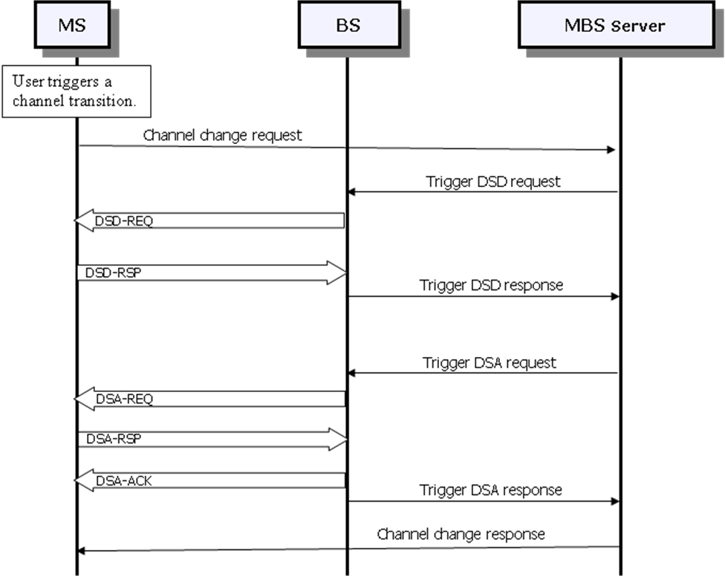

There is a difficulty to support MBS for idle-mode terminals because an MS in idle mode need to make a transition to awake mode before sending DSx messages.

If we add multiple MBS contents at the beginning of MBS service, we can avoid the above-mentioned problems in MBS content channel transition, but the waste of air resource for multiple DSA transactions for MBS contents would be another problem.

Table 1 – Comparison of possible operations for MBS setup.

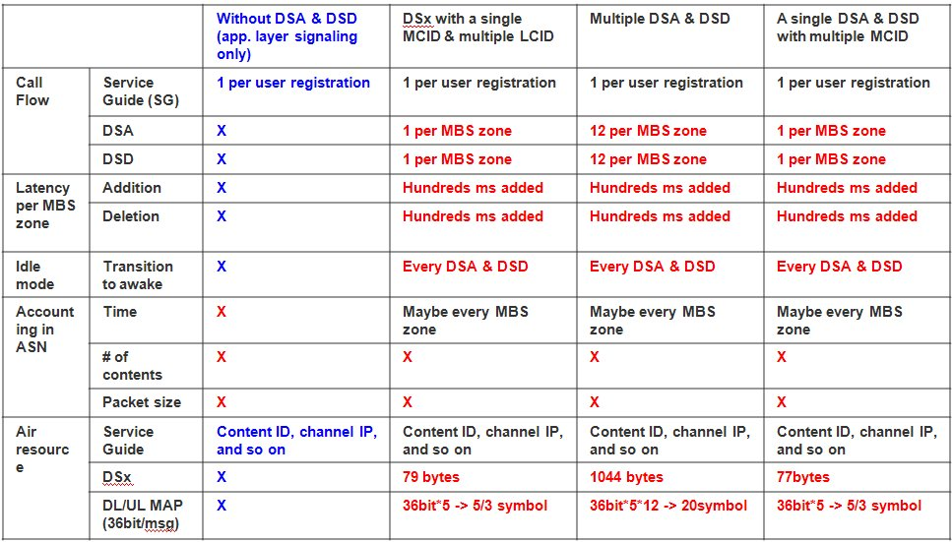

Proposed Changes

Add an optional feature which enables MBS service by application signaling between MS and network (e.g., MBS server).

MBS client application in MS obtains MBS content information from MBS server. MBS content information is a type of service guide which may contain MBS Zone ID, IP address of content server, and so on.

MBS client application triggers the decoding of specific MBS bursts in Layer2.

Change #1: Add the following underlined paragraph next to the 4th paragraph in ‘6.3.23.2.1 Establishment and maintenance of MBSs’:

When the MS registers at the BS for receiving multicast and broadcast services, the BS or MS may initiate the DSA procedure with respect to multicast and broadcast connections. Such knowledge may be used to initiate bi-directional upper layers communication between the MS and the network for the purpose of configuration of multicast/broadcast service. After the successful configuration, the MS may reuse the same configuration when it moves to another BS without re-configuration.

The configuration of multicast/broadcast service may be done by upper layer communication only, without DSA procedure. In this case, the communication between the MS and the network includes MBS content information – i.e., a service guide for MBS service, and is outside the scope of this specification.

References

[IEEE802.16-Rev2/D3] IEEE Computer Society and IEEE Microwave Theory and Techniques Society, “DRAFT Standard for Local and Metropolitan Area Networks Part 16: Air Interface for Broadband Wireless Access Systems”, P802.16Rev2/D3 (February 2008). Revision of IEEE Std 802.16-2004 and consolidates material from IEEE Std 802.16e-2005, IEEE Std 802.16-2004/Cor1-2005, IEEE Std 802.16f-2005 and IEEE Std802.16g-2007.

