Project | IEEE 802.16 Broadband Wireless Access Working Group <http://ieee802.org/16>
Title | Efficient Signaling to Support Partitioning/Grouping for H-FDD Operation
Date Submitted | 2008-01-14
Source(s) | Pallav Sudarshan  Jeff Zhuang  Mark Cudak  Motorola, Inc. | E-mail:  Pallav.Sudarshan@motorola.com  Jeff.Zhuang@motorola.com  Mark.Cudak@motorola.com  <http://standards.ieee.org/faqs/affiliationFAQ.html>
Re: | IEEE 802.16 Working Group Letter Ballot Recirc #26a
Abstract | Clarifications and signaling mechanisms are provided for efficient operation of H-FDD in 802.16e.
Purpose | Accept the proposed specification changes on IEEE P802.16Rev2/D2.
Notice | This document does not represent the agreed views of the IEEE 802.16 Working Group or any of its subgroups. It represents only the views of the participants listed in the “Source(s)” field above. It is offered as a basis for discussion. It is not binding on the contributor(s), who reserve(s) the right to add, amend or withdraw material contained herein.
Release | The contributor grants a free, irrevocable license to the IEEE to incorporate material contained in this contribution, and any modifications thereof, in the creation of an IEEE Standards publication; to copyright in the IEEE’s name any IEEE Standards publication even though it may include portions of this contribution; and at the IEEE’s sole discretion to permit others to reproduce in whole or in part the resulting IEEE Standards publication. The contributor also acknowledges and accepts that this contribution may be made public by IEEE 802.16.
Patent Policy | The contributor is familiar with the IEEE-SA Patent Policy and Procedures:  <http://standards.ieee.org/guides/bylaws/sect6-7.html#6> and <http://standards.ieee.org/guides/opman/sect6.html#6.3>.  Further information is located at <http://standards.ieee.org/board/pat/pat-material.html> and <http://standards.ieee.org/board/pat>.

Efficient Signaling to Support Partitioning/Grouping for H-FDD Operation

Introduction
The default UL transmission is “time-first”, as opposed to default “frequency-first” allocation in DL. The UL transmission for a user starts after the end of previous allocation. The temporal duration of the UL transmission for a user usually spans the entire zone. This is the so-called “snake-like” allocation, which means essentially that in order to enable H-FDD SS with both UL and DL traffic in the same frame, uplink subframe needs to be divided into partitions. Given that a partition can not be defined on a per-SS basis, the more common case is that each partition contains allocation to a group of users.

This contribution proposes texts to clarify that a frame can be partitioned when serving H-FDD users with an associated efficient signaling mechanism.

2. Proposed Text

I: Modification to the legend of existing Figure 59 (copied below):
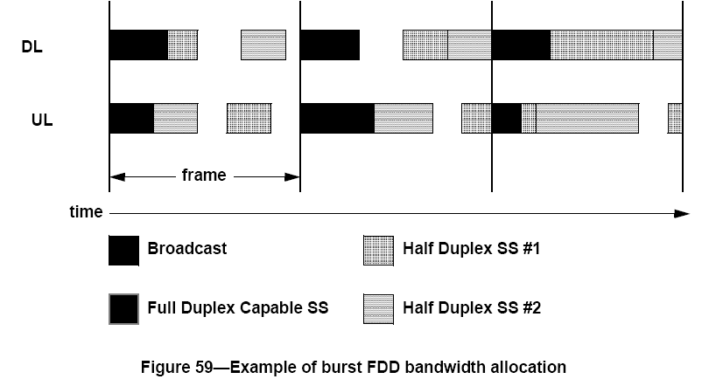

Fig 59 should denote the different temporal regions more generically as “Half Duplex Partition #1” and “Half Duplex Partition #2”, instead of “Half Duplex SS #1” and “Half Duplex SS #2”.

II. Add the following paragraph after Fig 59 pg 293:

“To efficiently serve H-FDD SS, the downlink and uplink portion of a frame can be divided into two DL and UL partitions. A DL partition associated with a non-overlapping UL partition, along with a properly defined gap in between designated for RTG or TTG, can be used to serve a group of H-FDD users. For example, the first (or second) DL partition and the corresponding second (or first) UL partition can be used to serve a first (or second) group of SSs. Each DL partition of the H-FDD frame may have an independent MAP region including FCH intended for only the SSs assigned to the corresponding group in any given frame.”

III: Insert new subclause 8.4.5.3.28 at line 44 Pg. 753 (i.e., after 8.4.5.3.27):

8.4.5.3.28: H-FDD Frame Configuration IE
For H-FDD operation, the DL Frame Configuration IE shall be used by the BS to signal the partitioning of DL subframes. The end of the DL portion of Half-Duplex Partition #1 and start of the DL portion of Half-Duplex Partition #2 are specified in the H-FDD Frame Configuration IE as follows.

Syntax | Size | Notes
DL_Frame_Configuration_IE() { | - | -
Extended DIUC | 4 bits | DL_Frame_Configuration_IE() = 0x0D
Symbol offset1 | 6 bits | Symbol offset of the end of first partition from the preamble
Symbol offset2 | 2 bits | Symbol offset of the start of second partition from the end of first group
} | - | -

The corresponding UL partitioning is implicitly defined according to the DL partitioning, after observing the specified RTG and TTG. Particularly, the start of the UL portion of Half-Duplex Partition #1 is defined as “Symbol offset 1 + RTG”, and the end of the UL portion of Half-Duplex Partition #2 is defined as “Symbol offset1 + Symbol offset 2 –TTG”.

IV: Change Table 323 Pg. 701 as indicated:
Extended DIUC  (Hexadecimal) | Usage
0D-0E | Reserved
0D | DL Frame Configuration IE
0E | Reserved

