Project | IEEE 802.16 Broadband Wireless Access Working Group <http://ieee802.org/16>
Title | MAP Overhead Reduction through Signaling MCS and Allocation Size
Date Submitted | 2008-01-18
Source(s) | Shantidev Mohanty, Roshni M. Srinivasan, Apostolos Papathanassiou, Hassan Yaghoobi  Intel Corporation | shantidev.mohanty@hotmail.com, roshni.m.srinivasan@intel.com, apostolos.papathanassiou@intel.com,  hassan.yaghoobi@intel.com  *<http://standards.ieee.org/faqs/affiliationFAQ.html>
Re: | IEEE Working Group 802.16 Letter Ballot #26a
Abstract | Proposes methods to reduce MAP overhead by eliminating the repetitive occurrence of MCS and duration information in consecutive MAP IEs through signaling.
Purpose | To discuss and adopt the proposed specification changes into IEEE 802.16 Rev 2/D3
Notice | This document does not represent the agreed views of the IEEE 802.16 Working Group or any of its subgroups. It represents only the views of the participants listed in the “Source(s)” field above. It is offered as a basis for discussion. It is not binding on the contributor(s), who reserve(s) the right to add, amend or withdraw material contained herein.
Release | The contributor grants a free, irrevocable license to the IEEE to incorporate material contained in this contribution, and any modifications thereof, in the creation of an IEEE Standards publication; to copyright in the IEEE’s name any IEEE Standards publication even though it may include portions of this contribution; and at the IEEE’s sole discretion to permit others to reproduce in whole or in part the resulting IEEE Standards publication. The contributor also acknowledges and accepts that this contribution may be made public by IEEE 802.16.
Patent Policy | The contributor is familiar with the IEEE-SA Patent Policy and Procedures:  <http://standards.ieee.org/guides/bylaws/sect6-7.html#6> and <http://standards.ieee.org/guides/opman/sect6.html#6.3>.  Further information is located at <http://standards.ieee.org/board/pat/pat-material.html> and <http://standards.ieee.org/board/pat>.

MAP Overhead Reduction through Signaling MCS and Allocation Size
Shantidev Mohanty, Roshni Srinivasan, Apostolos Papathanassiou, and Hassan Yaghoobi
Intel Corporation

Introduction
Multiple HARQ subbursts may be present in a HARQ region. The allocation information about these subbursts is specified using Sub-Burst_IEs. For chase HARQ MCS used for these subursts is indicated using the ‘DIUC’ and ‘Repetition Coding Indication’ fields of Sub-Burst IEs; and the size of subbursts is indicated using the ‘Duration’ field of the Sub-Burst IEs. In an IEEE 802.16Rev2/D2 OFDMA frame, consecutive HARQ subbursts may have the same MCS and/or size. For example, HARQ subbursts K, K+1, and K+2 in a DL burst may have the same size L. Currently, the HARQ Sub-Bursts IEs of these subbursts specify L in their respective ‘Duration’ field. It can be observed that in this scenario the value of the ‘Duration’ field of these sub-burst IEs is repetitive and contribute towards MAP overhead. Similarly when multiple consecutive HARQ subbursts have same MCS, specification of MCS for all the sub-bursts is repetitive and contributes towards MAP overhead.

IEEE 802.16Rev2/D2 uses ‘Sub-Burst DIUC Indicator’ flag in DL Chase HARQ Sub-Burst IEs and DL IR HARQ for CC IEs to eliminate the repetitive specification of MCS of two or more consecutive subbursts. This is referred to as MCS optimization in the remaining part of this document. However, 802.16Rev2/D2 does not specify any such mechanism to eliminate the repetitive specification of size of two or more consecutive subbursts. The mechanism of eliminating the repetitive specification of size is referred to as Duration optimization in the remaining part of this document. This repetitive specification of size in the Sub-Burst IEs occurs more frequently when many subbursts have the same size such as in case of VoIP. In a HARQ region when several VoIP subbursts are present many of these may have the same size. One example scenario is illustrated below.

In this example scenario it is considered that 115 VoIP users using AMR 12.2 Kbps are active in an IEEE 802.16Rev2/D2 based system. Voice activity factor of 50 %, 50 ms delay budget, and mixed mobility (60 % ITU PB3, 30 % ITU VA30, and 10 % ITU VA120) is considered for this scenario. Asynchronous and chase combining HARQ is used and dynamic MAP overhead with compressed MAP and sub-MAPs are considered. MAP overhead for this scenario with MCS optimization, Duration optimization, and MCS as well as Duration optimization are shown in Figure 1, Figure 2, and Figure 3, respectively. Comparison of Figure 1 and Figure 2 indicates that Duration optimization reduces MAP size by the amount similar to what is achieved by MCS optimization. It can be observed from Figure 3 that by using both MCS and Duration optimization the gain from these two optimizations gets summed up to achieve double reduction in MAP overhead. Simulations results indicate that by using MCS as well as Duration optimization MAP overhead can be reduced up to 20 % for VoIP applications.

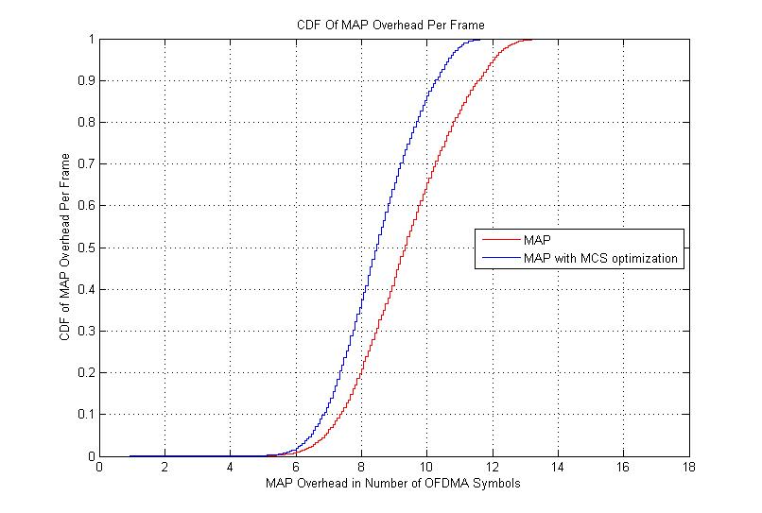
Figure 1: Overhead comparison of MAP with no optimization and MAP with MCS optimization.

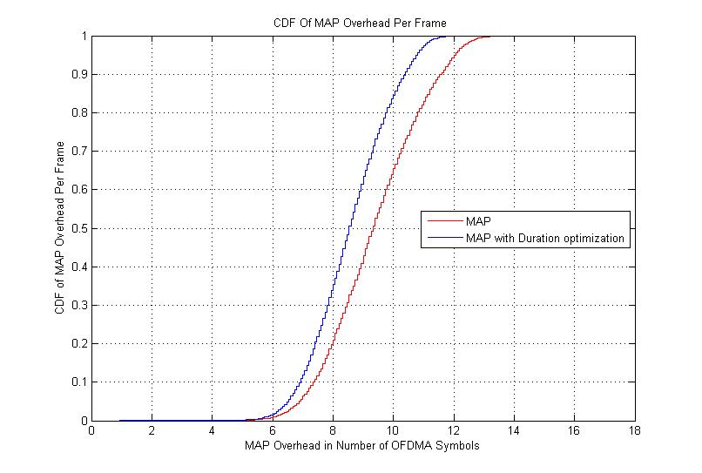
Figure 2: Overhead comparison of MAP with no optimization and MAP with Duration optimization

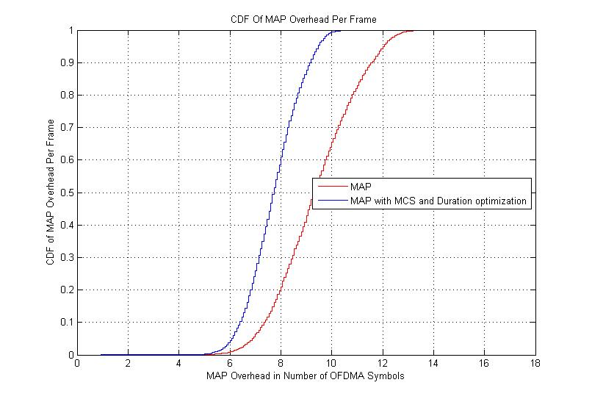
Figure 3: Overhead comparison of MAP with no optimization and MAP with MCS as well as Duration optimization.

Proposed Solution
It is proposed that when the size of N consecutive HARQ subbursts is same, the size of the subbursts is specified only for the first subburst. For the remaining (N-1) subbursts it is indicated that the size is same as the previous subbursts using a 'Duration Indication’ flag. Some of the Sub-Burst IEs have a reserved bit. It is proposed to use this reserved bit as 'Duration Indication’ flag. It may be noted that for chase HARQ IEEE 802.16Rev2/D2 provides similar mechanism to eliminate the specification of MCS scheme of a subburst when the MCS is same as the previous subburst using the 'Sub-Burst DIUC Indicator' flag.

Similarly, for HARQ modes for which MCS optimization is not specified in IEEE 802.16Rev2/D2 it is proposed that when the MCS of N consecutive HARQ subbursts is same, the MCS of the subbursts is specified only for the first subburst. For the remaining (N-1) subbursts it is indicated that the MCS is same as the previous subbursts using a 'Sub-Burst DIUC Indication' flag.

In order to minimize changes to the IEEE 802.16Rev2/D2 we have proposed applying the proposed optimization to the scenarios where reserve bit(s) are available. This optimization could also be applied to all scenarios of HARQ operation with new Sub-Burst IE formats.

Table 1 indicates whether or not MCS and Duration optimizations are present in IEEE 802.16Rev2/D2 and in the proposed solution for different HARQ modes for DL. Similarly, Table 2 indicates whether or not MCS and Duration optimizations are present in IEEE 802.16Rev2/D2 and in the proposed solution for different HARQ modes for UL. It may be noted that because of lack of reserved bits the MCS and Duration optimizations can not be applicable in certain scenarios. However, these optimizations could be easily incorporated for all HARQ modes in DL and UL using new Sub-Burst IE format.
Table 1: MCS and Duration optimization in IEEE 802.16Rev2/D2 and proposed solution for DL.
HARQ Mode | HARQ Type | MCS Optimization |  | Duration Optimization
HARQ Mode | HARQ Type | IEEE 802.16Rev2/D2 | Proposed | IEEE 802.16Rev2/D2 | Proposed
0b0000 | DL Chase HARQ | Yes | Yes (no change to 16Rev2/D2) | No | Yes
0b0001 | DL Incremental redundancy HARQ for CTC | No | Yes | No | Yes
0b0010 | DL Incremental redundancy for HARQ for Convolutional Code | Yes | Yes (no change to 16Rev2/D2) | No | Yes
0b0011 | DL MIMO Chase HARQ | No | No | No | No
0b0100 | DL MIMO IR HARQ | No | No | No | No
0b0101 | DL MIMO IR HARQ for Convolutional Code | No | No | No | No
0b0110 | DL MIMO STC HARQ | No | Yes | No | Yes
0b0111-0b1111 | Reserved | NA | NA | NA | NA

Table 2 MCS and Duration optimization in IEEE 802.16Rev2/D2 and proposed solution for UL.
HARQ Mode | HARQ Type | MCS Optimization |  | Duration Optimization
HARQ Mode | HARQ Type | IEEE 802.16Rev2/D2 | Proposed | IEEE 802.16Rev2/D2 | Proposed
0b000 | UL Chase HARQ | No | No | No | Yes
0b001 | UL Incremental redundancy HARQ for CTC | No | Yes | No | Yes
0b010 | UL Incremental redundancy for HARQ for Convolutional Code | No | Yes | No | Yes
0b011 | UL MIMO Chase HARQ | No | No | No | No
0b100 | UL MIMO IR HARQ | No | No | No | No
0b101 | UL MIMO IR HARQ for Convolutional Code | No | No | No | No
0b110* | UL MIMO STC HARQ | No | No | No | No
0b111 | Reserved | NA | NA | NA | NA
* It is not clear from Table 420 of IEEE 802.16Rev2/D2 whether a reserved bit is available or not. If reserve bit is available it can be used for Duration optimization.

Recommended Text Changes

8.4.5.3.21 HARQ DL MAP IE

DL Chase HARQ
Table 347-DL HARQ Chase Subburst IE Format
Syntax | Size  (bit) | Notes
DL_HARQ_Chase_Sub-Burst_IE () { | -
N sub burst | 4
N ACK channel | 4
For (j=0; j< Number of sub-bursts; j++){ | -
RCID_IE() | variable
Duration | 10
If (j==0) { | -
Duration | 10
} | -
Else if (Duration Indicator of next Sub-Burst for (j-1)== 1) { | -
Duration | 10
} | -
Sub-Burst DIUC Indicator | 1
Reserved Duration Indicator of next Sub-Burst | 1 | If Duration Indicator of next Sub-Burst is 1, it indicates that Duration of the next subburst is explicitly assigned. Otherwise, the next subburst will use the same Duration as this subburst.  If j is (Number of sub-bursts-1) then this indicator shall be 0.
If (Sub-Burst DIUC Indicator == 1) { | -
DIUC | 4
Repetition Coding Indication | 2
Reserved | 2
} | -
}
ACID | 4
AI_SN
ACK disable
Dedicated DL Control Indicator

Incremental redundancy HARQ for CTC
Table 348-DL HARQ IR CTC Subburst IE Format
Syntax | Size  (bit) | Notes
DL_HARQ_Chase_Sub-Burst_IE () { | -
N sub burst [ISI] | 4
N ACK channel | 4
For (j=0; j< Number of sub-bursts; j++){ | -
RCID_IE() | variable
N_{EP} | -4-
N_{SCH} | -4-
If (j==0) { | -
N_{EP} | 4
} | -
Else if (N_{EP} Indicator of next Sub-Burst for (j-1)== 1) { | -
N_{EP} | 4
} | -
If (j==0) { | -
N_{SCH} | 4
} | -
Else if (N_{SCH} Indicator of next Sub-Burst for (j-1)== 1) { | -
N_{SCH} | 4
} | -
SPID
ACID
AI_SN
ACK disable | 1
Reserved  N_{EP} Indicator of next Sub-Burst  N_{SCH} Indicator of next Sub-Burst | 2  1  1 | If N_{EP} Indicator of next Sub-Burst is 1, it indicates that N_{EP} of the next subburst is explicitly assigned. Otherwise, the next subburst will use the same N_{EP} as this subburst.  If j is (Number of sub-bursts-1) then this indicator shall be 0.  If N_{SCH} Indicator of next Sub-Burst is 1, it indicates that N_{SCH} of the next subburst is explicitly assigned. Otherwise, the next subburst will use the same N_{SCH} as this subburst.  If j is (Number of sub-bursts-1) then this indicator shall be 0.
Dedicated DL Control Indicator | 1

DL HARQ IR CC
Table 349-DL HARQ IR CC Subburst IE Format
Syntax | Size  (bit) | Notes
DL_HARQ_IR_CC_Sub-Burst_IE () { | -
N sub burst | 4
N ACK channel | 4
For (j=0; j< Number of sub-bursts; j++){ | -
RCID_IE() | variable
Duration | 10
If (j==0) { | -
Duration | 10
} | -
Else if (Duration Indicator of next Sub-Burst for (j-1)== 1) { | -
Duration | 10
} | -
Sub-Burst DIUC Indicator | 1
Reserved Duration Indicator of next Sub-Burst | 1 | If Duration Indicator of next Sub-Burst is 1, it indicates that Duration of the next subburst is explicitly assigned. Otherwise, the next subburst will use the same Duration as this subburst.  If j is (Number of sub-bursts-1) then this indicator shall be 0.
If (Sub-Burst DIUC Indicator == 1) { | -
DIUC | 4
Repetition Coding Indication | 2
Reserved | 2
} | -
ACID | 4
AI_SN
ACK disable
Dedicated DL Control Indicator

MIMO DL STC HARQ
Table 353-MIMO DL STC HARQ Subburst IE Format
Syntax | Size  (bit) | Notes
MIMO_DL_STC_HARQ_Sub-Burst_IE () { | -
N sub burst | 4
N ACK channel | 4
For (j=0; j< Number of sub-bursts; j++){ | -
Tx count | 2
Duration | 10
If (j==0) { | -
Duration | 10
} | -
Else if (Duration Indicator of next Sub-Burst for (j-1)== 1) { | -
Duration | 10
} | -
Sub-burst offset indication | 1
Reserved  Sub-Burst DIUC Indicator  Sub-Burst Duration Indicator of next Sub-Burst | 3 1  1  1 | If Sub-Burst DIUC Indicator is 1, it indicates that DIUC is explicitly assigned for this subburst. Otherwise, this subburst will use the same DIUC as the previous subburst.  If j is 0 then this indicator shall be 1.  If Sub-Burst Duration Indicator of next Sub-Burst is 1, it indicates that Duration of the next subburst is explicitly assigned. Otherwise, the next subburst will use the same Duration as this subburst.  If j is (Number of sub-bursts-1) then this indicator shall be 0.
If (Sub-burst offset indication == 1) { | -
Sub-burst offset | 8
}
RCID IE () | variable
} | -
ACK disable
If (Tx count == 0) { | -
Dedicated DL Control Indicator | 1
If (Dedicated DL Control Indicator == 1){
Dedicated MIMO DL Control IE () | variable
}
DIUC | -4-
Repetition Coding Indication | 2
If (Sub-Burst DIUC Indicator == 1) { | -
DIUC | 4
Repetition Coding Indication | 2
}
If (ACK Disable == 0) {
ACID | 4
}
}
}

8.4.5.4.24 HARQ UL-MAP IE

UL HARQ Chase
Table 414-UL HARQ Chase Subburst IE Format
Syntax | Size  (bit) | Notes
HARQ Chase UL Sub-Burst IE () { | -
RCID IE () | variable
Dedicated UL Control Indicator | 4
If (Dedicated UL Control Indicator==1)
Dedicated UL Control IE () | variable
} | -
DIUC | 4
Repetition Coding Indication | 2
Duration | 10
If (j==0) { | -
Duration | 10
} | -
Else if (Duration Indicator of next Sub-Burst for previous subburst== 1) { | -
Duration | 10
} | -
ACID | 4
AI_SN | 1
ACK disable | 1
Reserved Duration Indicator of next Sub-Burst | 1 | If Duration Indicator of next Sub-Burst is 1, it indicates that Duration of the next subburst is explicitly assigned. Otherwise, the next subburst will use the same Duration as this subburst.

UL HARQ IR CTC

Table 415-UL HARQ IR CTC Subburst IE Format
Syntax | Size  (bit) | Notes
HARQ_IR_CTC_UL_Sub-Burst_IE () { | -
RCID_IE() | variable
Dedicated UL Control Indicator | 1
If (Dedicated UL Control Indicator==1)
Dedicated UL Control IE () | variable
} | -
N_{EP} | -4-
N_{SCH} | -4-
If first subbursts in HARQ region for the HARQ mode) { | -
N_{EP} | 4
} | -
Else if (N_{EP} Indicator of next Sub-Burst for previous subburst== 1) { | -
N_{EP} | 4
} | -
If (first subbursts in HARQ region for the HARQ mode) { | -
N_{SCH} | 4
} | -
Else if (N_{SCH} Indicator of next Sub-Burst for previous subburst== 1) { | -
N_{SCH} | 4
} | -
SPID
ACID
AI_SN
ACK disable | 1
Reserved  N_{EP} Indicator of next Sub-Burst  N_{SCH} Indicator of next Sub-Burst | 3 1  1  1 | If N_{EP} Indicator of next Sub-Burst is 1, it indicates that N_{EP} of the next subburst is explicitly assigned. Otherwise, the next subburst will use the same N_{EP} as this subburst.  If this is the last subburst of a particular HARQ mode then this indication shall be zero.  If N_{SCH} Indicator of next Sub-Burst is 1, it indicates that N_{SCH} of the next subburst is explicitly assigned. Otherwise, the next subburst will use the same N_{SCH} as this subburst.  If this is the last subburst of a particular HARQ mode then this indication shall be zero.

UL HARQ IR CC

Table 416-UL HARQ IR CC Subburst IE Format
Syntax | Size  (bit) | Notes
HARQ_IR_CC_UL_Sub-Burst_IE () { | -
RCID_IE() | variable
Dedicated UL Control Indicator | 1
If (Dedicated UL Control Indicator==1)
Dedicated UL Control IE () | variable
} | -
UIUC | -4-
Repetition Coding Information | 2
If (first subbursts in HARQ region for the HARQ mode) { | -
UIUC | 4
Repetition Coding Information | 2
} | -
Else if (Sub-Burst DIUC Indicator of next Sub-Burst for previous subburst== 1) { | -
UIUC | 4
Repetition Coding Indication | 2
} | -
Duration | 10
If (first subbursts in HARQ region for the HARQ mode) { | -
Duration | 10
} | -
Else if (Sub-Burst Duration Indicator of next Sub-Burst for previous subburst == 1) { | -
Duration | 10
} | -
SPID
ACID
AI_SN
ACK disable | 1
Reserved  Sub-Burst UIUC Indicator of next Sub-Burst  Sub-Burst Duration Indicator of next Sub-Burst | 3 1  1  1 | If Sub-Burst UIUC Indicator of next Sub-Burst is 1, it indicates that UIUC and Repetition Coding Indication of the next subburst is explicitly assigned. Otherwise, the next subburst will use the same UIUC and Repetition Coding Indication as this subburst.  If this is the last subburst of a particular HARQ mode then this indication shall be zero.  If Sub-Burst Duration Indicator of next Sub-Burst is 1, it indicates that Duration of the next subburst is explicitly assigned. Otherwise, the next subburst will use the same Duration as this subburst.  If this is the last subburst of a particular HARQ mode then this indication shall be zero.

