Project | IEEE 802.16 Broadband Wireless Access Working Group <http://ieee802.org/16>
Title | Seamless MS transfer to another BS supported by BS controlled MS initiated handover
Date Submitted | 2008-01-23
Source(s) | Vikas Mehrotra, Apurv Mathur, Simon Jing, Rishi Arora, Joseph Schumacher  Motorola  Tommi Rantanen  Nokia  Giovanni Maggi, Aik Chindapol  Nokia Siemens Networks | Voice: 8472816757  E-mail: Vikas.Mehrotra@motorola.com  Tommi.O.Rantanen@nokia.com.  Aik.Chindapol@nsn.com  *<http://standards.ieee.org/faqs/affiliationFAQ.html>
Re: | Letter Ballot 26a
Abstract | A method to support smooth transition of the subscriber at the time of network entry, idle mode reentry, or MSS initiated flow creation to another base station when the serving base station is at full capacity and to avoid ping-pong effect.
Purpose | Approve for inclusion in Revision 2.
Notice | This document does not represent the agreed views of the IEEE 802.16 Working Group or any of its subgroups. It represents only the views of the participants listed in the “Source(s)” field above. It is offered as a basis for discussion. It is not binding on the contributor(s), who reserve(s) the right to add, amend or withdraw material contained herein.
Release | The contributor grants a free, irrevocable license to the IEEE to incorporate material contained in this contribution, and any modifications thereof, in the creation of an IEEE Standards publication; to copyright in the IEEE’s name any IEEE Standards publication even though it may include portions of this contribution; and at the IEEE’s sole discretion to permit others to reproduce in whole or in part the resulting IEEE Standards publication. The contributor also acknowledges and accepts that this contribution may be made public by IEEE 802.16.
Patent Policy | The contributor is familiar with the IEEE-SA Patent Policy and Procedures:  <http://standards.ieee.org/guides/bylaws/sect6-7.html#6> and <http://standards.ieee.org/guides/opman/sect6.html#6.3>.  Further information is located at <http://standards.ieee.org/board/pat/pat-material.html> and <http://standards.ieee.org/board/pat>.
Seamless MS transfer to another BS supported by BS controlled MS initiated handover
Vikas Mehrotra, Apurv Mathur, Simon Jing, Rishi Arora, Joseph Schumacher
Motorola Inc.
Tommi Rantanen,
Nokia
Giovanni Maggi, Aik Chindapol,
Nokia Siemens Networks

Problem definition:
Current WiMAX networks do not support a smooth transition of the subscriber at the time of network entry, idle mode reentry, and MSS initiated flow creation to another base station when the serving base station is at full capacity. At any time, there could be other neighboring Base stations that are not as loaded and have the available resources for MS or its flows to be admitted.
In addition the current WiMAX network is prone to ping-pong effect, since the MS, after transition to the new base station, can immediately initiate handover to the previous serving BS, overruling any BS initiated Load Balancing decision.
Draft specification [IEEE802.16-Rev2/D2] allows the MS to scan and to initiate at any time handover to target cells different from the ones indicated by the serving BS. Moreover MS can execute handover without even notifying the target BSID to the BS. Such behavior may lead to conflicting decisions between MS and the BS initiated Load Balancing. MS initiated HO primarily aims at individual MS link optimization by taking into account channel quality situation. BS initiated Load Balancing may in general pursue overall network resources optimization by taking into account Serving BS and network load conditions.
BS initiated Load Balancing is especially needed in case of high capacity layered networks, when multiple BS service areas overlaps in certain geographical areas. A certain geographical location can be served by a few cells presenting different radio channel conditions (e.g. small/large cells, micro/macro cells). In a similar scenario the MS may regularly tend to affiliate to larger cells since they provide best radio channel conditions, leaving smaller cells unloaded. Even in case of two overlapping cells with identical coverage, carriers might be unequally loaded, since affiliation depends on implementation specific features in the MS such as cell selection and re-selection mechanism. In all of the above cases it is essential to enable BS initiated Load Balancing without incurring in network instabilities caused by ping-pong handover effect.

- Initial Network Entry
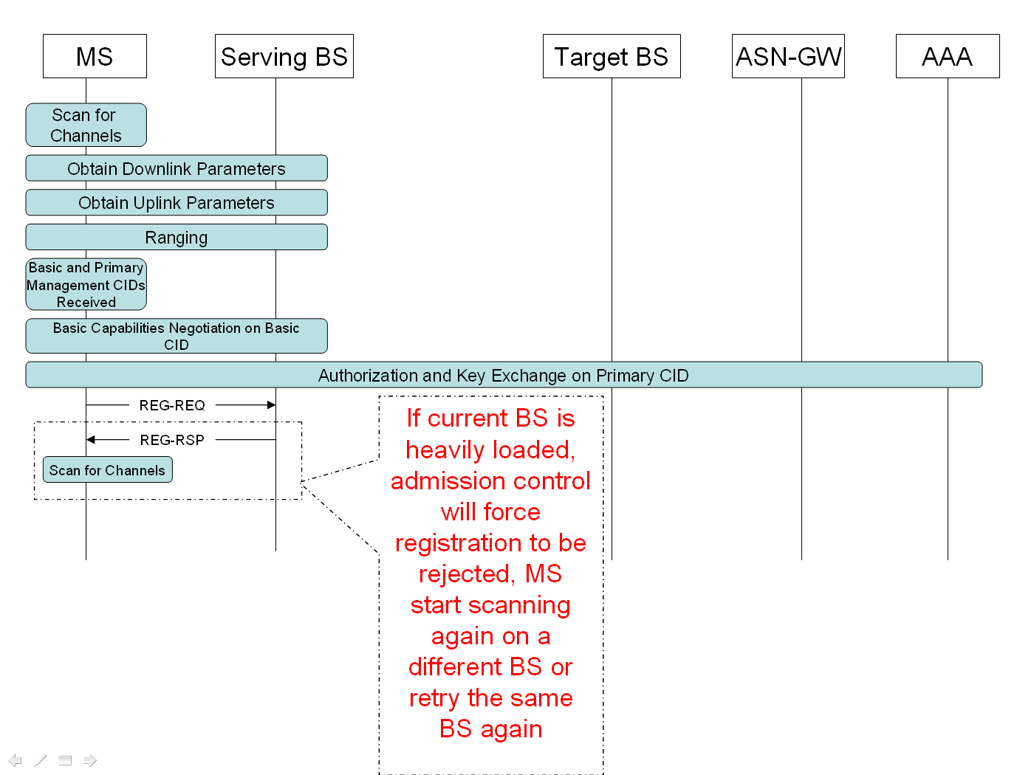
After MS has completed Network Entry on a different BS, MS may initiate handover to the previous Serving BS (ping-pong effect).

- Idle Mode Re-entry
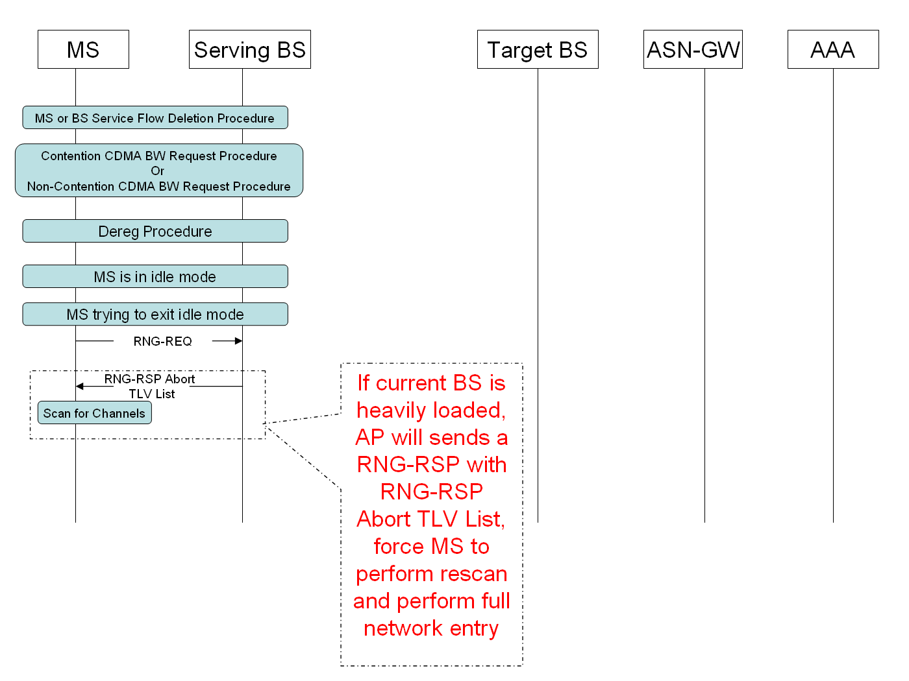

After MS has completed Network Entry on a different BS, MS may initiate handover to the previous Serving BS (ping-pong effect).

- MSS Initiated data flow
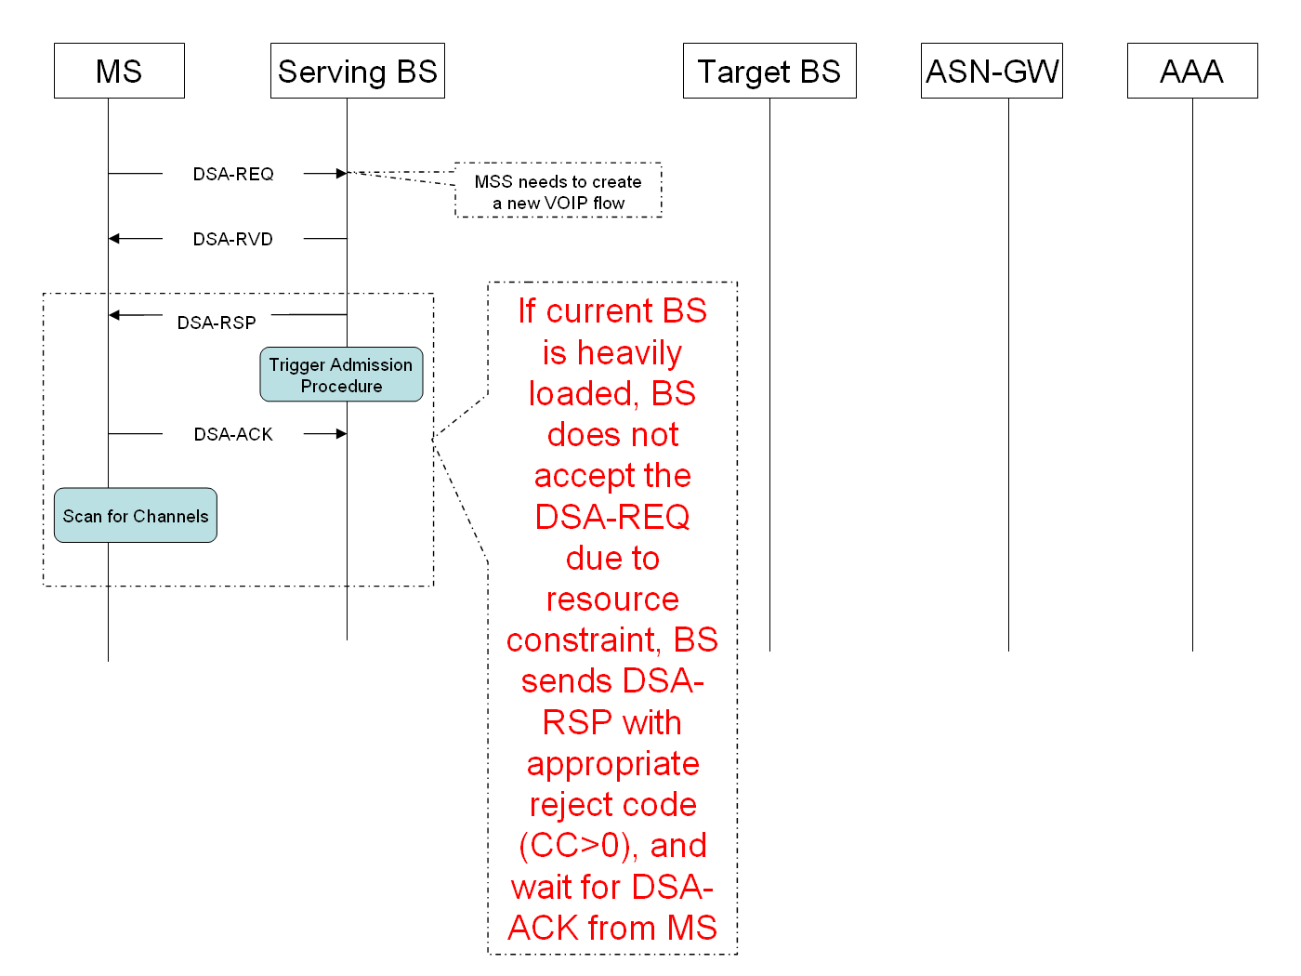

Suggested remedy

The present contribution proposes to add a busy-bit in DSx-REQ, DSx-RSP, DSx-ACK and REG-RSP messages to trigger a BS initiated handover procedure at the time of network entry, idle mode reentry, and MSS initiated flow creation when the serving base station is at full capacity.

In order to enforce the BS initiated handover command and to prevent ping-pong occurrence, it is also proposed to introduce a new BS controlled MS initiated handover mechanism. The new mechanism can be enabled or disabled by DCD message settings. MS can signal support of BS controlled MS initiated handover mechanism by means of a capability attribute in RNG-REQ message. In case the new mechanism is enabled, MS supporting the new capability shall initiate handover only in those cases defined by trigger event settings in DCD message or in MOB-NBR-ADV message.

Initial Network Entry

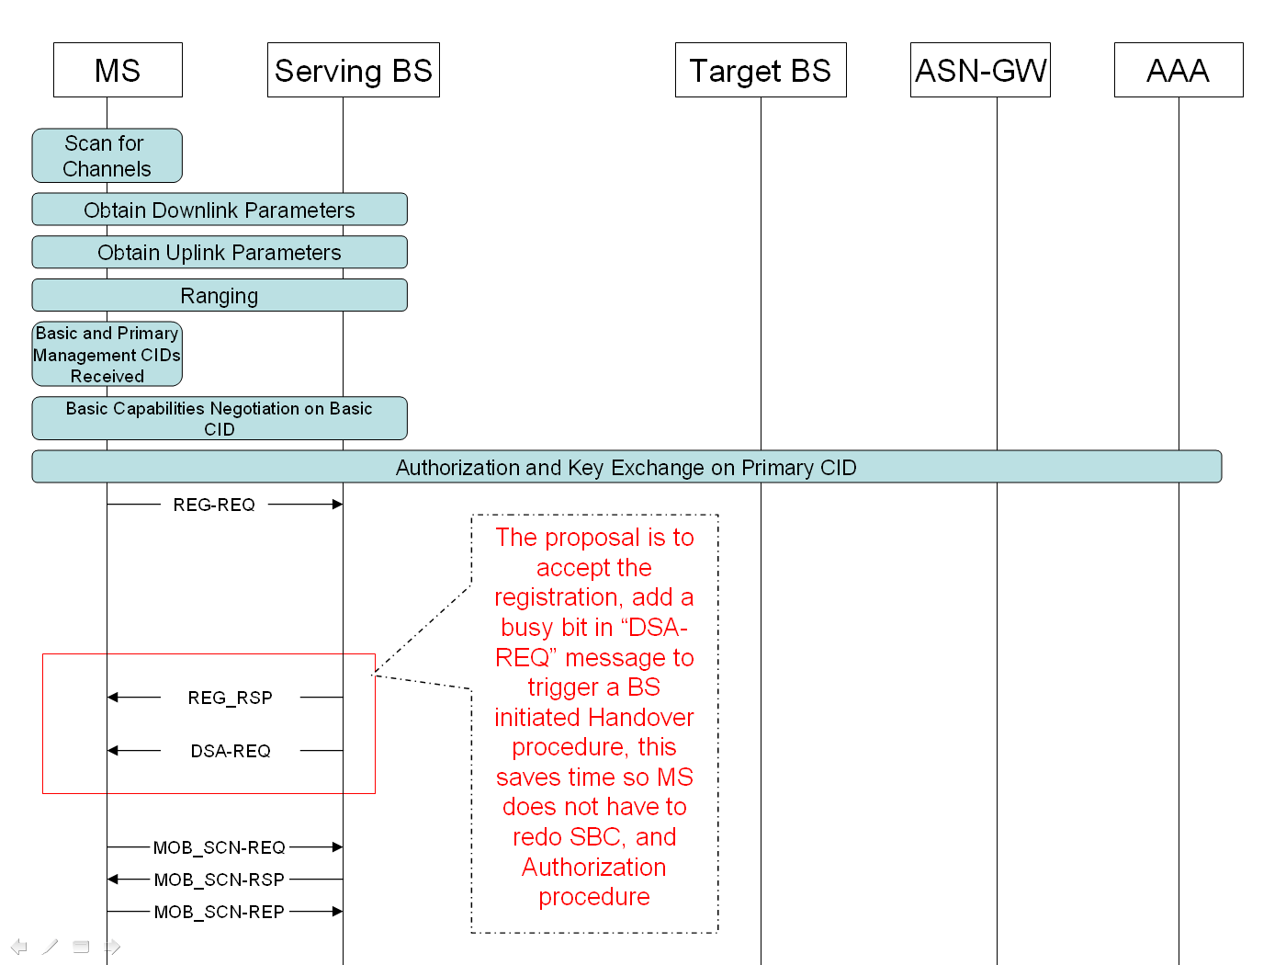
DCD (HO type support = BS_Controlled_MSHO)
RNG-REQ (BS_Controlled_MSHO = BS Controlled MS Initiated HO supported)
MS shall not initiate handover to other BSs unless triggering conditions in Trigger TLV or Neighbor BS Trigger TLV occur (no ping-pong)

Idle Mode Re-entry

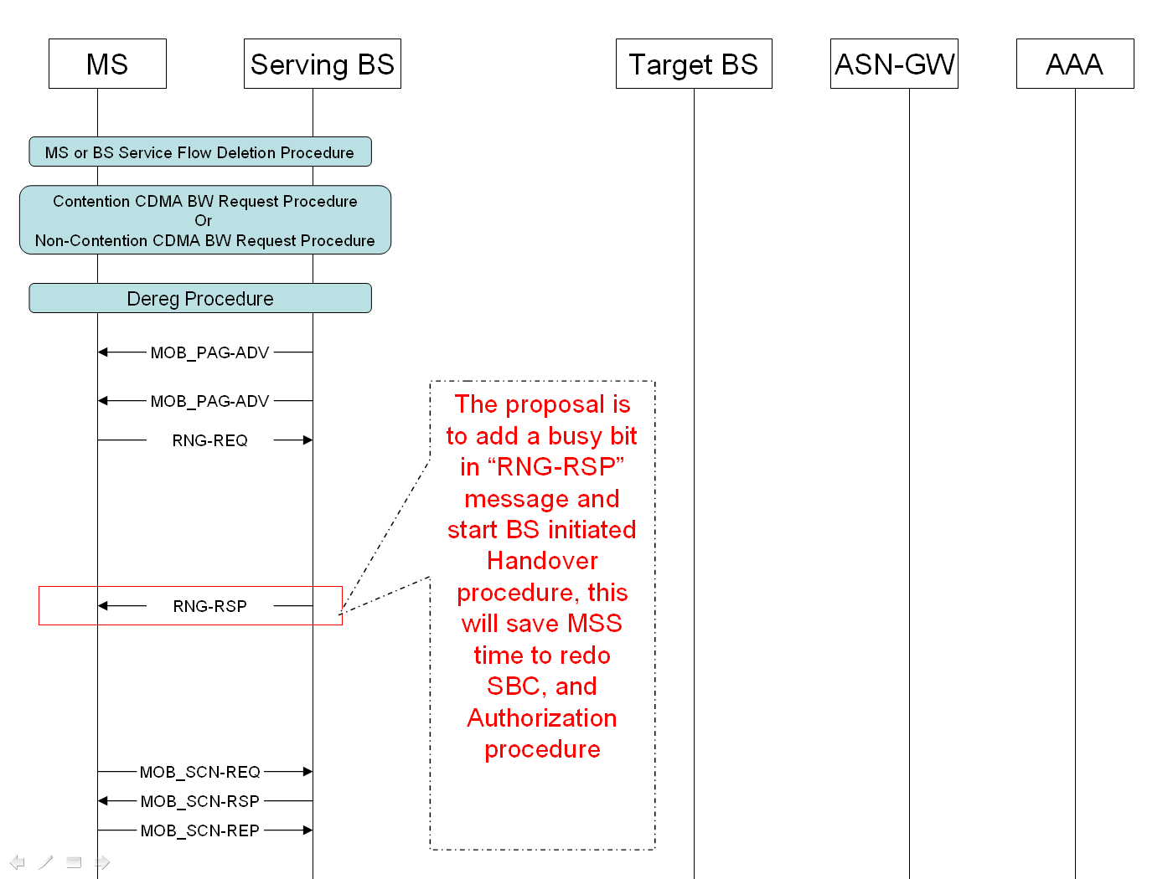
RNG-REQ (BS_Controlled_MSHO = BS Controlled MS Initiated HO supported)

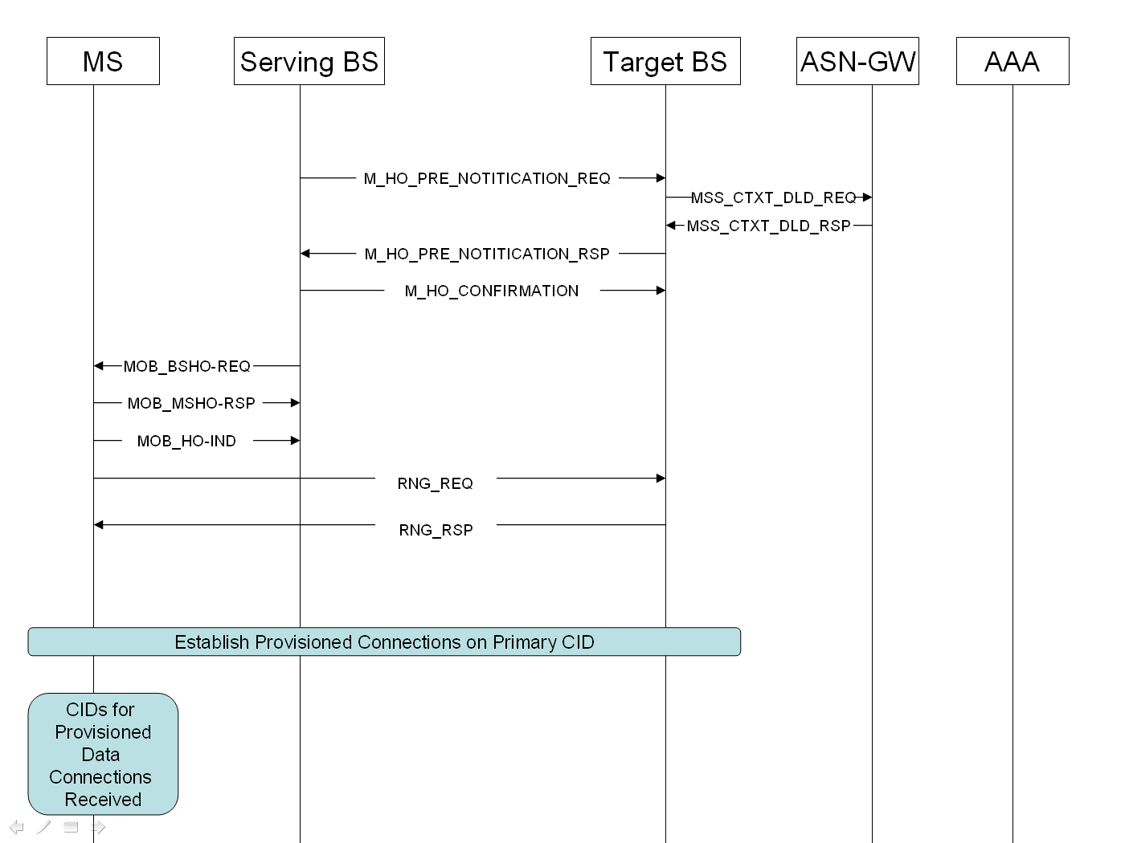

MS shall not initiate handover to other BSs unless triggering conditions in Trigger TLV or Neighbor BS Trigger TLV occur (no ping-pong)

MSS Initiated Data Flow
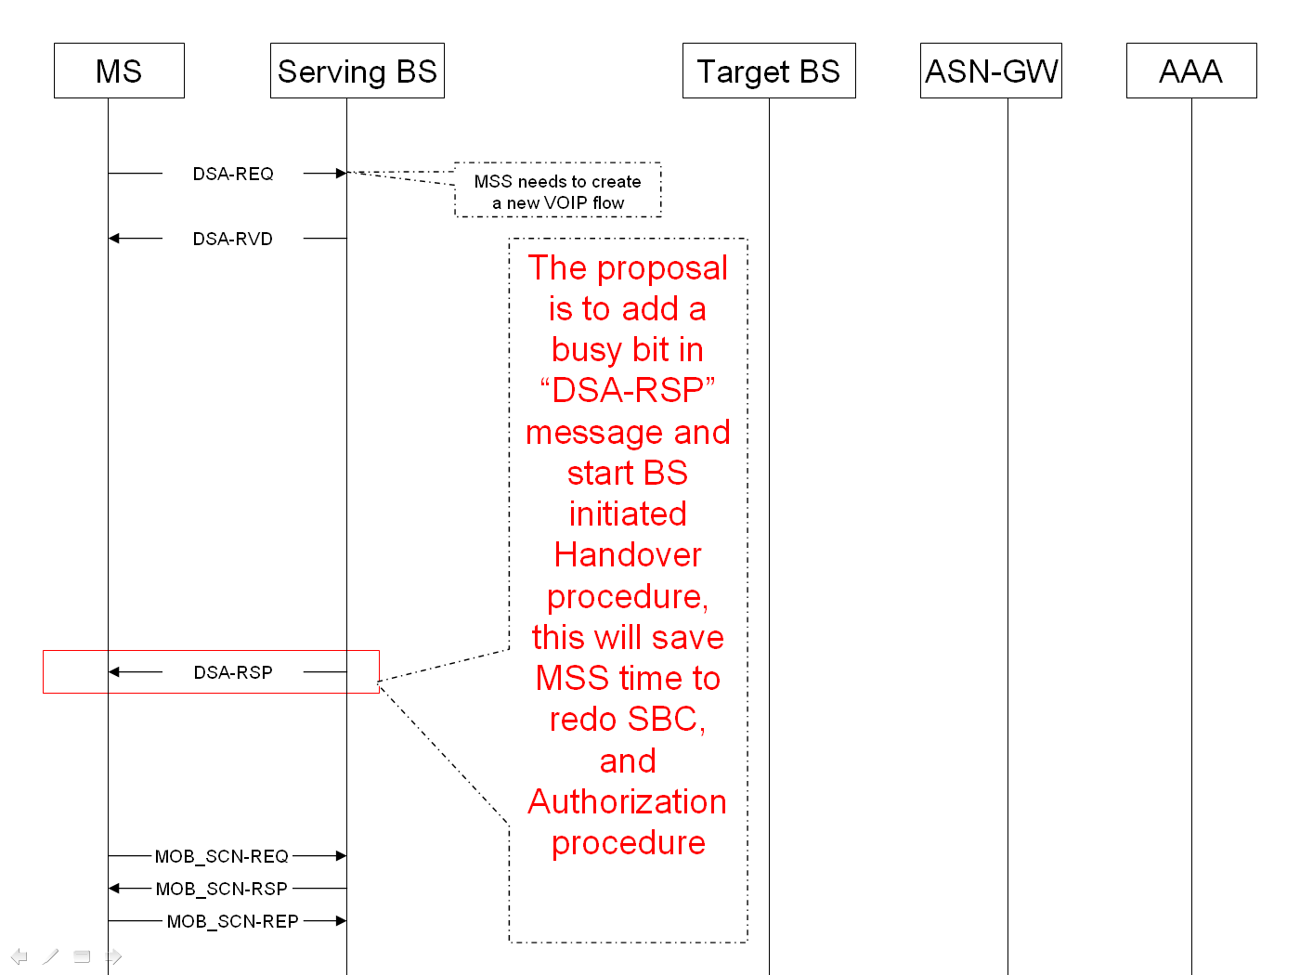

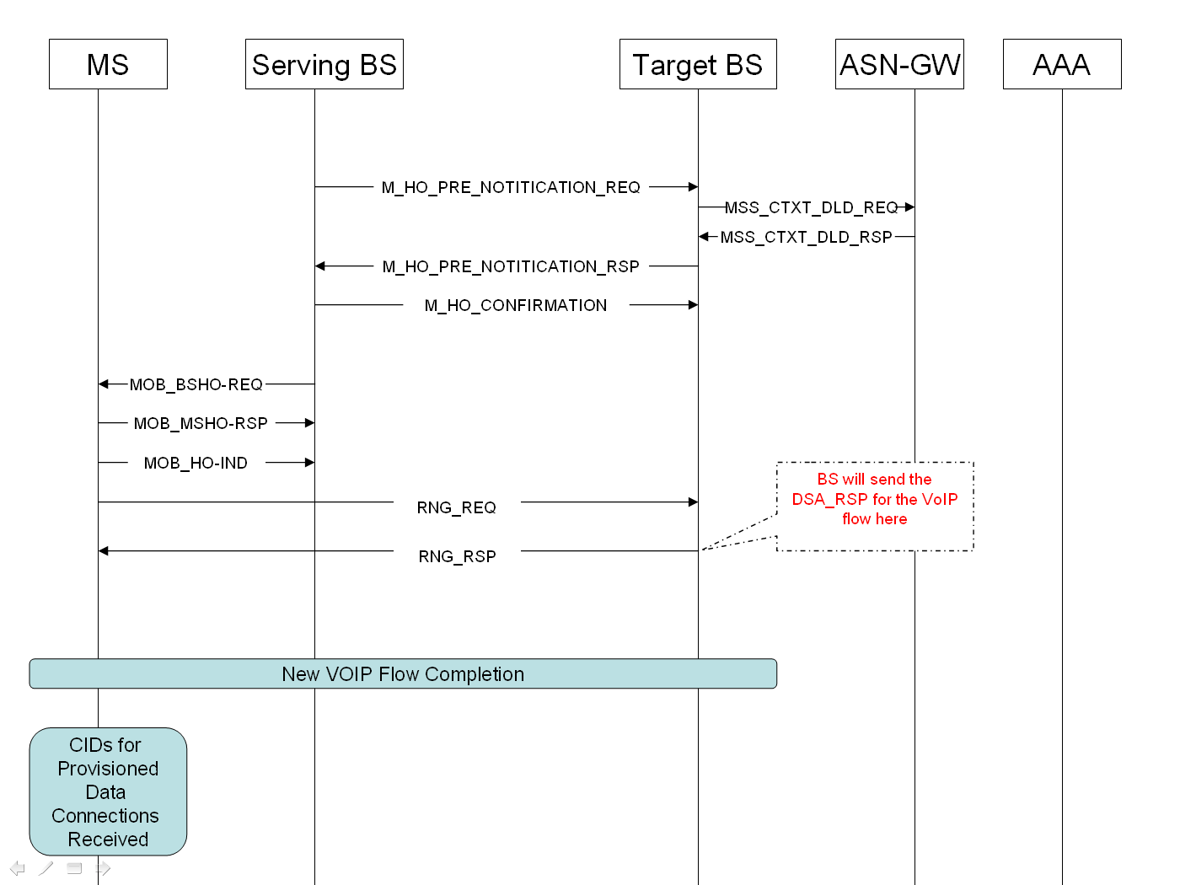

MS shall not initiate handover to other BSs unless triggering conditions in Trigger TLV or Neighbor BS Trigger TLV occur (no ping-pong)

Proposed Changes

Change #1: Suggest adding Section 11.13.40 “Busy Bit Indicator”:

Insert following the following section in the 11.13 Service flow management encodings

11.13.40 Busy Bit Indicator

This parameter is used by BS to indicate lack of resources to support this flow in the Base Station. If this parameter is set and mobility is supported, MS is requested to perform Scanning procedure and send a MOB_SCN-REP to the BS. If another candidate BS is available, and can admit the flows from this subscriber, then BS will initiate a BS initiated Handover for this MS. BS may provide the new Flow parameters for this MS in the RNG_RSP sent to the MS at the new target BS.

Type | Length | Value | Scope
[145/146].48 | 1 | 0-BS can admit this user’s flow  1- BS has reached maximum capacity and cannot admit this current flow | DSx-REQ  DSx-RSP  DSx-ACK  REG-RSP

Change #2: Enhancement of subsection 6.3.2.3.5, Ranging request (RNG-REQ) message:

Insert following text at the end of 6.3.2.3.5

If the BS_Controlled_MSHO flag (see Table 544) is set to “1” and the MS supports BS Controlled MS Initiated HO, the BS_Controlled_MSHO TLV shall be included in the RNG-REQ message during initial ranging.

BS_Controlled_MSHO

Change #3: Enhancement of Table 550 “RNG-REQ message encodings”:

Insert the following entry into Table 550:

Table 550—RNG-REQ message encodings

Name | Type  (1 byte) | Length | Value | PHY scope
BS_Controlled_MSHO | 14 | 1 | Bit 0:  0: BS Controlled MS Initiated HO not supported  1: BS Controlled MS Initiated HO supported  Bits 1–7: Reserved | OFDMA

Change #4: Enhancement of Table 544 “DCD channel encoding”:

Change the following entry in Table 544 as indicated:

Table 544—DCD channel encoding
Name | Type  (1 byte) | Length | Value | PHY scope
HO type support | 50 | 1 | Bit 0: HO  Bit 1: MDHO  Bit 2: FBSS HO  Bit 3: BS_Controlled_MSHO (default value: 0)  Bit 4–7: Reserved | OFDMA

Change #5: Enhancement of subsection 6.3.22.2.2, HO decision and initiation:

Change the subclause6.3.22.2.2 as indicated:

An HO begins with a decision for an MS to HO from a serving BS to a target BS. The decision may originate either at the MS, the serving BS, or on the network.

In case of MS initiated HO, HO initiation and notification mode depends on the value of BS_Controlled_MSHO flag in the HO type support field of DCD message and on the BS_Controlled_MSHO TLV in RNG-REQ message. If the BS_Controlled_MSHO TLV is not included in RNG-REQ message the default value “0” shall be applied.

If BS_Controlled_MSHO flag is set to “0” in HO type support field of DCD message or Value field of BS_Controlled_MSHO in RNG-REQ message is set to “0”, the HO may proceed with a notification through either MOB_MSHO-REQ or MOB_BSHO-REQ messages. The HO notification is recommended, but not required. Acknowledgement of MOB_MSHO-REQ with MOB_BSHO-RSP is required.

If BS_Controlled_MSHO flag is set to “1” in HO type support field of DCD message and Value field of BS_Controlled_MSHO in RNG-REQ message is set to “1”, HO notification is mandatory. The HO shall proceed with a notification through either MOB_MSHO-REQ or MOB_BSHO-REQ messages. Acknowledgement of MOB_MSHO-REQ with MOB_BSHO-RSP is mandatory. MS shall send MOB_MSHO-REQ only in case a triggering conditions specified in Trigger TLV or Neighbor BS Trigger TLV has occurred.

After MS transmits MOB_MSHO-REQ, MS shall not transmit any MOB_MSHO-REQ prior to expiration of timer MS_handover_retransmission_timer. MS shall deactivate timer MS HO retransmission timer on MS transmission of MOB_HO-IND or MS receipt of MOB_BSHO-RSP.

If an MS that transmitted a MOB_MSHO-REQ message detects an incoming MOB_BSHO-REQ message, it shall ignore that MOB_BSHO-REQ message. A BS that transmitted a MOB_BSHO-REQ message and detects an incoming MOB_MSHO-REQ message from the same MS shall ignore its MOB_BSHO-REQ. A BS that transmitted a MOB_BSHO-REQ message and detects an incoming MOB_HO-IND message from the same MS shall ignore its own previous request.

When MOB_MSHO-REQ is sent by an MS, the MS may indicate one or more possible target BS. When MOB_BSHO-REQ is sent by a BS, the BS may indicate one or more possible target BSs. MS may evaluate possible target BS(s) through previously performed scanning and Association activity.

Serving BS criteria for recommendation of target BS may include factors such as expected MS performance at potential target BS, BS and network loading conditions, and MS QoS requirements. The serving BS may obtain expected MS performance and BS and network loading conditions at a potential target BS through the exchange of messages with that BS over the backbone network. The serving BS may negotiate location of common time interval where dedicated initial ranging transmission opportunity for the MS will be provided by all potential target BSs. This information may be included into MOB_BSHO-RSP message, and is indicated by Action Time.

Dedicated allocation for transmission of RNG-REQ means that channel parameters learned by the MS autonomously, based on information acquired at the time of HO with the target BS or during Association of that BS are considered valid during sufficient time and can be reused for actual network reentry without preceding CDMA Ranging. Information such as indicators of link quality in the UL direction learned by the MS during Association may be provided to the serving BS over the backbone.

If Network Assisted HO supported flag is set to “1” in MOB_BSHO-REQ message, MS may perform an HO to any BS among the recommended BSs in MOB_BSHO-REQ without notifying the serving BS of a selected target BS. As an acknowledgement to the MOB_BSHO-REQ message, the MS may send a MOB_HO-IND message with its target BSID set to “0x00000000”.

When the serving BS, transmitted MOB_BSHO-REQ with Network Assisted HO supported flag = “1”, receive MOB_HO-IND with target BS ID = 0x00000000, it may neglect target BS ID included in MOB_HO-IND message.

If BS_Controlled_MSHO flag is set to “0” in HO type support field of DCD message or Value field of BS_Controlled_MSHO in RNG-REQ message is set to “0”, MS actual pursuit of HO to one of BSs specified in MOB_BSHO-RSP is recommended, but not required. MS may decide to attempt HO to a different BS that may or may not have been included in MOB_BSHO-RSP.

If BS_Controlled_MSHO flag is set to “1” in HO type support field of DCD message and Value field of BS_Controlled_MSHO in RNG-REQ message is set to “1”, MS actual pursuit of HO to one of BSs specified in MOB_BSHO-RSP is required. Only in case a triggering condition specified in Trigger TLV or Neighbor BS Trigger TLV has occurred for a target BS not listed in MOB_BSHO-RSP, MS may decide to attempt HO to the BS not included in MOB_BSHO-RSP by sending a MOB_HO-IND indicating the selected BS.

If the MS signals rejection of serving BS instruction to HO through HO_IND_type field in the MOB_HO-IND set value of 0b10 (HO reject option), the BS may reconfigure the neighbor BS list and retransmit MOB_BSHO-RSP message including a new neighbor BS list.

In some instances, the BS may need to force the MS to conduct HO. The BS shall include a value of HO operation mode = 1 in either the MOB_BSHO-REQ or MOB_BSHO-RSP to signal to the MS that the MS must conduct HO. Upon receiving a message with HO operation mode = 1, the MS should treat the HO request as required and shall respond with a HO-IND. MS should send HO-IND with option HO_IND_type = 0b00 indicating commitment to HO unless MS is unable to HO to any of the recommended BSs in the message, in which case MS may respond with HO-IND with option HO_IND_type=0b10 indicating HO reject.

If BS_Controlled_MSHO flag is set to “0” in HO type support field of DCD message or Value field of BS_Controlled_MSHO in RNG-REQ message is set to “0”, Aan MS required to conduct HO is not restricted to conducting HO to those BS included in the notifying message. In other words, the MS may attempt HO to a different BS that may or may not have been included in either the MOB_BSHO-REQ or MOB_BSHO-RSP.

If BS_Controlled_MSHO flag is set to “1” in HO type support field of DCD message and Value field of BS_Controlled_MSHO in RNG-REQ message is set to “1”, an MS required to conduct HO is restricted to conducting HO to those BS included in the notifying message. In other words, the MS may not attempt HO to a BS not included in the MOB_BSHO-REQ or in the MOB_BSHO-RSP. Only in case a triggering condition specified in Trigger TLV or Neighbor BS Trigger TLV has occurred for a target BS not listed in MOB_BSHO-REQ or in the MOB_BSHO-RSP, MS may decide to attempt HO to the BS not included in MOB_BSHO-REQ or in the MOB_BSHO-RSP by sending a MOB_HO-IND indicating the selected BS.

The serving BS may notify one or more potential target BS over the backbone network of MS intent to HO. The serving BS may also send MS information to potential target BS over the backbone network to expedite HO.

In order to verify the MS can complete the HO preparation phase in time to receive the Fast_Ranging_IE in the target base station (i.e., after action time), the serving BS may grant an unsolicited UL allocation for transmission of MOB_HO-IND message. In this case, the Unsolicited UL Grant for HO-IND flag in MOB_BSHO-REQ/RSP message serving BS should be set to 1. Upon expiration of Handover Indication Readiness Timer, the serving BS should grant an UL allocation to the MS with a size enough for transmission of MOB_HO-IND message.

The serving BS may continue to issue DL and UL allocations to the MS until expiration of Handover Indication Readiness Timer or until MOB_HO-IND with HO_IND_type=0b00 was received or until it received an indication from the target BS (over the backbone) that MS successfully completed its HO attempt or until it decides that the MS is no longer available.

The MS that sent MOB_HO-IND with option HO_IND_type = 0b00 indicating commitment to HO and intent to release the serving BS, shall not be expected to monitor serving BS DL traffic after transmission of the MOB_HO-IND message.
.

Change #6: Enhancement of subsection 11.4.1, DCD channel encodings:

Add a new sentence under Table 546:

If BS_Controlled_MSHO flag is set to “1” in HO type support field of the DCD message, the BS shall ensure that the Trigger TLV is configured such that service degradation and connection drop are avoided. The BS shall adjust Trigger conditions to allow execution of a handover before service degradation starts or connection is lost.

Change #7: Enhancement of subsection 11.18.2, MOB-NBR-ADV message encodings:
Add a new sentence under Table 577:

If the BS_Controlled_MSHO flag is set to “1” in the HO type support field of DCD message, the BS shall configure the Neighbor BS Trigger TLV to avoid service degradation and connection drop . The BS shall adjust triggering conditions to allow execution of a handover before service degradation starts or connection is lost.

References

[IEEE802.16-Rev2/D2] IEEE Computer Society and IEEE Microwave Theory and Techniques Society, “DRAFT Standard for Local and Metropolitan Area Networks Part 16: Air Interface for Broadband Wireless Access Systems”, P802.16Rev2/D2 (December 2007) Revision of IEEE Std 802.16-2004 as amended by IEEE Std 802.16f-2005 and IEEE Std 802.16e-2005 .

