Project | IEEE 802.16 Broadband Wireless Access Working Group <http://ieee802.org/16>
Title | Modified pilot splitting pattern for AMC MIMO
Date Submitted | 2008-03-19
Source(s) | Yuval Lomnitz  Dov Andelman  Intel Corp. | Voice: +972-3-9205773  E-mail: Yuval.lomnitz@intel.com  dov.andelman@intel.com
Re: | Letter Ballot 26b
Abstract | We propose to change pilot order in AMC+MIMO mode to avoid power fluctuations
Purpose | Adopt the proposed specification changes in IEEE P802.16Rev2
Notice | This document does not represent the agreed views of the IEEE 802.16 Working Group or any of its subgroups. It represents only the views of the participants listed in the “Source(s)” field above. It is offered as a basis for discussion. It is not binding on the contributor(s), who reserve(s) the right to add, amend or withdraw material contained herein.
Release | The contributor grants a free, irrevocable license to the IEEE to incorporate material contained in this contribution, and any modifications thereof, in the creation of an IEEE Standards publication; to copyright in the IEEE’s name any IEEE Standards publication even though it may include portions of this contribution; and at the IEEE’s sole discretion to permit others to reproduce in whole or in part the resulting IEEE Standards publication. The contributor also acknowledges and accepts that this contribution may be made public by IEEE 802.16.
Patent Policy | The contributor is familiar with the IEEE-SA Patent Policy and Procedures:  <http://standards.ieee.org/guides/bylaws/sect6-7.html#6> and <http://standards.ieee.org/guides/opman/sect6.html#6.3>.  Further information is located at <http://standards.ieee.org/board/pat/pat-material.html> and <http://standards.ieee.org/board/pat>.

Modified pilot splitting pattern for AMC MIMO
Yuval Lomnitz, Dov Andelman - Intel Corp.

Purpose
We correct two flaws in the pilot patterns of AMC in MIMO zone:
- The pilots for antenna 1 are concentrated on symbols 0,2,4 and for antenna 2 on symbols 1,3,5. This results in power fluctuation of 1.6dB between the symbols which degrades performance, especially when this scheme is used for the UL.
- The diagrams are confusing since they include also the “original” pilot locations for SISO on top of the MIMO configuration.

Note: the contribution C802.16maint-08/007r2 covering different topics related to the AMC+MIMO zone was split into the following contributions in order to enable separate discussion/decision on each item, and this contribution is part of this pack:
- C802.16maint-08/007r3 (Definitions for AMC permutation slot structure in MIMO zone): covers definitions of AMC slot structures in the map IE-s and STC mapping (DL and UL), except matrix A support for 2x3 slot structure
- C802.16maint-08/087 (Definitions for matrix A in 2x3 AMC structure): adds the definition of matrix A support (both DL and UL)
- C802.16maint-08/088 – Modified pilot splitting pattern for AMC MIMO: both UL and DL.
- C80216maint-08/089 – Generalization of allocation granularity definitions: this contribution generalizes the allocation granularity definitions that were defined for PUSC+MIMO+dedicated pilots to AMC.
- C80216maint-08/090 - Correction to MIMO Pilot and Data Power

Discussion
In the current draft the pilots for antenna 1 are concentrated on symbols 0,2,4 and for antenna 2 on symbols 1,3,5. This results in power fluctuation of 1.6dB between the symbols when considering the power per antenna, which degrades performance since it requires the transmitter to lower its power so that the peak power on these symbols will not be exceeded. This is an issue especially when this scheme is used for the UL (MS 0,1 transmit transmits the pattern of antennas 0,1 and therefore there are power fluctuations in the transmit power of each MS). In all other MIMO and SISO pilot patterns in 802.16 the issue of equal power per symbol per antenna has been considered and it seems to have been mistakenly neglected here.

We propose to exchange the roles of the antennas in the bottom AMC bin in order to equalize the power used from each antenna. In the downlink, the effect of power fluctuations may be smaller since the BS may not be power limited, and if the pilots are dedicated then the precoding of pilots may lead to averaging of this effect. In the UL, the effect is 0.8dB improvement in the transmit power (since for average power P, in the current scheme the transmit powers on alternating symbols are P+0.8dB and P-0.8dB, and therefore P ≤ P_{MAX}-0.8dB).

We show below that this change doesn’t affect the performance. The performance is shown using multiplication noise model for modeling the effect of channel estimation loss, similar to the models used for 802.16m evaluation methodology. The effective SNR is used to calculate an effective SE which is averaged over the 18x6 subchannel. The channel estimation filter is 2D-LMMSE with flat power delay profile of 5μs. We present results for two cases of velocity (120Km/h and 10Km/h, both at 3.5Ghz carrier for worst case), and two cases of power normalization:
- Non-power limited: the mean power of the symbols is normalized to 1 (the noise is at σ²=1/SNR⋅N_{TX})
- Power limited: the mean power of the worst case symbol is normalized to 1 (other symbols have lower power and suffer SNR loss).

We show that we have no degradation in case (1), and enjoy the gain of the additional power in case (2). For each case we present the mean SE and the ratio of the SE-s of the two schemes.

Pilot patterns

Case 1A: V=120Km/h, non power limited

Case 1B: V=10Km/h, non power limited

Case 2A: V=120Km/h, power limited

Case 2B: V=10Km/h, power limited

Text Changes
8.4.8.3.1.1 Allocation of pilot subcarriers
[change the text as follows]
Pilot Location for Antenna #0 = 9k+3[m mod 3]+1 (m = even) 18k + 9⋅mod(m,2) + 3[floor(m/2)⋅2 mod 3]+1
Pilot Location for Antenna #1 = 9k+3[(m – 1) mod 3]+1 (m = odd) 18k + 9⋅mod(m+1,2) + 3[floor(m/2)⋅2 mod 3]+1
for m = [symbol index], symbol index 0 is the first symbol (except midamble) in which the STC
Zone is applied, k is defined in 8.4.6.1.2.3 the subchannel index.

[change figure 273 to the following figure]
Figure 273—Pilot allocation for 2-antenna BS for the optional FUSC and the optional AMC zones

[change figure 275 to the following figure]

Figure 275—Pilot allocation for 4-antenna BS for the optional FUSC and the optional AMC zones

[Perform the following change in figures 275, 276, 277:
Replace the boxes indicating “pilots” and “nulls” by a similar looking box, and change the legend to pilot/null, for example:
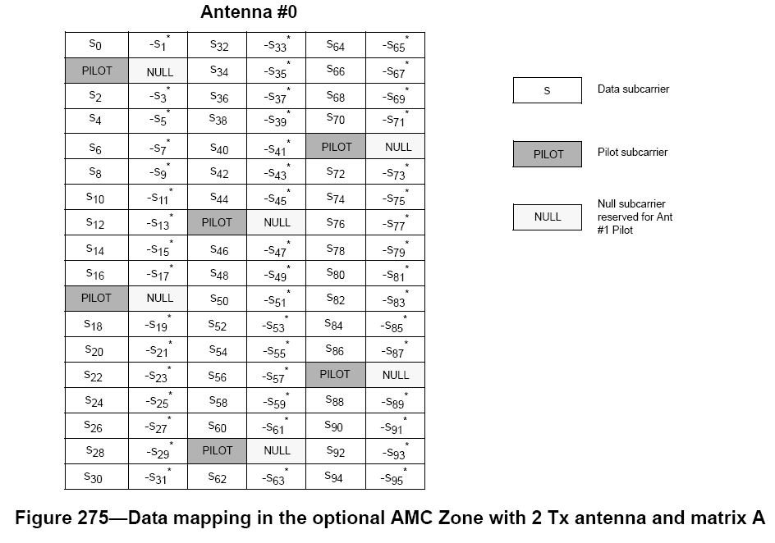 ➔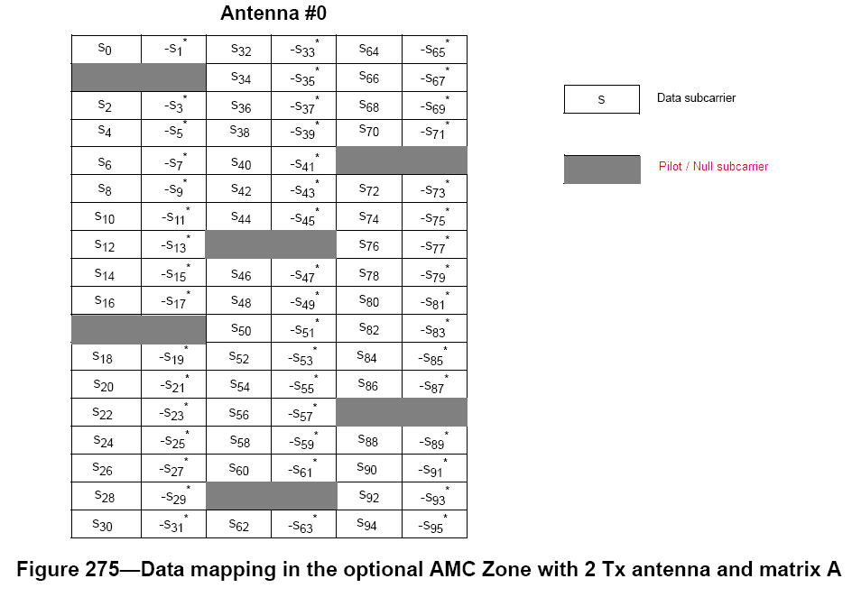
]

8.4.8.4.1 Allocation of pilot subcarriers
[Change the second paragraph as follows]
For 2-antenna MS and the optional AMC, pilot allocation pattern shall be identical to that for the DL optional AMC with 2 antennas described in 8.4.8.3.1.1; all pilots in the even symbols marked as antenna 0 shall be allocated for antenna 0 or pattern A, while pilots in the odd symbols marked as antenna 1 shall be allocated for antenna #1 or pattern B. This is shown in Figure 273.

