Project | IEEE 802.16 Broadband Wireless Access Working Group <http://ieee802.org/16>
Title | Quick Paging
Date Submitted | 2008-05-09
Source(s) | Havish Koorapaty, Per Ernström  Ericsson AB  SE-164 80 Stockholm, Sweden | Voice: +1 – 919-472-7524  mailto:havish.koorapaty@ericsson.com  *<http://standards.ieee.org/faqs/affiliationFAQ.html>
Re: | Letter Ballot #26
Abstract | This contribution proposes a design for a quick paging signal for IEEE 802.16e
Purpose | Discuss and Adopt
Notice | This document does not represent the agreed views of the IEEE 802.16 Working Group or any of its subgroups. It represents only the views of the participants listed in the “Source(s)” field above. It is offered as a basis for discussion. It is not binding on the contributor(s), who reserve(s) the right to add, amend or withdraw material contained herein.
Release | The contributor grants a free, irrevocable license to the IEEE to incorporate material contained in this contribution, and any modifications thereof, in the creation of an IEEE Standards publication; to copyright in the IEEE’s name any IEEE Standards publication even though it may include portions of this contribution; and at the IEEE’s sole discretion to permit others to reproduce in whole or in part the resulting IEEE Standards publication. The contributor also acknowledges and accepts that this contribution may be made public by IEEE 802.16.
Patent Policy | The contributor is familiar with the IEEE-SA Patent Policy and Procedures:  <http://standards.ieee.org/guides/bylaws/sect6-7.html#6> and <http://standards.ieee.org/guides/opman/sect6.html#6.3>.  Further information is located at <http://standards.ieee.org/board/pat/pat-material.html> and <http://standards.ieee.org/board/pat>.

Quick Paging Signal for IEEE 802.16e
Havish Koorapaty, Per Ernström
Ericsson AB

Summary
In this document, we propose a design for a quick paging signal in IEEE 802.16e. The quick paging signal notifies a subset of MS whether to read a full paging message in the near future. The shorter duration of the quick paging signal in comparison to the full paging signal helps improve standby time. We propose a design based on a bi-orthogonal Walsh-Hadamard code to be used in the preamble part of the frame. The performance of this design is evaluated and the design is found to work effectively without causing any noticeable effects on legacy users.
We recommend that quick paging functionality be included in the revision to the baseline specification. In addition, we recommend that the proposal in this contribution be included as the method to achieve quick paging functionality.

Introduction
A quick paging signal is used in systems such as CDMA2000 and WCDMA in order to extend battery life. The quick paging signal provides an indication to selected mobiles to read the full paging message that occurs in a subsequent frame. Due to the significantly shorter duration of the quick paging message, the wake-up time of the MS is lowered, thereby saving battery life.
The quick paging mechanism is not currently available in the IEEE 802.16e-2005 standard [1]. A similar quick paging concept for IEEE 802.16m has been proposed in [2]. In this contribution, we propose a design for the quick paging signal using the unused part of the preamble portion of the downlink frame. We use a signal that is significantly lower in power than the preamble signal in order to minimize effects on legacy equipment, and in order not to affect common functions for which the preamble is needed. The signal is designed to be received reliably in spite of the low signal level. We perform a detailed performance analysis of the signal using link and system simulations, and demonstrate its efficacy.

Background
The frame structure as specified in IEEE 802.16e, is shown in Figure 1.
Figure 1 Frame Structure Used in IEEE 802.16e
Each frame starts with a preamble signal that consists of a known binary signal sent every third OFDM sub-carrier. In the specification, the preamble signal is defined by the segment (i.e., one of the three sets of tones to be used), and the parameter IDCell. Mobile stations use the preamble for initial synchronization to the system, and to determine the location of the FCH message, which gives further information on the signal parameters. Mobile stations also use the preambles in neighbor cell signals in order to synchronize to them for purposes of measurement for handover. The use of every third tone for the preamble signal allows for a 1/3 reuse of the preamble signal, thereby improving its reception by mobile stations. The use of every third tone also implies a repetitive structure in the time domain, which can be used by mobile stations for initial acquisition. The DL-MAP signal contains downlink assignments in time and frequency for identified mobile stations, which can then receive the data in the particular location. The structure of the preamble in the frequency domain for a 2048-FFT system is shown in Figure 2.
Figure 2 Structure of Preamble in Frequency Domain. Every third tone (or subcarrier) is occupied.

Sleep modes are used in IEEE 802.16e to extend battery life. A mobile station requests sleep mode from the system, which assigns it a sleep time and a particular cycle of frame numbers on which to wake up and listen for a paging message. In order to maximize the use of paging resources, it makes sense for the system to form groups with multiple MS in each group, and have the MS in a group wake up during a particular frame in order to receive a paging message. On waking up, a MS has to receive the preamble, then decode the FCH and the DL-MAP message to determine whether it has an assignment in the particular frame, and decode the message if it finds an assignment in the DL-MAP. The DL-MAP may be quite long, especially if a significant number of assignments are carried in it.
The quick paging message is used to minimize the wake-up time of the MS in order to extend battery life. In general, the probability of having a paging message addressed to the MS is quite low, but it needs to read the paging message in order not to miss pages which can occur at any time. If a message of a short duration is provided that indicates whether the MS can expect a page, and thus has to read the full paging message at a subsequent block, then the MS only reads the ‘quick paging’ message, and can avoid reading the full paging message most of the time. Due to its shorter duration, receiving the quick paging message lowers the power consumption at the MS.

Signal Design
In this contribution, we propose a quick paging message that can be implemented during the duration of the preamble message. As stated before, the preamble utilizes only every third OFDM tone, thus there are empty spaces available to utilize for the quick paging message. For example, in Figure 2, the quick paging message would be used on subcarriers 1, 2, 4, 5 and so on. However, care has to be taken not to affect any of the essential functions of the preamble, which are mainly for initial acquisition, and for neighbor cell measurement purposes. Thus, any quick paging signal implemented in the duration of the preamble needs to have very low power compared to the preamble signal. This will be the focus of the design of a quick paging signal.
The quick paging signal needs to operate at a very low signal to noise ratio. However, it can rely on good channel estimates that can be obtained using the preamble signal, and the significant amount of frequency coherence that can be expected even in a highly dispersive channel. In addition, the quick paging signal should be able to address a large number of users. For example, it should be possible to divide the pool of MS into many groups, and signal the identity of the group of the MS that needs to read the full paging message. By using many such groups, the number of users that need to read a full paging message can be minimized.
It is well known that orthogonal codes perform well at low signal to noise ratios [3]. In addition, an orthogonal code of a long length can provide many codewords that can be used to address multiple groups. For example, an orthogonal code of length 512 can address 512 groups of users. In addition, due to the presence of reliable channel information obtainable from the preamble, we can choose a bi-orthogonal code that uses both a code and its inverse. The distance between a codeword and its inverse is large, and the use of reliable channel information helps make discrimination between these codewords highly reliable. Thus, 1024 groups of users can be addressed using codewords of length 512.
Of the orthogonal codes, the best known are the Hadamard codes, which exist for all lengths that are multiples of 4, though lengths that are a power of 2 (i.e., the Walsh-Hadamard codes) are most popular. The use of a Walsh-Hadamard code permits the use of a Fast Walsh Transform in the decoding, so that the relative merit of many codewords can be assayed with low complexity.
We thus propose the use of a Walsh-Hadamard code as the signal for quick paging. With a 10 MHz WiMAX channel (using a FFT of length 1024), the preamble used is of length 284 bits. Thus, we have 568 unused positions that can be used for the quick paging signal, and a Walsh-Hadamard code of length 512 fits well. For a 5 MHz 802.16e channel, the FFT size is 512, the preamble used is of length 143, and 286 unused positions are available for the quick paging signal, thereby suggesting a Walsh-Hadamard code of length 256.
However, we also note that the Walsh-Hadamard codewords do not have particularly desirable spectral properties. For example, the all zeros codeword has a spectral line at zero frequencies. To whiten the spectrum, we suggest applying a pseudo-random masking sequence to the codeword. Sector-specific PN sequences already employed in IEEE 802.16e can be reused for this purpose.
The quick paging signal indicates the possible presence of a page in a subsequent frame to an MS that belongs to the group for which a quick paging signal is sent. The delay of one or more frames allows a further reduction in the wake-up time thereby enhancing the power savings that may be obtained using the quick paging signal.

Performance Evaluation

Detection Performance
We characterize the performance of the proposed quick paging signal using a combination of link and system simulations. Using a system simulation, including path loss, antenna patterns and shadow fading, we obtain the path losses from all base stations (3 sectors per site) in the system to a set of mobile stations uniformly distributed through the system. A wrap-around procedure is used to eliminate edge-effects. The losses for segments of the base stations are also logged. For each mobile station, we generate the preamble with a randomly chosen IDCell, and a quick paging codeword at a specified power level below the preamble, and apply the composite path loss to the whole signal. For the interfering sectors, we generate different preambles at a signal level as obtained from the system simulation, in the corresponding segments, and quick paging signals in the rest of the tones at a similar power offset to that between the serving cell preamble and the serving cell codeword. Additive white Gaussian noise is also added at a level corresponding to a given noise figure. The signals from the different BS to the MS pass through different radio channels. This is assumed true for different sectors from the same site also, since the transmit antennas used are different. The channel is applied to the signal from each BS, and the combined signal is then received by the MS. Since the relative signal levels from the system simulation, corresponding to a BS transmit power, are used, the average CINR achieved is fixed. For each set of channel realizations from the different base stations, many noise realizations are used for averaging, and multiple sets of channel realizations are also used.
Three receiver algorithms are used in the evaluation: (1) A conventional receiver based on correlations, similar to an MRC receiver (2) An interference-cancelling MMSE-based receiver that exploits the structure of the signal and (3) An enhanced interference-cancelling receiver that uses knowledge of the two strongest neighbor cell preambles to subtract them before applying the MMSE-based receiver algorithm. A threshold can be used to determine if an assigned codeword has been detected. The relative power of the quick paging codeword to the preamble signal in the same cell is assumed to be known. This information can be sent in the DCD message.
The performance of the scheme is characterized in terms of the Missed Detection probability and the False Alarm probability. A missed detection occurs when the BS sends the assigned codeword to a MS, but the MS does not detect the codeword. Thus, the MS will not read the full page intended for it. A missed detection is detrimental to the paging performance of the system. A false alarm occurs when the MS detects that its assigned codeword has been sent when the BS sent a different codeword. A false alarm will cause the MS to read the full paging message. A false alarm is not detrimental to the paging performance of the system, though it does reduce the battery life savings obtained from use of the quick paging signal. The probability of missed detection and the probability of false alarm can be traded off by choosing appropriate thresholds for detection of the assigned codeword.
The parameters used in the simulation are shown in Table 1.
Aspect | Value
Number of Cells/Sites | 57/19
Reuse | 1/1 (1/3 for preamble)
Path Loss Model | 20 +35 log(d) (Similar to ITU Vehicular)
Site-to-Site Distance | 2.8km
Penetration Loss | None
Shadowing Standard Deviation | 8dB
Shadowing Correlation Distance | 100m
Bandwidth | 10 MHz
FFT Size | 1024
Transmit Power (for Preamble) | 20 W
Noise Figure | 9 dB
Channel Model | Pedestrian B
Relative Power of Paging Signal | -20dB
Codeword Size | 512
Table 1 Simulation Parameters

The geometry characteristics of the simulation are shown in Figure 3, assuming full occupancy of the signal and the noise. These geometry results are presented just as a validation of the simulation environment and are not completely relevant to the performance evaluation to be presented later since the reuse for the preamble is 1/3, whereas these results assume a 1/1 reuse. The interference-limited nature of the environment is clearly seen, the signal to noise ratio is quite high in most cases. It is to be noted that the preamble signal in IEEE 802.16-2005 is sent at a power level that is boosted compared to normal transmissions, thus it is highly likely that the preamble part of the downlink transmission is limited by interference rather than noise.
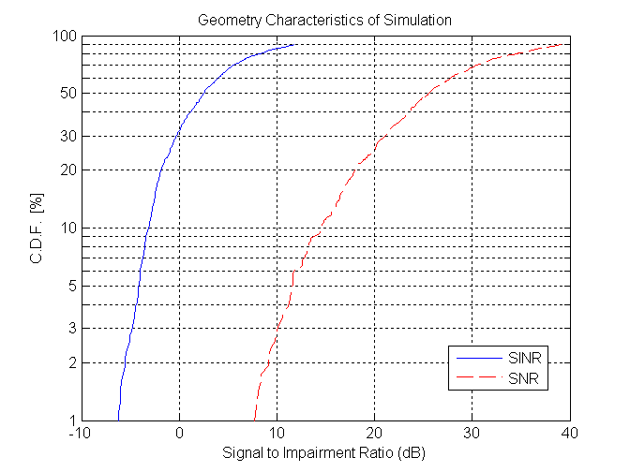
Figure 3 Geometry Characteristics of Simulation Used for Quick Paging Evaluation

The results of this evaluation are shown in Figures 4-6. Figure 4 shows the CDF of the probability of missed detection and the probability of false alarm with the receiver using interference cancellation (the second type of receiver described above). The figure shows results with the use of two different detector threshold values. The figure illustrates that there is a trade-off between the missed detection probability and the false alarm probability that may be controlled using the detector threshold.
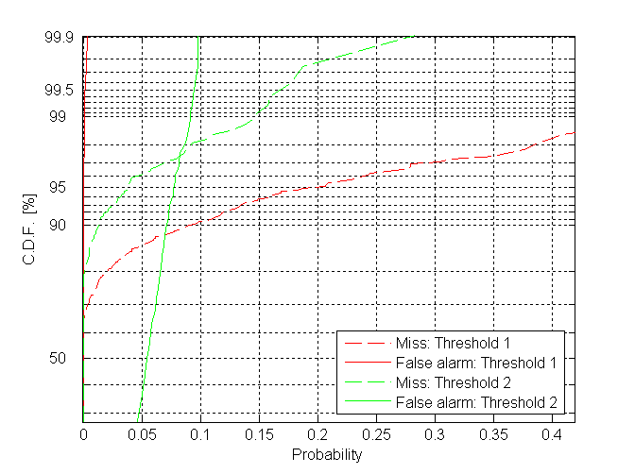
Figure 4: Variation of quick paging performance using the detection threshold. Interference suppression is used at the receiver.

Figure 5 shows the missed detection probability with the traditional receiver (denoted “AWGN” in the figure, since it makes an AWGN assumption for the impairment), the interference cancelling receiver (denoted “Blind IC” in the figure, since it assumes no knowledge of the interferer preambles), and the enhanced interference cancelling receiver. Figure 6 shows the corresponding false alarm probabilities.
Figure 5 and 6 show that the missed detection probability can be significantly reduced with the use of interference cancellation while keeping the false alarm probability more or less unchanged. With the traditional receiver, 95 percent of users experience a missed detection probability 12.5% or less. The probability of missed detection improves with the degree of interference cancellation used. With the blind interference cancelling receiver, we see that the missed detection probability experienced by 95 percent of the users reduces to 4% or less. With the enhanced interference cancelling receiver, we see that the 95th percentile missed detection probability further reduces to 2% or less. It is seen from the figure that the probability of false alarm does not get affected by the use of interference cancellation. Using different thresholds, the probability of missed detection can be traded off with the probability of false alarm.
Finally, we note that the improved performance of the enhanced interference cancelling receiver also indicates the benign effect of the quick paging signal on the performance of neighbor cell preamble measurements. The improvement indicates that the neighbor cell preamble can be detected reliably. The reliable detection leads to a reliable subtraction, which improves the performance.
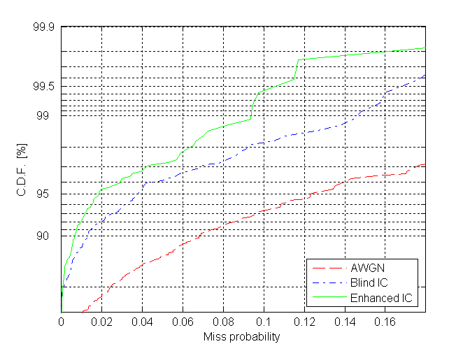
Figure 5: Miss probability of quick paging with various receivers
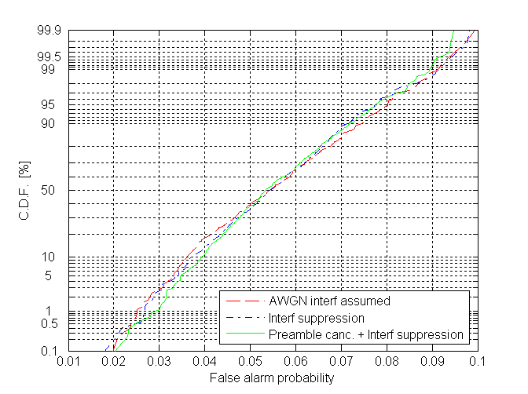
Figure 6: False alarm probability of quick paging with various receivers

Standby Energy Savings with Quick Paging
We briefly explore the standby energy savings possible with the use of a quick paging signal as proposed in this contribution. When normal paging is used, the MS needs to wake up, read the preamble, the FCH, DL-MAP and some number of subsequent symbols, by which time it could verify whether it has an assignment. Let the number of symbols that the MS needs to wake up for be denoted by n. Note that n has to take into account the number of frames in the BS’s paging interval.

We denote the current drawn by the device when the receiver is on as I, and the current drawn when the receiver is idle by kI. For a one symbol interval, the corresponding energy consumed is denoted E and kE respectively. The energy expended in turning on the receiver including the RF portion is proportional to I times the number of symbols for which the receiver is on. Let the number of symbols in each paging interval be denoted by C. Thus, the total energy needed in receiving the full paging message is given by

E_{full} = C.kE + nE.

When Quick Paging is used, the RF portion of the receiver needs to be awake only for one symbol if there is no indication of a full paging message, or for 1+n symbols if there is an indication of a full paging signal. If the probability that a MS will be paged in a paging slot is p, then the probability that at least 1 out of M mobiles will be paged is s=1 - (1-p)^{M}, where M is the number of MS in the paging group. For very small p, we have s~Mp. A reasonable p may be of the order of one thousandth or lower. Thus, the energy consumption with the quick paging signal is given by

E_{quick}= C.kE + E + nE.(s+f) ~ C.kE + E+nE(Mp+f),

where f is the false alarm probability. With n equal to 20 symbols, M of the order of 10, C of the order of 5000 symbols and k of the order of 0.004, and an average false alarm probability, f, of 0.055, we see that the energy consumption is about 40E without quick paging, and 22.3E with quick paging, a savings of a factor of 1.79. Note that this calculation has ignored other aspects of energy consumption at the MS.

If the total number of MS (in the paging area) was N, and the number of paging groups is P, then M=N/P. If an average of q mobiles is paged in every paging slot, then we have p= q/N. Thus, Mp = (N/P).(q/N) = q/P. In terms of the average number of MS paged per paging slot, the expression can be rewritten as

E_{quick}= C.kE + E + nE.(s+f) ~E+nE(q/P+f).

Improvements in standby time are computed as

Imp = ((1/E_{quick}) - (1/E_{full})) / (1/E_{full})

The total number of mobiles in the paging area is assumed to be N=250*57=14250. The probability that an MS will be paged is set to 0.001 and the number of paging groups P is set to 512.

Figure 7 shows potential standby time improvement as a function of the ratio k, which is the ratio of current drawn by the MS when idle to the current drawn when it is receiving. The improvement is shown for different values of the paging cycle length, with the assumption that the receive time for full paging is equal to 20 symbols, and thus 40 symbols over the default paging interval of two frames as specified in the WiMAX Mobile System Profile. The figure shows that approximately 35% improvement in battery life is obtained for a paging cycle of 1s length when the ratio k = 1%, i.e., when the current drawn during idle symbols is 1% of the current drawn when the receiver is on. When the ratio k reduces to 0.5%, we obtain about 65% improvement in battery life.
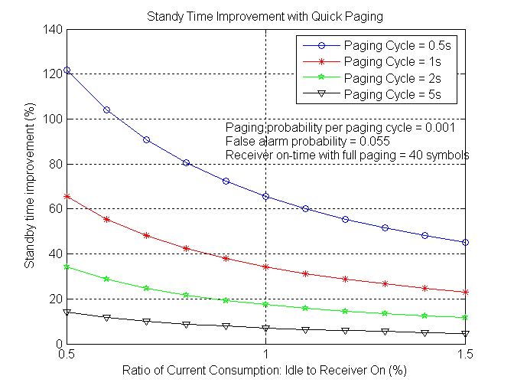
Figure 7: Standby Time Improvement with Quick Paging
In Figure 8 , we show the standby time improvements as a function of the paging cycle length for various values of the ratio k of idle current to receiver on current.
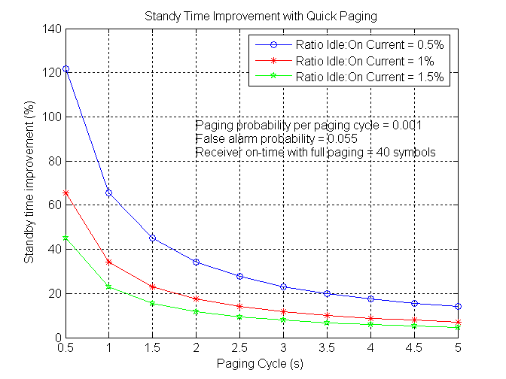
Figure 8: Standby Time Improvement due to Quick Paging
Note that in sleep mode, the listening window can be much longer, in which case the improvements in standby time can be significantly higher.

System Impact
We show further system simulation results evaluating the CINR on the various preamble signals expected to be received by a MS, and how it may degrade due to the use of the quick paging signal. As seen in Figure 9, the degradation is minimal. Note that the CINRs seen here take the 1/3 reuse of the preamble into account. The CINR of the strongest BS is relevant for functions such as initial synchronization and network entry. As seen in the figure, the degradation of the CINR is negligible, thereby no impact to initial synchronization is seen. The CINR’s of the second and third strongest base stations are relevant to measurements on other cells/sectors for the purpose of handover. As seen in the figure, there is minimal degradation of these also. Also, it is seen that the degradation mainly occurs when the second and third strongest base stations are in the better CINR regime, thus it is not expected that measurements on other cells/sectors will exhibit any serious degradation due to the presence of the quick paging signal.

Figure 10 shows the CDF of the differences in CINR between the strongest BS and the second and third strongest BSs with and without quick paging. These differences are important since they are used to make decisions on handoffs. The figure illustrates that the presence of the quick paging signal has negligible impact on the distribution of these CINR differences. Thus there is no impact on handoff performance due to quick paging. The figure also shows the CDF of the difference in CINR of the strongest BS with quick paging and the strongest BS without quick paging. The figure illustrates that the impact of quick paging on the CINR of the preamble from the strongest BS is minimal.

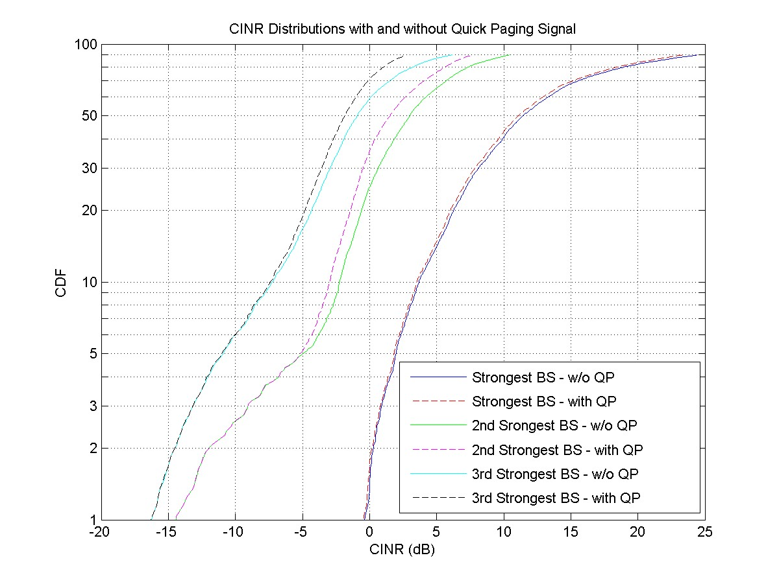
Figure 9: CINR Distribution for various Preambles

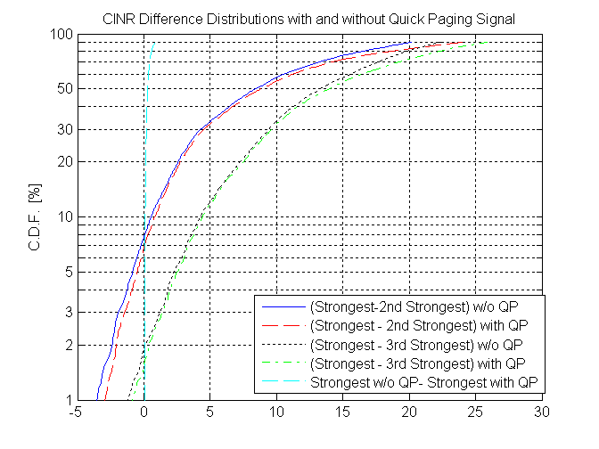
Figure 10: Impact of quick paging on relative differences of SINRs from surrounding base stations

Assignments of Codewords to Mobile Stations
The use of quick paging functionality as defined in this contribution requires the assignment of codewords to mobile stations so that they may determine whether to read the full paging functionality.
This may involve the classification of mobile stations into groups that can be identified using the codewords. Though these may be done based on MAC ID’s, however, the method to do so can be left unspecified and up to the implementation of the network provider. The signaling has been designed to communicate the actual codeword indices in point-to-point messages, thus the MS does not need the knowledge of the actual groups, but rather is just assigned the codewords it need to listen for, and act accordingly. Such a design follows the general philosophy of WiMAX, wherein network functionality is independent of the MAC & PHY layers.

Text Proposal
- Change to SS Capabilities: Please change table in section 11.7.14.1 as below

11.7.14. 1 Mobility Features Supported

Type | Length | Value | Scope
31 | 1 | Bit 0: Mobility (HO) support  Bit 1: Sleep mode support  Bit 2: Idle mode support  Bit 3: Quick Paging Support | REG-REQ  REG-REQ, REG-RSP

- Add the following TLV and its description to the DREG-CMD message and the MOB_SLP-RSP (sleep response) message :

6.3.2.3.26 DREG-CMD (de/reregister command) message
The DREG-CMD message may include the following parameters encoded as TLV tuples:
REQ-duration
Waiting value for the DREG-REQ message re-transmission (measured in frames) if this is included with action code 0x06 in DREG-CMD. If serving BS includes REQ-duration in a DREG-CMD message including an Action Code = 0x05, the MS may initiate an Idle Mode request through a DREG-REQ with Action Code = 0x01, request for MS De-Registration from serving BS and initiation of MS Idle Mode, at REQ-duration expiration.

When the DREG-CMD message is sent with action code 0x05, the following TLVs may be included:
Quick Paging
This is a TLV that indicates the number of quick paging codewords assigned to an MS and the indices of these codewords (11.1.8.4).

6.3.2.3.40 MOB_SLP-RSP (sleep response) message
The following TLV parameter may be included in MOB_SLP-RSP message transmitted by the BS.
Enabled-Action-Triggered (11.1.8.1)
This TLV indicates the enabled action that the MS performs upon reaching trigger condition in sleep mode. Next Periodic Ranging (11.1.8.3)
This value indicates the offset of frame in which MS shall be ready to perform a periodic rang-ing with respect to the frame where MOB_SLP-RSP is transmitted.
Quick Paging
This is a TLV that indicates the number of quick paging codewords assigned to an MS and the indices of these codewords (11.1.8.4)
…
…

- Add the following section and TLV description to the sleep mode TLVs in section 11.1.8.

11.1.8.4 Quick Paging

Type (1 byte) | Length | Value | Scope
TBD | The length of the word is equal to the ceil((Number of codewords assigned to MS)*log2(N_{FFT})/8), where N_{FFT} is defined in section 8.4.2.4 for OFDMA. Padding may be used to byte-align the field. | Indices of the assigned codewords concatenated into a single word with each index spanning log2(N_{FFT}) bits. | MOB_SLP-RSP, DREG-CMD

Number of Codewords Assigned to MS
This indicates the number of quick paging codewords assigned by the BS to the MS. If the MS detects any of the appropriate codewords have been sent, it shall activate the MS listening interval in sleep mode, or listen to a paging message in idle mode.

- DCD Message: Please add to Table 613 as below

11.4.1 DCD channel encodings
The DCD Channel Encoding are provided in Table 543.
Table 543—DCD channel encoding
Name | Type (1 byte) | Length | Value (variable length) | PHY scope
Quick_Paging_Signal_Power_Offset | TBD | 1 | 0-255; steps of -0.25 dB,  Gives offset of power per occupied quick paging subcarrier wrt occupied preamble subcarrier | OFDMA
Quick_Paging_Signal_Frame_Offset | TBD | 1 | 1-31 frames, other values invalid  Gives the number of frames before the start of the MS listening interval where the quick paging message will be sent | OFDMA
Nr_Used_Quick_Paging_Codewords | TBD | 2 | Index of highest quick paging codeword that is in use | OFDMA

- MAC Section:
  - Please add to section 6.3.21.1, at the end
The BS may implement a wake-up indication or quick paging signal to inform the MS in sleep mode whether it needs to be active during its listening window. The quick paging signal is sent over the duration of the frame preamble a specified number of frames before the start of the MS’s listening window. If the BS implementing the quick paging functionality requires the MS to be active during the listening window (e.g., it intends to send data or a keep-alive check to the MS, or the DCD/UCD configuration has changed), it shall send a quick paging signal to the MS in the specified time period. If the MS receives a quick paging signal intended for it, it shall be active during the listening window and perform the required tasks.

The quick paging signal is implemented using a set of codewords in OFDMA mode, as defined in section 8.4.9.2.6. The BS assigns a subset of codewords to each MS in the MOB-SLP-RSP message sent to the MS via its basic CID. The MS determines if a codeword assigned to it was sent in the quick paging interval, and acts according to such determination. Of the set of codewords defined in section 8.4.2.9.6, the first codeword is reserved to notify all sleeping MS to become active during the listening window, and the second codeword is reserved to notify all sleeping MS that none of them need become active during the listening window.

The MS indicates its support of the quick paging functionality using the SS Capabilities message. The BS adds the TLV encodings Quick_Paging_Signal_Power_Offset and Quick_Paging_Signal_Frame_Offset in the DCD message to indicate its support of the quick paging functionality, and also to provide important information the MS can use to receive the quick paging signal. In addition, the BS sends the TLV encoded parameter Nr_Used_Quick_Paging_Codewords to inform all MS of the codewords currently in use. The BS shall assign codewords to various MS in sequence starting from codeword index zero.

  - Please add to section 6.3.24 around indicated text

Idle mode is intended as a mechanism to allow the MS to become periodically available for DL broadcast traffic messaging without registration at a specific BS as the MS traverses an air link environment populated by multiple BSs, typically over a large geographic area. Idle mode benefits MS by removing the active requirement for HO, and all normal operation requirements. By restricting MS activity to scanning at discrete intervals, idle mode allows the MS to conserve power and operational resources. Additionally, the MS may be assigned a subset of quick paging codewords allowing further power savings.
…
…
  - Add to section 6.3.24.1 at the end
The serving BS may also include a Quick Paging TLV with an Action Code = 0x05 in the DREG-CMD, signaling for an MS capable of quick paging functionality, the assignment of quick paging codewords that the MS needs to detect. The BS may choose to omit such information if such has already been communicated to the MS in a different message. The quick paging signal is sent over the duration of the frame preamble a specified number of frames before the start of the MS’s paging interval. If the BS implementing the quick paging functionality requires the MS to be active during the paging interval, it shall send a quick paging signal to the MS in the specified time period. If the MS receives a quick paging signal intended for it, it shall be active during the paging interval and perform the required tasks. The MS shall ensure that it looks for quick paging signals defined for its preferred base station, as per Section 8.4.9.2.6. Of the set of codewords defined in section 8.4.2.9.6, the first codeword is reserved to notify all idle MS to become active during the paging interval, and the second codeword is reserved to notify all idle MS that none of them need become active during the paging interval.

The BS shall communicate information pertaining to the codewords it has assigned to the MS to other base stations within the paging group. The means for such communication are beyond the scope of this specification.

- PHY section :
  - Signal format (occupied subcarriers): Add new subsection 8.4.6.1.1.3
          - Quick Paging
The preamble carrier-sets are defined using Equation (74). For a given preamble carrier-set, say PreambleCarrierSet_{n}, the quick paging carrier-set nominally consists of all subcarriers not used in the preamble carrier-set. In other words, the quick paging carrier-set consists of all subcarriers in
PreambleCarrierSet_{(n+1 mod 3)} and PreambleCarrierSet_{(n+2 mod 3)}
except that values of k equal to (6 mod 10) are omitted (In other words, values of k equal to 6,16,26… are omitted)
  - Codeword Definition and Indices: Add new subsection 8.4.9.2.6
8.4.9.2.6 Bi-Orthogonal Hadamard Encoding
Bi-orthogonal Hadamard encoding is used for the Quick Paging Signal.
Hadamard matrices of sizes that are a power of two are defined as a recursion on a basic 2x2 Hadamard matrix, as given by the following equation (TBD).
$H_{2}=\left[\begin{matrix}1 & 1 \\ 1 & −1\end{matrix}\right],H_{2m}=\left[\begin{matrix}H_{m} & H_{m} \\ H_{m} & −H_{m}\end{matrix}\right]$ (TBD)
For an FFT size of N_{FFT} , as defined in section 8.4.2.4, the bi-orthogonal Hadamard codewords are given by the matrix C(NFFT) derived from the matrix H(NFFT/2). A(NFFT) is defined as follows, for k=0,….( NFFT/2) -1:
Row 2k of A(NFFT) = Row k of H(NFFT/2)
Row (2k+1) of A(NFFT) = (-1)*(Row k of H(NFFT/2))
Each element e of A(NFFT) is replaced by (1-e)/2 to get matrix B(NFFT)
Each element (bit) in a row of B(NFFT) is XORed with the bits in the sequence w_{k} as defined for the downlink in section 8.4.9.4.1, wherein the first (N_{FFT}/2) bits of w_{k} are used. This gives matrix C(NFFT).
The rows of C(NFFT) , read from left to right, define the codewords, and the index of a codeword is defined as the corresponding row number of C(NFFT).
  - Quick Paging Signal Modulation: Add new subsection 8.4.9.4.3.3
8.4.9.4.3.3 Quick Paging Signal Modulation
The BPSK modulation on the quick paging signal, real and imaginary parts, is defined by Equation (TBD):
Re{ck} = (10^{(GD/20)})*4*2^{(1/2)}*(1/2 – Ck)
Im{ck} =0
(TBD)
where ck is the k-th subcarrier in order of increasing frequency of the quick paging carrier-set defined in section 8.4.6.1.1.3, and Ck is the k-th bit of the codeword of the Bi-Orthogonal Hadamard code generated according to section 8.4.9.2.6. GD is the gain differential of the Quick Paging Signal with respect to the Preamble, as given by the parameter Quick_Paging_Signal_Power_Offset in the DCD message.

Conclusions
We have presented a design for a quick paging signal in IEEE 802.16e that utilizes the unoccupied space available in the preamble signal to send an indication of a full paging signal in a succeeding frame. The performance of this scheme was evaluated using a combination of link and system simulations for multiple types of receivers. By utilizing the structure of the interferer, it is possible to achieve significant gains in performance and arrive at low probabilities of missed detection along with acceptable probabilities of false alarm. In addition, due to its low power, the proposed scheme has negligible impact on the other functionalities that require the preamble, a fact that was confirmed by the results of the simulation. Thus, the proposed scheme is a viable candidate for implementing quick paging functionality in IEEE 802.16e. Proposed text changes to the specification to incorporate quick paging functionality were provided.

References
[1] IEEE P802.16Rev2/D3, “Draft Standard for local and metropolitan area networks, Part 16: Air Interface for Fixed and Mobile Broadband Wireless Access Systems,’’ Feb. 2008
[2] S. Shawn Tsai, Stefan Lindgren, and Sten Sjöberg, `Wake-up Signal for 802.16m OFDMA Idle Mode,’ IEEE C802.16m07/217r1.
[3] John G. Proakis, `Digital Communications.’

