Project | IEEE 802.16 Broadband Wireless Access Working Group <http://ieee802.org/16>
Title | Mapping of Authentication Rejection from PKMv1 to PKMv2
Date Submitted | 2008-04-16
Source(s) | David Fox  Vodafone Group PLC  Newbury, UK | Voice: +44 7919308756  E-mail: david.fox@vodafone.com  *<http://standards.ieee.org/faqs/affiliationFAQ.html>
Re: | IEEE 802.16 Working Group Letter Ballot Recirc #26c on IEEE Rev2/D4
Abstract | In the current definition of PKMv2 the use of the Auth Reject message, defined for PKMv1, has been omitted. This message and the associated functionality are important to successful operation of a mobile network.  For example, it is needed for the BS to inform the SS that the authentication is not possible through this access network or through a particular NSP. This would occur in the case when no roaming agreement exists between the network and home network of the SS. Without this functionality these SS would repeatedly request access from a WiMAX network which could appear like a DDoS to the WiMAX network, and unnecessarily drain the battery of the SS.
Purpose | Adopt the proposed text and incorporate into 802.16 Rev2/D5.
Notice | This document does not represent the agreed views of the IEEE 802.16 Working Group or any of its subgroups. It represents only the views of the participants listed in the “Source(s)” field above. It is offered as a basis for discussion. It is not binding on the contributor(s), who reserve(s) the right to add, amend or withdraw material contained herein.
Release | The contributor grants a free, irrevocable license to the IEEE to incorporate material contained in this contribution, and any modifications thereof, in the creation of an IEEE Standards publication; to copyright in the IEEE’s name any IEEE Standards publication even though it may include portions of this contribution; and at the IEEE’s sole discretion to permit others to reproduce in whole or in part the resulting IEEE Standards publication. The contributor also acknowledges and accepts that this contribution may be made public by IEEE 802.16.
Patent Policy | The contributor is familiar with the IEEE-SA Patent Policy and Procedures:  <http://standards.ieee.org/guides/bylaws/sect6-7.html#6> and <http://standards.ieee.org/guides/opman/sect6.html#6.3>.  Further information is located at <http://standards.ieee.org/board/pat/pat-material.html> and <http://standards.ieee.org/board/pat>.

Mapping of Authentication Rejection from PKMv1 to PKMv2
David Fox
Vodafone Group PLC

First modified sub-clause
6.3.2.3.9 Privacy key management (PKM) messages (PKM-REQ/PKM-RSP)
[…]
Table 48—PKM message codes
Code | PKM message type | MAC management  message name
[…] | […] | […]
33 | MIH Comeback Response | PKM-RSP
34–255 | Reserved | —

Auth Invalid, Auth Reject and Auth Info messages may be used in PKMv1 and PKMv2.
Formats for each of the PKM messages are described in the following subclauses. The descriptions list the PKM attributes contained within each PKM message type. The attributes themselves are described in 11.9. Unknown attributes shall be ignored on receipt and skipped over while scanning for recognized attributes.
The BS shall silently discard all requests that do not contain ALL required attributes. The SS shall silently discard all responses that do not contain ALL required attributes.

Next modified sub-clause

7.2.2.5 Authentication state machine
[…]
Through operation of an Authentication state machine, the MS attempts to get authenticated with the NW, maintain this authentication and support Authentication context switching for HO and Idle situations. The state machine takes care of getting authenticated with the NW, ensuring re-authentication will occur before authentication expires and support key derivations according to support optimized re-entry for HO and idle.
The optimized re-entry support is done in a special state in which the NW connection is suspended and therefore re-authentication can’t occur, the triggers for re-authentication continue to work in this state but the initiation is done only after returning to an authenticated state.
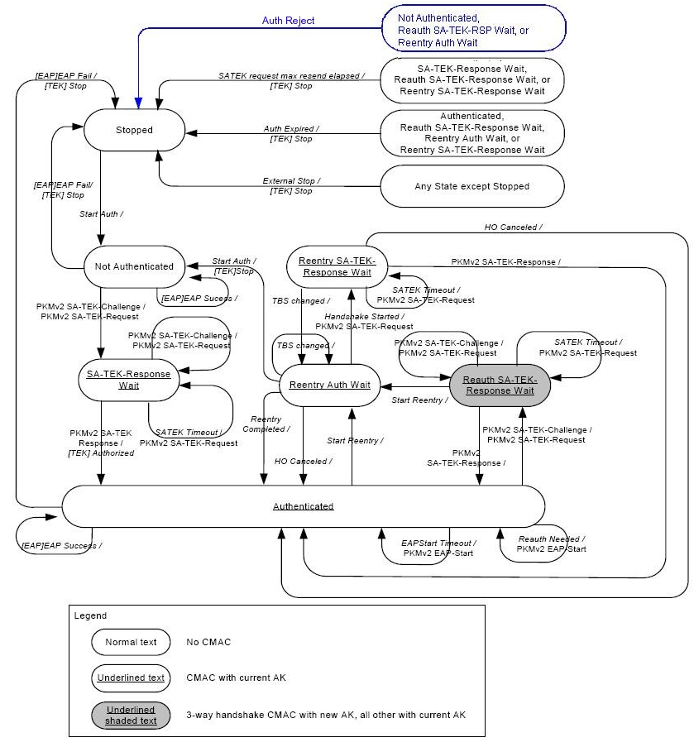
Figure 162—Authentication State Machine for PKMv2 single EAP

Table 205—Authentication FSM state transition matrix for PKMv2
State Event or receive message | (A) Stopped | (B) Not Authenticated | (C) SA_TEK Rsp Wait | (D) Authenticated | (E) Reauth SA-TEK-RSP Wait | (F) Reentry Auth Wait | (G) Reentry SA-TEK-Rsp Wait
[…] | […] | […] | […] | […] | […] | […] | […]
(15) EAP Fail |  | Stopped |  | Stopped
(16) External Stop |  | Stopped | Stopped | Stopped | Stopped | Stopped | Stopped
(17) Auth Reject |  | Stopped |  |  | Stopped | Stopped

Next modified sub-clause
7.2.2.5.3 Events Start Authentication: After completion of basic capabilities negotiation, this event is generated to start the Authentication state machine. It is also issued when the HO Process Optimization Bit #1 of the RNG-RSP message is set to zero during HO or network reentry.
EAP Success: EAP FSM generates this event to notify the Authorization FSM that EAP protocol has been completed successfully.
SATEK Timeout: This event is generated when the MS does not receive PKMv2 SA-TEK-Response mes-sage from the BS within SATEK Timer after transmitting a PKMv2 SA-TEK-Request message. The MS may resend the PKMv2 SA-TEK-Request up to SATEKRequestMaxResends times.
SATEK request max resends elapsed: The Authorization state machine generates this event when the MS has transmitted the PKMv2 SA-TEK-Request message up to SATEKRequestMaxResends times and SATEK Timer expires.
Re-authentication Needed: An internal event to trigger re-authentication. This event can be derived from several sources such as Authorization Grace Timeout or other reason that makes authentication close to expiration.
Start Reentry: An event to inform the Authorization FSM that MS is in reentry phase. The FSM should derive the new AK context for the target BS.
EAPStart Timeout: A timer event that causes the MS to resend a PKMv2 EAP-Start message in order to ask the BS to start EAP-based re-authentication. This event is used in the case Authorization FSM receives neither the EAP Failure event nor the EAP Success event after transmitting the PKMv2 EAP Start message. This timer is active only after Re-authentication Needed event occurred.
Handshake Started: An event to notify the Authorization FSM that the MS has received SA-Challenge Tuple TLV to start SA-TEK 3-way handshake. This event is issued when the MS receives a RNG-RSP mes-sage including HO Process Optimization Bit #1 and Bit #2 set to one and zero respectively and SA-Chal-lenge Tuple TLV during HO or network re-entry.
Reentry Completed: An event to notify the Authorization FSM that reentry has finished successfully. This event is issued when the MS receives a RNG-RSP message including HO Process Optimization Bit #1 and Bit #2 set to one and zero respectively and SA-TEK-Update TLV during HO or network re-entry from Idle mode. This event is also issued when the MS receives a RNG-RSP message including HO Process Optimi-zation Bit #1 and Bit #2 both set to one during HO.
HO Canceled: An event to notify the Authorization FSM that HO was canceled. The cached AK context for the serving BS should be retrieved. TBS (Target BS) changed: An Event to notify the Authorization FSM that it needs to generate the AK con-text for the new target BS.
Authentication Expired: This event indicates the AK context became obsolete due to the expiration of AK lifetime.
EAP Failure: This event indicates EAP-based authentication has failed.
External Stop: The event to stop the Authorization FSM and terminate connection with BS.
Auth Reject: This event indicates that authentication has been rejected by the BS. This event is issued when the MS receives an Auth-Reject message including an Error Code. The Error Code indicates to MS when the MS can again perform network re-entry onto this network.
NOTE-The following events are sent by an Authorization state machine to the TEK state machine:
[TEK] Stop: Sent by the Authorization FSM to an active (non-START state) TEK FSM to terminate the FSM and remove the corresponding SAID’s keying material from the SS’s key table.
[TEK] Authorized: Sent by the Authorization FSM to a nonactive (START state), but valid TEK FSM.
[TEK] Authorization Pending (Auth Pend): Sent by the Authorization FSM to a specific TEK FSM to place that TEK FSM in a wait state until the Authorization FSM can complete its reauthorization operation. This event shall be sent to the TEK FSM in the Operational Wait (Op Wait) or Rekey Wait states when Authori-zation FSM starts re-authentication.
[TEK] Authorization Complete (Auth Comp): Sent by the Authorization FSM to a TEK FSM in the Opera-tional Reauthorize Wait (Op Reauth Wait) or Rekey Reauthorize Wait (Rekey Reauth Wait) states to clear the wait state begun by a TEK FSM Authorization Pending event. This event shall be sent to the TEK FSM in the Operational Reauthorize Wait or Rekey Reauthorize Wait states when Authorization FSM ends re-authentication.
Next modified sub-clause
7.2.2.5.5 Actions
[…]
16-D,E,F,G: Any state except Stopped, Not Authenticated, and SA-TEK-Response Wait (External Stop) −> Stopped
- Stop TEK FSMs
- Stop Authorization Grace Timer
- Stop the Authorization FSM

17-B,E,F: Not Authenticated, Reauth SA-TEK-RSP Wait, Reentry Auth Wait -> Stopped

- Stop Authorization Grace Timer
- Stop the Authorization FSM

Next modified sub-clause
11.9.10 Error code

The Error-Code attribute contains a 1-byte error code providing further information about an Authorization Reject, Key Reject, Authorization Invalid, or TEK Invalid. A summary of the Error-Code attribute format is shown below. Table 563 lists code values for use with this attribute. The BS may employ the nonzero error codes (1–6) listed below; it may, however, return a code value of zero (0). Error code values other than those defined in Table 563 shall be ignored. Returning a code value of zero sends no additional failure information to the SS; for security reasons, this may be desirable.

Type | Length | Value (Units) | Scope
16 | 1 | Error-Code | Authorization Reject, Authorization Invalid, Key Reject, TEK Invalid

Table 563—Error-code attribute code values
Error Code | Messages | Description
0 | All | No information
1 | Auth Reject, Auth Invalid | Unauthorized SS
2 | Auth Reject, Key Reject | Unauthorized SAID
3 | Auth Invalid | Unsolicited
4 | Auth Invalid, TEK Invalid | Invalid Key Sequence Number
5 | Auth Invalid | Message (Key Request) authentication failure
6 | Auth Reject | Permanent Authorization Failure
7 | Auth Reject | Permanent Authorization Failure at the NAP
8 | Auth Reject | Permanent Authorization Failure at the NSP
9 | Auth Reject | Permanent Authorization Failure due to Illegal device
10 | Auth Reject | Location Specific Failure

Error Code 6 (Permanent Authorization Failure) is used to indicate a number of different error conditions affecting the PKM authorization exchange. These include:
- An unknown manufacturer; i.e., the BS does not have the CA certificate belonging to the issuer of an SS certificate
- SS certificate has an invalid signature
- ASN.1 parsing failure during verification of SS certificate
- SS certificate is on the “hot list”
- Inconsistencies between certificate data and data in accompanying PKM attributes
- SS and BS have incompatible security capabilities
The common property of these error conditions is that the failure condition is considered permanent; any reattempts at authorization would continue to result in Authorization Rejects. Details about the cause of a Permanent Authorization Failure may be reported to the SS in an optional Display-String attribute that may accompany the Error-Code attribute in Authorization Reject messages. Note that providing this additional detail to the SS should be administratively controlled within the BS. The BS may log these Authorization failures, or even trap them to an SNMP manager.
Error Code 7 (Permanent Authorization Failure at the NAP) is used to indicate to the SS that it should not attempt Network Entry on this NAP again until the SS has been manually powered down.
Error Code 8 (Permanent Authorization Failure at the NSP) is used to indicate to the SS that it should not attempt to register on this NSP again until the SS has been manually powered down.
Error Code 9 (Permanent Authorization Failure due to Illegal device) is used to indicate to the SS that it should not attempt Network Entry on this NAP again until the SS has been manually powered down.
Error Code 10 (Location Specific Failure) is used to indicate to the SS that it should not attempt Network Entry on this NAP until the SS has been manually powered down or the first Paging Group ID in List of Paging Group IDs advertised on the DCD message of this cell, no longer appears in the List of Paging Group IDs of a cell from this Network.

