Project | IEEE 802.16 Broadband Wireless Access Working Group <http://ieee802.org/16>
Title | MIMO midamble in HFDD/FDD structure
Date Submitted | 2008-04-19
Source(s) | Jin Young Chun  Bin-chul Ihm  LG Electronics | E-mail: jychun03@lge.com  bcihm@lge.com  *<http://standards.ieee.org/faqs/affiliationFAQ.html>
Re: | 802.16 Working Group Letter Ballot #26c
Abstract | This document proposes the operation of MIMO midamble in HFDD/FDD.
Purpose | To be discussed and adopted by 802.16 Rev2.
Notice | This document does not represent the agreed views of the IEEE 802.16 Working Group or any of its subgroups. It represents only the views of the participants listed in the “Source(s)” field above. It is offered as a basis for discussion. It is not binding on the contributor(s), who reserve(s) the right to add, amend or withdraw material contained herein.
Release | The contributor grants a free, irrevocable license to the IEEE to incorporate material contained in this contribution, and any modifications thereof, in the creation of an IEEE Standards publication; to copyright in the IEEE’s name any IEEE Standards publication even though it may include portions of this contribution; and at the IEEE’s sole discretion to permit others to reproduce in whole or in part the resulting IEEE Standards publication. The contributor also acknowledges and accepts that this contribution may be made public by IEEE 802.16.
Patent Policy | The contributor is familiar with the IEEE-SA Patent Policy and Procedures:  <http://standards.ieee.org/guides/bylaws/sect6-7.html#6> and <http://standards.ieee.org/guides/opman/sect6.html#6.3>.  Further information is located at <http://standards.ieee.org/board/pat/pat-material.html> and <http://standards.ieee.org/board/pat>.
MIMO midamble in HFDD/FDD structure
Jin Young Chun, Bin-chul Ihm
LG Electronics

Problem statement
In current spec, the MIMO midamble is transmitted in the first symbol of the STC zone in TDD mode. But it’s not clear the operation in HFDD/FDD. If we apply the same operation with TDD, there are two midambles in a frame. Normally CL-MIMO is operated in low speed and the channel varying is not severe in a frame. Therefore a midamble is enough in a frame and it makes DL overhead reduced.
We suggest that MIMO midamble is located in a symbol between group1 and group2 in HFDD/FDD. Then HFDD MS as well as FDD MS can receive the midamble without any more tx/rx switching. There is an example as figure 1. Group1 MS receives the DL data from the preamble to the midamble and then transmits UL data from the midamble + TTG1 to the next preamble – RTG1. The operation of Group2 MS is opposite to that. We assume that DL_{gap} is zero.
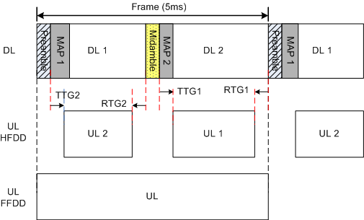
Figure 1

For the operation, BS shall inform the presence and the location of MIMO midamble. For group 1 MS in HFDD or MS in FDD, midamble presence is indicated by MAP1 in current frame. And for group 2 MS in HFDD, midamble presence is indicated by MAP2 in previous frame.
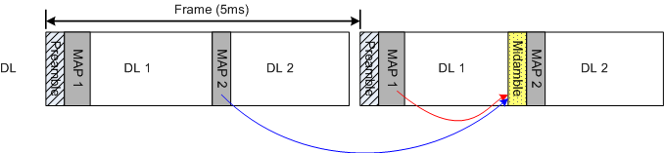
Figure 2

Proposed text change

[Modify the field of ‘Midamble presence’ in Table 326 as below]
Syntax | Size (bit) | Notes
Midamble presence | 1 | 0: Not present  1: MIMO midamble present  In TDD, at the first symbol in STC zone  In FDD, at the last symbol of this group1 frame  In HFDD for group1, at the last symbol in this group1 frame  In HFDD for group2, at the previous symbol of FCH in the next group2 frame

