Project | IEEE 802.16 Broadband Wireless Access Working Group <http://ieee802.org/16>
Title | IEEE 802.16 Repeater and Standard Clarification in Rev2
Date Submitted | 2008-08-26
Source(s) | Toshiyuki Kuze  Mitsubishi Electric Corp  Zhifeng (Jeff) Tao, Jinyun Zhang  Mitsubishi Electric Research Lab  Hongyun Qu  ZTE | Voice: +81-467-41-2885  Fax: +81-467-41-2486  Kuze.Toshiyuki@ah.MitsubishiElectric.co.jp  Voice: 617-621-{7557, 7595}  Fax: 617-621-7550  {tao, jzhang}@merl.com  qu.hongyun@zte.com.cn
Re: | IEEE802.16Rev2/D6a Sponsor Ballot
Abstract | IEEE 802.16 Repeater and Standard Clarification in Rev2
Purpose | For adoption by IEEE802.16 Maintenance TG
Notice | This document does not represent the agreed views of the IEEE 802.16 Working Group or any of its subgroups. It represents only the views of the participants listed in the “Source(s)” field above. It is offered as a basis for discussion. It is not binding on the contributor(s), who reserve(s) the right to add, amend or withdraw material contained herein.
Release | The contributor grants a free, irrevocable license to the IEEE to incorporate material contained in this contribution, and any modifications thereof, in the creation of an IEEE Standards publication; to copyright in the IEEE’s name any IEEE Standards publication even though it may include portions of this contribution; and at the IEEE’s sole discretion to permit others to reproduce in whole or in part the resulting IEEE Standards publication. The contributor also acknowledges and accepts that this contribution may be made public by IEEE 802.16.
Patent Policy | The contributor is familiar with the IEEE-SA Patent Policy and Procedures:  <http://standards.ieee.org/guides/bylaws/sect6-7.html#6> and <http://standards.ieee.org/guides/opman/sect6.html#6.3>.  Further information is located at <http://standards.ieee.org/board/pat/pat-material.html> and <http://standards.ieee.org/board/pat>.

IEEE 802.16 Repeater and Standard Clarification in Rev2

Toshiyuki Kuze
Mitsubishi Electric Corp

Zhifeng (Jeff) Tao, Jinyun Zhang
Mitsubishi Electric Research Lab

Introduction
Repeaters have already been widely used for many wireless systems such as GSM, iDEN, etc., since they can enhance the existing coverage and provide service to rural and isolated areas as well as for indoor coverage, all at a fraction of the cost of a new cell site. Indeed, repeaters have become essential for these wireless networks with large base station (BS) coverage footprint.

In the meantime, IEEE 802.16 system is deployed in such a high frequency band (2.5GHz, 3.5GHz, etc.) that its signals don't propagate as well as the conventional cellular technologies that operate in lower band. Thus, in order for IEEE 802.16 network to proliferate in global market, efficient outdoor range extension and indoor coverage enhancement solutions are demanded for both residential and enterprise applications.

IEEE 802.16 Repeater
Repeater is a cost-effective solution to outdoor range extension and indoor coverage enhancement for high quality broadband IEEE 802.16 wireless access service. In-band repeater and frequency shift repeater (FSR) are two compelling options.

The in-band repeaters use the same band to communicate with BS and MSs, which is frequency F1 in Figure 1.

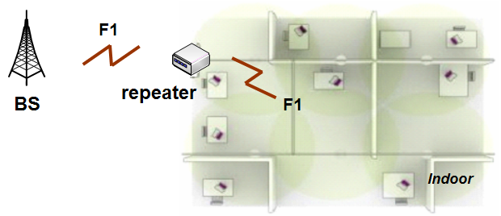
Figure 1: In-band repeater

In contrast, frequency shift repeaters use one frequency to communicate with BS, and use a different frequency to talk to MSs. As shown in Figure 2, for example, repeaters convert the frequency F1 to frequency F2 for downlink, and vice versa for uplink communications. Therefore, frequency shift repeaters sometimes are also known as frequency translation or conversion repeater.

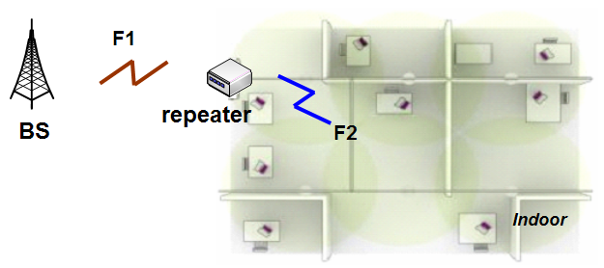
Figure 2: Frequency shift repeater

Frequency Shift Repeater
In general, as the repeaters assume a compact form factor, it becomes difficult to obtain the high antenna isolation between donor and service antenna (e.g., patch antenna). Indeed, as shown in Figure 3, in-band repeaters have to use such pricey component as canceller to achieve sufficient antenna isolation, thereby inevitably rendering the entire repeater solution approach more expensive and less desirable.

Figure 3: In-band repeater and its isolation problem

Instead, frequency shift repeaters can use digital filter to effectively address the isolation problem between donor and the service antenna, as illustrated in Figure 4. In general, as the bandpass filter is included in the RF module, frequency shift repeaters shall be a much more cost-effective solution than in-band repeaters.

Figure 4: Frequency shift repeater with digital filter

Standard Clarification
The current specification essentially supports the frequency shift repeater. However it’s necessary to clarify the handling of center frequency TLV in DCD and UCD messages for a smooth repeater operation.

BS includes a center frequency TLV in the DCD and UCD message to indicate the synchronization frequency to MS. This TLV is important for the FDD/H-FDD MS to obtain the UL frequency information.

When a frequency shift repeater is used in a TDD IEEE 802.16 network, it translates the signal from frequency F1 to F2 in downlink as shown in Figure 2. For an MS that synchronizes to the frequency shift repeater on F2 frequency, it may potentially get confused when it receives the DCD message that instead points to F1 as center frequency.

Fortunately, nevertheless, the center frequency TLV is not needed by TDD MSs at all, because each TDD MS must have already synchronized to this center frequency before it actually can receive and understand the DCD message.

Thus, the center frequency TLV in DCD message essentially is redundant for a TDD MS. In order to avoid any unnecessary confusion for frequency shift repeater operation, it is safe to clarify that the center frequency TLV in DCD message is used by FDD/H-FDD MS only. Similar conclusion can be drawn for the center frequency TLV in UCD message.

Proposed Text Change

11.3.1 UCD channel encodings
…
Table 560 – UCD channel encodings
Name | Type  (1 byte) | Length | Value
Uplink_Burst_Profile | 1 | — | May appear more than once (see 6.3.2.3.3). The length is the number of bytes in the overall object, including embedded TLV items.
Contention-based reservation timeout | 2 | 1 | Number of UL-MAPs to receive before contention-based reservation is attempted again for the same connection
Frequency | 5 | 4 | UL center frequency (kHz).
… | … | … | …

[Insert following sentences after Table 560]
When the Frequency TLV is contained in a UCD message, it is only used by MSs operating in FDD or H-FDD mode. When this TLV is contained in MOB_NBR-ADV message as a part of UCD_settings compound TLV, it can be used by MSs operating in both TDD and FDD/H-FDD mode.

11.4.1 DCD channel encodings
…
Table 567 – DCD channel encodings
Name | Type  (1 byte) | Length | Value | PHY scope
Downlink_Burst_Profile | 1 | — | May appear more than once (see 6.3.2.3.1). The length is the number of bytes in the overall object, including embedded TLV items. | All
… | … | … | … | …
Frequency | 12 | 4 | DL center frequency (kHz). | All
… | … | … |  | …

[Insert following sentences after Table 567]
When the Frequency TLV is contained in a DCD message, it is only used by MSs operating in FDD or H-FDD mode. When this TLV is contained in MOB_NBR-ADV message as a part of DCD_settings compound TLV, it can be used by MSs operating in both TDD and FDD/H-FDD mode.

