Project | IEEE 802.16 Broadband Wireless Access Working Group <http://ieee802.org/16>
Title | IEEE 802.16 Repeater and Standard Clarification in Rev2
Date Submitted | 2008-10-29
Source(s) | Toshiyuki Kuze, Kentarou Sawa  Mitsubishi Electric Corp  Zhifeng (Jeff) Tao, Jinyun Zhang  Mitsubishi Electric Research Lab | Voice: +81-467-41-2885  Fax: +81-467-41-2486  Kuze.Toshiyuki@ah.MitsubishiElectric.co.jp  Voice: 617-621-{7557, 7595}  Fax: 617-621-7550  {tao, jzhang}@merl.com
Re: | IEEE802.16Rev2/D7 Sponsor Ballot
Abstract | IEEE 802.16 Repeater and Standard Clarification in Rev2
Purpose | For adoption by IEEE802.16 Maintenance TG
Notice | This document does not represent the agreed views of the IEEE 802.16 Working Group or any of its subgroups. It represents only the views of the participants listed in the “Source(s)” field above. It is offered as a basis for discussion. It is not binding on the contributor(s), who reserve(s) the right to add, amend or withdraw material contained herein.
Release | The contributor grants a free, irrevocable license to the IEEE to incorporate material contained in this contribution, and any modifications thereof, in the creation of an IEEE Standards publication; to copyright in the IEEE’s name any IEEE Standards publication even though it may include portions of this contribution; and at the IEEE’s sole discretion to permit others to reproduce in whole or in part the resulting IEEE Standards publication. The contributor also acknowledges and accepts that this contribution may be made public by IEEE 802.16.
Patent Policy | The contributor is familiar with the IEEE-SA Patent Policy and Procedures:  <http://standards.ieee.org/guides/bylaws/sect6-7.html#6> and <http://standards.ieee.org/guides/opman/sect6.html#6.3>.  Further information is located at <http://standards.ieee.org/board/pat/pat-material.html> and <http://standards.ieee.org/board/pat>.

IEEE 802.16 Repeater and Standard Clarification in Rev2

Toshiyuki Kuze, Kentarou Sawa
Mitsubishi Electric Corp

Zhifeng (Jeff) Tao, Jinyun Zhang
Mitsubishi Electric Research Lab

Introduction
Repeaters have already been widely used for many wireless systems such as GSM, iDEN, etc., since they can enhance the existing coverage and provide service to rural and isolated areas as well as for indoor coverage, all at a fraction of the cost of a new cell site. Indeed, repeaters have become essential for these wireless networks with large base station (BS) coverage footprint.

In the meantime, IEEE 802.16 system is deployed in such a high frequency band (2.5GHz, 3.5GHz, etc.) that its signals don't propagate as well as the conventional cellular technologies that operate in lower band. Thus, in order for IEEE 802.16 network to proliferate in global market, efficient outdoor range extension and indoor coverage enhancement solutions are demanded for both residential and enterprise applications.

IEEE 802.16 Repeater
Repeater is a cost-effective solution to outdoor range extension and indoor coverage enhancement for high quality broadband IEEE 802.16 wireless access service. In-band repeater and frequency shift repeater (FSR) are two compelling options.

The in-band repeaters use the same band to communicate with BS and MSs, which is frequency F2 in Figure 1.

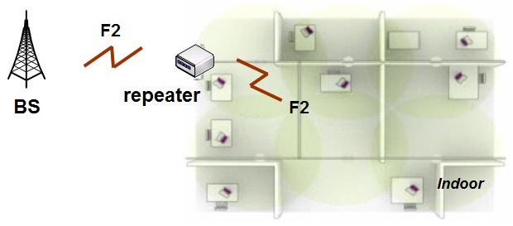
Figure 1: In-band repeater

In contrast, frequency shift repeaters use one frequency to communicate with BS, and use a different frequency to talk to MSs. As shown in Figure 2, for example, repeaters convert the frequency F2 to frequency F1 for downlink, and vice versa for uplink communications. Therefore, frequency shift repeaters sometimes are also known as frequency translation or conversion repeater.

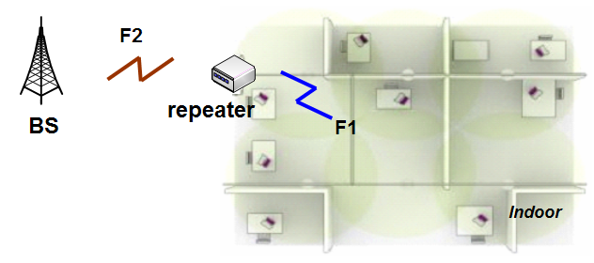
Figure 2: Frequency shift repeater

Frequency Shift Repeater
In general, as the repeaters assume a compact form factor, it becomes difficult to obtain the high antenna isolation between donor and service antenna (e.g., patch antenna). Indeed, as shown in Figure 3, in-band repeaters have to use such pricey component as canceller to achieve sufficient antenna isolation, thereby inevitably rendering the entire repeater solution approach more expensive and less desirable.

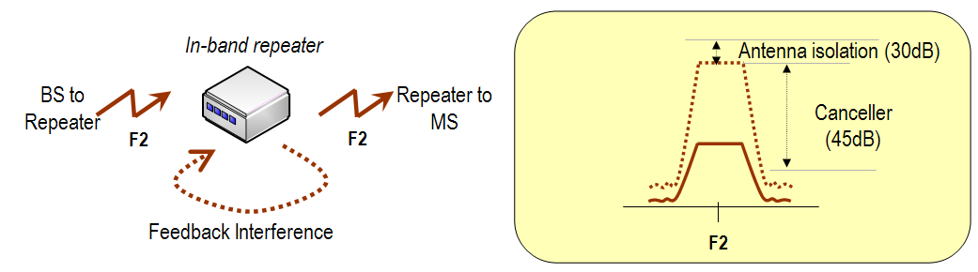
Figure 3: In-band repeater and its isolation problem

Instead, frequency shift repeaters can use digital filter to effectively address the isolation problem between donor and the service antenna, as illustrated in Figure 4. In general, as the bandpass filter is included in the RF module, frequency shift repeaters shall be a much more cost-effective solution than in-band repeaters.

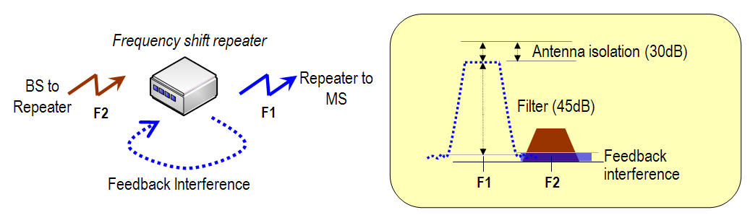
Figure 4: Frequency shift repeater with digital filter

Standard Modification
For simple FSRs, both the outdoor and indoor frequency should be specified in advance by operator. Therefore, the mapping relation between outside and inside frequency would be fixed. In this contribution, only simple FSRs following this fixed mapping approach will be considered.

In order to support frequency shift repeater in TDD network, we propose to introduce a new TLV called FSR center frequency TLV. The FSR center frequency TLV included in the DCD and UCD message indicates the center frequency that FSR uses to communicate with the MSs in downlink and uplink, respectively.

A legacy MS does not understand this FSR center frequency TLV, and thus shall ignore this TLV. If MS understands this FSR center frequency TLV, and notices that the physical frequency it uses to synchronize with matches that indicated by FSR center frequency TLV, the MS learns that it is currently communicating directly with the FSR.

Proposed Text Change

3. Definition

[Add following definition in this subclause]

3.x frequency shift repeater (FSR):a generalized equipment set, dependent of a base station, providing connectivity, to mobile station (MS). The communications between an FSR and a BS, and the communications between the FSR and an MS occur on different frequency band. The air interface between an FSR and an MS is identical to the air interface between a BS and an MS.

11.3.1 UCD channel encodings
…
[Insert a new row at the end of Table 564]

Table 564 – UCD channel encodings
Name | Type  (1 byte) | Length | Value
Uplink_Burst_Profile | 1 | — | May appear more than once (see 6.3.2.3.3). The length is the number of bytes in the overall object, including embedded TLV items.
Contention-based reservation timeout | 2 | 1 | Number of UL-MAPs to receive before contention-based reservation is attempted again for the same connection
Frequency | 5 | 4 | UL center frequency (kHz) used by BS.
… | … | … | …
FSR frequency | xxx | 4 | Center frequency (kHz) used by frequency shift repeater to communicate with MSs in the uplink

11.4.1 DCD channel encodings
…
[Insert a new row at the end of Table 571]
Table 571 – DCD channel encodings
Name | Type  (1 byte) | Length | Value | PHY scope
Downlink_Burst_Profile | 1 | — | May appear more than once (see 6.3.2.3.1). The length is the number of bytes in the overall object, including embedded TLV items. | All
… | … | … | … | …
Frequency | 12 | 4 | DL center frequency (kHz) used by BS. | All
… | … | … |  | …
CDD STC descriptor | 157 | variable | This TLV may be transmitted to specify CDD parameters to the MS. It applies to zones with STC = 0b01 and 2/3 antennas select = 0b00 (STC using 2 antennas), i.e. 2 logical antennas, and dedicated pilots = 0 in STC DL zone IE. Each byte represents one CDD parameter: 5 LSBs are for delay in samples (1 to 32) from physical antenna #0, 3 MSBs are reserved and shall be set to 0's. The same parameters shall apply to logical antenna 0 and 1. If the Length of this CDD descriptor is n bytes, then the number of Tx antenna is 2(n+1). The power of each antenna is the same. | OFDMA
FSR frequency | xxx | 4 | Center frequency (kHz) used by frequency shift repeater to communicate with MSs in the downlink | All

