Project | IEEE 802.16 Broadband Wireless Access Working Group <http://ieee802.org/16>
Title | Proposal on Power control mode change
Date Submitted | 2008-12-18
Source(s) | Li Wang,  Xinyu Hou  ZTE Corporation | Voice:  E-mail:  wangli@zte.com.cn  *<http://standards.ieee.org/faqs/affiliationFAQ.html>
Re: | P802.16 Revision 2
Abstract | This contribution proposed some clarification on start frame of power control mode change.
Purpose | Adopt for 802.16 Revision 2
Notice | This document does not represent the agreed views of the IEEE 802.16 Working Group or any of its subgroups. It represents only the views of the participants listed in the “Source(s)” field above. It is offered as a basis for discussion. It is not binding on the contributor(s), who reserve(s) the right to add, amend or withdraw material contained herein.
Release | The contributor grants a free, irrevocable license to the IEEE to incorporate material contained in this contribution, and any modifications thereof, in the creation of an IEEE Standards publication; to copyright in the IEEE’s name any IEEE Standards publication even though it may include portions of this contribution; and at the IEEE’s sole discretion to permit others to reproduce in whole or in part the resulting IEEE Standards publication. The contributor also acknowledges and accepts that this contribution may be made public by IEEE 802.16.
Patent Policy | The contributor is familiar with the IEEE-SA Patent Policy and Procedures:  <http://standards.ieee.org/guides/bylaws/sect6-7.html#6> and <http://standards.ieee.org/guides/opman/sect6.html#6.3>.  Further information is located at <http://standards.ieee.org/board/pat/pat-material.html> and <http://standards.ieee.org/board/pat>.
Proposal on Power control mode change
Li Wang, Xinyu Hou

Problem description
In the table 161 of section 6.3.2.3.54, size of start frame is 6 bit in the PMC_RSP message. But in the SBC-REQ/RSP message size of related parameter is 1 byte. Please see the following tables. That may cause some problems when the value of the parameter in SBC-REQ/RSP is bigger than 64 and make inconsistency between BS and MS.

11.8.3.5.9 OFDMA SS UL power control support
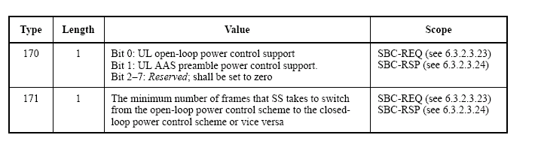

6.3.2.3.54 PMC_RSP (power control mode change response) message
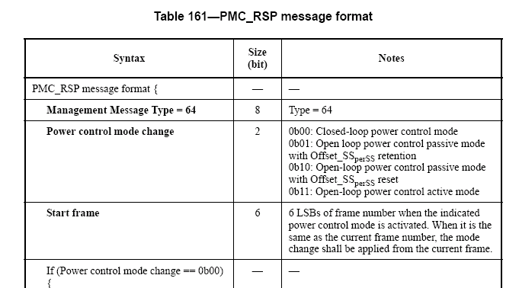

Proposed solution
Size of parameter in SBC-REQ/RSP shall be changed as follows:
Type | Length | Value | Scope
171 | 1 | Bits 0–5:  The minimum number of frames that SS takes to switch from the open-loop power control scheme to the closed-loop power control scheme or vice versa  Bits 6–7: Reserved | SBC-REQ (see 6.3.2.3.23)  SBC-RSP (see 6.3.2.3.24)

References
IEEE Std 802.16Rev2-D8 (Revision of IEEE Std 802.16-2004 and consolidates material from IEEE Std 802.16e-2005, IEEE Std 802.16-2004/Cor1-2005, IEEE Std 802.16f-2005 and IEEE Std802.16g-2007), “IEEE Standard for Local and Metropolitan Area Networks - Part 16: Air Interface for Broadband Wireless Access Systems,” November, 2008.

