Project | IEEE 802.16 Broadband Wireless Access Working Group <http://ieee802.org/16>
Title | DL-MAP and UL-MAP relevance diagrams for H-FDD
Date Submitted | 2009-01-13
Source(s) | Sean McBeath, Huawei  Joe Schumacher, Motorola | Voice: +1-847-632-5978  E-mail: j.schumacher@motorola.com  *<http://standards.ieee.org/faqs/affiliationFAQ.html>
Re: | P802.16 Revision 2, sponsor ballot #2
Abstract | Remedy for Comments B30009 and B30010
Purpose | Review and adopt
Notice | This document does not represent the agreed views of the IEEE 802.16 Working Group or any of its subgroups. It represents only the views of the participants listed in the “Source(s)” field above. It is offered as a basis for discussion. It is not binding on the contributor(s), who reserve(s) the right to add, amend or withdraw material contained herein.
Release | The contributor grants a free, irrevocable license to the IEEE to incorporate material contained in this contribution, and any modifications thereof, in the creation of an IEEE Standards publication; to copyright in the IEEE’s name any IEEE Standards publication even though it may include portions of this contribution; and at the IEEE’s sole discretion to permit others to reproduce in whole or in part the resulting IEEE Standards publication. The contributor also acknowledges and accepts that this contribution may be made public by IEEE 802.16.
Patent Policy | The contributor is familiar with the IEEE-SA Patent Policy and Procedures:  <http://standards.ieee.org/guides/bylaws/sect6-7.html#6> and <http://standards.ieee.org/guides/opman/sect6.html#6.3>.  Further information is located at <http://standards.ieee.org/board/pat/pat-material.html> and <http://standards.ieee.org/board/pat>.

DL-MAP and UL-MAP relevance diagrams for H-FDD
Sean McBeath, Joe Schumacher
Huawei, Motorola

Introduction
The following diagrams are provided as proposed remedies for comments B30009 and B30010.

Proposed Changes

Replace Figure 224 with the following:

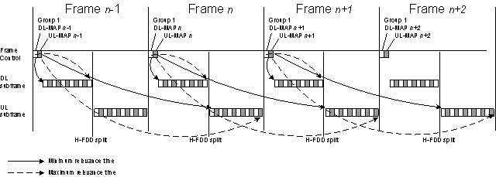

Replace Figure 225 with the following

Replace Figure 225 with the following:

