Project | IEEE 802.16 Broadband Wireless Access Working Group <http://ieee802.org/16>
Title | Multi-tier Simulation Methodology
Date Submitted | 2010-07-12
Source(s) | Shu-ping Yeh, Shilpa Talwar  Intel Corporation | E-mail: shu-ping.yeh@intel.com, shilpa.talwar@intel.com
Re: | Hierarchical networks Study Report
Abstract | This document proposes a simulation methodology for the hierarchical networks study report.
Purpose | For discussion
Notice | This document does not represent the agreed views of the IEEE 802.16 Working Group or any of its subgroups. It represents only the views of the participants listed in the “Source(s)” field above. It is offered as a basis for discussion. It is not binding on the contributor(s), who reserve(s) the right to add, amend or withdraw material contained herein.
Copyright Policy | The contributor is familiar with the IEEE-SA Copyright Policy <http://standards.ieee.org/IPR/copyrightpolicy.html>.
Patent Policy | The contributor is familiar with the IEEE-SA Patent Policy and Procedures:  <http://standards.ieee.org/guides/bylaws/sect6-7.html#6> and <http://standards.ieee.org/guides/opman/sect6.html#6.3>.  Further information is located at <http://standards.ieee.org/board/pat/pat-material.html> and <http://standards.ieee.org/board/pat>.

Multi-tier Simulation Methodology
Shu-ping Yeh and Shilpa Talwar
Intel Corporation

1. Introduction
Multi-tier network is a cost-effective architecture for indoor coverage and hotspot capacity enhancement. Low-power and low cost access points are deployed for coverage holes or capacity-demanding hotspots to supplement conventional single-tier network. The hierarchical architecture is illustrated in Figure 1.

Figure 1 Hierarchical (Multi-tier) Architecture

There are two possible usage scenarios: open access and closed subscriber group (CSG). The open access devices are available to all subscribers. They are usually public infrastructure based, like picocell base stations (BS) and relay stations, and the deployment is planned by the operators. On the contrary, only a restricted group of users have permission to access a CSG device. This is the typical scenario for femtocells since Femto access points (FAP) are usually privately owned and deployed by users.
In order to better capture the performance gain and interference issues of multi-tier networks, a good simulation methodology is required. This contribution proposes a simulation framework for multi-tier networks with focus on modeling the femtocell overlay networks. It is more difficult to model the femtocell overlay networks since the FAP deployment pattern is unpredictable and highly depends on the environment. In addition, the interference issue is more serious given that the access to FAP is restricted. The uncertainty of FAP locations makes the behavior of FAP interference more random and thus a good deployment model is crucial for evaluating the interference problem.
It is a challenging task to form a general and unified model for femtocell overlay network. A good simulation methodology should at least consider the following factors:

- Simple but representative FAP deployment model
The FAP deployment pattern is environment dependent, e.g., a city or a suburban area can have very different FAP deployment patterns. More specific modeling can give more accurate result but is less extensible to different environment settings.
- Comprehensive channel model
Existing single-tier network simulation methodologies are insufficient to model inter-tier interference. In addition, channel conditions are very different for outdoor and indoor environment. Antenna characteristics and power levels difference for Macro-BS and FAP should also be considered.
- Realistic user distribution
User locations can significantly bias the performance results. Proper indoor versus outdoor user ratio should be selected.
- Practical performance metrics
The performance metrics should demonstrate load balancing between macrocells and femtocells. New metrics such as areal capacity should be considered.
- Reasonable system level simulation (SLS) complexity
SLS complexity grows as the number of FAPs increases. It is important to manage the simulation complexity for the extremely dense urban scenario.
In this contribution, we propose a potential simulation methodology for femtocell overlay networks that can be used to evaluate 802.16 based systems.

2. General Simulation Settings
This contribution is built on top of existing 802.16m evaluation methodology document [1]. Parameters specified in [1] should be adopted in simulations for femtocell overlay networks. If not state explicitly, we will directly inherit settings from [1] for our simulations. Additional parameter settings are described in the following.
FAP spectrum usage:
Table 1 FAP spectrum usage
Scenario | Description
Co-channel operation | FAPs share the same carrier as MBSs.
Separate channel operation | FAPs transmit at different carrier as MBSs.
The operating band for FAPs can be either the same as MBSs or using a separate spectrum. The priority should be given to the co-channel operating case where FAPs share the same spectrum with the MBSs since the interference issue is most severe there.
Traffic Model:
For simplicity, only full buffer traffic is considered at this stage. More advanced traffic patterns can be evaluated in the future.
Scheduling
Simple round-robin scheduling can be used for initial performance evaluation. More realistic scheduling schemes, like proportional-fair scheduling, should also be accessed.
MBS, Subscriber Station and FAP parameters:
For MBSs and subscriber stations, we will adopt parameters from [1]. For FAPs, the parameters are summarized as follows.
Table 2 FAP settings
Parameters | Value
Antenna Gain | 0dB
Antenna Height | 2 meters + floor height
Antenna Pattern | A(θ) = 0 (omni-directional)
Maximum Transmit Power Level | -10, 0, 10, 20 dBm

Macrocell Deployment:
The macrocell deployment model is the same as [1]. We consider hexagonal grid with 19 cell sites, each with 3 sectors (Total 57 sectors). Additional 6 clusters wrap around can be added. The deployment is show in Figure 2.

Figure 2 Macrocells deployment

We suggest two scenarios being evaluated in addition to the baseline settings in [1].
The small cell scenario:
    - Cell radius = 500 meters (Site to site distance = 866 meters)
    - BS TX Power = 36dBm
The large cell scenario:
    - Cell radius = 1500 meters (Site to site distance = 2598 meters)
    - BS TX Power = 46dBm

3. FAP and Subscribers Deployment Model
The FAP deployment is illustrated in Error: Reference source not found. We assume single floor circular houses with 10 meters radius. There is one FAP in every house located at the center of the house. The house locations are determined as follows. We first form a square grid with 20m minimum separation and then randomly select house locations from this grid. A fully populated grid has around 538 houses per sector (2500 FAPs/km²).
The FAP density is a programmable parameter. We suggest considering two representative deployment densities: dense deployment with about 100 FAPs per sector (~465 FAPs/km²) and sparse deployment with about 10 FAPs per sector (~46 FAPs/km²).

Figure 3. Illustration of FAP deployment

For the subscribers, we deploy indoor and outdoor users separately. Indoor user locations are uniformly distributed within the houses they are in. The probabilities that there are 1, 2, 3 and 4 users per house are 80%, 12%, 6% and 2%, respectively. The outdoor users are uniformly distributed over the area outside of houses, i.e., 10 meters away from all FAPs. The ratio of the number of indoor users to outdoor users is programmable. Typically, there can be equal number of indoor and outdoor users or 70% subscribers being indoors.
For simplicity, all FAPs are assumed to be CSG (or OSG). We assume only users within the same house as the FAP have access permission to the CSG FAP. CSG user will choose between all MBSs and its FAP and pick the one that results in the maximum received power at SS. Users not in CSG can only associate with MBSs and will choose the one with the maximum received power level. The cell association rule is demonstrated in Figure 4.
Statistics are only collected from SSs associated with MBSs and FAPs locating inside the center cell. However, to take into account the shadowing effect and to better capture the interference behavior, both FAPs and SSs are deployed inside a hexagon with radius equals five times of the macrocell radius.

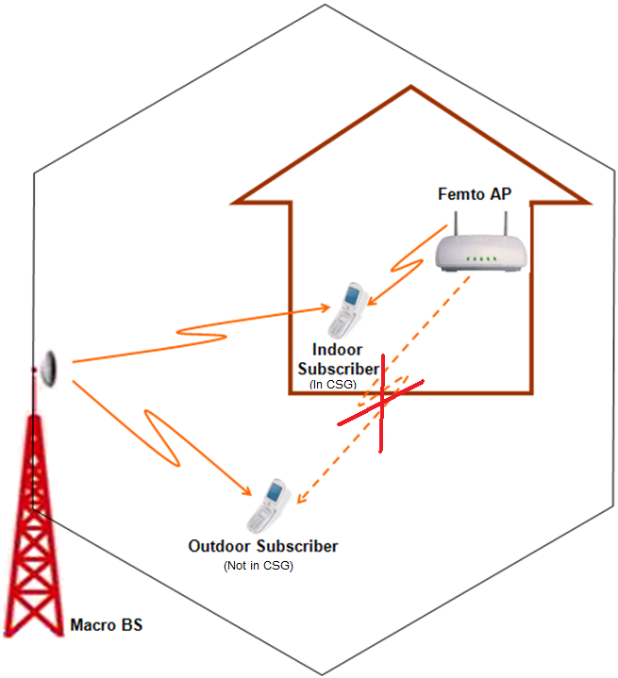
Figure 4 CSG cell association

4. Channel Model
Path loss Models and Shadowing Models
We summarize the path loss, shadow fading (SF) and penetration loss under different cases in Table 3. A combination of ITU channel models [2] and Winner models [3] is used for static channel modeling.
Table 3 Channel Models
 | Path Loss | SF | Penetration
Macro-BS to outdoor SS | (>500m) ITUv: 40(1-4×10⁻³h_{b})log₁₀(R[km]) + 21log₁₀(f[MHz]) + 80 – 18log10(h_{b})  (≤500m) ITUm: 40log₁₀(R[km]) + 30log₁₀(f[MHz]) + 49 | 10 dB | 0
Macro-BS to indoor SS | (>500m) ITUv  (≤500m) ITUm | 12 dB | Mean 12dB, Std 8dB
Femto-AP to indoor SS | Winner A1 NLOS (through wall): PL_{free_space} = 46.4 + 20log₁₀(R[m]) + 20log₁₀(f[GHz]/5) | 6 dB | One light wall (3dB) every 3 meters
Femto-AP to outdoor SS | Winner A2 NLOS: max( PL_{free_space}, PL_{B1})  If d<d_{BP}, PL_{B1} = 41 + 22.7log₁₀(d[m]*) + 20log₁₀(f[GHz]/5)  If d≥d_{BP}, PL_{B1} = 41 + 22.7log₁₀(d[m]*) + 40log₁₀(d[m]/d_{BP}) + 20log₁₀(f[GHz]/5) | 7 dB | PL_{tw}=(14+15(1-cosθ)² ); PL_{in} = 0.5din;
Femto-AP to neighbor SS | Same as above | 7 dB | Above + 12dB wall loss
*d_{BP} = 4h’_{BS}h’_{MS}f_{c}/c, where f_{c} is the center frequency in Hz, c = 3.0×10⁸ m/s is the propagation velocity in free space, and h’_{BS} and h’_{MS} are computed as h’_{BS} = h_{BS} – 1[m] and h’_{MS} = h_{MS} – 1[m], where h_{BS} and h_{MS} are the actual antenna heights and the effective environment height in urban environments is assumed to be equal to 1 meter.
Fast fading models in [2] and [3] can also be used to model the fast fading effects in femtocell overlay networks.

5. Interference Modeling
The interference modeling for dynamic simulation generally follows [1]. We describe the procedure, and highlight the difference in bold.
- Determine the path loss, BS/FAP antenna gain, and shadowing from all interfering sectors and FAPs to MS.
- Rank the interfering sectors and FAPs in order of received power (based on pathloss, BS/FAP antenna gain, and shadowing).
- Model the channels of the strongest ( strong I ) interferers as the siganl path. (account for the pathloss, BS antenna gain, shadowing, and fast fading variations.) The value of strong I is set to 8 for MBSs and 18 for FAPs.
- Model the remaining sectors as spatially white Gaussian noise processes whose variances are based on a spectrally flat Rayleigh fading process. The power of the Rayleigh fading process includes the effects of pathloss, BS antenna gain, and shadowing. The fading processes for all links between MS and BS are assumed to be independent, and the Doppler rate is determined by the speed of the mobile. At any instant in time, the total received interference power is the summation of the receive power from of all weak interferers. Hence, the interference power is varying in time during a simulation drop.

6. Performance Metrics
The following metrics should be considered for multi-tier network performance evaluation.
  - 5% outdoor throughput
  - 5% indoor throughput
  - 50% outdoor throughput
  - 50% indoor throughput
  - Overall areal throughput
  - Percentage of subscribers associated with FAPs.

7. Conclusion
In this contribution, we propose a simulation methodology for femtocell overlay networks. This model has the following advantages.
- A simple and unified deployment model for different FAP density situations.
- Fixed outdoor and indoor user ratio to better capture the traffic off-loading to femtocell network.
- Use different models for MBS to indoor users and FAP to outdoor/neighbor users.

References:
    - IEEE 802.16m Evaluation Methodology Document (EMD), January 2009
    - “Guidelines for evaluation of radio transmission technologies for IMT-2000”, Rec. ITU-R M.1225
    - IST-WINNER II Deliverable D1.1.1 V1.1, WINNER II interim channel models, September 2007.

