Project | IEEE 802.16 Broadband Wireless Access Working Group <http://ieee802.org/16>
Title | Text proposal for cooperative small base-stations in Hierarchical Networks
Date Submitted | 2011-09-16
Source(s) | Yong-Up Jang, Ju Yong Lee,  Dong-Ho Cho  KAIST IT Convergence  Jaeweon Cho  Samsung Electronics | E-mail: yujang@itc.kaist.ac.kr, jylee@itc.kaist.ac.kr, dhcho@kaist.ac.kr  jaeweon.cho@samsung.com
Re: | Call for contributions for the 802.16 PPC
Abstract | It proposes cooperative small base-stations in Hierarchical Networks Study Report.
Purpose | For discussion
Notice | This document does not represent the agreed views of the IEEE 802.16 Working Group or any of its subgroups. It represents only the views of the participants listed in the “Source(s)” field above. It is offered as a basis for discussion. It is not binding on the contributor(s), who reserve(s) the right to add, amend or withdraw material contained herein.
Release | The contributor grants a free, irrevocable license to the IEEE to incorporate material contained in this contribution, and any modifications thereof, in the creation of an IEEE Standards publication; to copyright in the IEEE’s name any IEEE Standards publication even though it may include portions of this contribution; and at the IEEE’s sole discretion to permit others to reproduce in whole or in part the resulting IEEE Standards publication. The contributor also acknowledges and accepts that this contribution may be made public by IEEE 802.16.
Patent Policy | The contributor is familiar with the IEEE-SA Patent Policy and Procedures:  <http://standards.ieee.org/guides/bylaws/sect6-7.html#6> and <http://standards.ieee.org/guides/opman/sect6.html#6.3>.  Further information is located at <http://standards.ieee.org/board/pat/pat-material.html> and <http://standards.ieee.org/board/pat>.
Text proposal for cooperative small base-stationS in Hierarchical Networks

Yong-Up Jang, Ju Yong Lee, Dong-Ho Cho
KAIST IT Convergence
Jaeweon Cho
Samsung Electronics

Introduction
This contribution suggests cooperative small base-stations in C802.16ppc-11/0004, where wireless back-haul is adopted to easily deploy the cooperative small base-stations including micro, pico, and femto APs. The proposed text is described in the introduction section, and Figure 1 and Figure 2 are modified accordingly.

Proposed text change
Adopt the following remedies in IEEE 802.16ppc-11/0004.

---------------------------------- The start of text -----------------------------------------

[Remedy #1: Replace Figure 1, and add the texts as indicated.]

Introduction
…

Error: Reference source not found below illustrates the hierarchical network architecture for future 802.16 networks as described on [1].
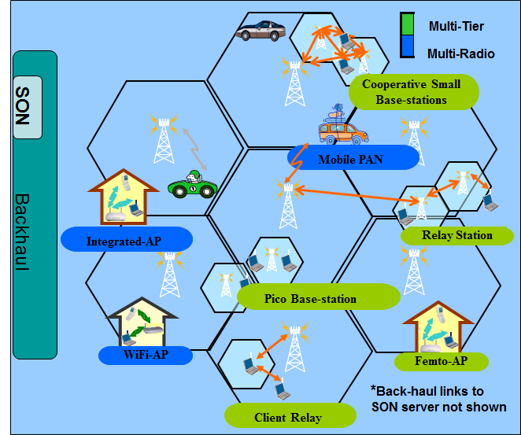
Figure 1: Overview of Hierarchical and Multi-Radio Architecture
The network architecture shown in the figure represents an evolution and integration of existing network elements in a multi-tier or hierarchical deployment. In the multi-tier hierarchy shown, large cells provide ubiquitous coverage to clients as well as support mobility. The smaller network elements such as relays, pico, and femto access points (APs) take connectivity closer to the clients thereby increasing the available capacity in the system. Key elements of the “multi-tier” network are shown in “green”. The lower cost structure associated with the smaller APs makes this an attractive method of adding lower cost/bit capacity. Small base stations (BSs) including micro, pico, and femto APs can cooperate to reduce interference and increase the capacity, where macro BS and small BSs may be connected in a wireless manner and the cooperative small BSs form a cluster to support the clients. The channel information and user context data can be shared among BSs through the wireless link between macro BS and small BS. Further, clients (mobile stations) can also be utilized as another tier in the network hierarchy without incurring additional infrastructure deployment cost. Here intelligent client cooperation can improve capacity as well as connectivity for the client.

…

