Project | IEEE 802.16 Broadband Wireless Access Working Group <http://ieee802.org/16>
Title | Technical Comments to P802.16j Baseline Document: 6.3.4 ARQ Operation - MR-Timer
Date Submitted | 2007-7-5
Source(s) | Tzu-Ming Lin Wern-Ho Sheen, Fang-Ching Ren, Chie-Ming Chou, I-Kang Fu,  ITRI/NCTU  195,Sec. 4, Chung Hsing Rd.  Chutung, Hsinchu, Taiwan 310, R.O.C | E-mail: tmlin@itri.org.tw
Re: | IEEE 802.16j-07/019, “Call for Technical Comments Regarding IEEE Project 802.16j.”
Abstract | This contributions provides editorial comments to the P802.16j baseline document
Purpose | Improve the text of section 6.3.4 “ARQ operation” in IEEE 802.16j-07/026r4 in technical manner
Notice | This document does not represent the agreed views of the IEEE 802.16 Working Group or any of its subgroups. It represents only the views of the participants listed in the “Source(s)” field above. It is offered as a basis for discussion. It is not binding on the contributor(s), who reserve(s) the right to add, amend or withdraw material contained herein.
Release | The contributor grants a free, irrevocable license to the IEEE to incorporate material contained in this contribution, and any modifications thereof, in the creation of an IEEE Standards publication; to copyright in the IEEE’s name any IEEE Standards publication even though it may include portions of this contribution; and at the IEEE’s sole discretion to permit others to reproduce in whole or in part the resulting IEEE Standards publication. The contributor also acknowledges and accepts that this contribution may be made public by IEEE 802.16.
Patent Policy | The contributor is familiar with the IEEE-SA Patent Policy and Procedures:  <http://standards.ieee.org/guides/bylaws/sect6-7.html#6> and <http://standards.ieee.org/guides/opman/sect6.html#6.3>.  Further information is located at <http://standards.ieee.org/board/pat/pat-material.html> and <http://standards.ieee.org/board/pat>.
Technical Comments to P802.16j Baseline Document:
6.3.4.6 ARQ Operation

Tzu-Ming Lin, Wern-Ho Sheen, Fang-Ching Ren, Chie-Ming Chou, I-Kang Fu
ITRI/NCTU
- Introduction
The original text of section 6.3.4.6 in the P802.16j baseline document (IEEE 802.16j-07/026r4) is still empty. This contribution aims to propose a timer operation to this section.

- Problem Statement and Proposed MR-Timer operation
In this contribution, MR-Timer is proposed to recovery the error and to reduce resource wasted in retransmission during relay transmission. In legacy mechanism, fixed and predefined retransmission timer (ARQ_Retry_Timeout) is used. Figure 1 shows the problem when legacy mechanism applied in multi-hop environment. In this figure, MS fails in transmitting ACK to RS3 so that neither do RS2 nor RS1 can relay the ACK to MR-BS. As a result, only when retransmission timer expired, MR-BS can re-arrange the retransmission of the failed data blocks. Even transmission is only failed in last hop, MR-BS still treats the transmission fail as totally failure due to lack of feedback from any RSs, and retransmit all the data blocks again. As a sequence, 8, 7, and 7 data blocks are over retransmitted in 1st, 2nd, and 3rd hop because only 0, 1, and 1 data blocks are needed to be retransmitted in these hops in this example. Even when each RS maintains fixed retransmission, the situation remains unchanged (dotted line in figure 1).
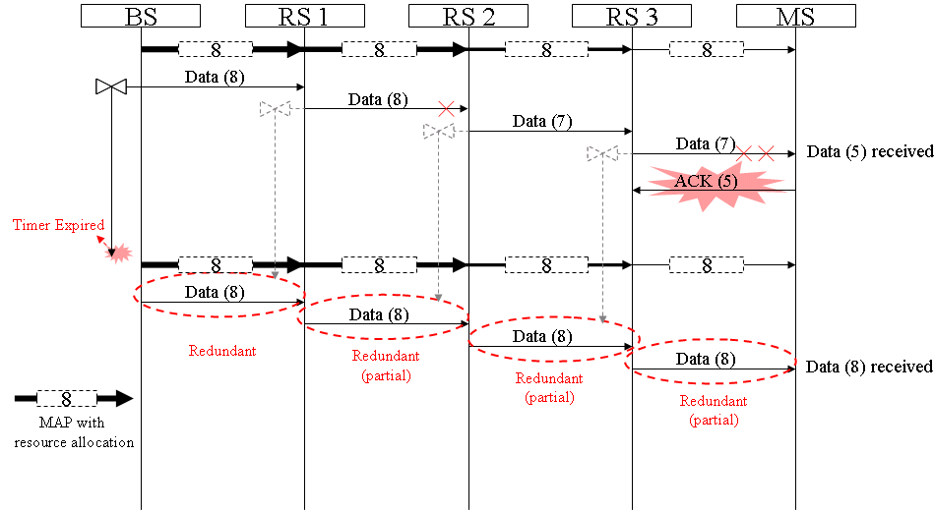
Figure 1, Transmission error when RS maintains no or fixed retransmission timer

If each RS along the transmission path maintain a variable retransmission timer, which is configured bases on the round-trip time between itself and MS, the RS can feedback the transmission error quickly when the timer expired. In normal case, ACK from MS should be received before the timer expired. When no ACK received from MS nor previous RSs after timer expired, it implies that the data transmission between itself and MS is failed, and then RS triggers sending the RACK toward BS to report the situation. In the example shown in figure 2, when transmission error occurred in access link, RS3 cannot receive the ACK sent by MS before retransmission timer T4 expired. After T4 expired, RS3 generates a RACK and sends toward MR-BS. When RS1 and RS2 receive the RACK from its previous RSs, them append its transmission status into the received RACK and relay to MR-BS. When MR-BS received RACK from RS1, it decodes the RACK and gets the idea what happened along the relay path so that MR-BS can arrange resource for retransmission. In this example, BS allocates 0, 1, 1 and 8 data blocks for 1st, 2nd, 3rd, and last hop. Compared with figured, resource of 8, 7, and 7 data blocks are saved in 1st, 2nd, and 3rd hop.
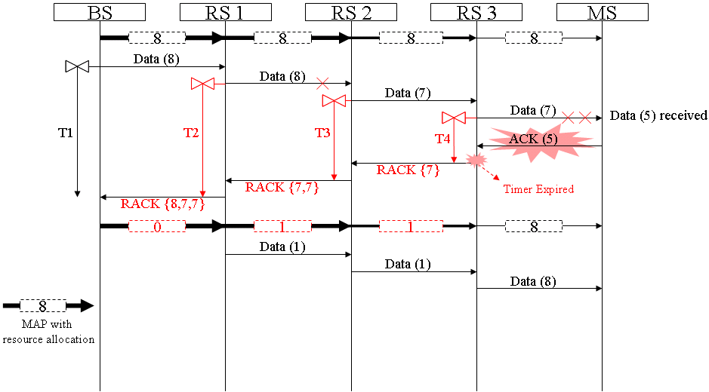
Figure 2, Transmission error when RS maintains per-connection retransmission timer

Summary of the technical comment:
- Maintaining retransmission timer in each RS is required for transmission status feedback in case data or ACK is failure in transmission.
- A well-configured retransmission timer can help to report transmission status in time when some transmission occurred.

- Text Proposal
---------------------------------------------------------Start of the Text--------------------------------------------------------
[Adopt the following text modification into the P802.16j baseline document]
6.3.4.6.4 ARQ modifications for relaying

Insert the following text in the end of 6.3.4.6.4:

In MR system, each RS shall maintain a MR-Timer for each ARQ-enabled connection. The MR-Timer shall be configured to ensure the receiving of feedback messages from receiving station, e.g. MS for downlink and MR-BS for uplink. The MR-Time may be configured based on the round-trip time between RS and the receiving station, and plus some timing offset, including data processing, Tx/Rx transition, and so on.

---------------------------------------------------------End of the Text--------------------------------------------------------

