Project | IEEE 802.16 Broadband Wireless Access Working Group <http://ieee802.org/16>
Title | Technical Comments to P802.16j Baseline Document: 6.3.4 ARQ Operation - ARQ transmit block state
Date Submitted | 2007-7-16
Source(s) | Tzu-Ming Lin Wern-Ho Sheen, Fang-Ching Ren, Chie-Ming Chou, I-Kang Fu,  ITRI/NCTU  195,Sec. 4, Chung Hsing Rd.  Chutung, Hsinchu, Taiwan 310, R.O.C | E-mail: tmlin@itri.org.tw
Re: | IEEE 802.16j-07/019, “Call for Technical Comments Regarding IEEE Project 802.16j.”
Abstract | This contributions provides editorial comments to the P802.16j baseline document
Purpose | Improve the text of section 6.3.4 “ARQ operation” in IEEE 802.16j-07/026r4 in technical manner
Notice | This document does not represent the agreed views of the IEEE 802.16 Working Group or any of its subgroups. It represents only the views of the participants listed in the “Source(s)” field above. It is offered as a basis for discussion. It is not binding on the contributor(s), who reserve(s) the right to add, amend or withdraw material contained herein.
Release | The contributor grants a free, irrevocable license to the IEEE to incorporate material contained in this contribution, and any modifications thereof, in the creation of an IEEE Standards publication; to copyright in the IEEE’s name any IEEE Standards publication even though it may include portions of this contribution; and at the IEEE’s sole discretion to permit others to reproduce in whole or in part the resulting IEEE Standards publication. The contributor also acknowledges and accepts that this contribution may be made public by IEEE 802.16.
Patent Policy | The contributor is familiar with the IEEE-SA Patent Policy and Procedures:  <http://standards.ieee.org/guides/bylaws/sect6-7.html#6> and <http://standards.ieee.org/guides/opman/sect6.html#6.3>.  Further information is located at <http://standards.ieee.org/board/pat/pat-material.html> and <http://standards.ieee.org/board/pat>.
Technical Comments to P802.16j Baseline Document:
6.3.4.6 ARQ Operation

Tzu-Ming Lin, Wern-Ho Sheen, Fang-Ching Ren, Chie-Ming Chou, I-Kang Fu
ITRI/NCTU
- Introduction
The original text of section 6.3.4.6 in the P802.16j baseline document (IEEE 802.16j-07/026r4) is still empty. This contribution aims to propose an ARQ transmit block state for RS to this section.

- Proposed ARQ Transmit Block States for RS
To support multi-transmission, RS should maintain ARQ transmit lock states for relay connections. The proposed ARQ transmit block state sequence is shown in figure 1. When RS receives data block from other RS or BS, it keeps in “Not Sent” state. Once the data is transmitted, the state gets into “Outstanding” state. In successful case, the RS receives ACK from MS and get into “Done” state. If timer “ARQ_RETRY_TIMEOUT” is expired or NACK is received from MS or other RS, the state enters into “Wait for retransmission”. This implies that some transmission error occurred between itself and MS. There might be some cases that RS receiving RACK from RS when it is in “Outstanding” state. In this case, RS relays RACK toward MR-BR or MS and then keeps in the same state. Note that receiving RACK from other RS does not imply the successful transmission. Only ACK from MS is received can show that the transmission is correct and can enter into “Done” sate. If RACK is received or data retransmitted in “Wait for retransmission” state, it goes back to “Outstanding” state and waits for ACK from MS. No matter in “Outstanding” or “Wait for retransmission” state, it should enter into “Discard” state when the timer DATA_LIFETIME expired. The state goes to “Done” when ACK from MS is received in “Outstand”, “Wait for retransmission”, and “Discard”. If RS receives RACK from other RSs even when the current state is “Discard”, it goes to “Done”.
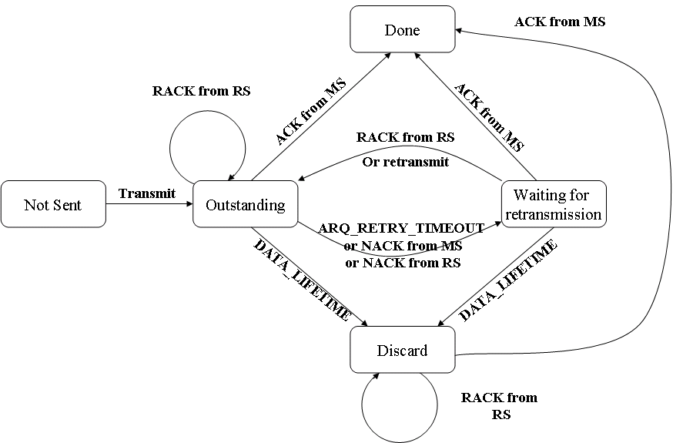
Figure 1, ARQ Transmit Block States for RS
Summary of the technical comment:
- An ARQ transmit block states for RS is proposed for ARQ operations in MR system.

- Text Proposal
---------------------------------------------------------Start of the Text--------------------------------------------------------
[Adopt the following text modification into the P802.16j baseline document]

Insert new subclause 6.3.4.6.x

6.3.4.6.4.x Transmitter state machine for relaying

In MR system, a relayed ARQ block may be in one of the following states – not-sent, outstanding, discard, and waiting-for-retransmission. Any relayed ARQ block begins as not-sent. After it is sent it becomes outstanding for a period of time termed ARQ_RETRY_TIMEOUT. While a block is in outstanding state, it is either acknowledged or discarded by MS, or transitions to wait for retransmission after ARQ_RETRY_TIMEOUT or NACK from MS or RS, or stay in outstanding state after receiving ACK from RS. A relayed ARQ block can become wait-for-retransmission before the ARQ_RETRY_TIMEOUT period expires if it is negatively acknowledged. A relayed ARQ block may also change from waiting-for-retransmission to discard after a timeout ARQ_BLOCK_LIFETIME.

For a given connection the transmitter shall first (transmit or discard) blocks in “waiting-for-retransmission” state and only then blocks in “non-sent” state. Blocks in “outstanding” or “discarded” state shall not be transmitted. When blocks are retransmitted, the block with the lowest BSN shall be retransmitted first.

The ARQ transmit block state sequence for RS is shown in Figure xx.
Figure xx, ARQ Transmit Block States for RS

---------------------------------------------------------End of the Text--------------------------------------------------------

