Project | IEEE 802.16 Broadband Wireless Access Working Group <http://ieee802.org/16>
Title | Editorial Comments to P802.16j Baseline Document: 6.3.2.3.75 RS Configuration Description Message
Date Submitted | 2007-7-18
Source(s) | I-Kang Fu, Wern-Ho Sheen, Fang-Ching Ren, Tzu-Ming Lin, Chie-Ming Chou  NCTU/ITRI  ED922, 1001 Ta Hsueh Road,  Hsinchu, Taiwan 300, ROC  Gamini Senarath, Hang Zhang, Peiying Zhu, Mo-Han Fong, Wen Tong, David Steer, G.Q. Wang, Derek Yu, Israfil Bahceci, Robert Sun and Mark Naden Nortel Networks  Yong Sun Toshiba Research Europe  Wei-Peng Chen, Chenxi Zhu  Fujitsu Laboratories of America | IKFu@itri.org.tw  gamini@nortel.com  Sun@toshiba-trel.com  wei-peng.chen@us.fujitsu.com  chenxi.zhu@us.fujitsu.com
Re: | IEEE 802.16j-07/019, “Call for Technical Comments Regarding IEEE Project 802.16j.”
Abstract | This contributions provides editorial comments to the P802.16j baseline document
Purpose | Improve the text of section 6.3.2.3.75 “RS Configuration Description message” in IEEE 802.16j-07/026r4 in editorial manner.
Notice | This document does not represent the agreed views of the IEEE 802.16 Working Group or any of its subgroups. It represents only the views of the participants listed in the “Source(s)” field above. It is offered as a basis for discussion. It is not binding on the contributor(s), who reserve(s) the right to add, amend or withdraw material contained herein.
Release | The contributor grants a free, irrevocable license to the IEEE to incorporate material contained in this contribution, and any modifications thereof, in the creation of an IEEE Standards publication; to copyright in the IEEE’s name any IEEE Standards publication even though it may include portions of this contribution; and at the IEEE’s sole discretion to permit others to reproduce in whole or in part the resulting IEEE Standards publication. The contributor also acknowledges and accepts that this contribution may be made public by IEEE 802.16.
Patent Policy | The contributor is familiar with the IEEE-SA Patent Policy and Procedures:  <http://standards.ieee.org/guides/bylaws/sect6-7.html#6> and <http://standards.ieee.org/guides/opman/sect6.html#6.3>.  Further information is located at <http://standards.ieee.org/board/pat/pat-material.html> and <http://standards.ieee.org/board/pat>.
Editorial Comments to P802.16j Baseline Document:
6.3.2.3.75 RS Configuration Description Message

I-Kang Fu, Wern-Ho Sheen, Fang-Ching Ren, Tzu-Ming Lin, Chie-Ming Chou
NCTU/ITRI

- Introduction
This message was originally the RS-Config message in 802.16j-06/026r3. In Portland’s meeting, this message is renamed as RS Configuration Description message and moved to this new section. Unfortunately, there is a figure missed when moving all these text from 802.16j-06/026r3. This contribution aims to perform some editorial modification and bring the figure back without any technical changes to this section.

- Text Proposal

---------------------------------------------------------Start of the Text--------------------------------------------------------
[Revise the section title in line#1, page#47]

6.3.2.3.75 RS Cconfiguration Description (RS-CD) message

[Add the following text at line#20, page#48]

Start Frame Number | 8 bits | 8 LSB bits of the frame number at MR-BS

[Revise the text begin from line#23, page#48]

Prefix | 2 bits | 00: The R-amble transmission and reception measurement is instructed by MR-BS  01: The R-amble transmission and measurement shall be performed autonomously  10: The RSs shall report its neighbor measurement results  11: reserved

[Revise the text begin from line#31, page#50]

Amble index
R-amble means preamble, midamble or postamble amble transmitted in relay zone. It will be determined by R-amble location in downlink relay zone.

[Adopt the following text modification begin from line#1, page#51]

according to the field where its amble index is. Start Frame Number is the 8 LSB bits of frame number index used to indicate the starting point of subsequent R-amble transmission/reception opportunities. In order to coordinate the R-amble transmission/reception in different MR-cell, a coordinator in backhaul network is needed to ensure the Start Frame Number parameters sent in different MR-cell will align to the same time. The transmission opportunities are identified by Monitoring Duration and Interleaving Interval for each iteration. An example is given in Figure xxx, where the Duration = 2, Interleaving Interval = 3 and the Iteration = 2. When the Iteration is more than one, the pattern for each iteration will be carried in this message. After the last iteration, the RSs shall report the measurement results by RS_NBR-MEAS-REP message defined in 6.3.2.3.63.

[Add the following text and figure before the end of section 6.3.26]

The pre-planned R-amble transmission opportunities are identified by Monitoring Duration and Interleaving Interval for each iteration. An example is given in Figure xx, where the Duration = 2, Interleaving Interval = 3 and the Iteration = 2. When the Iteration is more than one, the pattern for each iteration will be carried in this message. After the last iteration, the RSs shall report the measurement results by RS_NBR-MEAS-REP message defined in 6.3.2.3.63.

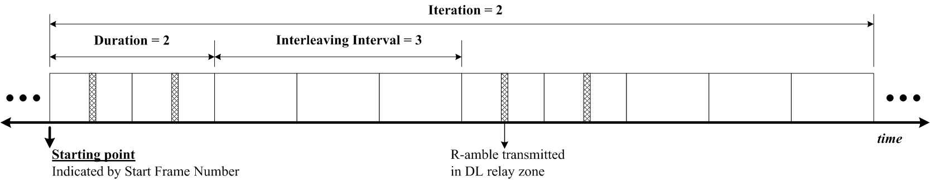
Figure xx- R-amble transmission pattern as per the pre-planned scheme instructed by MR-BS

---------------------------------------------------------End of the Text--------------------------------------------------------

