Project | IEEE 802.16 Broadband Wireless Access Working Group <http://ieee802.org/16>
Title | An Efficient Management Method for the RSs along a relay path
Date Submitted | 2007-09-09
Source(s) | Chie Ming Chou, Tzu-Ming Lin, Fang-Ching Ren, Wern-Ho Sheen, I-Kang Fu  ITRI/ NCTU | chieming@itri.org.tw
Re: | Comments associated with the Letter Ballot #28
Abstract | This contribution proposes a simple method to manage the RSs on a relay path
Purpose | Improve the efficiency of RS management for draft IEEE 802.16j/D1 standard
Notice | This document does not represent the agreed views of the IEEE 802.16 Working Group or any of its subgroups. It represents only the views of the participants listed in the “Source(s)” field above. It is offered as a basis for discussion. It is not binding on the contributor(s), who reserve(s) the right to add, amend or withdraw material contained herein.
Release | The contributor grants a free, irrevocable license to the IEEE to incorporate material contained in this contribution, and any modifications thereof, in the creation of an IEEE Standards publication; to copyright in the IEEE’s name any IEEE Standards publication even though it may include portions of this contribution; and at the IEEE’s sole discretion to permit others to reproduce in whole or in part the resulting IEEE Standards publication. The contributor also acknowledges and accepts that this contribution may be made public by IEEE 802.16.
Patent Policy | The contributor is familiar with the IEEE-SA Patent Policy and Procedures:  <http://standards.ieee.org/guides/bylaws/sect6-7.html#6> and <http://standards.ieee.org/guides/opman/sect6.html#6.3>.  Further information is located at <http://standards.ieee.org/board/pat/pat-material.html> and <http://standards.ieee.org/board/pat>.
An Efficient Management Method for the RSs along a relay path

- Introductions
In MR network, MR-BS always needs to send identical MAC management message to a couple of RSs. According to MR topology, these management operations may be divided into two scenarios (see Figure 1): one is for multi-RSs which have the same hop count such as RS grouping; the other is for multi-RSs which are distributed along a path. In the first scenario, the section 6.3.9.16.3 of P802.16j/D1 has already specified operations regarding with identifications to control these RSs.
For the second scenario, section 6.3.25 introduces two methods to manage multi-RSs along one relay path. The first method is that the information of CIDs to path binding is required in-advanced and then intermediate RSs need to replace corresponding next hop’s CID in relay MAC header during forwarding. Take Figure 1 as an example: when MR-BS wants to update the path information by sending the DSC-REQ message to RS1, RS4, and RS5; RS1/RS4 will need to perform the operation as requested in the received message and then retrieve the CIDs and path id information to send this request to RS4/RS5 by replacing RS4/RS5’s CID in the relay MAC header. This results in more overhead in relay links and computation load for MAC process of each RS.
The second method is that a multicast distribution tree is constructed through MBS initiation, and then a common multicast CID is placed in relay MAC header to let intermediate RSs can receive and read the MPDU. When embedded path management with systematic CID assignment is used, additional CID encapsulation may be needed for using common multicast CID. Besides, the construction of multicast distribution tree is more complicated. Therefore, an optional mechanism is proposed to facilitate the management for the RSs along the same path.
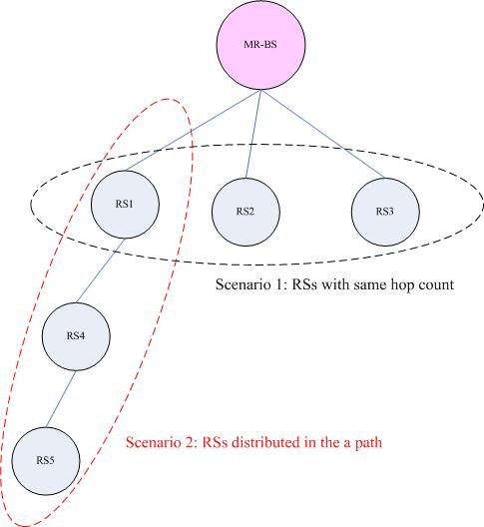
Figure 1 Scenarios for RSs’ management

- Suggested Remedy
In order to manage the RSs along one path, a simple method that using one of the reserved bits in relay MAC header is proposed to indicate whether intermediate RSs need to read the MAC management message or not. When this bit is set to ‘1’, the intermediate RSs will read the associated payload after forwarding; otherwise, the RS will only forward the MPDU as the way defined in section 6.3.3.8. Here we also take Figure 1 as an example: when MR-BS wants to update the path information by sending the DSC-REQ message to RS1, RS4, and RS5; MR-BS can set the ‘SHA’ bit (one of original reserved bit which is in the 10th bit of relay MAC header format) to ‘1’ and place the tunnel CID of RS5 in the relay MAC header; as a result, RS1/RS4 will be instructed that this MPDU shall be forwarded and operations requested in DSC-REQ message shall be performed. Note that the CID placed in the relay MAC header for this mechanism could be a basic CID or a tunnel CID of the access RS. Besides, to ensure the CMAC/HMAC validation, it is expected that a group security key will be assigned to intermediate RSs. When this bit is enabled, the RS will use the group security key to authenticate the message. In summary, the IEEE 802.16j MR network can be benefited by this proposal on:
- More efficient transmission – Managements for RSs along a specific path can be achieved by one connection without other processing per-hop. .
- Less overhead– with this scheme, no additional overhead such as CID replacing or multicast distribution tree is required.

- Proposed Text

-----------------------------------------------------Start of the Text---------------------------------------------------------
[Modify the following text in Section 6.3.2.1.1.1]
6.3.2.1.1.1 Relay MAC PDU header format

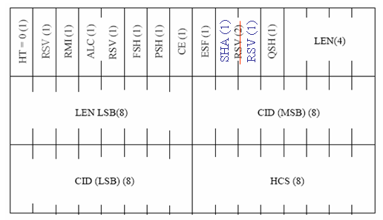
Figure 22a-Header format of relay MAC PDU with payload

Table 7a Relay MAC PDU header
Syntax | Size | Notes
Relay MAC Header() {
HT | 1 bit | Shall be set to zero
Reserved | 1 bit | Currently reserved. Content is subject to further discussion
RMI | 1 bit | Relay mode indication (RMI) is used to indicate whether this MAC header is GMH or Relay MAC header  RMI=0; use GMH  RMI=1; use relay MAC header
ALC | 1 bit | Allocation subheader  1=present; 0=absent
Reserved | 1 bit | Currently reserved. Content is subject to further discussion
Fragmentation subheader | 1 bit | Fragmentation subheader (FSH)  1=present; 0=absent
Packing subheader | 1 bit | Packing subheader (PSH)  1=present; 0=absent
CE | 1 bit | CID encapsulation  1=present; 0=absent
ESF | 1 bit | Extended subheader field  If ESF=0, the extended subheader is absent  If ESF=1, the extended subheader is present and immediately follows the relay MAC header  The ESF is applicable in both the DL and UL
SHA | 1 bit | Shared type bit is used to indicate whether this payload needs to be read by intermediate RSs  SHA=0; forward without reading  SHA=1; forward with reading
Reserved | 2 1 bits | Currently reserved. Content is subject to further discussion
QoS subheader | 1 bit | QoS subheader (QSH)  1=present; 0=absent
LEN | 12 bits | The length in bytes of the relay MAC PDU including the relay MAC header
CID | 16 bits | May be tunnel CID or basic CID of the RS
HCS | 8 bits | Header Check Sequence
}

[Insert new subclause] 6.3.28.2
6.3.28.2 Connection management for RSs on the same path
For managing multi-RSs along one relay path, MR-BS may transmit MPDU with the CID of access RS with the shared type bit (SHA) in relay MAC header set to “1” to indicate all intermediate RSs along this path should forward this MPDU and read associated payload. Besides, a security zone key specified in section 7.4.3 will be employed for the security control of this mechanism.

------------------------------------------------------End of the Text---------------------------------------------------------

