Project | IEEE 802.16 Broadband Wireless Access Working Group <http://ieee802.org/16>
Title | An Efficient Management Method for the RSs along a relay path
Date Submitted | 2007-11-15
Source(s) | Chie Ming Chou, Tzu-Ming Lin, Fang-Ching Ren, Wern-Ho Sheen, I-Kang Fu  ITRI/ NCTU | chieming@itri.org.tw
Re: | Comments associated with the Letter Ballot #28
Abstract | This contribution proposes a simple method to manage the RSs on a relay path
Purpose | Improve the efficiency of RS management for draft IEEE 802.16j/D1 standard
Notice | This document does not represent the agreed views of the IEEE 802.16 Working Group or any of its subgroups. It represents only the views of the participants listed in the “Source(s)” field above. It is offered as a basis for discussion. It is not binding on the contributor(s), who reserve(s) the right to add, amend or withdraw material contained herein.
Release | The contributor grants a free, irrevocable license to the IEEE to incorporate material contained in this contribution, and any modifications thereof, in the creation of an IEEE Standards publication; to copyright in the IEEE’s name any IEEE Standards publication even though it may include portions of this contribution; and at the IEEE’s sole discretion to permit others to reproduce in whole or in part the resulting IEEE Standards publication. The contributor also acknowledges and accepts that this contribution may be made public by IEEE 802.16.
Patent Policy | The contributor is familiar with the IEEE-SA Patent Policy and Procedures:  <http://standards.ieee.org/guides/bylaws/sect6-7.html#6> and <http://standards.ieee.org/guides/opman/sect6.html#6.3>.  Further information is located at <http://standards.ieee.org/board/pat/pat-material.html> and <http://standards.ieee.org/board/pat>.
An Efficient Management Method for the RSs along a relay path

- Introductions
In MR network, MR-BS always needs to send identical MAC management message to a couple of RSs. According to MR topology, these management operations may be divided into two scenarios (see Figure 1): one is for multi-RSs which have the same hop count such as RS grouping; the other is for multi-RSs which are distributed along a path. In the first scenario, the section 6.3.9.16.3 of P802.16j/D1 has already specified operations regarding with identifications to control these RSs.
For the second scenario, section 6.3.25 introduces the method to manage multi-RSs along one relay path. The first method is that the information of CIDs to path binding is required in-advanced and then intermediate RSs need to replace corresponding next hop’s CID in relay MAC header during forwarding. Take Figure 1 as an example: when MR-BS wants to update the path information by sending the DSC-REQ message to RS1, and RS2; RS1 will need to perform the operation as requested in the received message and then retrieve the CIDs and path id information to send this request to RS2 by replacing RS2’s CID in the relay MAC header. This results in more overhead in relay links and computation load for MAC process of each RS.
Therefore, an optional mechanism is proposed to facilitate the management for the RSs along the same path.
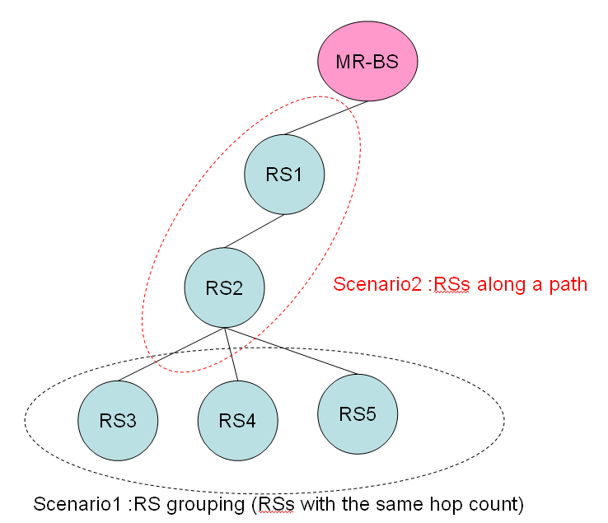
Figure 1 Scenarios for RSs’ management

- Suggested Remedy
In order to manage the RSs along one path, a simple method that using Sharing extended-subheader is proposed to indicate whether intermediate RSs need to read the MAC management message or not. When the Read bit in sharing extended-subheader is set to ‘1’, the intermediate RSs will read the associated payload after forwarding; otherwise, the RS will only forward the MPDU as the way defined in section 6.3.3.8. Here we also take Figure 1 as an example: when MR-BS wants to update the path information by sending the DSC-REQ message to RS1, RS2; MR-BS can organize a connection with the tunnel CID of RS2 and set the ESF bit to ‘1’ with appending the Sharing extended-subheader in the relay MAC PDU; as a result, when RS1 finds the Read bit in Sharing extended-subheader be set to’1’, and then they will read and perform operations requested in DSC-REQ message after forwarding. Note that the CID placed in the relay MAC header for this mechanism could be a basic CID or a tunnel CID of the access RS. Besides, to ensure the CMAC/HMAC validation, it is expected that a group security key will be assigned to intermediate RSs. When this bit is enabled, the RS will use the group security key to authenticate the message. In summary, the IEEE 802.16j MR network can be benefited by this proposal on:
- More efficient transmission – Managements for RSs along a specific path can be achieved by one connection without other processing per-hop. .
- Less overhead– with this scheme, no additional overhead such as CID replacing or multicast distribution tree is required.

- Proposed Text

-----------------------------------------------------Start of the Text---------------------------------------------------------
[Modify the following text in Section 6.3.2.2.7]
Table27-Description of extended subheader types (DL)
Extended  subheader type | Name | Extended subheader  Body size  (byte) | Description
0 | SDU_SN extended subheader | 1 | See 6.3.2.2.7.1
1 | DL sleep control extended subheader | 3 | See 6.3.2.2.7.2
2 | Feedback request extended subheader | 3 | See 6.3.2.2.7.3
3 | SN request extended subheader | 1 | See 6.3.2.2.7.4
4 | PDU SN(short) extended subheader | 1 | See 6.3.2.2.7.5
5 | PDU SN(long) extended subheader | 2 | See 6.3.2.2.7.6
6-127 | Reserved Sharing extended subheader | —1 | — See 6.3.2.2.8.3
7-127 | Reserved | — | —

[Insert the following text after Section 6.3.2.2.8.2]
6.3.2.2.8.3 Sharing extended subheader
The MR-BS may include the Sharing extended subheader in a relay MAC PDU to instruct whehter intermediate RSs along a path shall read the payload or not after its forwarding. The Sharing extended subheader is specified in Table xx.

Table xx Sharing extended subheader
Name | Size | Description
Read | 1 bit | Shared type bit is used to indicate whether this payload needs to be read by intermediate RSs  Read=0; forward without reading  Read=1; forward with reading
Reserved | 7 bits

[Insert new subclause 6.3.28.2]
6.3.28.2 Connection management for RSs on the same path
For managing multi-RSs along one relay path, MR-BS may transmit MPDU with the CID of access RS and append Sharing extended subheader to indicate all intermediate RSs along this path should forward this MPDU and read/perform associated management message or not. When the Read bit in sharing extended subheader is set to ‘1’, intermediate shall read and perform the associated control message after forwarding; otherwise it doesn’t after forwarding. Besides, a security zone key specified in section 7.4.3 will be employed for the security control of this mechanism.

[Modify the following text in Section 11.7.25]

11.7.25 MAC header and extended subheader support

Type | Length | Value | Scope
43 | 3 | Bit #0: Bandwidth request and UL Tx Power Report header  support  Bit #1: Bandwidth request and CINR report header support  Bit #2: CQICH Allocation Request header support  Bit #3: PHY channel report header support Bit #4: Bandwidth  request and uplink sleep control header support  Bit #5: SN report header support  Bit #6: Feedback header support  Bit #7-10: SDU_SN extended subheader support and parameter  Bit #7: SDU_SN extended subheader support  Bit #8-10 (=p): period of SDU_SN transmission for connection  with ARQ disabled = once every 2p MAC PDUs  Bit #11: DL sleep control extended subheader  Bit #12: Feedback request extended subheader  Bit #13: MIMO mode feedback extended subheader  Bit #14: UL Tx Power Report extended subheader  Bit #15: Mini-feedback extended subheader  Bit #16: SN request extended subheader  Bit #17: PDU SN(short) extended subheader  Bit #18: PDU SN(long) extended subheader  Bit #19: ACK header  Bit#20: RS BR header  Bit#21: RS UL_DCH request header  Bit#22: HARQ RS error report header  Bit#23: Relay MAC header  Bit#24: Sharing extended subheader  Bit #19–23: Reserved | REG-REQ  REG-RSP

------------------------------------------------------End of the Text---------------------------------------------------------

