Project | IEEE 802.16 Broadband Wireless Access Working Group <http://ieee802.org/16>
Title | Technical Comments to P802.16j/D1 : 7.1.6 Centralized Security Control in Multihop Relay System
Date Submitted | 2007-09-09
Source(s) | Jui-Tang Wang, Tzu-Ming Lin Wern-Ho Sheen, Fang-Ching Ren, Chie-Ming Chou, I-Kang Fu,  ITRI/NCTU  195,Sec. 4, Chung Hsing Rd.  Chutung, Hsinchu, Taiwan 310, R.O.C | tmlin@itri.org.tw
Re: | Comments with Letter Ballot #28 “P802.16j/D1”
Abstract | This contribution describes the clarifications for RS configuration message to avoid the confliction on usage of multicast CIDs.
Purpose | To make IEEE Project 802.16j more maturity
Notice | This document does not represent the agreed views of the IEEE 802.16 Working Group or any of its subgroups. It represents only the views of the participants listed in the “Source(s)” field above. It is offered as a basis for discussion. It is not binding on the contributor(s), who reserve(s) the right to add, amend or withdraw material contained herein.
Release | The contributor grants a free, irrevocable license to the IEEE to incorporate material contained in this contribution, and any modifications thereof, in the creation of an IEEE Standards publication; to copyright in the IEEE’s name any IEEE Standards publication even though it may include portions of this contribution; and at the IEEE’s sole discretion to permit others to reproduce in whole or in part the resulting IEEE Standards publication. The contributor also acknowledges and accepts that this contribution may be made public by IEEE 802.16.
Patent Policy | The contributor is familiar with the IEEE-SA Patent Policy and Procedures:  <http://standards.ieee.org/guides/bylaws/sect6-7.html#6> and <http://standards.ieee.org/guides/opman/sect6.html#6.3>.  Further information is located at <http://standards.ieee.org/board/pat/pat-material.html> and <http://standards.ieee.org/board/pat>.
Clarifications for RSID in RS Configuration Message

- Problem Statement
Section 7.1.6.1 states that “RS doesn’t have any key information associated with MS” and only relays message whenever it receives from MS. This sentence conflicts with the relay QoS specified in section 6.3.14., where the RS needs to read QoS subheader (section 6.3.2.2.5.1) to enable relay QoS. Without key information, RS cannot read QoS subheader nor obtain QoS related parameters since the subheader is defined as payload and encrypted during transmission. In order to enable relay QoS, subheader should be readable by RSs in relay links.

- Proposal
To read the QoS subheader and reduce the overhead of authentication and encryption processing, we propose a key-based authentication in 802.16j multi-hop relay network. An MR-BS and the RSs connected to the MR-BS form a secure relay zone. An MS only performs 802.1X authentication while first time connects to an AR-RS within the SRZ. Authentication latency is removed from the following handoffs in the same SRZ. Furthermore, end-to-end security channel between an MS and an MR-BS is established without exchanging any extra management message. The security channel can improve the performance of 802.16j multi-hop relay network in routing the encrypted frame. In order to protect Authorization Key (AK) security and read the QoS subheader to enable relay QoS, we only transfer the Traffic Encryption Key (TEK) and HMAC_KEY_U/CMAC_KEY_U from serving MR_BS to AR-RS and keep AK in serving MR-BS.

2.1 System Architecture
With SRZ, security function of the AR-RS service, such as Key Management, are implemented in the serving MR-BS.
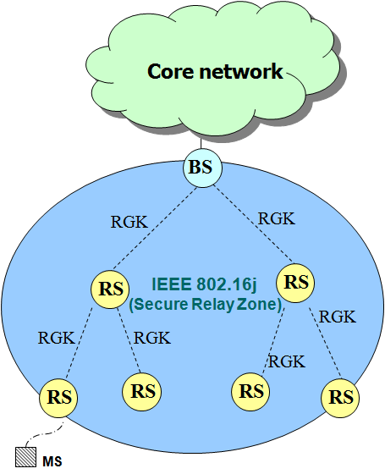
Figure 1. System Architecture

AR-RS is the edge of Secure Relay Zone and responsible for blocking malicious MSs from accessing the 802.16j multi-hop network. In order to provide the ability for AR-RS to verify frame integrity, TEK and HMAC_KEY_U/CMAC_KEY_U are distributed from serving MR-BS to the serving AR-RS via secured relay links (RGK protocol, SZK protocol).

2.2 MS’s Security Association Establishment
While an MS initially associated to any AR-RS within the SRZ, it is required to perform 802.1X authentication, SA-TEK 3-way handshake and TEK and HMAC_KEY_U/CMAC_KEY_U distribution to establish the security association with the serving MR-BS. For being compatible with conventional 802.16e MSs, the management message flows in the MS portion are identical to SRZ and 802.16e in the SA establishment. The AR-RS is responsible for forwarding all security management messages between MS and serving MR-BS. The following figure illustrates the procedure of security association establishment for an MS initially authenticating with an AR-RS with the SRZ.

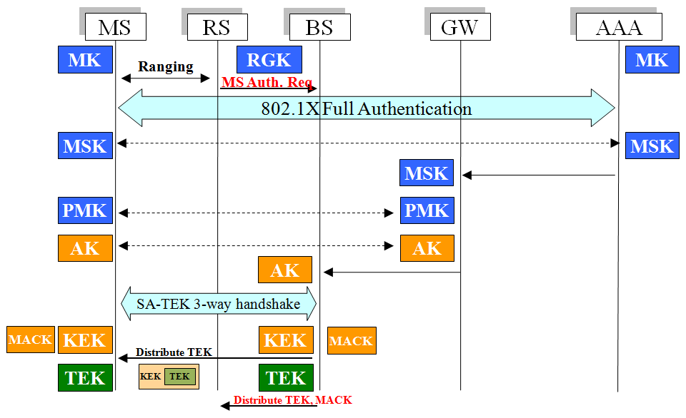
Figure 2, Security Association establishment with SRZ

- The serving AR-RS checks the Ranging frame to see is any AKID included. If not, an MS Authentication Request message is sent to the serving MR-BS to initialize 802.1X authentication.
- The MS and AAA server perform 802.1X authentication. If the result is successful, the serving MR-BS will obtain the Authorization Key (AK) from ASN-GW. Next, the MS and the serving MR-BS carry out the SA-TEK 3-way handshake procedure. All authentication management messages are forwarded via the serving AR-RS.
- The Serving MR-BS distributes the TEK to the MS for data confidentiality.
- The serving MR-BS distributes the TEK and HMAC_KEY_U/CMAC_KEY_U to the serving AR-RS for data filtering in the serving AR-RS.
- Once the serving AR-RS obtains the TEK and HMAC_KEY_U/CMAC_KEY_U, it will switch the state to the authorized state, and thus the MS is able to access the 802.16j multi-hop relay network. The serving AR-RS can take TEK to decrypt the frame and use the HMAC_KEY_U/CMAC_KEY_U verify the MAC. The Message Authentication Code (MAC) in the frame can also be verified by serving MR-BS.
- If multicast service is start, the multicast key will be distributed to the serving AR-RS as well.

2.2 Handoff Procedures
802.16j allows multiple AR-RSs reside in one 802.16j multi-hop relay network, and thus the handoff behaviors with SRZ are categorized into intra-MR-BS handoff and inter-MR-BS handoff. Moreover, the authentication procedures vary in the two types.

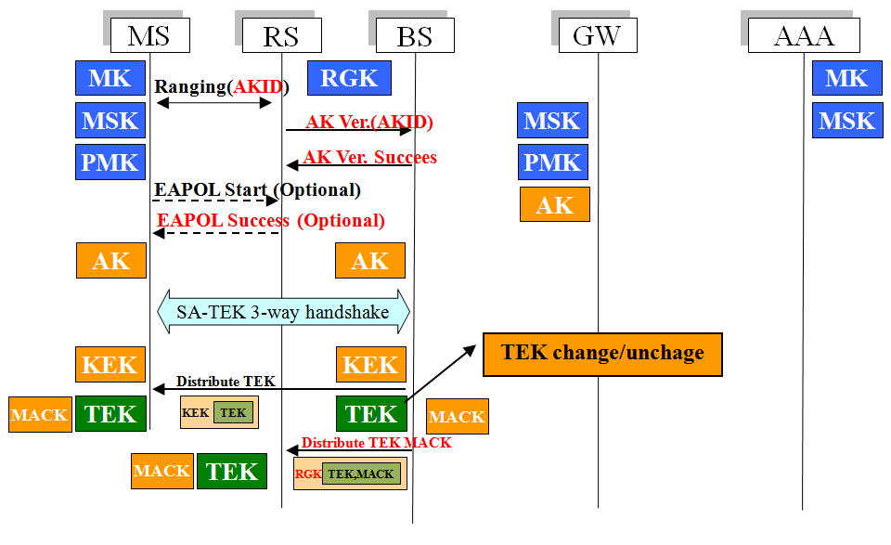
Figure 3. Intra-MR-BS handoff

2.2.1 Intra-MR-BS handoff
Intra-MR-BS handoff means that an MS drops current connection and re-associates with another AR-RS (target AR-RS) connecting to the same serving MR-BS. If the AK is cached by the serving MR-BS, 802.1X authentication will be skipped. The following figure illustrates the authentication management message flows of intra-MR-BS handoff.

- The MS re-associates with the target AR-RS. The AKID is passed to the serving MR-BS for verifying the AK cached in the MS.
- The AKID is compared with the AK cached in the serving MR-BS. If the AKID is valid, the serving MR-BS will inform the target AR-RS with an AK Verification Success Message.
- Some implementations of the MS use the EAPOL-Start message to initialize 802.1X authentication. If the target AR-RS receives an EAP-Start message, it will reply an EAP-Success message to skip the EAP authentication.
- Following the SA-TEK 3-way handshake and TEK and HMAC_KEY_U/CMAC_KEY_U distribution are identical to the security association establishment mentioned before.

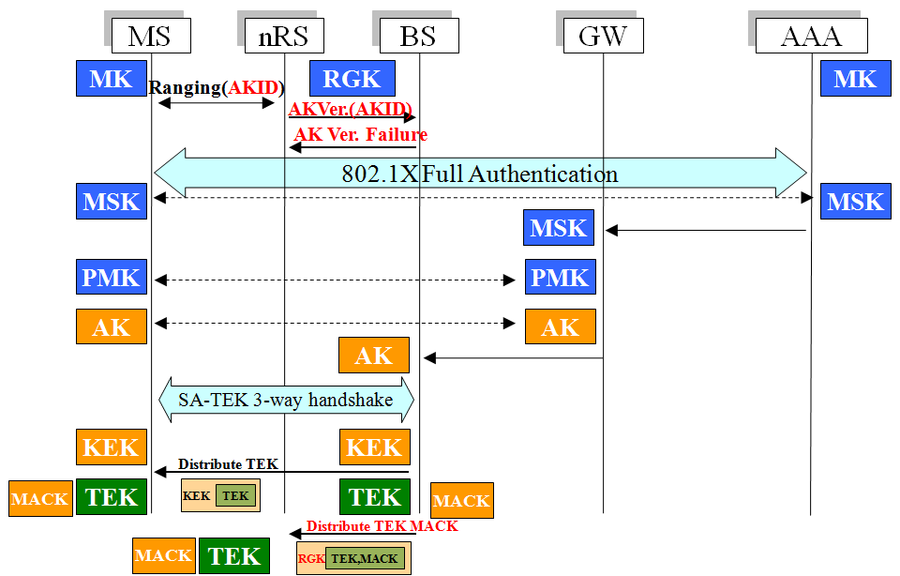
Figure 4. Inter-MR-BS handoff

2.2.2 Inter-MR-BS handoff
Inter-MR-BS handoff is performed while an MS moves from serving AR-RS to target AR-RS connecting to different MR-BS. The MS will switch to another SRZ in the inter-MR-BS handoff.
If the SRZ has not been visited by the MS or the cached AK is expired, pre-authentication will be performed. However, the MS may fail to pre-authenticate with the MR-BS, and thus the overhead of 802.1X authentication is introduced.
There are many factors cause pre-authentication to be failed, such as the moving speed of the MS, the size of the overlapping coverage area, the target AR-RS prediction, the latency of EAP authentication, etc.
The following figure illustrates the management flows of inter-MR-RS handoff and security association establishment. Detail procedures are as follows:
- The MS re-associates with the target AR-RS. The AKID is forwarded to the serving MR-BS for verifying the AK cached in the MS.
- Since the target MR-BS does not cache the AK, the AKID verification is failed, and a message will be sent to the target MR-BS for informing that following authentication message should be forwarded to the target MR-BS.
- 802.1X authentication and SA-TEK 3-way handshakes are performed, followed by the TEK distribution to the MS and TEK and HMAC_KEY_U/CMAC_KEY_U distribution to target AR-RS. The procedures are the same as the security association establishment described before.

- Suggested Remedy

Summary:
- AK only stored in MS and serving MR-BS
- Transmit MS’s TEK and MAC Key from serving MR-BS to AR-RS

Advantages:
- MS’s AK hold by MR-BS can ensure authentication and authorization of MS
- MS’s TEK and MAC Key hold by AR-RS can manage data transmission
- AR-RS can check MS’s data for integrity before data get into relay links
- For R-Link security, RSs can check confidentiality and integrity of relayed data

- Proposed Text Change
-----------------------------------------------------Start text proposal----------------------------------------------------
[Adopt the following modifications into the P802.16j/D1 document]

7.1.6 Centralized Security Control in Multihop Relay System

Insert the paragraph of the subclause as indicated:

To support relay functionalities in the 802.16j multi-relay network, the AR-RS may need to read subheader and verify the Message Authentication Code (MAC) in the data frame. Furthermore, With centralized security control in 802.16j multi-hop relay network, the MS’s TEK and HMAC_KEY_U/CMAC_KEY_U established between the MS and the serving MR-BS are distributed the serving AR-RS.

7.1.6.1 MS security control

Change subslause 7.1.6.1 as indicated:

With centralized security control residing in the MR-BS in the multihop multi-hop relay system, the security association is established between MS/RS and MR-BS without the involvement from the intermediate RS. RS does not try to decrypt the user data or authenticate the MAC management message it receives from the MS, but simply relays it. MS’s Authorization Key (AK) is the root key between MS and the serving MR-BS. For MS management, the AK should keep in the serving MR-BS. The serving MR-BS only transfers the TEK and HMAC_KEY_U/CMAC_KEY_U to the serving AR-RS via secure relay link. The AR-RS takes MS’s TEK to read subheader and use HMAC_KEY_U/CMAC_KEY_U to filter malicious data frame.

All the MS-related keys are stored and maintained at the MS and MR-BS, and RS does not have any key information associated with the MS.

7.1.6.2 RS security control

Change subslause 7.1.6.1 as indicated
With centralized security control residing in the MR-BS in the multihop multi-hop relay system, the security association is established between RS and MR-BS without the involvement from the intermediate RS. AK security context is shared and maintained at the particular RS and MR-BS, and intermediate RS does not have this information. Intermediate RS authenticates management messages it receives from other RSs using relay specific shared keys. AK security context is only shared and maintained at the MS and the serving MR-BS and all RSs do not have any this information. The serving AR-RS and each intermediate RS can take HMAC_KEY_U/CMAC_KEY_U to authenticate the management message it receives from the MS.

Insert new subclause 7.1.6.4:

7.1.6.4 MS Security Association Establishment

During the registration procedure, RS can be registered as Authenticator Relay (AR) RS based on its capability to become the AR-RS. At the beginning, the AR-RS relays all PKM messages between the serving MR-BS and MS/RS. When the Authorization Key (AK) for the downstream RS/MS is established and distributed the RS/MS and the serving MR-BS, the serving MR-BS shall securely transfer relevant Traffic Encryption Key (TEK) and HMAC_KEY_U/CMAC_KEY_U to the serving AR-RS. The following figure illustrates the MS security association establishment.

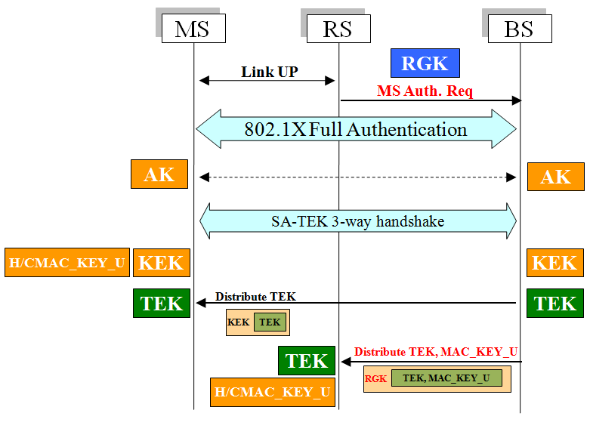
Figure 158b. The MS Security Association establishment

- The serving AR-RS checks the link up message to see is any AKID included. If not, an MS Authentication Request message is sent to the serving MR-BS to initialize 802.1X authentication.
- The MS and AAA server perform 802.1X authentication. If the result is successful, the serving MR-BS shall obtain the Authorization Key (AK) from ASN-GW. Next, the MS and the serving MR-BS carry out the SA-TEK 3-way handshake procedure. All authentication management messages are forwarded via the serving AR-RS.
- The Serving MR-BS distributes the TEK to the MS for data confidentiality.
- The serving MR-BS distributes the TEK and HMAC_KEY_U/CMAC_KEY_U to the serving AR-RS for data filtering in the serving AR-RS.
- Once the serving AR-RS obtains the TEK and HMAC_KEY_U/CMAC_KEY_U, it shall switch the state to the authorized state, and thus the MS is able to access the 802.16j multi-hop relay network. The serving AR-RS can take TEK to decrypt the frame and use the HMAC_KEY_U/CMAC_KEY_U verify the MAC. The Message Authentication Code (MAC) in the frame can also be verified by serving MR-BS.
- If multicast service is start, the multicast key shall be distributed to the serving AR-RS as well.

Authorization Key (AK) is the root key between MS and the serving MR-BS. AK should keep in the serving MR-BS. The serving MR-BS only transfer the TEK and HMAC_KEY_U/CMAC_KEY_U to the serving AR-RS via secure relay link (RGK protocol or SZK protocol). The AR-RS take MS’s TEK to read subheader and use HMAC_KEY_U/CMAC_KEY_U to filter malicious data frame.

The AR-RS would calculate a new MAC for relay link security. For Message Authentication Code (MAC) verification, the serving MR-BS still can check the MAC calculated by the MS in the data frame if the AR-RS do not drop the MAC.

Insert new subclause 7.1.6.5:

7.1.6.5 Handoff procedures

802.16j allows multiple AR-RSs reside in one 802.16j multi-hop relay network, and thus the handoff behaviors with SRZ are categorized into intra-MR-BS handoff and inter-MR-BS handoff. Moreover, the authentication procedures vary in the two types.

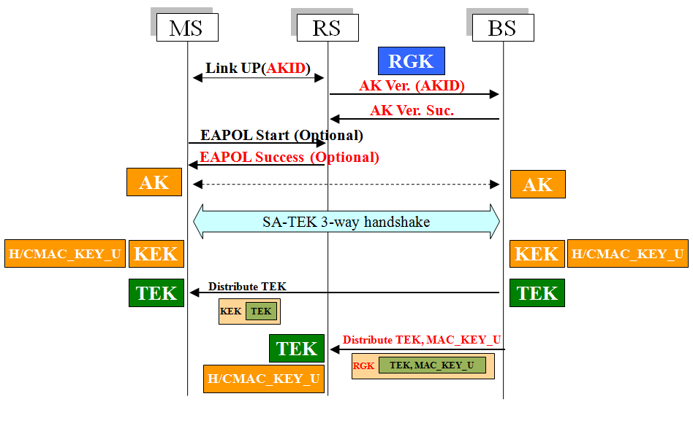
Figure 159b. Intra-MR-BS handoff

Insert new subclause 7.1.6.5.1:

7.1.6.5.1 Intra-MR-BS handoff

Intra-MR-BS handoff means that an MS drops current connection and re-associates with another AR-RS (target AR-RS) connecting to the same serving MR-BS. If the AK is cached by the serving MR-BS, 802.1X authentication shall be skipped. The following figure illustrates the authentication management message flows of intra-MR-BS handoff.

- The MS re-associates with the target AR-RS. The AKID is passed to the serving MR-BS for verifying the AK cached in the MS.
- The AKID is compared with the AK cached in the serving MR-BS. If the AKID is valid, the serving MR-BS shall inform the target AR-RS with an AK Verification Success Message.
- Some implementation of the MS use the EAPOL-Start message to initialize 802.1X authentication. If the target AR-RS receives an EAP-Start message, it shall reply an EAP-Success message to skip the EAP authentication.
- Following the SA-TEK 3-way handshake and TEK and HMAC_KEY_U/CMAC_KEY_U distribution are identical to the security association establishment mentioned before.

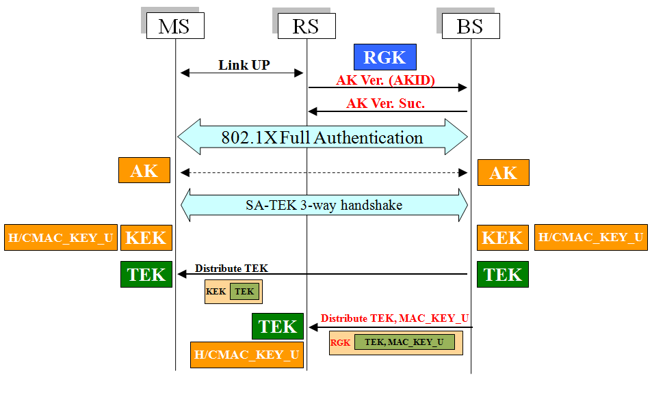
Figure 160b. Inter-MR-BS handoff

The AK Verification Request Message and the AK Verification Response Message could be replaced with RANG Request and RANG response. And TEK and HMAC_KEY_U/CMAC_KEY_U distribution could also take AK transfer protocol to distribute the TEK and HMAC_KEY_U/CMAC_KEY_U from the serving MR-BS to the serving AR-RS.

Insert new subclause 7.1.6.5.2:

7.1.6.5.2 Inter-MR-BS handoff

Inter-MR-BS handoff is performed while an MS moves from serving AR-RS to target AR-RS connecting to different MR-BS. The MS may switch to another SRZ in the inter-MR-BS handoff.

If the SRZ has not been visited by the MS or the cached AK is expired, pre-authentication shall be performed. However, the MS may fail to pre-authenticate with the MR-BS, and thus the overhead of 802.1X authentication is introduced.

There are many factors cause pre-authentication to be failed, such as the moving speed of the MS, the size of the overlapping coverage area, the target AR-RS prediction, the latency of EAP authentication, etc.

The following figure illustrates the management flows of inter-MR-RS handoff and security association establishment. Detail procedures are as follows:

- The MS re-associates with the target AR-RS. The AKID is forwarded to the serving MR-BS for verifying the AK cached in the MS.
- Since the target MR-BS does not cache the AK, the AKID verification is failed, and a message shall be sent to the target MR-BS for informing that following authentication message should be forwarded to the target MR-BS.
- 802.1X authentication and SA-TEK 3-way handshake are performed, followed by the TEK distribution to the MS and TEK and HMAC_KEY_U/CMAC_KEY_U distribution to target AR-RS. The procedures are the same as the security association establishment described before.

-------------------------------------------------------End of text ---------------------------------------------------------

