Project | IEEE 802.16 Broadband Wireless Access Working Group <http://ieee802.org/16>
Title | Technical Comments to P802.16j Baseline Document: 6.3.4 ARQ Operation - MR-ARQ
Date Submitted | 2007-9-15
Source(s) | Tzu-Ming Lin Wern-Ho Sheen, Fang-Ching Ren, Chie-Ming Chou, I-Kang Fu,  ITRI/NCTU  195,Sec. 4, Chung Hsing Rd.  Chutung, Hsinchu, Taiwan 310, R.O.C | E-mail: tmlin@itri.org.tw
Re: | To incorporate the proposed text into the P802.16j/D1 Baseline Document
Abstract | This contributions provides editorial comments to the P802.16j/D1
Purpose | To make IEEE Project 802.16j more maturity
Notice | This document does not represent the agreed views of the IEEE 802.16 Working Group or any of its subgroups. It represents only the views of the participants listed in the “Source(s)” field above. It is offered as a basis for discussion. It is not binding on the contributor(s), who reserve(s) the right to add, amend or withdraw material contained herein.
Release | The contributor grants a free, irrevocable license to the IEEE to incorporate material contained in this contribution, and any modifications thereof, in the creation of an IEEE Standards publication; to copyright in the IEEE’s name any IEEE Standards publication even though it may include portions of this contribution; and at the IEEE’s sole discretion to permit others to reproduce in whole or in part the resulting IEEE Standards publication. The contributor also acknowledges and accepts that this contribution may be made public by IEEE 802.16.
Patent Policy | The contributor is familiar with the IEEE-SA Patent Policy and Procedures:  <http://standards.ieee.org/guides/bylaws/sect6-7.html#6> and <http://standards.ieee.org/guides/opman/sect6.html#6.3>.  Further information is located at <http://standards.ieee.org/board/pat/pat-material.html> and <http://standards.ieee.org/board/pat>.
Technical Comments to P802.16j Baseline Document:
6.3.4 ARQ Operation - MR-ARQ

Tzu-Ming Lin, Wern-Ho Sheen, Fang-Ching Ren, Chie-Ming Chou, I-Kang Fu
ITRI/NCTU
- Introduction
The original text of section 6.3.4 in the P802.16j baseline document (IEEE 802.16j/D1) is still empty. This contribution aims to propose a concept of MR-ARQ operation to this section.

- Problem Statement and Proposed Concept - MR-ARQ
The legacy ARQ mechanism in IEEE 802.16e-2005 is developed to recovery packet error and process the retransmission for single-hop transmission. For multi-hop transmission, the mechanism would face more crucial issues that it needs some additional amendments. Taking figure 1 for example, it shows a scenario that packets are transmitted in two-hop network, and legacy ARQ mechanism is applied to convey the transmission. With some Relay ACK, which can carry some feedback information, MR-BS cannot be reminded the detail transmission status along the relay path. In this figure, two data blocks lost in first hop would not be feedback to MR-BS because only the ACK for last hop transmission is feedback to MR-BS. As a sequence, MR-BS arranges these unreported data blocks for retransmission. In next transmission, 8 block resources are allocated in MAP for 5 transmission and 3 new data blocks. However, allocating 5 block resource for retransmission is redundant because only 2 block resources are needed in first hop for retransmission. Two-Hop ARQ without RACK feedback would introduce redundant retransmission problem. If each RS appends RACK to the received ACK for reporting the transmission status between itself and its subordinate RS, MR-BS can get precise transmission status for each hop along the relay path and arrange retransmission resource per hop. In figure 2, RS 1 report 6 data block is received correctly in first hop and feedback a RACK appended in ACK. When MR-BS receives the ACK with RACK, it allocates only 5 resource blocks, 2 for retransmission and 3 for new transmission, for the first hop. Therefore, redundant retransmission is eliminated by such appending RACK. Note that, no stand alone RACK message, which consumes more resource, is required.
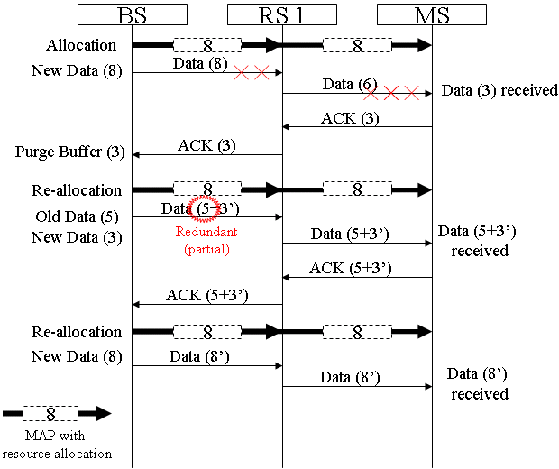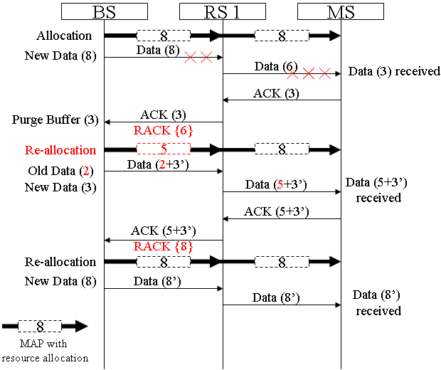
Figure 1, Two-Hop ARQ without RACK Figure 2, Two-Hop ARQ with Appending RACK
In multi-hop case, the redundant retransmission problem gets more serious. As illustrated in figure 3, 5, 3, and 3 resource blocks are over allocated in 1st, 2nd, and 3rd hop when only 2 and 3 blocks are error in 2nd and last hop because only 2, 2 , and 5 data blocks are needed to be retransmitted in 2nd, 3rd, and last hop.
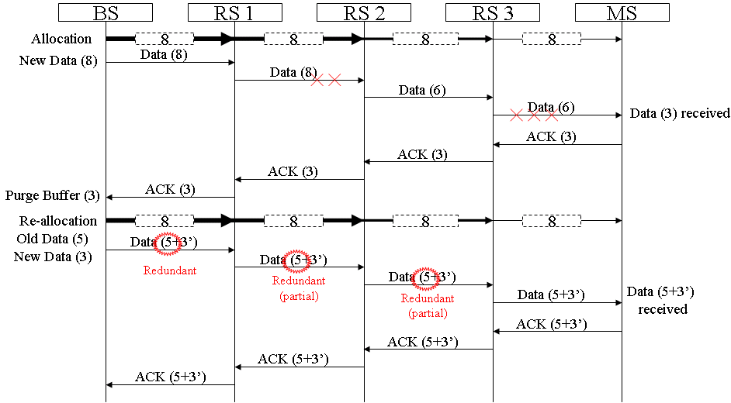
Figure 3, Multi-Hop ARQ without RACK
If we applied appending RACK in the multi-hop case, the resource can be saved. As shown in figure 4, the actually resource required for retransmission in each hop are 0, 2, 2, and 5 blocks, which can be reported by appending RACK in the ACK sent by MS.
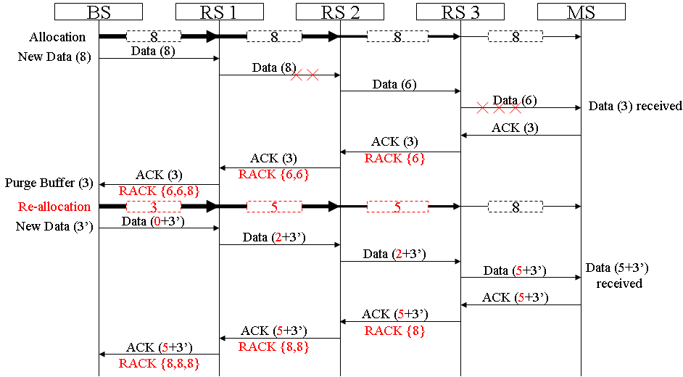
Figure 4, Multi-Hop ARQ with Appending RACK
If multi-hop transmission is conveyed by Pre-ACK, which sends feedback information toward MR-BS after receiving data correctly immediately, the additional signaling overhead problem is introduced. In figure 5, RS1, RS2, and RS3 sends Pre-ACKs to MR-BS to indicate the correct data blocks, 8, 6, and 6, are received by itself. The Pre-ACKs are transmitted redundantly in 1st, 2nd, and 3rd Hop, and additional resource is required for the feedback, which increases signaling overhead and reduces network utilization.
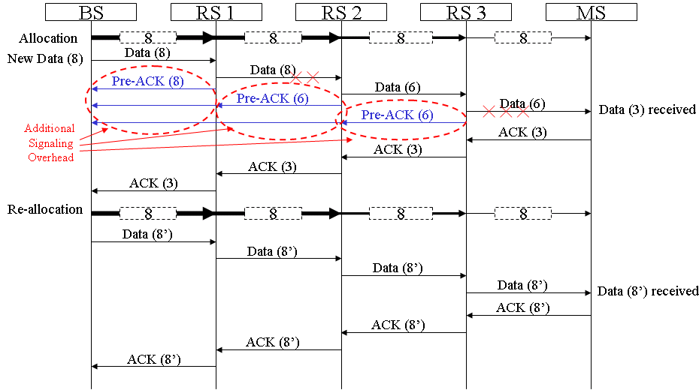
Figure 5, Multi-Hop ARQ with Pre-ACK

If Per-Hop (PH) ACK is used, the additional signaling overhead can be increased in a limited manner, say one PH-ACK per hop. Compared with Pre-ACK, PH RACK can save some resource wasted in signaling, but it still required additional resource for feedback. Moreover, there is another serous problem of this mechanism. When MR-BS receives PH-RACK, it realizes that the data blocks transmitted is successful received by the next hop. And then MR-BS purges the acknowledged data buffer and delegate retransmission responsibility to the RS in next hop. If handover happened during the transmission, only intermediate RS keep the copy the data block and can process the retransmission after handover. However, there should be complex retransmission problems no matter the responsible RS transmitted toward to MS-BR or another RS. If the responsible RS returns the retransmission responsibility to MR-BS, extra signaling and data transmission between MR-BS and the RS is required, which consume radio resource. What’s more, these data blocked might be dropped due to timeout if data forward process between serving station to target station takes long time. If the responsible RS decides to forward the buffered data block to the target station directly, additional signaling between itself, MR-BS, and target station is still required. If inter-BS handover happened, such data forward mechanism cannot work because RSs controlled by different MR-BS cannot communicate with each other directly, which is discussed in previous 16j TG meetings.

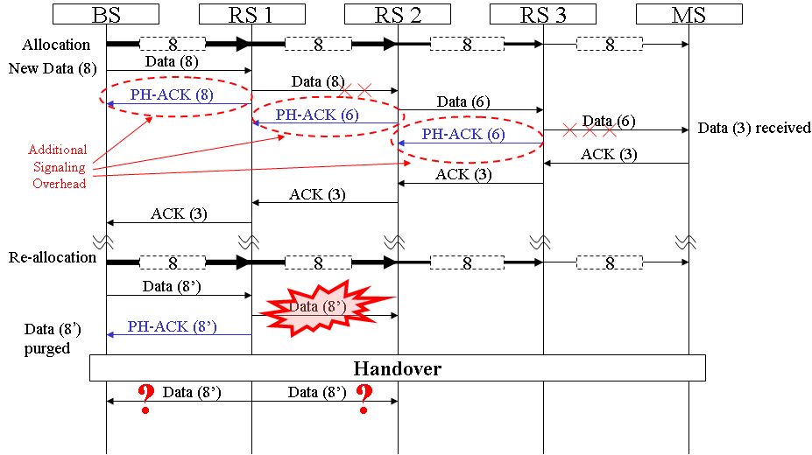
Figure 6, Multi-Hop with Per-Hop ACK

- Problem Statement and Proposal – MR-Timer Operation
In this contribution, MR-Timer is proposed to recovery the error and to reduce resource wasted in retransmission during relay transmission. In legacy mechanism, fixed and predefined retransmission timer (ARQ_Retry_Timeout) is used. Figure 7 shows the problem when legacy mechanism applied in multi-hop environment. In this figure, MS fails in transmitting ACK to RS3 so that neither do RS2 nor RS1 can relay the ACK to MR-BS. As a result, only when retransmission timer expired, MR-BS can re-arrange the retransmission of the failed data blocks. Even transmission is only failed in last hop, MR-BS still treats the transmission fail as totally failure due to lack of feedback from any RSs, and retransmit all the data blocks again. As a sequence, 8, 7, and 7 data blocks are over retransmitted in 1st, 2nd, and 3rd hop because only 0, 1, and 1 data blocks are needed to be retransmitted in these hops in this example. Even when each RS maintains fixed retransmission, the situation remains unchanged (dotted line in figure 7).
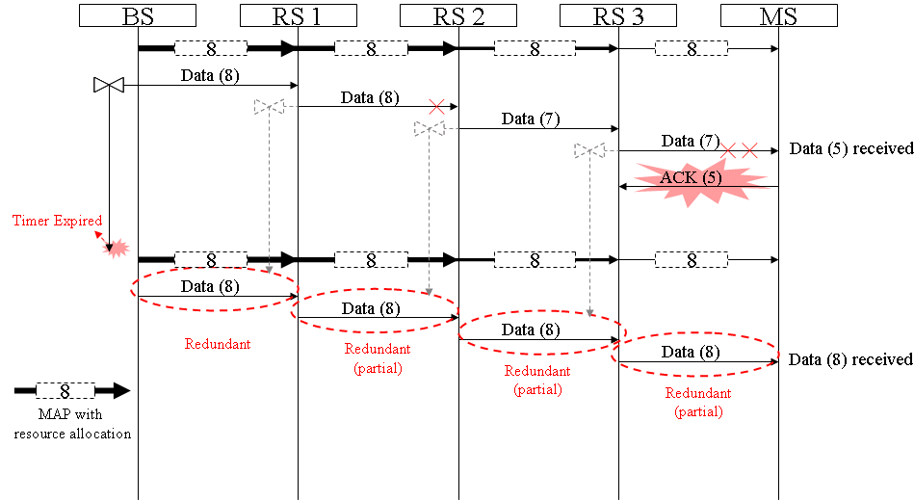
Figure 7, Transmission error when RS maintains no or fixed retransmission timer

If each RS along the transmission path maintain a variable retransmission timer, which is configured bases on the round-trip time between itself and MS, the RS can feedback the transmission error quickly when the timer expired. In normal case, ACK from MS should be received before the timer expired. When no ACK received from MS nor previous RSs after timer expired, it implies that the data transmission between itself and MS is failed, and then RS triggers sending the RACK toward BS to report the situation. In the example shown in figure 8, when transmission error occurred in access link, RS3 cannot receive the ACK sent by MS before retransmission timer T4 expired. After T4 expired, RS3 generates a RACK and sends toward MR-BS. When RS1 and RS2 receive the RACK from its previous RSs, them append its transmission status into the received RACK and relay to MR-BS. When MR-BS received RACK from RS1, it decodes the RACK and gets the idea what happened along the relay path so that MR-BS can arrange resource for retransmission. In this example, BS allocates 0, 1, 1 and 8 data blocks for 1st, 2nd, 3rd, and last hop. Compared with figured, resource of 8, 7, and 7 data blocks are saved in 1st, 2nd, and 3rd hop.
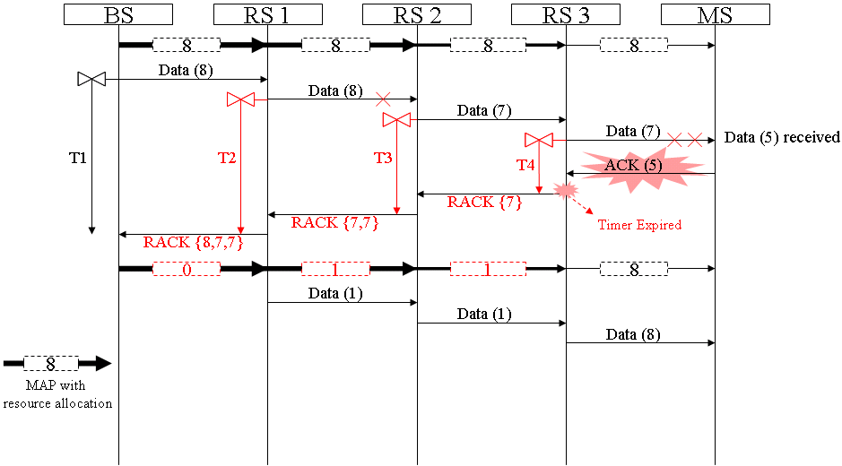
Figure 8, Transmission error when RS maintains per-connection retransmission timer

- ARQ Transmit Block States for RS
To support multi-transmission, RS should maintain ARQ transmit lock states for relay connections. The proposed ARQ transmit block state sequence is shown in figure 9. When RS receives data block from other RS or BS, it keeps in “Not Sent” state. Once the data is transmitted, the state gets into “Outstanding” state. In successful case, the RS receives ACK from MS and get into “Done” state. If timer “ARQ_RETRY_TIMEOUT” is expired or NACK is received from MS or other RS, the state enters into “Wait for retransmission”. This implies that some transmission error occurred between itself and MS. There might be some cases that RS receiving RACK from RS when it is in “Outstanding” state. In this case, RS relays RACK toward MR-BR or MS and then keeps in the same state. Note that receiving RACK from other RS does not imply the successful transmission. Only ACK from MS is received can show that the transmission is correct and can enter into “Done” sate. If RACK is received or data retransmitted in “Wait for retransmission” state, it goes back to “Outstanding” state and waits for ACK from MS. No matter in “Outstanding” or “Wait for retransmission” state, it should enter into “Discard” state when the timer DATA_LIFETIME expired. The state goes to “Done” when ACK from MS is received in “Outstand”, “Wait for retransmission”, and “Discard”. If RS receives RACK from other RSs even when the current state is “Discard”, it goes to “Done”.
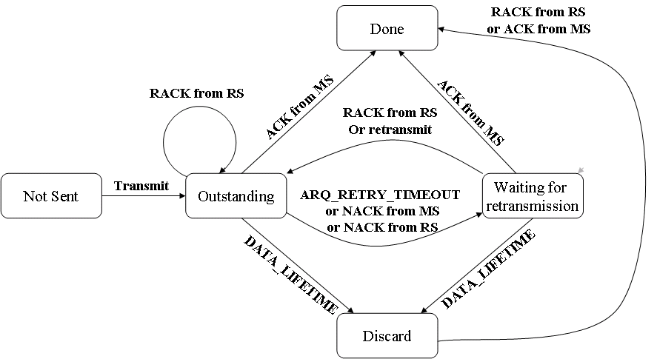
Figure 9, ARQ Transmit Block States for RS

Summary of the technical comment:
- Providing RACK can facilitate the resource allocation and reduce redundant retransmissions along the relay path in MR system.
- Appending RACK in ACK can reduce the amount of feedback messages and the size of each feedback message because transmission status of each hop is carried in single message.
- Maintaining retransmission timer in each RS is required for transmission status feedback in case data or ACK is failure in transmission.
- A well-configured retransmission timer can help to report transmission status in time when some transmission occurred.
- An ARQ transmit block states for RS is proposed for ARQ operations in MR system.

- Text Proposal
---------------------------------------------------------Start of the Text--------------------------------------------------------
[Adopt the following text modification into the P802.16j baseline document]

[Modify the following text in Section 6.3.2.1.1.1]
6.3.2.1.1.1 Relay MAC PDU header format

Table 7a Relay MAC PDU header
Syntax | Size | Notes
Relay MAC Header() {
HT | 1 bit | Shall be set to zero
Reserved | 1 bit | Currently reserved. Content is subject to further discussion
RMI | 1 bit | Relay mode indication (RMI) is used to indicate whether this MAC header is GMH or Relay MAC header  RMI=0; use GMH  RMI=1; use relay MAC header
ALC | 1 bit | Allocation subheader  1=present; 0=absent
Reserved | 1 bit | Currently reserved. Content is subject to further discussion
Fragmentation subheader | 1 bit | Fragmentation subheader (FSH)  1=present; 0=absent
Packing subheader | 1 bit | Packing subheader (PSH)  1=present; 0=absent
CE | 1 bit | CID encapsulation  1=present; 0=absent
ESF | 1 bit | Extended subheader field  If ESF=0, the extended subheader is absent  If ESF=1, the extended subheader is present and immediately follows the relay MAC header  The ESF is applicable in both the DL and UL
Relay ARQ subheader | 1 bit | Relay ARQ subheader (RSH)  1=present; 0=absent
Reserved | 2 1 bits | Currently reserved. Content is subject to further discussion
QoS subheader | 1 bit | QoS subheader (QSH)  1=present; 0=absent
LEN | 12 bits | The length in bytes of the relay MAC PDU including the relay MAC header
CID | 16 bits | May be tunnel CID or basic CID of the RS
HCS | 8 bits | Header Check Sequence
}

Insert new subclause 6.3.2.2.8.3:

6.3.2.2.8.3 Relay ARQ subheader

The Relay ARQ subheader shall be used for ARQ enabled connections and only applied in relay links. If the Relay ARQ subheader bit in Relay MAC header field (see Table 7a) is set, the Relay ARQ Feedback Payload shall be transported. If packing is used, it shall be transported as the first packed payload. See 6.3.3.4.3.
The Relay ARQ subheader shall be used for ARQ enabled connections and only applied in relay links.

6.3.4.6 ARQ Operation

Change the paragraph of the subclause as indicated:

The ARQ feedback information can be sent as a standalone MAC management message on appropriate basic management connection, or piggybacked on an existing connection. ARQ feedback cannot be fragmented. For the RS in MR system, appending feedback information – RACK (Relay ACK), which reports the transmission status of each RS, is mandatory for ARQ enabled connections.

6.3.4.6.4 ARQ modifications for relaying

Insert the following text in 6.3.4.6.4:

If ARQ is enabled at the connection in MR system, RS shall send feedback information toward BS to facilitate resource allocation and transmissions along the relay path. The feedback information shall contain the transmission status of the RS and appended in the feedback message it received.

In MR system, each RS shall maintain a MR-Timer for each ARQ-enabled connection. The MR-Timer shall be configured to ensure the receiving of feedback messages from receiving station, e.g. MS for downlink, RS for downlink/uplink, and MR-BS for uplink. Before MR-Timer expired, the intermediate RS shall append its ARQ-Feedback status into the received ARQ Feedback message toward transmitter, and reset the timer. If MR-timer is expired, a standalone ARQ-Feedback message shall be sent out to transmitter by the intermediate RS for reporting the ARQ-Feedback status. The MR-Time may be configured based on the round-trip time between RS and the receiving station, and plus adequate timing offset, including data processing, Tx/Rx transition, and so on.

The detail operations of Relay ARQ are illustrated in Figure xxx-1.

Figure xxx-1 – Relay ARQ Operation

Insert new subclause 6.3.4.6.1

6.3.4.6.4.1 Transmitter state machine for Relay ARQ

In MR system, a relayed ARQ block may be in one of the following states – not-sent, outstanding, discard, and waiting-for-retransmission. Any relayed ARQ block begins as not-sent. After it is sent it becomes outstanding for a period of time termed ARQ_RETRY_TIMEOUT. While a block is in outstanding state, it is either acknowledged or discarded by MS, or transitions to wait for retransmission after ARQ_RETRY_TIMEOUT or NACK from MS or RS, or stay in outstanding state after receiving RACK from RS. A relayed ARQ block can become wait-for-retransmission before the ARQ_RETRY_TIMEOUT period expires if it is negatively acknowledged. A relayed ARQ block may also change from waiting-for-retransmission to discard after a timeout ARQ_BLOCK_LIFETIME.

For a given connection the transmitter shall first (transmit or discard) blocks in “waiting-for-retransmission” state and only then blocks in “non-sent” state. Blocks in “outstanding” or “discarded” state shall not be transmitted. When blocks are retransmitted, the block with the lowest BSN shall be retransmitted first.

The ARQ transmit block state sequence for RS is shown in Figure xxx-2.

Figure xxx-2 – Relay ARQ Transmit Block States for RS

---------------------------------------------------------End of the Text--------------------------------------------------------

