Project | IEEE 802.16 Broadband Wireless Access Working Group <http://ieee802.org/16>
Title | Technical Comments to P802.16j Baseline Document: 6.3.4 ARQ Operation
Date Submitted | 2007-11-13
Source(s) | Tzu-Ming Lin, Wern-Ho Sheen, Fang-Ching Ren, Chie-Ming Chou, I-Kang Fu,  ITRI/NCTU  195,Sec. 4, Chung Hsing Rd.  Chutung, Hsinchu, Taiwan 310, R.O.C  Ismail Guvenc  DoCoMo USA Labs  3240 Hillview Ave., Palo Alto, CA, 95051 | E-mail: tmlin@itri.org.tw  E-mail: iguvenc@docomolabs-usa.com
Re: | To incorporate the proposed text into the P802.16j/D1 Baseline Document
Abstract | This contributions provides resolutions for relay ARQ comments to the P802.16j/D1
Purpose | To make IEEE Project 802.16j more maturity
Notice | This document does not represent the agreed views of the IEEE 802.16 Working Group or any of its subgroups. It represents only the views of the participants listed in the “Source(s)” field above. It is offered as a basis for discussion. It is not binding on the contributor(s), who reserve(s) the right to add, amend or withdraw material contained herein.
Release | The contributor grants a free, irrevocable license to the IEEE to incorporate material contained in this contribution, and any modifications thereof, in the creation of an IEEE Standards publication; to copyright in the IEEE’s name any IEEE Standards publication even though it may include portions of this contribution; and at the IEEE’s sole discretion to permit others to reproduce in whole or in part the resulting IEEE Standards publication. The contributor also acknowledges and accepts that this contribution may be made public by IEEE 802.16.
Patent Policy | The contributor is familiar with the IEEE-SA Patent Policy and Procedures:  <http://standards.ieee.org/guides/bylaws/sect6-7.html#6> and <http://standards.ieee.org/guides/opman/sect6.html#6.3>.  Further information is located at <http://standards.ieee.org/board/pat/pat-material.html> and <http://standards.ieee.org/board/pat>.
Technical Comments to P802.16j Baseline Document:
6.3.4 ARQ Operation

Tzu-Ming Lin, Wern-Ho Sheen, Fang-Ching Ren, Chie-Ming Chou, I-Kang Fu
ITRI/NCTU
- Introduction
ARQ support for 16j relay system is approved in 16j Guideline document - 802.16j-06_016r1 (Technical requirement) and 802.16j-06_017r1 (ToC). However, the related sections 6.3.4.6 and 6.3.4.6.4 in the P802.16j/D1 are still empty. The draft standard shall specify ARQ operations for 16j multi-hop relay system.
This contribution addressed the comment # 488, 490, 508, 509, 510, 511. The proposed resolutions in the texts are to accommodate these comments for:
- Propose remedy for ARQ support and keeping compatibility with 802.16e in 16j relay system
- Propose a optional enhanced relay ARQ support 802.16e ARQ in relay links
Here are the summary of these comments:
  - 488 : propose optional relay ARQ support
  - 490 : request for relay ARQ clarification (differentiate different modes for ARQ operation)
  - 508, 509, 510, and 511 : remove relay ARQ sections due to no specification
  - 816, 818, 819,820 : request for relay ARQ clarification due to no specification

- Resolution for comment # 488, 490, 508, 509, 510, 511

- 488 : Accepted with modified
- 490 : Superseded by 488
- 508~511 : Superseded by 488
- 816 : Superseded by 488
- 817~820 : Superseded by 488

- Text Proposal
---------------------------------------------------------Start of the Text--------------------------------------------------------
[Adopt the following text modification into the P802.16j baseline document]

[Modify section 6.3.4.6.4 as following]

6.3.4.6.4 ARQ modifications support for relaying

Insert the following text in 6.3.4.6.4:

Stations in MR system shall support ARQ operation specified in 6.3.4.6. If relay ARQ is not enabled in the relay links, RS may forward MPDUs of access links to/from MS from/to MR-BS without ARQ processing. If relay ARQ is enabled in the relay links, RS may operate relay ARQ as specified in 6.3.4.6.4.1.

6.3.4.6.4.1 Optional relay ARQ support

Optional relay ARQ support is end-to-end based operations and not applied in tunnel bust mode. For MBS pre-transmission, the relay ARQ can be also applied between MR-BS and receiving RSs.
If relay ARQ is enabled and Allocation Subheader is presented in relay MAC PDUs, ARQ indication bit shall be set to 1 to indicate ARQ connection existed in the allocation. Figure xxx-1 shows an example when Allocation Subheader is presented in relay MAC PDU.

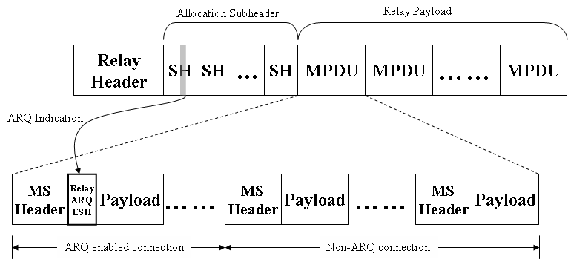
Figure xxx-1 – Relay ARQ support (if Allocation Subheaders are presented)

If ARQ is enabled at the connection in MR system, RS shall send feedback information toward BS to facilitate resource allocation and transmissions along the relay path. The feedback information shall contain the transmission status of the RS and appended in the feedback message it received.

In MR system, each RS shall maintain a MR-Timer for each ARQ-enabled connection. The MR-Timer shall be configured to ensure the receiving of feedback messages from receiving station, e.g. MS for downlink, RS for downlink/uplink, and MR-BS for uplink. Before MR-Timer expired, the intermediate RS shall append its ARQ-Feedback status into the received ARQ Feedback message toward transmitter, and reset the timer. If MR-timer is expired, a standalone ARQ-Feedback message shall be sent out to transmitter by the intermediate RS for reporting the ARQ-Feedback status. The MR-Time may be configured based on the round-trip time between RS and the receiving station, and plus adequate timing offset, including data processing, Tx/Rx transition, and so on.

The detail operations of Relay ARQ are illustrated in Figure xxx-2.

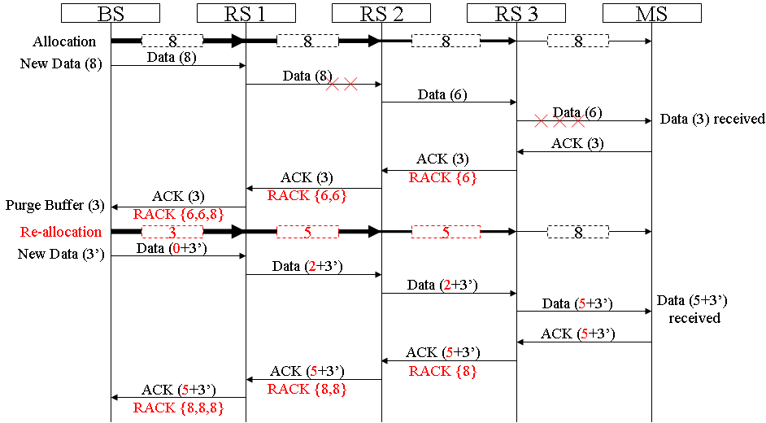
Figure xxx-2 – Relay ARQ Operation

6.3.4.6.4.2 Transmitter state machine for Relay ARQ

In MR system, a relayed ARQ block may be in one of the following states – not-sent, outstanding, discard, and waiting-for-retransmission. Any relayed ARQ block begins as not-sent. After it is sent it becomes outstanding for a period of time termed ARQ_RETRY_TIMEOUT. While a block is in outstanding state, it is either acknowledged or discarded by MS, or transitions to wait for retransmission after ARQ_RETRY_TIMEOUT or NACK from MS or RS, or stay in outstanding state after receiving RACK from RS. A relayed ARQ block can become wait-for-retransmission before the ARQ_RETRY_TIMEOUT period expires if it is negatively acknowledged. A relayed ARQ block may also change from waiting-for-retransmission to discard after a timeout ARQ_BLOCK_LIFETIME.

For a given connection the transmitter shall first (transmit or discard) blocks in “waiting-for-retransmission” state and only then blocks in “non-sent” state. Blocks in “outstanding” or “discarded” state shall not be transmitted. When blocks are retransmitted, the block with the lowest BSN shall be retransmitted first.

The ARQ transmit block state sequence for RS is shown in Figure xxx-3.

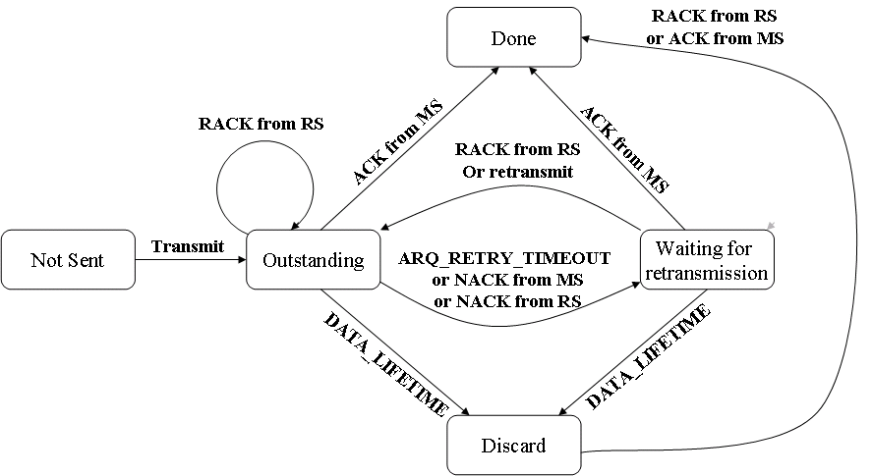
Figure xxx-3 – Relay ARQ Transmit Block States for RS

[Modify the following text in Section 6.3.2.2.7]

Table27-Description of extended subheader types (DL)
Extended  subheader type | Name | Extended subheader  Body size (byte) | Description
0 | SDU_SN extended subheader | 1 | See 6.3.2.2.7.1
1 | DL sleep control extended subheader | 3 | See 6.3.2.2.7.2
2 | Feedback request extended subheader | 3 | See 6.3.2.2.7.3
3 | SN request extended subheader | 1 | See 6.3.2.2.7.4
4 | PDU SN(short) extended subheader | 1 | See 6.3.2.2.7.5
5 | PDU SN(long) extended subheader | 2 | See 6.3.2.2.7.6
6-127 | Reserved Relay ARQ extended subheader | —1 | See 6.3.2.2.8.x
7-127 | Reserved | — | —

Table28-Description of extended subheader types (UL)
Extended  subheader type | Name | Extended subheader  Body size (byte) | Description
0 | MIMO mode feedback extended subheader | 1 | See 6.3.2.2.7.4
1 | UL Tx power report extended subheader | 1 | See 6.3.2.2.7.5
2 | Mini-feedback extended subheader | 2 | See 6.3.2.2.7.3
3 | PDU SN(short) extended subheader | 1 | See 6.3.2.2.7.8
4 | PDU SN(long) extended subheader | 2 | See 6.3.2.2.7.8
5-127 | Reserved Relay ARQ extended subheader | —1 | See 6.3.2.2.8.x
6-127 | Reserved | — | —

[Modify the following text in Section 6.3.2.2.8.2]

6.3.2.2.8.2 Allocation Subheader

The MR-BS may include the Allocation subheader in a relay MAC PDU to instruct the RS when to relay the MAC PDU. When included, the MR-BS shall use one Allocation subheader per RS for the relay link, and one or more Allocation subheader for the access link. The Allocation subheaders corresponding to the relay link shall precede the ones for access link. The access RS shall use the continuation bit in the Allocation Subheader to detect whether there is a subsequent Allocation subheader. The Allocation subheader shall be the last subheader before the payload.

Syntax | Size | Note
Allocation Subheader {
Target Transmission Frame | 6 bits | LSB 6 bits of frame number of the frame hat RS shall transmit the MAC PDU
Allocation Index | 6 bits | Allocation Index pointing to DL-MAP-IE in the MAP message
Number of MAC PDUs | 3 bits | Number of MAC PDUs in this allocation
Continuation | 1 bits | 1: Another Allocation subheader follows  0: This is the last Allocation Subheader for the RS
ARQ Indication | 1 bits | ARQ connection indication  1: ARQ connection existed  0: No ARQ connection existed
Reserved | 3 bits
}

Note : If ARQ indication bits is set, processing MPDUs in the allocation for relay ARQ os required

Insert new subclause after 6.3.2.2.8.2:

6.3.2.2.8.x Relay ARQ extended subheader

The Relay ARQ extended subheader shall be used for ARQ enabled connections and only applied in relay links. If the ESF bit in Relay MAC header field (see Table 7a) and the extended type field of Relay ARQ extended subheader (see Table 27 and Table 28) are both set, the Relay ARQ Feedback Payload shall be transported. If packing is used, it shall be transported as the first packed payload. See 6.3.3.4.3.

[Modify the following text in Section 11.7.28]

11.7.28 MR MAC features support

This TLV indicates the MR features supported by the RS and the MR-BS

Type | Length | Value | Scope
TBA | 1 | Bit #0: RS scheduling support  Bit #1: NBR-ADV generating  Bit #2: Tunneling packet mode support  Bit #3: Tunneling burst mode support  Bit #4: RS mobility support  Bit #5: Subordinate RS network entry support  Bit #6-7 : Reserved Relay ARQ support  Bit #7 : Reserved | REG-REQ  REG-RSP

---------------------------------------------------------End of the Text--------------------------------------------------------

