Project | IEEE 802.16 Broadband Wireless Access Working Group <http://ieee802.org/16>
Title | Support for Miscellaneous Functions in Relay MAC Header
Date Submitted | 2007-11-01
Source(s) | Zhifeng (Jeff) Tao, Jinyun Zhang  Mitsubishi Electric Research Lab  Toshiyuki Kuze  Mitsubishi Electric Corp | Voice: 1-617-621-7557  E-mail: tao@merl.com  Voice: +81-467-41-2885  Kuze.Toshiyuki@ah.MitsubishiElectric.co.jp
Re: | Response to the IEEE 802.16 Working Group Letter Ballot #28 (i.e., IEEE 802.16j-07/043).
Abstract | This contribution proposes more detailed bit assignment in relay MAC header.
Purpose | To adopt the bit assignment proposed herein into IEEE 802.16j.
Notice | This document does not represent the agreed views of the IEEE 802.16 Working Group or any of its subgroups. It represents only the views of the participants listed in the “Source(s)” field above. It is offered as a basis for discussion. It is not binding on the contributor(s), who reserve(s) the right to add, amend or withdraw material contained herein.
Release | The contributor grants a free, irrevocable license to the IEEE to incorporate material contained in this contribution, and any modifications thereof, in the creation of an IEEE Standards publication; to copyright in the IEEE’s name any IEEE Standards publication even though it may include portions of this contribution; and at the IEEE’s sole discretion to permit others to reproduce in whole or in part the resulting IEEE Standards publication. The contributor also acknowledges and accepts that this contribution may be made public by IEEE 802.16.
Patent Policy | The contributor is familiar with the IEEE-SA Patent Policy and Procedures:  <http://standards.ieee.org/guides/bylaws/sect6-7.html#6> and <http://standards.ieee.org/guides/opman/sect6.html#6.3>.  Further information is located at <http://standards.ieee.org/board/pat/pat-material.html> and <http://standards.ieee.org/board/pat>.

Support for Miscellaneous Functions in Relay MAC Header

Zhifeng (Jeff) Tao, Jinyun Zhang
Mitsubishi Electric Research Lab

Toshiyuki Kuze
Mitsubishi Electric Corp

Introduction
The MAC PDUs transmitted on relay link can use relay MAC (i.e., R-MAC) header. The R-MAC header specified in the current IEEE 802.16j baseline draft [1] can support following functions:
- Routing/forwarding control
- QoS control (via QoS subheader)
- Efficient resource allocation/consumption (via Fragmentation/Packing subheader)
- Timing indication in centralized scheduling (via ALC subheader)
- CID encapsulation needed by systematic CID assignment protocol (via CE bit)
- Extended subheader (via ESF bit)

Figure 1 illustrates the R-MAC header specified in the current baseline [1].

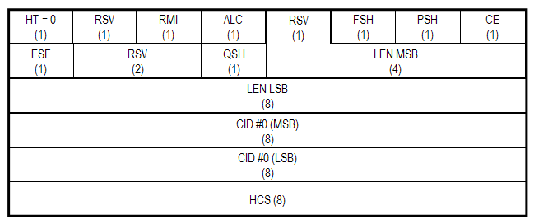
Figure 1: Relay MAC header specified in the current baseline.

This contribution intends to further discuss and suggest the usage of a few “reserved” bits in order to support some new features that 802.16j need to provide.

Summary of Proposal
There are still a few functions whose support in R-MAC header is absent.

  - CRC indication on relay link
According to the current baseline, a CRC-32 field can be attached at the very end of the constructed relay MPDU. To indicate the existence of this relay CRC-32 field, a CRC Indication (i.e., “CI”) bit is needed in the R-MAC header.

  - Bandwidth request support (UL)
In 802.16d/e, the grant management subheader (GMSH) is used to convey bandwidth management needs. According to subclause 6.3.6.7.1.1 of the 16j baseline [1], when it is time to forward traffic upstream, an RS may request uplink bandwidth via a stand-alone bandwidth request header, or piggybacked on to other MAC PDUs. If the MAC PDUs are relay MAC PDU, the use of piggybacked bandwidth request (i.e., grant management subheader) need to be supported by an indication bit in the relay MAC header.

  - Fast feedback Support (DL)
In 802.16e, the fast feedback allocation subheader (FFSH) is used to define the uplink resource which will be used by MS to report the fast downlink measurement or fast MIMO feedback. This fast feedback mechanism will also be needed on relay link between an MR-BS and its subordinated RSs, and between a RS and its subordinate RSs. Thus, a bit will be needed in the R-MAC header in DL to indicate the presence or absence of such a fast feedback subheader.

Proposed Text Changes
6. MAC Common Part Sublayer
6.3.2.1.1.1 Relay MAC header format

[Change Figure 22a as follows]

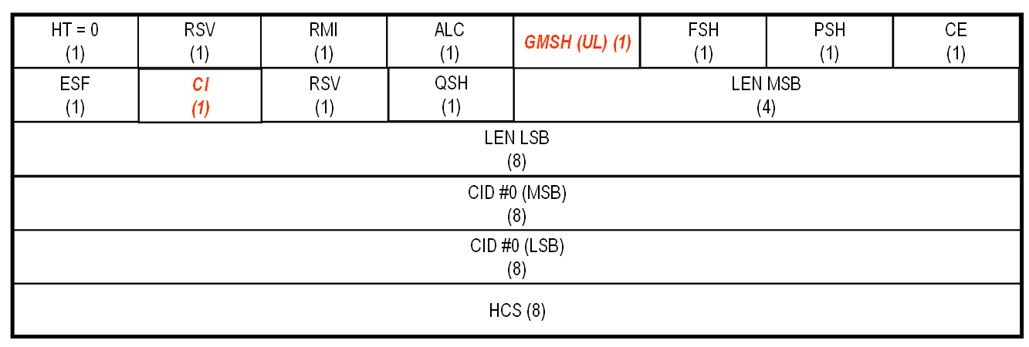

[Change Table 7a as follows]

Table 7a—Description of relay MAC header fields

Syntax | Size | Notes
MAC Header() {
HT | 1 bit
if (HT == 0) {
Reserved | 1 bit | Currently reserved. Content is subject to further discussion
RMI | 1 bit | Relay mode indication (RMI) is used to indicate whether this MAC header is GMH or Relay MAC header  RMI = 0: use GMH  RMI = 1: use relay MAC header
ALC | 1 bits | Allocation subheader  1=present; 0=absent
GMSH subheader | 1 bit | UL: grant management subheader (GMSH)  1 = present, 0 = absent  DL: reserved
Fragmentation subheader | 1 bit | Fragmentation/packing subheader (F/PSH)  1 = present, 0 = absent
Packing subheader | 1 bit | Fragmentation/packing subheader (F/PSH)  1 = present, 0 = absent
CE | 1 bit | CID encapsulation  1 = present, 0 = absent
ESF | 1 bit | Extended subheader field.  If ESF = 0, the extended subheader is absent.  If ESF = 1, the extended subheader is present and will follow the GMH immediately.  The ESF is applicable both in the DL and in the UL.
CI | 1 bit | CRC indication  1 = CRC is included in the PDU by appending it to the PDU payload after encryption,  if any.  0 = No CRC is included.
Reserved | 2 bits | Currently reserved. Content is subject to further discussion
QoS subheader | 1 bit | QoS subheader (QSH)  1 = present,  0 = absent
LEN | 12 bits | The length in bytes of the relay MAC PDU including the relay MAC header.
CID | 16 bits | May be tunnel CID or basic CID of the RS
HCS | 8 bits | Header check sequence
}
else if (HT == 1) { |  | If no payload is attached
Use legacy 802.16e or 802.16j  Format | 39 bits
HCS | 8 bits
}
}

6.3.6.7.1.1 Bandwidth request handling and transmission in distributed mode with non-transparent RS
[Revise the line 24 to 25 on page 79 as follows]

When it is time to forward traffic upstream, an RS may request uplink bandwidth via a stand-alone bandwidth request header, or piggybacked on to other relay MAC PDUs or other MAC PDUs. The grant management subheader can be piggybacked onto MAC PDUs only in distributed security mode.

Reference
- “Part 16: Air Interface for Fixed and Mobile Broadband Wireless Access Systems - Multihop Relay Specification”, IEEE P802.16j/D1, August 2007

- “IEEE Standard for Local and Metropolitan Area Networks − Part 16: Air Interface for Fixed Broadband Wireless Access Systems, Amendment 2: Physical and Medium Access Control Layers for Combined Fixed and Mobile Operation in Licensed Bands,” IEEE Computer Society and the IEEE Microwave Theory and Techniques Society, February 2006.

