Project | IEEE 802.16 Broadband Wireless Access Working Group <http://ieee802.org/16>
Title | HARQ Operations on RS_UL_DCH
Date Submitted | 2007-11-15
Source(s) | Sungcheol Chang, Sunggeun Jin, Kwangjae Lim, and Chulsik Yoon  ETRI  161, Gajeong-dong, Yuseong-Gu, Daejeon, 305-350, Korea  Derek Yu, hang Zhang, Peiying Zhu, Wen Tong, David Steer, Gamini Senarath, Mark Naden, G.Q. Wang  Nortel  3500 Carling Avenue  Ottawa, Ontario K2H 8E9 | scchang@etri.re.kr  sgjin@etri.re.kr  kjlim@etri.re.kr  csyoon@etri.re.kr  wentong@nortel.com  pyzhu@nortel.com
Re: | IEEE P802.16j/D1: IEEE 802.16j working group letter ballot #28.
Abstract | The baseline document defines the Dedicated Uplink Channel (RS_UL_DCH) for RS and its operation of resource allocation for the channel using UL_DCH assignment IE. There is no definition for HARQ operations on the RS_UL_DCH. An HARQ operation of the burst is proposed.
Purpose | To incorporate the proposed text into P802.16j Baseline Document.
Notice | This document does not represent the agreed views of the IEEE 802.16 Working Group or any of its subgroups. It represents only the views of the participants listed in the “Source(s)” field above. It is offered as a basis for discussion. It is not binding on the contributor(s), who reserve(s) the right to add, amend or withdraw material contained herein.
Release | The contributor grants a free, irrevocable license to the IEEE to incorporate material contained in this contribution, and any modifications thereof, in the creation of an IEEE Standards publication; to copyright in the IEEE’s name any IEEE Standards publication even though it may include portions of this contribution; and at the IEEE’s sole discretion to permit others to reproduce in whole or in part the resulting IEEE Standards publication. The contributor also acknowledges and accepts that this contribution may be made public by IEEE 802.16.
Patent Policy | The contributor is familiar with the IEEE-SA Patent Policy and Procedures:  <http://standards.ieee.org/guides/bylaws/sect6-7.html#6> and <http://standards.ieee.org/guides/opman/sect6.html#6.3>.  Further information is located at <http://standards.ieee.org/board/pat/pat-material.html> and <http://standards.ieee.org/board/pat>.

HARQ Operations on RS_UL_DCH
Sungcheol Chang, Sunggeun Jin, Kwangjae Lim, Chulsik Yoon
ETRI
Derek Yu, hang Zhang, Peiying Zhu, Wen Tong, David Steer, Gamini Senarath, Mark Naden, G.Q. Wang
Nortel

1. Introduction

The RS UL_DCH supports signaling and data traffic associated with service flows, and hence HARQ on UL_DCH needs to be supported. As the UL_DCH is a persistence allocation and the resources are available periodically without any further signaling until it needs to be updated, such as, to a different size. As such, it is not possible to follow the current HARQ process of using embedded sub-burst IE inside HARQ UL MAP IE during HARQ BW allocation.

The current ACK/NAK for the UL HARQ transmission bursts from the MSs/RSs are sent using DL HARQ ACK IE. It contains an ACK/NAK bitmap and the order of bits follows the same order of the HARQ sub-burst allocations in the broadcasted HARQ UL MAP IE. As such, it also cannot be used for HARQ in UL_DCH.

This contribution supplies text to enable HARQ operation on the RS UL_DCH.

2. Proposed solution

The high level design of the HARQ operations on RS UL_DCH is NAK based and retransmission can either be done at the dedicated resource or additional resource depending on the needs. HARQ on RS UL_DCH is a hop-by-hop HARQ.

For multi-hop centralized scheduling, it is not possible to dynamically allocated NAK resource for RSs that are two or more hops away from the MR-BS as the minimum round trip delay will be larger than the maximum of 3 frames delay for the transmission of synchronous NAK signaling. To effectively enable NAK signaling for the UL HARQ transmission on the dedicated channel, the MR-BS needs to allocate dedicated signaling channel in the downlink for the RS using RS DL DCH assignment IE.

For distributed scheduling, in place of frequent/periodic ACK/NAK allocations, the superordinate station may allocate dedicated signaling channel in the downlink for its RSs when significant number of service flows have been established.

With synchronous NAK, there is much less buffer demand on the sender side. Successfully received HARQ packets by the receiver can be quickly removed at the sender side.

Retransmission can be required at the dedicated resource on RS_UL_DCH or at the additional resource. Dedicated resource allocation for retransmission can work with both centralized and distributed allocation. Additional resource allocation for retransmission can work with distributed allocation but may incur extra delay and signaling under multi-hop centralized allocation as an additional resource request to the MR-BS is needed. The additional retransmission resource is requested by indicating HARQ retransmission request in the RS UL_DCH header and it is sent to the MR-BS. The retransmission resource is allocated using RS_UL_DCH HARQ RETX IE. The transmission of RS_UL_DCH HARQ RETX IE to allocate retransmission resource provides the implicit NAK to the RSs.

The following figures illustrate the HARQ operation under different scenarios. Figure 1 illustrates the operation using the dedicated resources for retransmission for both centralized and distributed allocation. Figure 2 illustrates the operation using additional resource for retransmission when asynchronous NAK is used. Lastly, Figure 3 illustrates the operation without RS_DL_DCH for centralized allocation.

Fundamentally, retransmission is done through resource from the same DCH ACID. For retransmission using the dedicated resource, the next resource of the same DCH ACID is used for retransmission. For retransmission using the additional resource, one-time additional resource is allocated to the DCH ACID for retransmission.

For the retransmission described in Figure 1, the next occurrence of transmission resource for DCH ACID 0 is used to retransmit burst A after the synchronous NAK. For CTC IR HARQ, the SPID is also provided together with the NAK.

Figure 2 describes the same retransmission but asynchronous NAK is used because of no RS DL_DCH signaling channel. The RS_UL_DCH HARQ RETX IE provides the implicit NAKs.

In Figure 3, for centralized allocation, the request for asynchronous retransmission is sent from the superordinate RS to the MR-BS using RS UL_DCH HARQ retransmission request header. The MR-BS then constructs the required RS_UL_DCH HARQ RETX IE and forward to the superordinate RS for the one time retransmission resource allocation.

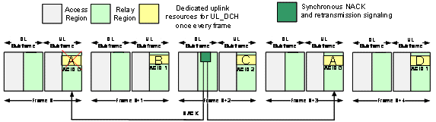
Figure 1: Synchronous NACK and retransmission using the dedicated resource.

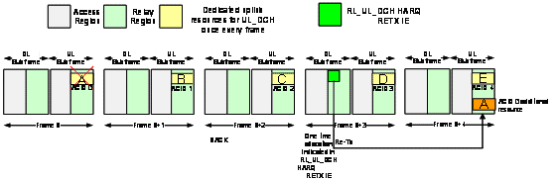

Figure 2: Asynchronous NACK and Retransmission using the additional resource.

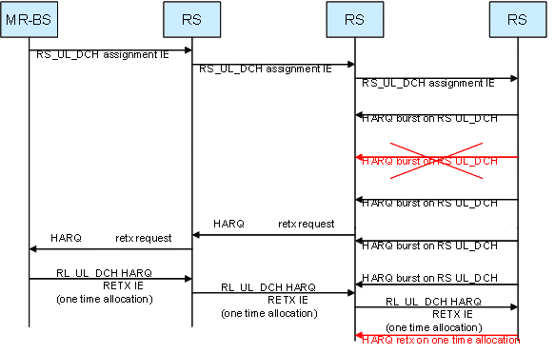

Figure 3: Retransmission for centralized allocation.

3. Text Proposals

+++++++++++++++ Start Text Proposal +++++++++++++++++++++++++++++++++++++++++++++

[Add the following Subclause]

6.3.17.6 HARQ support on RS_UL_DCH

The HARQ on RS_UL_DCH is a NAK-based HARQ and a hop-by-hop HARQ. The RS_UL_DCH assignment IE configures and updates HARQ operation on RS_UL_DCH. The HARQ control field indicates HARQ NAK feedback type on RS_UL_DCH, which is either synchronous HARQ NACK or asynchronous HARQ NAK. The NAK is sent only when one or more bursts that are received in error. The HARQ configuration for the RS_UL_DCH remains same and HARQ NAK feedbacks shall be as given in the format of the selected HARQ NAK feedback type.

Packets from multiple MSs/RSs are multiplexed and transmitted through the UL DCH. Each DCH resource block can be used for transmitting a single HARQ burst at a time. For allocation of new UL DCH resource block a number of DCH ACID is also assigned. Implicit sequential cycling of DCH ACID is used for each occurrence of the periodically assigned resource. The first transmission after enabling HARQ is always HARQ channel 0 (DCH ACID is 0). The DCH ACID is incremented by 1 for each periodic transmission and reset to 0 when the maximum DCH ACID number is reached.

The synchronous NAK and retransmission control signaling are sent by the RS. The RS that receives HARQ UL burst at i-th frame may transmit NAK signal at (i+j)-th frame. The frame offset “j” is defined by the “HARQ ACK Delay for UL Burst” field in the DCD message. The asynchronous NAKs are identified by a set of DCH resource ID and DCH ACID, which identify bursts on RS_UL_DCH. The asynchronous NAK may be sent if the feedback delay is variable.

The resources for retransmission are allocated at either dedicated resources on RS_UL_DCH or at additional resources using RS_UL_DCH HARQ RETX IE. For using the dedicated resource, the retransmission is sent using the same HARQ channel and it is sent on the next occurrence of the same HARQ channel after the NAK signal. Thus, the dedicated resource allocation minimizes signaling overhead for the retransmissions. For using the additional resource, a one-time additional resource is allocated to the HARQ channel that requires retransmission. In this case, the number of DCH ACID shall be large enough to allow for the maximum number of retransmission attempts before the DCH ACID wrap around. When the bandwidth on RS_UL_DCH is required to be guaranteed, the additional resources shall be allocated.

In case of centralized scheduling, the intermediate RS may also generate the RS_UL_DCH header with HARQ retransmission request so that the MR-BS can allocate resources for retransmission.

[Change Table 496d in Subclause 8.4.5.9.1.1 on page 192 as indicated]

Table 496d-RS_UL_DCH assignment IE format
Syntax | Size | Notes
RS_UL_DCH assignment IE() {
Type | 5 bits | RS UL DCH assignment IE = 0x00
Length | 4 bits | Variable
RSCID | 8 bits 4,8,12,16 bits | Reduced basic CID of the RS RS basic CID in RCID_IE format (see 8.4.5.3.20.1)
Update type | 2 bits | 00 = Normal  01 = Service flow based  10-11 = Reserved
If (Update type == 01) { |  | If service flow based update
Throughput size | 24 bits | Amount of throughput update in byte/s
Access RSCID | 8 bits 4,8,12,16 bits | Reduced basic CID of t The access RS of the MS that completed the service flow event. RS basic CID in RCID_IE format (see 8.4.5.3.20.1)
}
Assignment type | 2 bits | 00 = Incremental (Add the specified resource to UL DCH)  01 = Aggregate (An aggregate assignment with no resource indicates all UL DCH removal)  10 = Remove Removal (Remove the specified resource from UL DCH)  11 = Remove all Tx profile and settings update
OFDMA symbol offset | 8 bits
DCH resource ID | 3 bits | ID of the DCH resource being assigned or managed
HARQ Control | 1 bit | 0: Synchronous HARQ NAK bitmap  1: Asynchronous HARQ NAK
HARQ type | 2 bits | 0b00 – Disabled  0b01 – HARQ Chase  0b10 – HARQ CTC IR  0b11 – HARQ CC IR
if (HARQ type == 0b10) {
N_{EP} | 4 bits
N_{SCH} | 4 bits
} else {
UIUC | 4 bits
Repetition coding indication | 2 bits | 0b00 – no repetition coding  0b01 – repetition coding of 2  0b10 – repetition coding of 4  0b11 – repetition coding of 6
}
if (Assignment type == 01 || Assignment == 11) {
Number of DCH ACID | 5 bits | Maximum number of HARQ channels associated with this assignment
}
if (Assignment type != 0b11) {
OFDMA symbol offset | 8 bits
Subchannel offset | 8 bits
Duration | 10 bits | Resources allocated to DCH (in OFDMA slots)
}
if (Assignment type == 0b01) {
Frequency (N) | 4 bits | Allocation repeats once every N frames.
}
}

[Change Table 496c in Subclause 8.4.5.9.1 as indicated]

Table 496c—R-link specific IE types

Type  (hexadecimal) | Usage
00 | RS_UL_DCH assignment IE
01 | RS_BW-ALLOC IE
02 | RS_UL_DCH HARQ RETX IE
0203-1F | Reserved

[Add the following Subclause]

8.4.5.9.1.4 RS_UL_DCH HARQ RETX IE

RS_UL_DCH HARQ RETX IE is transmitted to RSs to request the retransmission of HARQ bursts on RS UL_DCH. The corrupted HARQ bursts are indicated by their corresponding DCH resource ID and DCH ACID. If DCH ACID is not provided, the RS that receives HARQ UL burst at i-th frame should transmit NAK signal at (i+j)-th frame. The frame offset “j” is defined by the “HARQ ACK Delay for UL Burst” field in the DCD message. RS_UL_DCH HARQ RETX IE includes the allocation of either dedicated UL DCH or additional resources for retransmission. If Retransmission Type is 0, a RS that receives HARQ NAK feedbacks should retransmit the corrupted bursts in the dedicated resources on RS_UL_DCH. For a DCH resource ID in the RS, the burst indicated by k-th NAK should be retransmitted at k-th dedicated burst from the burst with the frame offset j. If Retransmission Type is 1, the corrupted burst is retransmitted in the additional resource.

The format of the RS_UL_DCH HARQ RETX IE is shown in Table XXX.

Table XXX. RS_UL_DCH HARQ RETX IE format.

Syntax | Size | Notes
RS_UL_DCH HARQ RETX IE () {
Type | 5 bits | RS_UL_DCH HARQ RETX IE = 0x03
Length | 4 bits | Variable
Number of bursts | 3 bits
for (i=0;i<Number of bursts; i++) {
RSCID | 4,8,12,16 bits | RS basic CID in RCID_IE format (see 8.4.5.3.20.1)
DCH resource ID | 3 bits | ID of the RS_UL_DCH resource has transmission failure
HARQ Control | 1 bit | 0: Synchronous HARQ NAK  1: Asynchronous HARQ NAK
if (HARQ Control == 1) { |  | Asynchronous HARQ NAK
DCH ACID | 5 bit | HARQ channel required retransmission
}
Retransmission Type | 1 bit | 0: HARQ retransmission to occur in allocated dedicated UL_DCH  1: HARQ retransmission to occur in resource assigned in this IE
if (Retransmission Type == 1) { |  | HARQ retransmission to occur in resource assigned in this IE
OFDMA Symbol offset | 8 bits
Subchannel offset | 8 bits
Duration | 10 bits | Resources allocated for HARQ retransmission (in OFDMA slots)
}
SPID | 2 bits | For CTC IR, specify SPID for retransmission bursts. If HARQ type for the DCH resource does not require SPID, this SPID shall be set to 0.
}
}

[Change the text in Subclause 6.3.2.1.2.2.2.2 on page 11]

6.3.2.1.2.2.2 RS UL DCH request header (RS_UL_DCH)

The RS requests a dedicated uplink resource through the RS_UL_DCH request header by specifying DCH Request. Under centralized allocation, it is also used for intermediate RS to request HARQ retransmission resource from the MR-BS by specifying HARQ retransmission request. The MR-BS responses with RS_UL_DCH HARQ RETX IE. The format of this header is illustrated in Figure 35c and described in Table 19c.

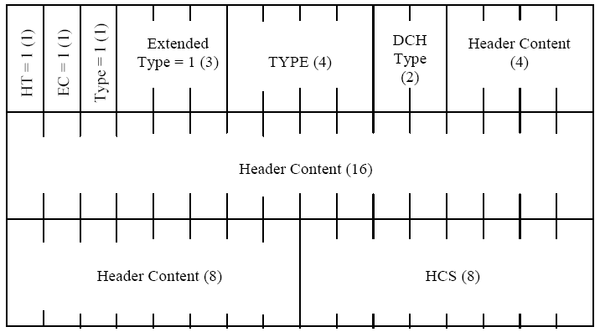

Figure 35c-RS_UL_DCH request header format

Table 19c-Description of fields in RS UL_DCH request header

Syntax | Size | Notes
MAC Header() {
HT | 1 bit | Shall be set to 1
EC | 1 bit | Shall be set to 1
Type | 1 bit | Shall be set to 1
Extended TYPE | 3 bits | Shall be set to 001 for RS_UL_DCH request header
TYPE | 4 bits | 0000 = DCH Request  0001 = Reserved  0010 = HARQ retransmission request  0001 0011 – 1111 = Reserved
if (TYPE==0000) { |  | DCH Request
DCHTYPE | 2 bits | 00 = DCH Request Incremental  01 = DCH Request Aggregate  10 = DCH Request Rate Based  11 = Reserved
if (DCHTYPE == 00) { |  | DCH Request Incremental
Bandwidth request | 16 bits | Number of bytes requested by the RS. Zero in this field indicated DCH release request.
N | 4 bits | Allocation repeats once every N frames.
} else if (DCHTYPE == 01) { |  | DCH Request Aggregate
Bandwidth request | 16 bits | Number of bytes requested by the RS. Zero in this field indicated DCH release request.
N | 4 bits | Allocation repeats once every N frames.
} else if (DCHTYPE == 10) { |  | DCH Request Rate Based
Average rate | 20 bits | Average data rate in units of bytes per second  18 MSB bits: magnitude  2 LSB bits: base-10 exponent
}
RS CID | 8 bits | 8 LSB of Reduced Basic CID of RS
}
if (TYPE == 0010) { |  | HARQ retransmission request
RS CID | 8 bits | 8 LSB of Basic CID of the RS requiring HARQ retransmission
Number of bursts | 2 bits
for (i=0;i< Number of bursts; i++) {
DCH resource ID | 3 bits | ID of the DCH resource that needs HARQ retransmission
DCH ACID | 5 bits | HARQ channel require retransmission
}
Reserved | variable
}
HCS | 8 bits | Header check sequence
}

