Project | IEEE 802.16 Broadband Wireless Access Working Group <http://ieee802.org/16>
Title | Proposal on MS Periodic Ranging in Multihop Relay System with Transparent RS
Date Submitted | 2007-09-14
Source(s) | Qu Hongyun, Chen Yuqin, Liu Yang  ZTE  Mary Chion  ZTE USA | E-mail: qu.hongyun@zte.com.cn  mchion@zteusa.com  *<http://standards.ieee.org/faqs/affiliationFAQ.html>
Re: | 80216-07_043: IEEE 802.16 Working Group Letter Ballot #28: Announcement
Abstract | This contribution proposes MS periodic ranging in relay system with transparent RS.
Purpose | To be discussed and accepted by TGj.
Notice | This document does not represent the agreed views of the IEEE 802.16 Working Group or any of its subgroups. It represents only the views of the participants listed in the “Source(s)” field above. It is offered as a basis for discussion. It is not binding on the contributor(s), who reserve(s) the right to add, amend or withdraw material contained herein.
Release | The contributor grants a free, irrevocable license to the IEEE to incorporate material contained in this contribution, and any modifications thereof, in the creation of an IEEE Standards publication; to copyright in the IEEE’s name any IEEE Standards publication even though it may include portions of this contribution; and at the IEEE’s sole discretion to permit others to reproduce in whole or in part the resulting IEEE Standards publication. The contributor also acknowledges and accepts that this contribution may be made public by IEEE 802.16.
Patent Policy | The contributor is familiar with the IEEE-SA Patent Policy and Procedures:  <http://standards.ieee.org/guides/bylaws/sect6-7.html#6> and <http://standards.ieee.org/guides/opman/sect6.html#6.3>.  Further information is located at <http://standards.ieee.org/board/pat/pat-material.html> and <http://standards.ieee.org/board/pat>.
Proposal on MS Periodic Ranging in Multihop Relay System with Transparent RS
Qu Hongyun, Mary Chion, Chen Yuqin, Liu Yang
ZTE

Problem Introduction
As specified in current draft 16j/D1 in the section 6.3.10.3.4.1, MS performs periodic ranging process by sending a randomly selected periodic ranging CDMA codes in a randomly selected ranging slot on the UL periodic ranging region, which is same as in 16e standard.
The periodic ranging code can be received by MR-BS and RSs near the MS. RS receiving the code shall transmit a RNG-REQ message with RS basic CID to the serving MR-BS through the relay path.
When MR-BS receives ranging code, it shall wait for RNG-REQ message containing the same periodic ranging code attributes from its subordinate RS before the expiration of timer T48. Once T48 expired, MR-BS could compare the measured signal information at each access station and decide the adjustment information for RMG-RSP. Then MR-BS shall transmit RNG-RSP to the MS directly. The following figure in current draft 16j/D1 shows the above MS periodic ranging process.

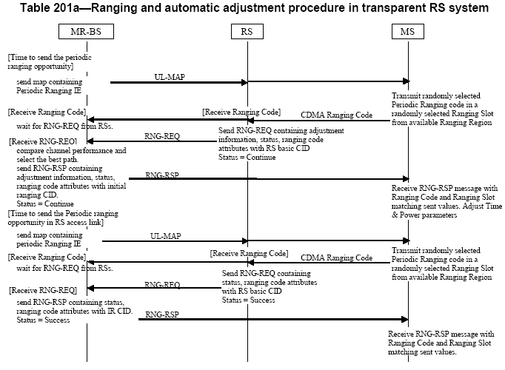

The problem existing in the MS periodic ranging process mentioned above is neither MR-BS nor RS can tell which MS sent the periodic ranging code. As showed in the above figure and specified in current 16j/D1, MR-BS selects the best ranging path based on the measurements of received ranging code and decides the adjustment information for MS. In some scenarios, such as channel fluctuation, MS movement, etc, the best ranging path may not be same ad the selected relay path for the MS performing periodic ranging code. In cases where the best ranging path is not the same as the selected relay path, the RNG-RSP message sent from MR-BS will contain erroneous adjustment information, since MR-BS is adjusting MS transmission parameters based on the channel condition of different RS. When MS adjust its parameters based on RNG-RSP message, it could cause further degradation on radio link due to the mismatch of best ranging path and selected relay path.

As described above, during MS periodic ranging process in multihop relay system with transparent RS, the MR-BS can not always select the correct path to perform ranging adjustment since MR-BS can not determine which MS has sent the periodic ranging code. This mismatch could cause degradation of radio link quality after MS performs adjustment directed by MR-BS, in worse situation, the communication link between MR-BS and MS can be dropped.

Proposed solution
To resolve the above problem and keep the backward compatibility with MS compliant with IEEE802.16-2004 and IEEE802.16e-2005, we propose the following solution.
- In the multihop relay system with transparent RS, once MR-BS receives MS periodic ranging code or a RS RNG-REQ message which is indicated for MS periodic ranging, MR-BS shall send RNG-RSP with success status containing no adjustment to terminate MS periodic ranging.
- In order to adjust MS parameters in the multihop relay system with transparent RS same as done by normal MS periodic ranging process, transparent RS shall report MS adjustment information and corresponding MS basic CID to MR-BS, and MR-BS sends unsolicted RNG-RSP message to perform MR-BS controlled periodic ranging.
The access transparent RS shall send the modified MOB_RSSCN-REP message with RS basic CID unsolicited periodically or triggered by event, for example the channel quality degradation, to MR-BS. MOB_RSSCN-REP message include the suggested adjustment information, such as power, time, frequency. MR-BS decides MS adjustment information only based on the report from access transparent RS or its own MS measurement if MS communicates directly with it. MR-BS shall send unsolicited RNG-RSP with MS basic CID, in which the status is set to 1 and the adjustment information should be included.
Totally, the proposed solution is to terminate normal MS periodic ranging within transparent RS system, and in order to adjustment MS transmission parameters, MR-BS controls the periodic ranging by unsolicited RNG-RSP with success status.

Specific Text
[To modify 6.3.2.3.77 MOB_RSSCN-REP message as follows]

An RS in an RS group may use MOB_RSSCN-REP message to report the measurement results to MR-BS.
The message shall be transmitted on the Basic Management CID of the RS.
The access transparent RS may send MOB_RSSCN-REP message with RS basic CID to report the suggested adjustment information to MR-BS, unsolicited periodically or triggered by events.

The format of the MOB_RSSCN-REP message is depicted in Table 183r.
Table 183r—MOB_RSSCN-REP message format

Syntax | Size | Notes
MOB_RSSCN-REP_Message_Format(){
Management Message Type = 83 | 8 bits
N_MS | 8 bits | Number ofMSs to be reported
Report metric | 8 bits | Bitmap indicating presence of certain metrics: Bit 0: MS RSSI mean
 |  | Bit 1: MS CINR mean
 |  | Bit 2: Timing Adjust
 |  | Bit 3: Frequency Adjust
 |  | Bit 4: power adjust
 |  | Bit 5~7: reserved
Padding | 5 bits
for(j=0;j<N_MS; j++){
MS CID | 16 bits | Basic CID of the MS to be reported
if(Report metric [Bit0] == 1)
MS RSSI mean | 8 bits | The value shall be 4nterpreted as an unsigned byte with units of 0.24dB, such that 0x00 is interpreted as -103.75 dBm, an RS shall be able to report values in the range -103.75dBm to -40 dBm
if(Report metric [Bit1] == 1)
MS CINR mean | 8 bits | MS_CINR mean shall be interpreted as a sin-gle value from -16dB to 47.5 dB in units of 0.5 dB.
If(Report metric [Bit2] == 1)
Timing Adjust | 32 bits | Tx timing offset adjustment (signed 32-bit). The amount of time required to adjust MS transmission so the bursts will arrive at the
 |  | expected time instance at the MR-BS or RS. Units are PHY specific (see 10.3)
If (Report Metric [Bit3=1])
Frequency adjust | 8bits
If (Report Metric {Bit4=1])
Power adjust | 8bits | Signed integer, which expresses the change in power level (in multiples of 0.25 dB) that the MS shall apply to its current transmission  power. When subchannelization is employed,  the subscriber shall interpret the power offset  adjustment as a required change to the transmitted power density.
}
Reserved | 3 bits
}

[To modify section 6.3.10.3.4.1 as follows]
6.3.10.3.4.1 MS periodic ranging and automatic adjustments in transparent RS systems

The periodic ranging process shall begin by sending a periodic-ranging CDMA codes on the UL allocation
dedicated for that purpose.

The code may be received by the MR-BS and RSs near the MS. RSs receiving the code should transmit a
RNG-REQ message with the RS basic CID to the serving MR-BS through the relay path.

When MR-BS receives a MS periodic ranging code or a RNG-REQ message from a RS containing MS periodic ranging code, MR-BS shall broadcast unsolicited RNG-RSP message with success status and periodic ranging code attributes, which contains no adjustment information for MS. Once receiving unsolicited RNG-RSP message from MR-BS, MS terminates periodic ranging code and performs no adjustment.

RS will not transmit RNG-REQ message to MR-BS due to the reception of periodic ranging code, if RS receives the RNG-RSP message from MR-BS containing the same periodic ranging code attribute as the received one.

MR-BS shall ignore the RNG-REQ message from a RS containing the MS periodic ranging code attributes if MR-BS already received the periodic ranging code with the same attributes from a MS or a RS.

When MR-BS receives the MOB_RSSCN-REP message from transparent RS, MR-BS shall decide the adjustment information only based on the report from access transparent RS. MR-BS shall send unsolicited RNG-RSP with success status containing the adjustment information over MS basic CID.

[To delete Table 201a, Figure 108a, and 108b.]

Reference
P802.16j/D1

