Project | IEEE 802.16 Broadband Wireless Access Working Group <http://ieee802.org/16>
Title | Technical Comments to P802.16j/D2: Relay support for End-to-End ARQ
Date Submitted | 2008-01-14
Source(s) | Tzu-Ming Lin, Wern-Ho Sheen, Fang-Ching Ren, Chie-Ming Chou  ITRI/NCTU  195,Sec. 4, Chung Hsing Rd.  Chutung, Hsinchu, Taiwan 310, R.O.C | E-mail: tmlin@itri.org.tw
Re: | To incorporate the proposed text into the P802.16j/D2 Baseline Document
Abstract | This contribution provides relay support for end-to-end ARQ in the P802.16j/D2
Purpose | To make IEEE Project 802.16j more mature
Notice | This document does not represent the agreed views of the IEEE 802.16 Working Group or any of its subgroups. It represents only the views of the participants listed in the “Source(s)” field above. It is offered as a basis for discussion. It is not binding on the contributor(s), who reserve(s) the right to add, amend or withdraw material contained herein.
Release | The contributor grants a free, irrevocable license to the IEEE to incorporate material contained in this contribution, and any modifications thereof, in the creation of an IEEE Standards publication; to copyright in the IEEE’s name any IEEE Standards publication even though it may include portions of this contribution; and at the IEEE’s sole discretion to permit others to reproduce in whole or in part the resulting IEEE Standards publication. The contributor also acknowledges and accepts that this contribution may be made public by IEEE 802.16.
Patent Policy | The contributor is familiar with the IEEE-SA Patent Policy and Procedures:  <http://standards.ieee.org/guides/bylaws/sect6-7.html#6> and <http://standards.ieee.org/guides/opman/sect6.html#6.3>.  Further information is located at <http://standards.ieee.org/board/pat/pat-material.html> and <http://standards.ieee.org/board/pat>.
Technical Comments to P802.16j/D2:
Relay support for End-to-End ARQ

Tzu-Ming Lin, Wern-Ho Sheen, Fang-Ching Ren, Chie-Ming Chou
ITRI/NCTU
- Introduction
According to some data from 3GPP LTE system, TCP throughput shall be impact due to HARQ residual error. The simulation results also evidence that ARQ can help for maintaining TCP throughput in wireless data transmission. This contribution proposes an optional relay support for 16e ARQ to enhance TCP throughput in relay links.

- Background

  - Why 16j needs ARQ in relay links
In [1], some simulations of ARQ in 3GPP system are provided. Figure 1 show the results of TCP throughput when ARQ is enabled or not. In the simulation, HARQ is performed in various conditions. “No Error” implies that packet is transmitted with no error under convey of HARQ, while “10% Error, 0.1% HARQ Residual Error” implies that packet is transmitted with 10% error rate and 0.1% HARQ residual error, e.g. ACK to NACK. A-axis (ARQ status polling frequency) represents the transmission frequency of ARQ feedback, e.g. acknowledgement. And it is assumed that ARQ is disabled when the frequency is lower than 2 polls/second. If the frequency is 50 polls/second, it is implied that ACK or NACK is feedback in every 20ms, in which is the same case when frame duration is set to be 20 ms and ARQ feedback is sent in every frame in IEEE 802.16e.
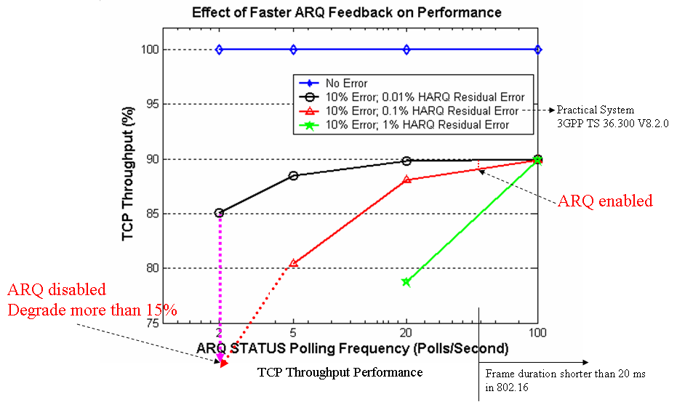
Figure 1: TCP Throughput in 3GPP system (HARQ vs ARQ)
Compared with two cases of 0.01% HARQ residual error (curve in black) and 0.1% HARQ residual error (curve in red), TCP throughput decreases more than 15% in ARQ disabled case and less than 2% in ARQ enabled case. It is evident that enabling ARQ in wireless transmission can prevent TCP throughput from degradation although HARQ is performed.
TCP performance for HARQ cooperated with or without ARQ is showed in [1]. The result shows that one-hop wireless transmission (3GPP) without ARQ will introduce a low TCP performance. It is no doubt that wireless transmission for more that two hops (802.16j) will cause lower TCP performance if ARQ is not supported in relay links. To maintain adequate end-to-end TCP throughput between MR-BS and MS, relay link should provide ARQ support.

  - Why relay links needs ARQ?
Compared with one-hop, multi-hop transmission in relay links faces extra issues, which might degrade system performance. Optional relay support for end-to-end ARQ shall provide some benefits in resource utilization and transmission. For some connections with strict QoS requirements, the functionality can help to achieve the requirements.
    - Increase Resource Utilization
End-to-End ARQ without relay support shall introduce end-to-end retransmission. Figure 2-a shows an example of this case. End-to-end retransmission of 2 data is triggered from MR-BS to MS even when these 2 data only fails in last hop (RS2 to MS). The retransmission between MR-BS to RS1 and RS1 to RS2 is redundant and waste scare radio resource. In this case, retransmission shall be only performed in last hop.
In Figure 2-b, the two redundant retransmissions can be avoided if RS1 and RS2 both support end-to-end ARQ and do not perform retransmission. After that, the resource for retransmission from BS to RS2 can be saved, and then resource utilization increases.
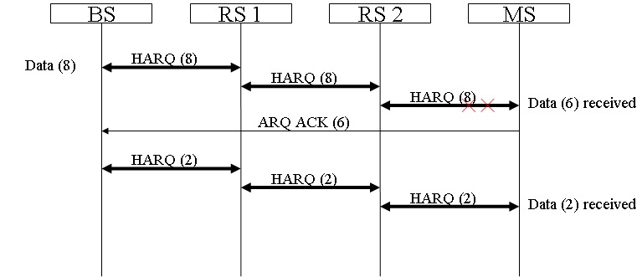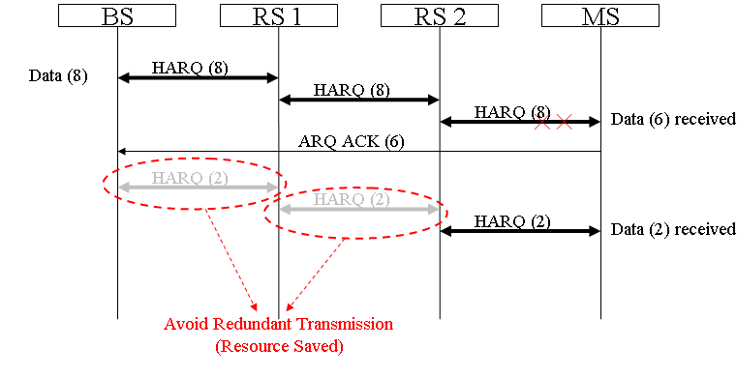
(a) Per-Hop HARQ without relay ARQ support (b) Per-Hop HARQ with relay ARQ support
Figure 2: Resource Utilization

    - Reduce End-to-End Transmission Delay
Due to multi-hop environment, data transmission in relay network would experience more transmission links and introduce longer delay. Moreover, retransmission triggered by the end station would double the transmission delay. In some cases, data may only need to be retransmitted in some relay links so that the delay for retransmission can be reduced. As showed in Figure 3-a, the end-to-end transmission delay is about 12t if 2 data is transmitted with error in last hop, where t denotes as per-hop transmission delay. In Figure 3-b, if RS2 provides relay support for end-to-end ARQ, local retransmission from RS2 to MS can be performed between RS2 and MS. RS2 relays end-to-end ARQ ACK toward MR-BS and triggers retransmission for the error data (in distribution scheduling). As a result, the end-to-end delay for this transaction is about 8t. It is easy to show that end-to-end transmission delay can be reduced by RS with relay support for end-to-end ARQ.

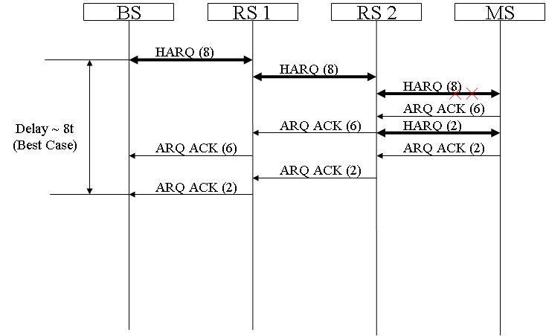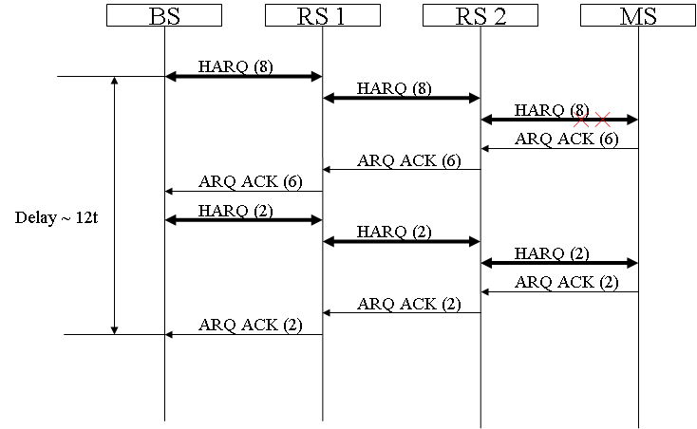
(a) End-to-End ARQ without relay support (b) End-to-End ARQ with relay support
Figure 3: End-to-End Transmission Delay,

- Summary
- Through [1][2], wireless network needs ARQ to maintain TCP throughput, especially relay networks.
- RS with relay support for end-to-end ARQ can save radio resource wasted in redundant retransmission.
- Local transmission for RS can decrease end-to-end transmission delay and met some strict QoS requirements in advance.
- RS with relay functionality shall support end-to-end ARQ and consist with 16e ARQ

- Text Proposal
---------------------------------------------------------Start of the Text--------------------------------------------------------
[Adopt the following text modification into the P802.16j baseline document]

[Modify section 6.3.4.6.4 as following]

6.3.4.6.4 Relay support for ARQ modifications for relaying

Insert the following text in 6.3.4.6.4:

In MR systems, ARQ operation is only performed between an MR-BS and an MS. RS may support for feedback and retransmission.

6.3.4.6.4.1 Optional relay support ARQ

Optional relay support for ARQ is end-to-end based operations.
If relay support for ARQ is enabled Allocation Subheader may be appeared in relay MPDU. If Allocation Subheader is presented in relay MPDUs, ARQ indication bit shall be set to 1 to indicate ARQ connection existed in the allocation. Figure 54a shows an example when Allocation Subheader is presented in relay MPDU.

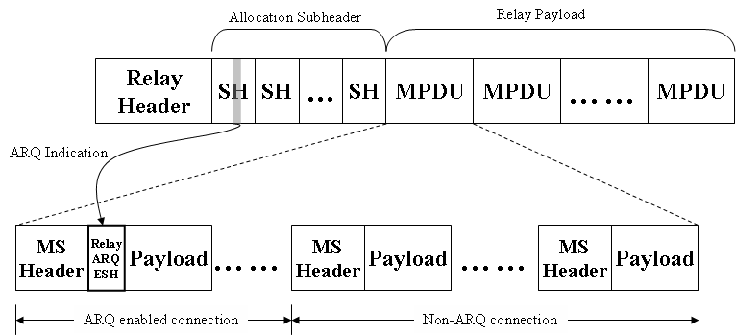
Figure 54a – Relay ARQ support (if Allocation Subheaders are presented)

If relay support for ARQ is enabled, RS shall send feedback information toward BS to facilitate resource allocation and transmissions along the relay path. The feedback information shall contain the transmission status of the RS and appended in the feedback message it received.

In MR system, each RS shall maintain timer of round trip delay (RTD) from itself to the receiving station for each ARQ-enabled connection. The RTD shall be configured to ensure the receiving of feedback messages from the receiving station, e.g. MS for downlink, RS for downlink/uplink, and MR-BS for uplink. Before the RTD expired, the intermediate RS shall append its ARQ-Feedback status into the received ARQ Feedback message and relay to transmitter. The ARQ feedback IE is specified in 6.3.4.2. After sending out the ARQ_Feedback message, the RTD timer shall be reset. If the timer is expired, a standalone ARQ-Feedback message shall be sent out to transmitter by RS for reporting the ARQ-Feedback status. The RTD time may be configured based on the round-trip time between RS and the receiving station, and plus adequate timing offset, including data processing, Tx/Rx transition, and so on.

The example operations of supporting for ARQ are illustrated in Figure 54b.

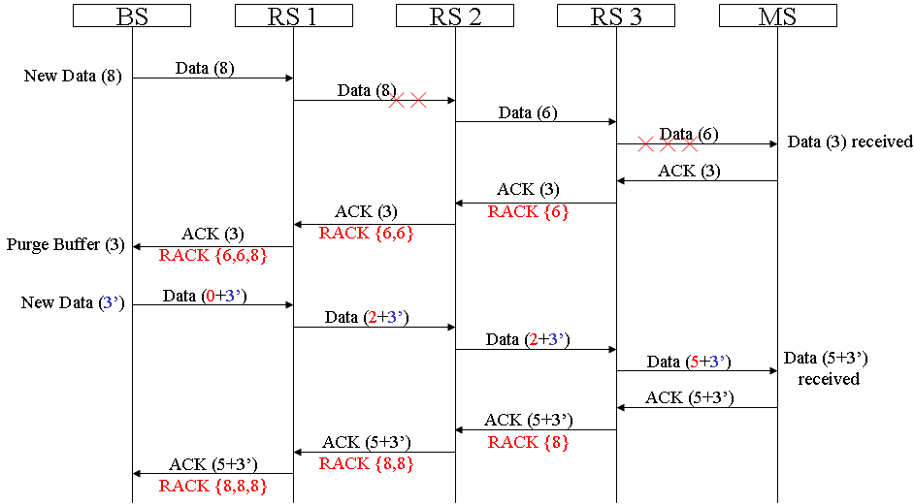
Figure 54b – Relay Support for ARQ

6.3.4.6.4.2 Transmitter state machine of RS support for ARQ

In MR system, a relayed ARQ block may be in one of the following states – not-sent, outstanding, discard, and waiting-for-retransmission. Any relayed ARQ block begins as not-sent. After it is sent, it becomes outstanding for a period of time termed ARQ_RETRY_TIMEOUT. While a block is in outstanding state, it is either acknowledged or discarded by MS, or transitions to wait for retransmission after ARQ_RETRY_TIMEOUT or NACK from MS or RS, or stay in outstanding state after receiving RACK from RS. A relayed ARQ block can become wait-for-retransmission before the ARQ_RETRY_TIMEOUT period expires if it is negatively acknowledged. A relayed ARQ block may also change from waiting-for-retransmission to discard after a timeout ARQ_BLOCK_LIFETIME.

For a given connection the transmitter shall first (transmit or discard) blocks in “waiting-for-retransmission” state and only then blocks in “non-sent” state. Blocks in “outstanding” or “discarded” state shall not be transmitted. When blocks are retransmitted, the block with the lowest BSN shall be retransmitted first.

The ARQ transmit block state sequence for RS is shown in Figure 54c

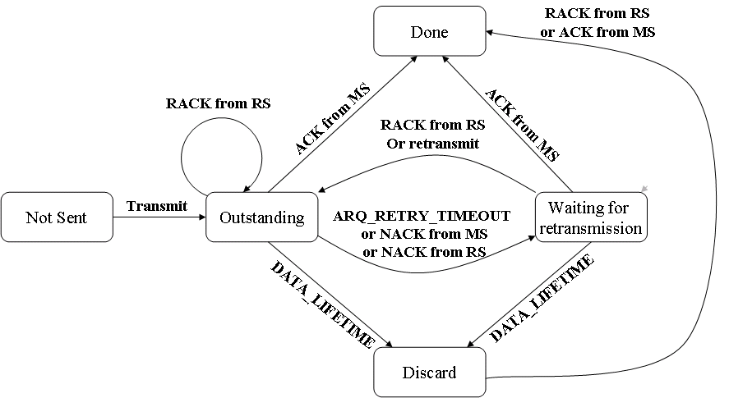
Figure 54c – Relay Support for ARQ Transmit Block States of RS

[Modify the following text in Section 6.3.2.2.7]

Table 25-Description of extended subheader types (DL)
Extended  subheader type | Name | Extended subheader  Body size (byte) | Description
0 | SDU_SN extended subheader | 1 | See 6.3.2.2.7.1
1 | DL sleep control extended subheader | 3 | See 6.3.2.2.7.2
2 | Feedback request extended subheader | 3 | See 6.3.2.2.7.3
3 | SN request extended subheader | 1 | See 6.3.2.2.7.4
4 | PDU SN(short) extended subheader | 1 | See 6.3.2.2.7.5
5 | PDU SN(long) extended subheader | 2 | See 6.3.2.2.7.6
6-127 | Reserved Relay support for ARQ extended subheader | —1 | See 6.3.2.2.8.3
7-127 | Reserved | — | —

Table26-Description of extended subheader types (UL)
Extended  subheader type | Name | Extended subheader  Body size (byte) | Description
0 | MIMO mode feedback extended subheader | 1 | See 6.3.2.2.7.4
1 | UL Tx power report extended subheader | 1 | See 6.3.2.2.7.5
2 | Mini-feedback extended subheader | 2 | See 6.3.2.2.7.3
3 | PDU SN(short) extended subheader | 1 | See 6.3.2.2.7.8
4 | PDU SN(long) extended subheader | 2 | See 6.3.2.2.7.8
5-127 | Reserved Relay support for ARQ extended subheader | —1 | See 6.3.2.2.8.3
6-127 | Reserved | — | —

[Modify the following text in Section 6.3.2.2.8.2]

6.3.2.2.8.2 Allocation Subheader

The MR-BS may include the Allocation subheader in a relay MAC PDU to instruct the RS when to relay the MAC PDU. When included, the MR-BS shall use one Allocation subheader per RS for the relay link, and one or more Allocation subheader for the access link. The Allocation subheaders corresponding to the relay link shall precede the ones for access link. The access RS shall use the continuation bit in the Allocation Subheader to detect whether there is a subsequent Allocation subheader. The Allocation subheader shall be the last subheader before the payload.

Table 37b—Allocation subheader format
Syntax | Size | Note
Allocation Subheader {
Target Transmission Frame | 6 bits | LSB 6 bits of frame number of the frame hat RS shall transmit the MAC PDU
Allocation Index | 6 bits | Allocation Index pointing to DL-MAP-IE in the MAP message
Number of MAC PDUs | 37 bits | Number of MAC PDUs in this allocation
Continuation | 1 bits | 1: Another Allocation subheader follows  0: This is the last Allocation Subheader for the RS
ARQ Indication | 1 bits | ARQ connection indication  1: ARQ connection presented  0: No ARQ connection absented
Reserved | 3 bits
}

Note : If ARQ indication bits is set, processing MPDUs in the allocation for relay ARQ is required

Insert new subclause after 6.3.2.2.8.2:

6.3.2.2.8.3 Relay ARQ extended subheader

The Relay ARQ extended subheader shall be used for ARQ enabled connections and only applied in relay links. If the ESF bit in Relay MAC header field (see Table 7a) and the extended type field of Relay support for ARQ extended subheader (see Table 25 or Table 26) are both set, the Relay ARQ Feedback Payload shall be transported. If packing is used, it shall be transported as the first packed payload. See 6.3.3.4.3.

[Modify the following text in Section 11.7.28]

11.7.8.10 MR MAC features support

This TLV indicates the MR features supported by the RS and the MR-BS

Type | Length | Value | Scope
49 | 3 | Bit #0: Centralized scheduling mode support  Bit #1: Distributed scheduling mode support  Bit #2: NBR-ADV generating support  Bit #3: Tunnel packet mode support  Bit #4: Tunnel burst mode support  Bit #5: RS mobility support  Bit #6: Subordinate RS network entry support  Bit #7: Location support  Bit #8: Multicast management support  Bit #9: DL Flow control  Bit #10: MRS mode  Bit #11: RS centralized security support  Bit #12: RS distributed security support  Bit #13: Embedded path management support  Bit #14: Explicit path management support  Bit #15: Burst-based forwarding support  Bit #16: Local CID allocation support  Bit #17-#23 : Reserved Relay support for ARQ  Bit #18-#23: Reserved | REG-REQ  REG-RSP

---------------------------------------------------------End of the Text--------------------------------------------------------

Reference
[1] “Retransmission: HARQ-ARQ Interactions”, 3GPP TSG RAN WG2 LTE AdHoc - R2-061942
[2] “Evolved Universal Terrestrial Radio Access (E-UTRA) and Evolved Universal Terrestrial Radio Access Network (E-UTRAN)”, 3GPP TS 36.300 V8.2.0
[3] “Technical Comments to P802.16j Baseline Document: 6.3.4 ARQ Operation - MR-ARQ”, IEEE C80216j-07_470r2, September 2007
[4] “Air Interface for Fixed and Mobile Broadband Wireless Access Systems - Multihop Relay Specification”, IEEE 802.16j-06/D2, December 2007

