Project | IEEE 802.16 Broadband Wireless Access Working Group <http://ieee802.org/16>
Title | Technical Comments to P802.16j/D2: Relay support for End-to-End ARQ
Date Submitted | 2008-01-21
Source(s) | Tzu-Ming Lin, Fang-Ching Ren, Chie-Ming Chou  ITRI  ICL/M100, 195 Chung Hsing Rd., Sec.4 Chu Tung, Hsin Chu, Taiwan 310, R.O.C.  Wern-Ho Sheen  ITRI/NCTU  1001 Ta Hsueh Road, Hsinchu, Taiwan 300, ROC | Voice: +886-3-5916020  E-mail: tmlin@itri.org.tw  Voice: +886-3-5916020  E-mail: whsheen@itri.org.tw
Re: | IEEE 802.16j-07/059: IEEE 802.16 Working Group Letter Ballot Recirc #28a
Abstract | This contribution provides relay support for end-to-end ARQ in the P802.16j/D2
Purpose | To incorporate the proposed text into the P802.16j/D2
Notice | This document does not represent the agreed views of the IEEE 802.16 Working Group or any of its subgroups. It represents only the views of the participants listed in the “Source(s)” field above. It is offered as a basis for discussion. It is not binding on the contributor(s), who reserve(s) the right to add, amend or withdraw material contained herein.
Release | The contributor grants a free, irrevocable license to the IEEE to incorporate material contained in this contribution, and any modifications thereof, in the creation of an IEEE Standards publication; to copyright in the IEEE’s name any IEEE Standards publication even though it may include portions of this contribution; and at the IEEE’s sole discretion to permit others to reproduce in whole or in part the resulting IEEE Standards publication. The contributor also acknowledges and accepts that this contribution may be made public by IEEE 802.16.
Patent Policy | The contributor is familiar with the IEEE-SA Patent Policy and Procedures:  <http://standards.ieee.org/guides/bylaws/sect6-7.html#6> and <http://standards.ieee.org/guides/opman/sect6.html#6.3>.  Further information is located at <http://standards.ieee.org/board/pat/pat-material.html> and <http://standards.ieee.org/board/pat>.
Technical Comments to P802.16j/D2:
Relay support for End-to-End ARQ

Tzu-Ming Lin, Fang-Ching Ren, Chie-Ming Chou, Wern-Ho Sheen
ITRI/NCTU

- Introduction
In section 6.3.4.6.4, ARQ operation between MR-BS and MS is specified. If some packet error occurs during the forwarding, the retransmission shall go back to the transceiver, e.g. MR-BR for downlink or MS for uplink. Redundant retransmission may be performed in end-to-end basis even if some access RSs already have the correct copy of the data. The redundant retransmission shall be avoid and limited for saving scare radio resource. According to texts in section 6.3.1.3, all connection types in PMPmode shall be supported between MR-BR and MS. The RS shall support ARQ connections between MR-BS and MS also. This contribution proposes an extended subheader appended in MS’s ARQ feedback to avoid redundant retransmission for supporting ARQ connections soecified in PMP mode.

- Problem Definition
  - Resource Utilization
End-to-End ARQ without relay support shall introduce end-to-end retransmission. Figure 1-a shows an example of this case. End-to-end retransmission of 2 data is triggered from MR-BS to MS even when these 2 data only fails in last hop (RS2 to MS). The retransmissions from MR-BS to RS1 and RS1 to RS2 are redundant and waste scare radio resource. In this case, retransmission shall be only performed in last hop.
In Figure 1-b, the two redundant retransmissions can be avoided if RS1 and RS2 both support end-to-end ARQ so that redundant retransmission can be avoided. After that, the resource for retransmission from BS to RS2 can be saved, and then resource utilization increases.
Besides that, end-to-end retransmission will increase the packet error rate and introduce another retransmission.
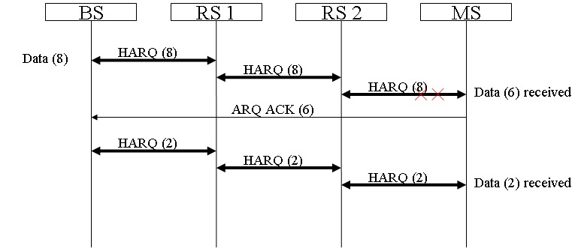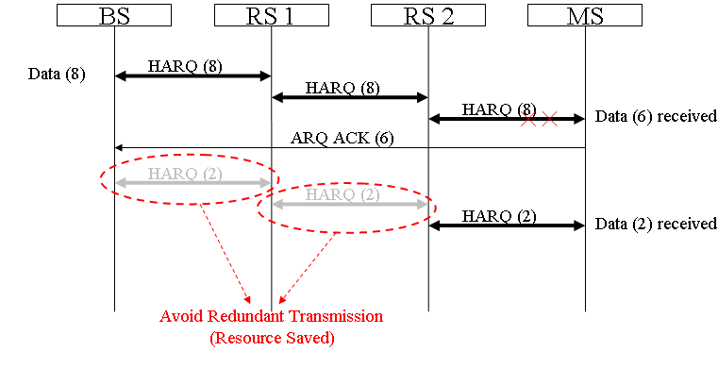
(a) Per-Hop HARQ without relay ARQ support (b) Per-Hop HARQ with relay ARQ support
Figure 1: Resource Utilization

  - End-to-End Transmission Delay
In multi-hop environment, data transmission in relay network would experience more transmission links and introduces longer delay. Moreover, retransmission triggered by the end station would increase the transmission delay, e.g. 1 retransmission would double the delay of 1 successful transmission. In some cases, data may only need to be retransmitted in particular relay links so that the delay for retransmission can be shortened. As showed in Figure 2-a, the end-to-end transmission delay in successful transmission is 6t, where t is one-hop transmission delay. If some packet error happens, e.g. 2 data errors in access link, the end-to-end transmission delay will increase to 12t. In Figure 2-b, if RS2 provides relay support for end-to-end ARQ, local retransmission from RS2 to MS can be performed. RS2 relays end-to-end ARQ ACK with additional information toward MR-BS and triggers local retransmission for the error data. The transmission delay would be reduced. In distributed scheduling case, RS 2 can trigger local retransmission immediately, and the delay may be reduced to 8t. It is easy to show that end-to-end transmission delay can be reduced by RS with relay support for end-to-end ARQ. For some services with strict QoS requirements, delay issue shall be considered seriously.

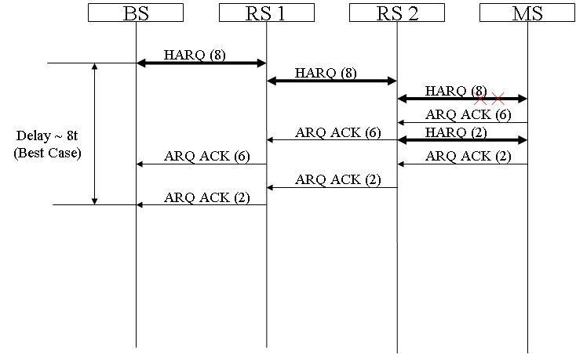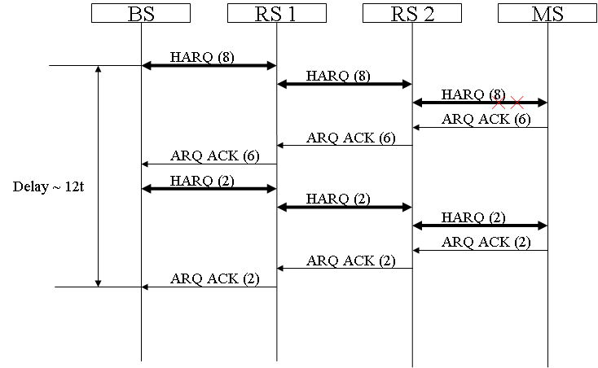
(a) End-to-End ARQ without relay support (b) End-to-End ARQ with relay support
Figure 2: End-to-End Transmission Delay

- Summary
- ARQ specified in current standard performs ARQ in an end-to-end basis.
- When packet error occurs, current end-to-end ARQ wastes radio resource in redundant retransmissions and may face another retransmission due to end-to-end retransmission.
- End-to-end retransmission introduces longer retransmission delay, which is harmful to some services with strict QoS requirement.
- RS provides ARQ support can help for reducing redundant retransmission so that resource utilization is increased and transmission delay is shortened when packet error is occurred.
- RS support for end-to-end ARQ shall be consisting with the ARQ operations between MR-BS and MS.

- Text Proposal
---------------------------------------------------------Start of the Text--------------------------------------------------------
[Adopt the following text modification into the P802.16j baseline document]

[Modify section 6.3.4.6.4 as following]

6.3.4.6.4 Relay support for ARQ modifications for relaying

Insert the following text in 6.3.4.6.4:

In MR systems, ARQ operation is only performed between an MR-BS and an MS. RS shall support ARQ for feedback and retransmission if ARQ is enabled.

6.3.4.6.4.1 Optional relay support ARQ

Optional relay support for ARQ is used to support ARQ specified in PMP mode (Section 6.3.4).

If relay support for ARQ is enabled, RS shall send feedback information (Relay ACK) toward BS to facilitate resource allocation and transmissions along the relay path. The feedback information shall contain the transmission status of the RS and appended in the feedback message it received.

In MR system, each RS shall maintain a timer of round trip delay (RTD) from itself to the receiving station. The RTD shall be configured to ensure the receiving of feedback messages from the receiving station, e.g. MS for downlink, RS for downlink/uplink, and MR-BS for uplink. Before the RTD expired, the access RS shall append its ARQ-Feedback status into the received ARQ Feedback message and relay to transmitter. The ARQ feedback IE is specified in 6.3.4.2. After sending out the ARQ_Feedback message, the RTD timer shall be reset. If the timer is expired, a standalone ARQ-Feedback message shall be sent out to transmitter by RS for reporting the ARQ-Feedback status. The RTD time may be configured based on the round-trip time between RS and the receiving station, and plus adequate timing offset, including data processing, Tx/Rx transition, and so on.

The example operations of supporting for ARQ are illustrated in Figure 54a, 54b, 54c,and 54d. The Data illustrated may be MPDU, Fragmented MPDU, or Packing MPDU.

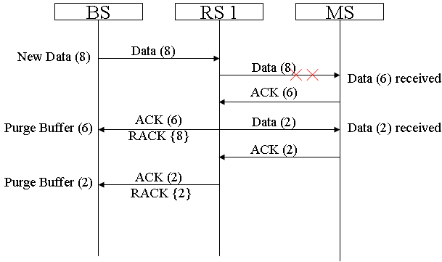
Figure 54a – Two-Hop Example of Relay Support for ARQ : Data Error in Access Link

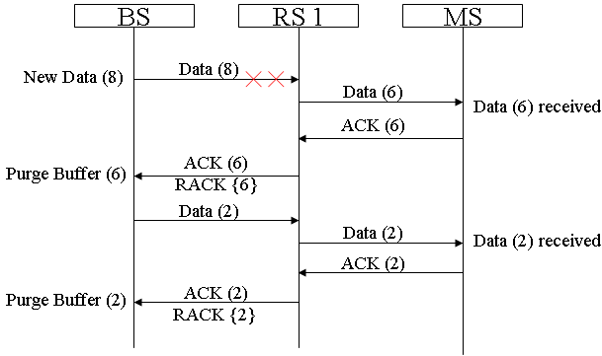
Figure 54b – Two-Hop Example of Relay Support for ARQ : Data Error in Relay Link

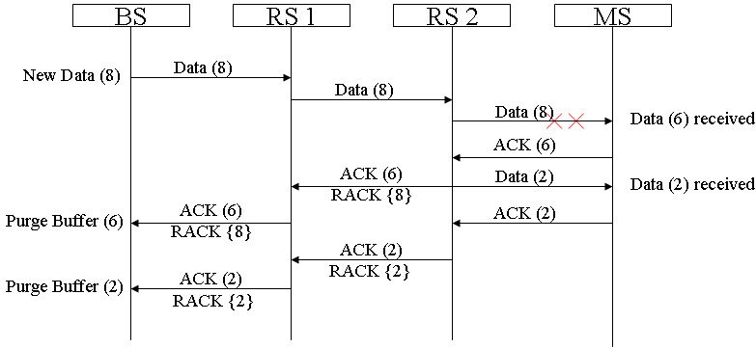
Figure 54c – Multi-Hop Example of Relay Support for ARQ : Data Error in Access Link

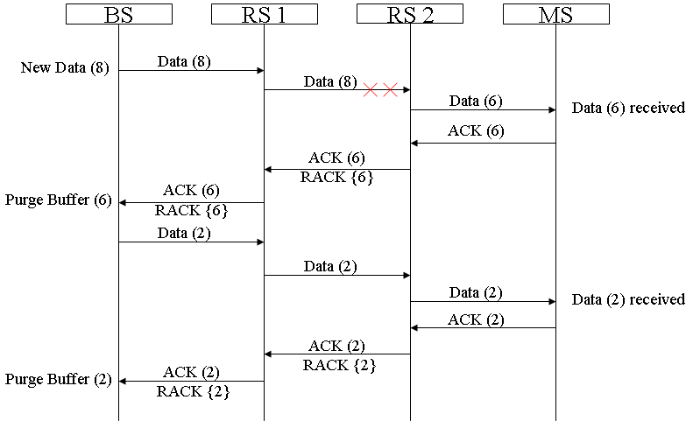
Figure 54d – Multi-Hop Example of Relay Support for ARQ : Data Error in Relay Link

6.3.4.6.4.2 Transmitter state machine of RS support for ARQ

In MR system, a relayed ARQ block may be in one of the following states – not-sent, outstanding, discard, and waiting-for-retransmission. Any relayed ARQ block begins as not-sent. After it is sent, it becomes outstanding for a period of time termed ARQ_RETRY_TIMEOUT. While a block is in outstanding state, it is either acknowledged or discarded by MS, or transitions to wait for retransmission after ARQ_RETRY_TIMEOUT or NACK from MS or RS, or stay in outstanding state after receiving RACK from RS. A relayed ARQ block can become wait-for-retransmission before the ARQ_RETRY_TIMEOUT period expires if it is negatively acknowledged. A relayed ARQ block may also change from waiting-for-retransmission to discard after a timeout ARQ_BLOCK_LIFETIME.

For a given connection the transmitter shall first (transmit or discard) blocks in “waiting-for-retransmission” state and only then blocks in “non-sent” state. Blocks in “outstanding” or “discarded” state shall not be transmitted. When blocks are retransmitted, the block with the lowest BSN shall be retransmitted first.

The ARQ transmit block state sequence for RS is shown in Figure 54e
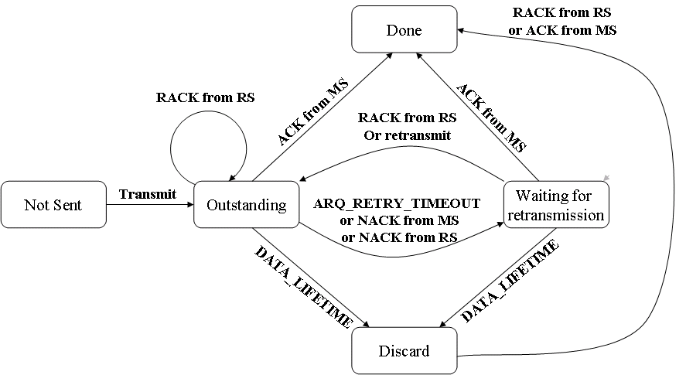
Figure 54e – Relay Support for ARQ Transmit Block States of RS

[Modify the following text in Section 6.3.2.2.7]

Table 25-Description of extended subheader types (DL)
Extended  subheader type | Name | Extended subheader  Body size (byte) | Description
0 | SDU_SN extended subheader | 1 | See 6.3.2.2.7.1
1 | DL sleep control extended subheader | 3 | See 6.3.2.2.7.2
2 | Feedback request extended subheader | 3 | See 6.3.2.2.7.3
3 | SN request extended subheader | 1 | See 6.3.2.2.7.4
4 | PDU SN(short) extended subheader | 1 | See 6.3.2.2.7.5
5 | PDU SN(long) extended subheader | 2 | See 6.3.2.2.7.6
6-127 | Reserved Relay support for ARQ extended subheader | —1 | See 6.3.2.2.8.3
7-127 | Reserved | — | —

Table26-Description of extended subheader types (UL)
Extended  subheader type | Name | Extended subheader  Body size (byte) | Description
0 | MIMO mode feedback extended subheader | 1 | See 6.3.2.2.7.4
1 | UL Tx power report extended subheader | 1 | See 6.3.2.2.7.5
2 | Mini-feedback extended subheader | 2 | See 6.3.2.2.7.3
3 | PDU SN(short) extended subheader | 1 | See 6.3.2.2.7.8
4 | PDU SN(long) extended subheader | 2 | See 6.3.2.2.7.8
5-127 | Reserved Relay support for ARQ extended subheader | —1 | See 6.3.2.2.8.3
6-127 | Reserved | — | —

Insert new subclause after 6.3.2.2.8.3

6.3.2.2.8.3 Relay support for ARQ extended subheader

The Relay ARQ extended subheader shall be used for ARQ enabled connections and only applied in relay links. If the ESF bit in Relay MAC header field (see Table 7a) and the extended type field of Relay support for ARQ extended subheader (see Table 25 or Table 26) are both set, the Relay ARQ Feedback Payload shall be transported. If packing is used, it shall be transported as the first packed payload. See 6.3.3.4.3.

[Modify the following text in Section 11.7.28]

11.7.8.10 MR MAC features support

This TLV indicates the MR features supported by the RS and the MR-BS

Type | Length | Value | Scope
49 | 3 | Bit #0: Centralized scheduling mode support  Bit #1: Distributed scheduling mode support  Bit #2: NBR-ADV generating support  Bit #3: Tunnel packet mode support  Bit #4: Tunnel burst mode support  Bit #5: RS mobility support  Bit #6: Subordinate RS network entry support  Bit #7: Location support  Bit #8: Multicast management support  Bit #9: DL Flow control  Bit #10: MRS mode  Bit #11: RS centralized security support  Bit #12: RS distributed security support  Bit #13: Embedded path management support  Bit #14: Explicit path management support  Bit #15: Burst-based forwarding support  Bit #16: Local CID allocation support  Bit #17-#23 : Reserved Relay support for ARQ  Bit #18-#23: Reserved | REG-REQ  REG-RSP

---------------------------------------------------------End of the Text--------------------------------------------------------

Reference
[1] “Retransmission: HARQ-ARQ Interactions”, 3GPP TSG RAN WG2 LTE AdHoc - R2-061942
[2] “Evolved Universal Terrestrial Radio Access (E-UTRA) and Evolved Universal Terrestrial Radio Access Network (E-UTRAN)”, 3GPP TS 36.300 V8.2.0
[3] “Technical Comments to P802.16j Baseline Document: 6.3.4 ARQ Operation - MR-ARQ”, IEEE C80216j-07_470r2, September 2007
[4] “Air Interface for Fixed and Mobile Broadband Wireless Access Systems - Multihop Relay Specification”, IEEE 802.16j-06/D2, December 2007

