Project | IEEE 802.16 Broadband Wireless Access Working Group <http://ieee802.org/16>
Title | Tunnel Burst Mode clarification for Centralized Scheduling
Date Submitted | 2008-01-14
Source(s) | Tzu-Ming Lin, Wern-Ho Sheen, Fang-Ching Ren, Chie-Ming Chou  ITRI/NCTU  195,Sec. 4, Chung Hsing Rd.  Chutung, Hsinchu, Taiwan 310, R.O.C | E-mail: tmlin@itri.org.tw
Re: | To incorporate the proposed text into the P802.16j/D2 Baseline Document
Abstract | This contribution provides the clarification of tunnel burst mode in centralized scheduling.
Purpose | To make IEEE Project 802.16j more mature
Notice | This document does not represent the agreed views of the IEEE 802.16 Working Group or any of its subgroups. It represents only the views of the participants listed in the “Source(s)” field above. It is offered as a basis for discussion. It is not binding on the contributor(s), who reserve(s) the right to add, amend or withdraw material contained herein.
Release | The contributor grants a free, irrevocable license to the IEEE to incorporate material contained in this contribution, and any modifications thereof, in the creation of an IEEE Standards publication; to copyright in the IEEE’s name any IEEE Standards publication even though it may include portions of this contribution; and at the IEEE’s sole discretion to permit others to reproduce in whole or in part the resulting IEEE Standards publication. The contributor also acknowledges and accepts that this contribution may be made public by IEEE 802.16.
Patent Policy | The contributor is familiar with the IEEE-SA Patent Policy and Procedures:  <http://standards.ieee.org/guides/bylaws/sect6-7.html#6> and <http://standards.ieee.org/guides/opman/sect6.html#6.3>.  Further information is located at <http://standards.ieee.org/board/pat/pat-material.html> and <http://standards.ieee.org/board/pat>.
Tunnel Burst Mode clarification for Distributed Scheduling

Tzu-Ming Lin, Wern-Ho Sheen, Fang-Ching Ren, Chie-Ming Chou
ITRI/NCTU
- Introduction
In the transmission case of non-transparent RS in two hop and multi-hop topology, Tunnel Burst Mode can be applied for centralized scheduling mode. This contribution provides the clarification of tunnel burst mode in this case.
- Clarification for Tunnel Burst Mode in Centralized Scheduling Case
In centralized scheduling, MR-BS determined the bandwidth allocation and generates the corresponding MAPs for all access and relay links in the MR-cell. By transmission of RS_Relay-MAP (6.3.2.3.91) and RS_Access-MAP (6.3.2.3.90), the bandwidth allocation can be distributed to RSs. In 802.16j/D2, the transmission of management messages, e.g. RS_Config-CMD, RS_MOB_MEAS-REP, RS_Relay-MAP and RS_Access-MAP can be conveyed by management tunnel connection, which shall be more reliable.
Tunnel burst mode and centralized scheduling both have been specified in 16j D2 for PDU transmission and resource allocation. Figure 1 shows the collaboration of these two methods. When tunnel burst mode is applied in centralized scheduling, MR-BS allocates resource for 1st, 2nd, 3rd, and access links, and forwards the allocation results to RS1, RS2, and RS3 using management tunnel with MT-CID 6, 7,8 respectively. For example, MR-BS sends RS_Relay-MAP 3’ to RS1 with MT-CID 6, RS_Relay-MAP 3’’ to RS2 with MT-CID 7, and RS-Access-MAP w/x/y/z to RS3 with MT-CID 8. After receiving the RS_Relay-MAP through tunnel, the RS can broadcast the received MAP and tunnel burst to next station without processing. Take RS2 as an example in figure 1, RS2 receives a relay-MAP 3’’ in RS_Relay MAP by MT-CID 7. Without any processing, RS2 broadcast MAP 3’’ and forwards the tunnel burst wxyz to RS3. MR-BS can also distribute access MAP to RS3 so that RS3 can broadcast MAP w/x/y/z, and transmit access bursts w/x/y/z to SSs.
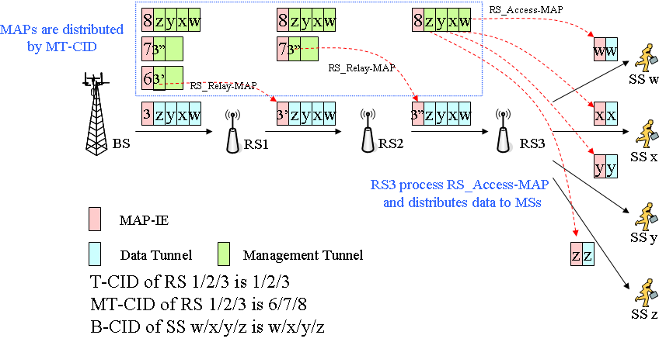

- Text Proposal
---------------------------------------------------------Start of the Text--------------------------------------------------------
[Adopt the following text modification into the P802.16j baseline document]

[Modify section 6.3.3.8 as following]

In case of a non-transparent RS in a two-hop topology, either the Tunnel Packet mode, Tunnel Burst mode with centralized scheduling, or the CID based forwarding mode is used.

In case of a non-transparent RS in a multi-hop topology, the tunnel packet mode, tunnel burst mode, and the CID based forwarding mode can be used. for centralized as well as distributed scheduling mode RSs while the tunnel burst mode can be used for distributed scheduling mode RSs.

---------------------------------------------------------End of the Text--------------------------------------------------------

Reference
- “Air Interface for Fixed and Mobile Broadband Wireless Access Systems - Multihop Relay Specification”, IEEE 802.16j-06/D2, December 2007

