Project | IEEE 802.16 Broadband Wireless Access Working Group <http://ieee802.org/16>
Title | Tunnel Burst Mode clarification for Centralized Scheduling
Date Submitted | 2008-01-21
Source(s) | Tzu-Ming Lin, Fang-Ching Ren, Chie-Ming Chou  ITRI  ICL/M100, 195 Chung Hsing Rd., Sec.4 Chu Tung, Hsin Chu, Taiwan 310, R.O.C.  Wern-Ho Sheen  ITRI/NCTU  1001 Ta Hsueh Road, Hsinchu, Taiwan 300, ROC | Voice: +886-3-5916020  E-mail: tmlin@itri.org.tw  Voice: +886-3-5916020  E-mail: whsheen@itri.org.tw
Re: | IEEE 802.16j-07/059: IEEE 802.16 Working Group Letter Ballot Recirc #28a
Abstract | This contribution provides the clarification of tunnel burst mode in centralized scheduling.
Purpose | To incorporate the proposed text into the P802.16j/D2
Notice | This document does not represent the agreed views of the IEEE 802.16 Working Group or any of its subgroups. It represents only the views of the participants listed in the “Source(s)” field above. It is offered as a basis for discussion. It is not binding on the contributor(s), who reserve(s) the right to add, amend or withdraw material contained herein.
Release | The contributor grants a free, irrevocable license to the IEEE to incorporate material contained in this contribution, and any modifications thereof, in the creation of an IEEE Standards publication; to copyright in the IEEE’s name any IEEE Standards publication even though it may include portions of this contribution; and at the IEEE’s sole discretion to permit others to reproduce in whole or in part the resulting IEEE Standards publication. The contributor also acknowledges and accepts that this contribution may be made public by IEEE 802.16.
Patent Policy | The contributor is familiar with the IEEE-SA Patent Policy and Procedures:  <http://standards.ieee.org/guides/bylaws/sect6-7.html#6> and <http://standards.ieee.org/guides/opman/sect6.html#6.3>.  Further information is located at <http://standards.ieee.org/board/pat/pat-material.html> and <http://standards.ieee.org/board/pat>.
Tunnel Burst Mode clarification for Centralized Scheduling

Tzu-Ming Lin, Fang-Ching Ren, Chie-Ming Chou, Wern-Ho Sheen
ITRI/NCTU
- Introduction
In the transmission case of non-transparent RS in two hop and multi-hop topology, Tunnel Burst Mode can be applied for centralized scheduling mode. This contribution provides the clarification of tunnel burst mode in this case.
- Background – Centralized Scheduling
Figure 1~3 brief the operations of centralized scheduling. In first phase, MR-BS sends an RS_Access-MAP after scheduling and resource allocation. In that management message, resource allocation of access link is included. The forwarding of this management message can be one of the forwarding methods defined in current draft. If multi-hop case is applied, the MR-BS shall send out a RS Relay-MAP for indicating the resource in relay links.
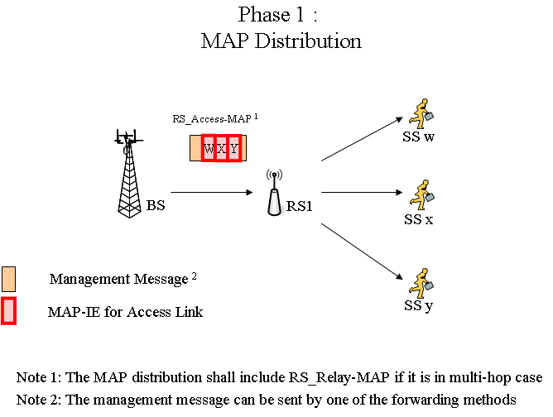
Figure 1: MAP Distribution in Centralized Scheduling

In Figure 2, the relay link forwarding is illustrated. MR-BS send out relay data to access RS by one of the forwarding method defined in current draft. The forwarding method may be independent of the method used in phase 1. In this phase, access RS buffers the MAP-IEs received in phase 1.
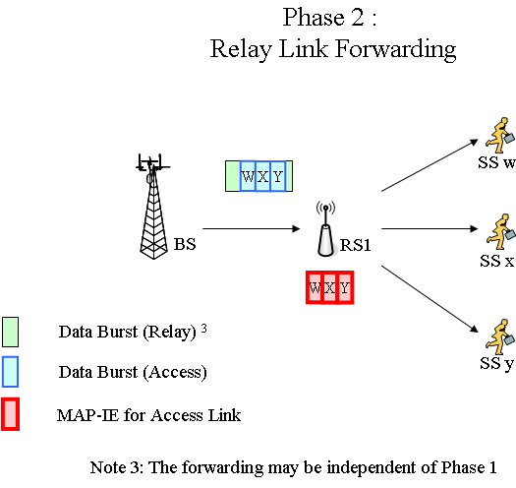
Figure 2: Relay Link Forwarding in Centralized Scheduling

In phase 3, access RS transmits the received MAP in phase 1 and forwards the data burst according to the indication in the received MAP in access link.
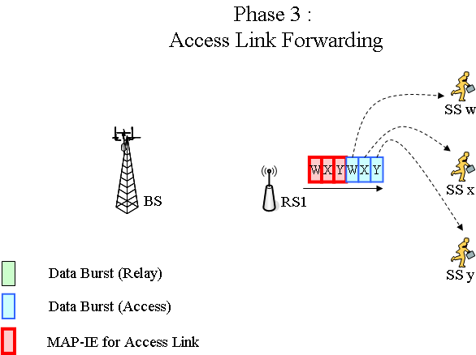
Figure 3: Access Link Forwarding in Centralized Scheduling

- Tunnel Burst Mode supported Centralized Scheduling
As decrypted in previous section, data forwarding for centralized scheduling is well defined in current draft. With the usage of T-CID defined in tunnel burst mode, T-CID can replace Basic-CID in MAP for indication.
Tunnel Burst Mode can be applied where centralized scheduling can applied naturally.

Following are informative comparisons of the forwarding modes along a relay path
Mode  Issues | Tunnel Packet Mode | Tunnel Burst Mode | CID based Forwarding
# of MAP-IEs  (in relay links) | Not specified  (MS B-CID : N_{MS}  RS B-CID : 1 ) | N_{tunnel} | Not specified  (MAP enabled : N_{tunnel} or N_{MS}  MAP disabled : 0 )
# of MAC headers  (in relay links) | N_{tunnel} + N_{MS} | N_{MS} | N_{MS}
Centralized Scheduling in two hop case | Useless  (packet tunnels are not needed in one- hop relay) | Multiple burst tunnels provide flexible transmissions | simple
Distributed Scheduling | Transmission Flexibility | Less Processing overhead | Transmission Flexibility

N_{RS} : # of RSs along a path;
N_{MS} : # of MSs in a RS
N_{tunnel} : # of tunnels in a RS

- Text Proposal
---------------------------------------------------------Start of the Text--------------------------------------------------------
[Adopt the following text modification into the P802.16j baseline document]

[Modify section 6.3.3.8 as following]

In case of a non-transparent RS in a two-hop topology, either the Tunnel Packet mode, Tunnel Burst mode with centralized scheduling, or the CID based forwarding mode is used.

In case of a non-transparent RS in a multi-hop topology, the tunnel packet mode, tunnel burst mode, and the CID based forwarding mode can be used. for centralized as well as distributed scheduling mode RSs while the tunnel burst mode can be used for distributed scheduling mode RSs.

---------------------------------------------------------End of the Text--------------------------------------------------------

Reference
- “Air Interface for Fixed and Mobile Broadband Wireless Access Systems - Multihop Relay Specification”, IEEE 802.16j-06/D2, December 2007

