Project | IEEE 802.16 Broadband Wireless Access Working Group <http://ieee802.org/16>
Title | Tunnel Burst Mode clarification for Distributed Scheduling
Date Submitted | 2008-01-18
Source(s) | Tzu-Ming Lin, Fang-Ching Ren, Chie-Ming Chou  ITRI  Wern-Ho Sheen  ITRI/NCTU | E-mail: tmlin@itri.org.tw
Re: | To incorporate the proposed text into the P802.16j/D2 Baseline Document
Abstract | This contribution provides the clarification of tunnel burst mode in distributed scheduling.
Purpose | To make IEEE Project 802.16j more mature
Notice | This document does not represent the agreed views of the IEEE 802.16 Working Group or any of its subgroups. It represents only the views of the participants listed in the “Source(s)” field above. It is offered as a basis for discussion. It is not binding on the contributor(s), who reserve(s) the right to add, amend or withdraw material contained herein.
Release | The contributor grants a free, irrevocable license to the IEEE to incorporate material contained in this contribution, and any modifications thereof, in the creation of an IEEE Standards publication; to copyright in the IEEE’s name any IEEE Standards publication even though it may include portions of this contribution; and at the IEEE’s sole discretion to permit others to reproduce in whole or in part the resulting IEEE Standards publication. The contributor also acknowledges and accepts that this contribution may be made public by IEEE 802.16.
Patent Policy | The contributor is familiar with the IEEE-SA Patent Policy and Procedures:  <http://standards.ieee.org/guides/bylaws/sect6-7.html#6> and <http://standards.ieee.org/guides/opman/sect6.html#6.3>.  Further information is located at <http://standards.ieee.org/board/pat/pat-material.html> and <http://standards.ieee.org/board/pat>.
Tunnel Burst Mode clarification for Distributed Scheduling

Tzu-Ming Lin, Fang-Ching Ren, Chie-Ming Chou, Wern-Ho Sheen
ITRI/NCTU
- Introduction
In the transmission case of non-transparent RS in two hop topology, Tunnel Burst Mode can be applied for distributed scheduling mode. This contribution provides the clarification of tunnel burst mode in this case.

- Clarification for Tunnel Burst Mode in Distributed Scheduling in two hop Case
Tunnel burst mode and distributed scheduling both have been specified in 16j D2 for PDU transmission and resource allocation. Figure 1 shows the collaboration of these two methods. When tunnel burst mode is applied in two hop case for distributed scheduling, MR-BR assigns or specify a T-CID for the PDUs traversing the tunnel connection. MR-BS shall also allocate a resource block for this tunnel burst in the first hop, and forward the burst toward SSs. When access RS, e.g RS1, receives the tunneled burst, the RS shall separate the received burst by distributed scheduling and allocate another radio resource for each SS. By identify the access MAP, each SS can receive access burst from the access RS. For example in Figure 1, MR-BS aggregates bursts w, x, y, z into a tunnel burst and transmits the aggregated burst with T-CID to RS 1. RS1 separates the tunnel burst into access burst w, x, y, and z, and forward these burst with B-CID w, x, y, and z in the access MAP by distributed scheduling.
Through the clarification, tunnel burst mode can be applied in two-hop case for distributed scheduling in two hop cases.
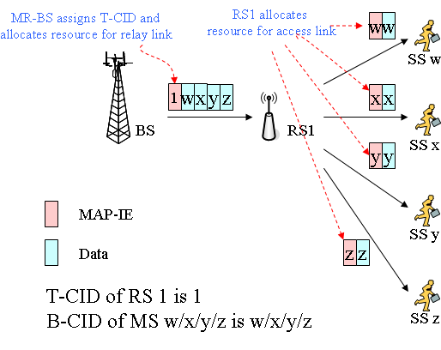
Figure 1: Tunnel Burst Mode for Distributed Scheduling in two hop case

- Text Proposal
---------------------------------------------------------Start of the Text--------------------------------------------------------
[Adopt the following text modification into the P802.16j baseline document]

[Modify section 6.3.3.8 as following]

In case of a non-transparent RS in a two-hop topology, either the Tunnel Packet mode, Tunnel Burst mode with distributed scheduling, or the CID based forwarding mode is used.

---------------------------------------------------------End of the Text--------------------------------------------------------

Reference
- “Air Interface for Fixed and Mobile Broadband Wireless Access Systems - Multihop Relay Specification”, IEEE 802.16j-06/D2, December 2007

