Project | IEEE 802.16 Broadband Wireless Access Working Group <http://ieee802.org/16>
Title | Clarification on Ranging Subchannel in the Relay Zone
Date Submitted | 2008-01-14
Source(s) | Gang Shen, Kaibin Zhang  Alcatel Shanghai Bell, Research & Innovation  388#, Ningqiao Road, Shanghai, P. R. C. | Voice: +86-21-50551240-7167  Fax: +86-21-50554554  Email: gang.a.shen@alcatel-sbell.com.cn
Re: | IEEE 802.16-07/059, IEEE 802.16 Letter Ballot Recirc #28a
Abstract | This contribution introduces some modifications regarding the ranging subchannel in the relay zone
Purpose | Discuss and adopt the proposed modifications
Notice | This document does not represent the agreed views of the IEEE 802.16 Working Group or any of its subgroups. It represents only the views of the participants listed in the “Source(s)” field above. It is offered as a basis for discussion. It is not binding on the contributor(s), who reserve(s) the right to add, amend or withdraw material contained herein.
Release | The contributor grants a free, irrevocable license to the IEEE to incorporate material contained in this contribution, and any modifications thereof, in the creation of an IEEE Standards publication; to copyright in the IEEE’s name any IEEE Standards publication even though it may include portions of this contribution; and at the IEEE’s sole discretion to permit others to reproduce in whole or in part the resulting IEEE Standards publication. The contributor also acknowledges and accepts that this contribution may be made public by IEEE 802.16.
Patent Policy | The contributor is familiar with the IEEE-SA Patent Policy and Procedures:  <http://standards.ieee.org/guides/bylaws/sect6-7.html#6> and <http://standards.ieee.org/guides/opman/sect6.html#6.3>.  Further information is located at <http://standards.ieee.org/board/pat/pat-material.html> and <http://standards.ieee.org/board/pat>.

Clarification on the Ranging subchannel in the Relay Zone

Introduction
The document is to introduce some modifications regarding ranging subchannel, as an input for call for IEEE 802.16 Letter Ballot Recirc #28a.
The ranging subchannel in the relay zone is used by RSs for ranging operations other than initial ranging. As the number of RS within a cell is much less than the number of MS, the ranging subchannel in the relay zone has low utilization with wasteful bandwidth, especially for the case that the dedicated relay uplink channel is used.
When dedicated relay uplink channel is used, RS requests bandwidth via the dedicated relay uplink channel instead of the ranging channel. From RS uplink data, the superordinate station can get the information regarding timing advance, power level, and etc., as the same information got from RS periodic ranging. When RS keeps silent for some time period, MR-BS allocates the resource and requests the RS to send something in UL, or RS send something via dedicated relay uplink channel for relay link information measurement. Thus RS periodic ranging can be omitted.
So the ranging subchannel in the relay zone can be optional. When the dedicated relay uplink channel is used, it could be removed for bandwidth efficiency.

Proposed Text Change
[Change the following texts in line 28 of page 183 as indicated]
The ranging subchannel in the access zone is used by RSs performing initial ranging and MSs for all ranging operations. The optional ranging subchannel in the relay zone is used by RSs for ranging operations other than initial ranging.
[Change the Figure 270a on page 184 as indicated]
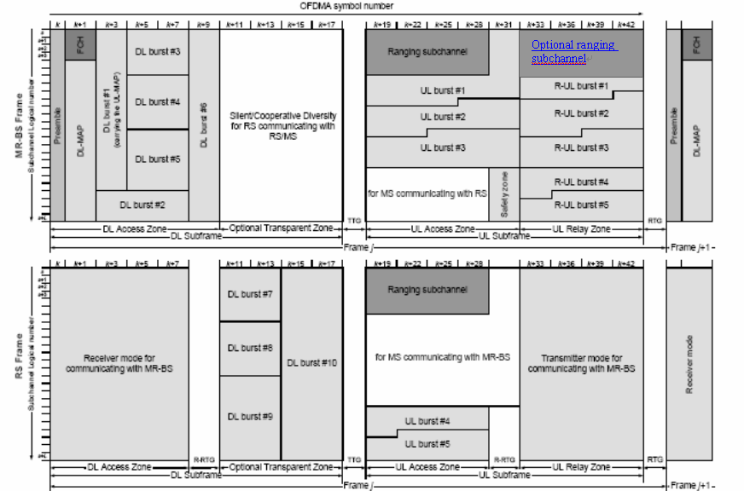

Optional ranging subchannel

