Project | IEEE 802.16 Broadband Wireless Access Working Group <http://ieee802.org/16>
Title | Clarification on RS UL_DCH request header format
Date Submitted | 2008-01-14
Source(s) | Jimin Liu, Gang Shen, Kaibin Zhang  Alcatel Shanghai Bell, Research & Innovation  388#, Ningqiao Road, Shanghai, P. R. C. | Voice: 86-21-50551240-3712  Fax: 86-21-50554554  Email: Jimin.Liu@alcatel-sbell.com.cn
Re: | IEEE 802.16-07/059, IEEE 802.16 Letter Ballot Recirc #28a
Abstract | This document proposes comments on the RS UL_DCH request header format
Purpose | Discuss and adopt the proposed modifications
Notice | This document does not represent the agreed views of the IEEE 802.16 Working Group or any of its subgroups. It represents only the views of the participants listed in the “Source(s)” field above. It is offered as a basis for discussion. It is not binding on the contributor(s), who reserve(s) the right to add, amend or withdraw material contained herein.
Release | The contributor grants a free, irrevocable license to the IEEE to incorporate material contained in this contribution, and any modifications thereof, in the creation of an IEEE Standards publication; to copyright in the IEEE’s name any IEEE Standards publication even though it may include portions of this contribution; and at the IEEE’s sole discretion to permit others to reproduce in whole or in part the resulting IEEE Standards publication. The contributor also acknowledges and accepts that this contribution may be made public by IEEE 802.16.
Patent Policy | The contributor is familiar with the IEEE-SA Patent Policy and Procedures:  <http://standards.ieee.org/guides/bylaws/sect6-7.html#6> and <http://standards.ieee.org/guides/opman/sect6.html#6.3>.  Further information is located at <http://standards.ieee.org/board/pat/pat-material.html> and <http://standards.ieee.org/board/pat>.

Clarification on RS UL DCH request header format

Introduction

The document is to introduce some modifications regarding MR Code-REP message format definition, as an input for call for comments on IEEE 802.16j/D2 [1].
In the subsection 6.3.2.1.2.2.2, the format of the RS UL DCH request header (RS UL_DCH) is illustrated in Figure 35c and described in Table 19c [1]. The field of header content has 28 bits.
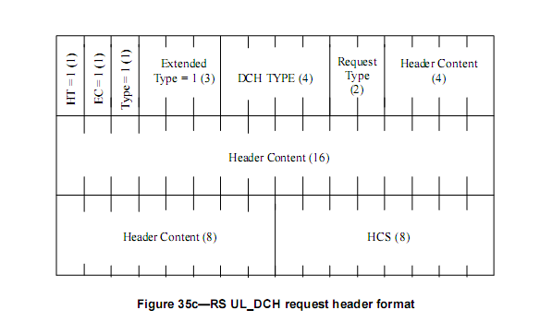
Table 19c presents the description of fields in RS UL_DCH request header. When the DCH TYPE is 0010, the last portion of the table is the following:
Table 19c Description of fields in RS UL_DCH request header
……
RS CID | 8 bits | 8 LSB of basic CID of the RS requiring HARQ transmission.
Number of bursts | 2 bits
for (i=0; i< Number of bursts; i++) {
DCH resource ID | 3 bits | ID of the DCH resource that need HARQ transmission.
DCH ACD | 4 bits | HARQ channel require retransmission.
Reserved | 1 bit | Shall be set to 0.
}
}
HCS | 8 bits | Header check sequence
When the field of Number of bursts is 1 or 2, the occupied space filled by header content is 18 or 26 bits, respectively. As mentioned above, the available space is 28 bits. It may lead to misunderstanding. Variable bits shall be reserved and inserted before the HCS.

Proposed Text Changes
6.3.2.1.2.2.2 RS UL_DCH request header (RS UL_DCH)
….
Table 19c Description of fields in RS UL_DCH request header

……
else if(DCH TYPE==0010)
{
RS CID | 8 bits | 8 LSB of basic CID of the RS requiring HARQ transmission.
Number of bursts | 2 bits
for (i=0; i< Number of bursts; i++) {
DCH resource ID | 3 bits | ID of the DCH resource that need HARQ transmission.
DCH ACD | 4 bits | HARQ channel require retransmission.
Reserved | 1 bit | Shall be set to 0.
}
Reserved | variable | Shall be set to 0.
}
HCS | 8 bits | Header check sequence

Reference
[1] P802.16j/D2, IEEE 802.16j task group, Dec. 2007

