Project | IEEE 802.16 Broadband Wireless Access Working Group <http://ieee802.org/16>
Title | Clarification of UL ACK transmission corresponding to Retx. HARQ burst
Date Submitted | 2008-01-23
Source(s) | Youngbin Chang, Jung Je Son  Samsung Electronics  Rakesh Taori  Samsung Advanced Institute of Technology  Shashikant Maheshwari, Adrian Boariu, Yousuf Saifullah, Haihong Zheng  Nokia Siemens Networks | E-mail: yb.chang@samsung.com  Voice: +82 31 279 5519  E-mail: rakesh.taori@samsung.com  Voice : +1 972 839 1878  E-Mail : Shashi.maheshwari@nsn.com  *<http://standards.ieee.org/faqs/affiliationFAQ.html>
Re: | In response to the call for comments on the IEEE 802.16j/D2
Abstract | In this document, we propose clarification text to explain UL ACK for HARQ retransmission bursts
Purpose | Discussion and Adoption in the IEEE 802.16j/D2 document
Notice | This document does not represent the agreed views of the IEEE 802.16 Working Group or any of its subgroups. It represents only the views of the participants listed in the “Source(s)” field above. It is offered as a basis for discussion. It is not binding on the contributor(s), who reserve(s) the right to add, amend or withdraw material contained herein.
Release | The contributor grants a free, irrevocable license to the IEEE to incorporate material contained in this contribution, and any modifications thereof, in the creation of an IEEE Standards publication; to copyright in the IEEE’s name any IEEE Standards publication even though it may include portions of this contribution; and at the IEEE’s sole discretion to permit others to reproduce in whole or in part the resulting IEEE Standards publication. The contributor also acknowledges and accepts that this contribution may be made public by IEEE 802.16.
Patent Policy | The contributor is familiar with the IEEE-SA Patent Policy and Procedures:  <http://standards.ieee.org/guides/bylaws/sect6-7.html#6> and <http://standards.ieee.org/guides/opman/sect6.html#6.3>.  Further information is located at <http://standards.ieee.org/board/pat/pat-material.html> and <http://standards.ieee.org/board/pat>.
Clarification of UL ACK transmission corresponding to Retx. HARQ burst
Youngbin Chang, Jung Je Son, Rakesh Taori
Shashikant Maheshwari, Adrian Boariu, Yousuf Saifullah, Haihong Zheng

1. Introduction
This contribution is a merged version of 08_027(Comment #2357) and 08_042r1(Comment #2356)

This contribution about:

1. Text clarification of UL ACK procedure regarding DL retransmission burst
The current text of procedure regarding UL encoded ACK for retransmission HARQ bursts is complex to understand and not to appropriate to describe detail procedure in general sub-clause of Non-transparent RS.
Therefore, this contribution proposed that the detail procedure of UL encoded ACK for retransmission HARQ bursts is moved to another sub-clause and modified to be understandable. The algorithm is not changed in the IEEE 802.16j/D2 document.

2. Add explanation text about Figure 157a, 157b
Figure 157a describes the example of initial transmission of DL HARQ for centralized scheduling and 157b describes the example of retransmission of DL HARQ for centralized scheduling. However, there is no corresponding text specified in IEEE 802.16j/D2 to explain those figures. Following proposed specification text provide the explanation for figures 157a and 157b and also see the corrections for the figures 157a and 157b.

2. Proposed Text Changes

[Change the text from line 7 to 34 on page 132, in 6.3.17.4.1 into proposed text below:]

When DL HARQ burst transmission from kth hop RS to (k+1)th hop RS/MS fails, the ACK/NAK from the (k+1)th hop RS/MS to the MR-BS shall be transmitted on the UL ACKCH Region. MR-BS shall schedule retransmissions on all the links between the k-th hop RS and the MS. The procedure of ACK/NAK scheduling corresponding to the retransmission HARQ burst is described in 6.3.17.4.1.2

[Delete the Figure 157a and Figure 157b:]

[Insert new subclause 6.3.17.4.1.2 after subclause 6.3.17.4.1.1 as below:]

6.3.17.4.1.2. ACK/NAK scheduling for HARQ retransmission burst

The MR-BS shall schedule additional UL ACKCH region for relaying ACK/NAK, corresponding to the retransmission burst, from the subordinate stations. This additional UL ACK region is allocated when ‘retx_region_present’ is set to 1 within HARQ ACKCH region allocation for data IE in 8.4.5.10.1.7, and the UL ACKCH region is divided into two regions. The first ACKCH sub-region is for the ACK/NAKs corresponding to the HARQ bursts related to DL HARQ MAP received from the superodinate RS. The second ACKCH sub-region is for relaying the ACK/NAKs corresponding to the retransmission HARQ bursts received from the subordinated RSs.

MR-BS shall provide the offset indicated by the "Retx_ACKCH_offset" field to each RS in the UL ACKCH region for relaying the ACK/NAK reports for the retransmitted HARQ burst. The RS that performed the retransmission of HARQ burst shall report the ACK/NAK signals to the superordinate RS in the second ACKCH sub-region

When RS has ACK/NAK of retransmitted burst received from the subordinate station, the RS shall relay it to the superordinate station in the second sub-region. If RS also has its own ACK/NAK of retransmitted burst that failed at its own link, the RS shall append it after the ACK/NAK for the retransmitted burst received from subordinate station in the second ACKCH sub-region.

Initial and retransmitted HARQ bursts that are transmitted to a subordinate station in frame N shall be acknowledged to the superordinate station in frame N + ACK_frame_delay. All the ACK/NAK for the retransmitted HARQ bursts received from subordinate stations in the same ACKCH region shall be forwarded to the superordinate station in the same frame along with the ACK/NAK corresponding to the RS HARQ DL MAP.

Figures 157a and 157b show examples of the initial transmission and retransmission of an HARQ burst.

In Figure 157a, MR-BS schedules 5 HARQ bursts for transmission 3 hop away MSs. When all HARQ burst is corrupted in different link (relay link and access link), MR-BS receive the encoded ACK/NAK which indicate the failed link.

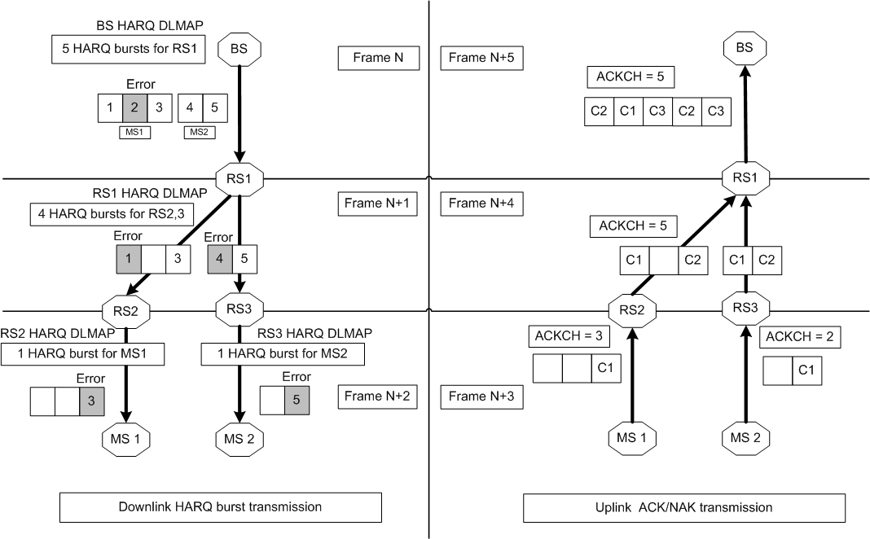
Figure 157a—Example of Initial transmission of HARQ burst

Figure 157b describes the HARQ retransmission along with new transmission and corresponding procedure about ACK/NAK reporting. Retransmission is only performed on the failed link and onwards while the ACK/NAK reporting for the retransmission burst is sent back to MR-BS.

In DL HARQ burst transmission, MR-BS schedules transmission of new bursts (6, 7 and 8) and also retransmit bursts (1 to 5) which was failed on relay link and access link in frame N to N+2.

When MS1 and MS2 received HARQ sub-bursts (1 to 8) correctly, MS1 and MS2 send ACK to RS2 and RS3 respectively corresponding DL HARQ MAP IE in frame N+3.

In frame N+4, RS2 and RS3 transmit the ACK/NAK to RS1 corresponding HARQ sunbursts in the RS HARQ DL IE received from RS1 in the first ACKCH sub-region. However, RS2 and RS3 transmit the UL ACK/NAK for the retransmitted bursts (2, 3) in the second ACKCH sub-region indicated by ‘retx_ACKCH_offset‘ field in the HARQ_ACKCH_region_allocation_for_Relay_Data IE.

When RS1 receives ACK/NAK from RS2 and RS3, it transmits the ACK/NAK to MR-BS corresponding HARQ sunbursts in the RS HARQ DL IE received from MR-BS in the first ACKCH sub-region along with the ACK/NAK for the retransmitted bursts (2, 3) from RS2 and RS3 in the second ACKCH sub-region. RS1 shall also append its own ACK/NAK of retransmitted bursts (1, 4) after ACK/NAK for the retransmitted bursts (2, 3) in the second ACKCH sub-region.

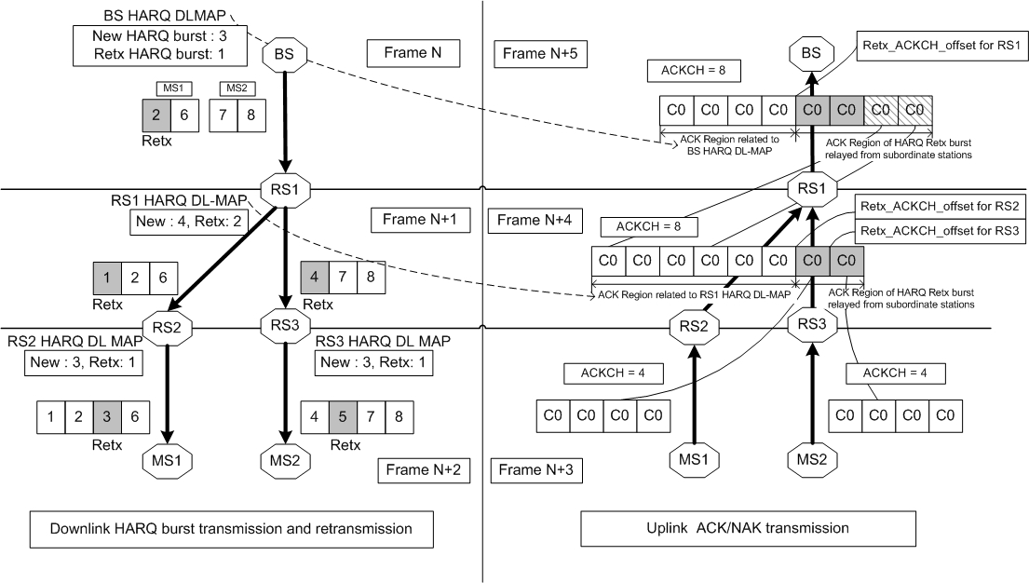
Figure 157b—Example of initial transmission and retransmission of HARQ burst

