Project | IEEE 802.16 Broadband Wireless Access Working Group <http://ieee802.org/16>
Title | RSRTG/RSTTG Modifications
Date Submitted | 2008-03-20
Source(s) | David Comstock  Huawei Technologies Co., Ltd. | E-mail: dcomstock@huawei.com  *<http://standards.ieee.org/faqs/affiliationFAQ.html>
Re: | IEEE P802.16j/D3, Letter Ballot 28b Technical Comments
Abstract | Proposal to correct usage of RSRTG/RSTTG and RTD
Purpose | Accept into P802.16j specification
Notice | This document does not represent the agreed views of the IEEE 802.16 Working Group or any of its subgroups. It represents only the views of the participants listed in the “Source(s)” field above. It is offered as a basis for discussion. It is not binding on the contributor(s), who reserve(s) the right to add, amend or withdraw material contained herein.
Release | The contributor grants a free, irrevocable license to the IEEE to incorporate material contained in this contribution, and any modifications thereof, in the creation of an IEEE Standards publication; to copyright in the IEEE’s name any IEEE Standards publication even though it may include portions of this contribution; and at the IEEE’s sole discretion to permit others to reproduce in whole or in part the resulting IEEE Standards publication. The contributor also acknowledges and accepts that this contribution may be made public by IEEE 802.16.
Patent Policy | The contributor is familiar with the IEEE-SA Patent Policy and Procedures:  <http://standards.ieee.org/guides/bylaws/sect6-7.html#6> and <http://standards.ieee.org/guides/opman/sect6.html#6.3>.  Further information is located at <http://standards.ieee.org/board/pat/pat-material.html> and <http://standards.ieee.org/board/pat>.
RSRTG/RSTTG Modifications
David Comstock
Huawei Technologies Co., Ltd.

Issue 1:
Referring to the Figure 1 below, RSRTG+RTD/2 is the minimum time required between:
- The time the RS last receives data in receive state and
- The time its first transmission must arrive at the target receiver in transmit state
where RSRTG is the time required for the RS transceiver to change states and RTD is the round trip propagation time between the RS and its superordinate station.
RSRTG is a gap in the RS frame where the RS is not receiving or transmitting.

Figure 1: RSRTG+RTD/2 applied against RS Access Zone

In P802.16j/D3, (RSRTG+RTD/2) is called R-RTG and is defined as a gap in the RS frame.

However, it is not a gap in the RS frame.
In the frame configuration shown Figure 1 it is an interval of time that may be used either:
- By the RS to determine when to stop scheduling MSs in the uplink access zone as shown in Figure 1 or
- By the BS to determine when it may first schedule the RS, as shown in Figure 2.

Figure 2: RSRTG+RTD/2 applied against RS Relay Zone

Issue 2:

In P802.16j/D3, the following text is inserted:

8.4.4.2 PMP frame structure
[…]

An R-RTG shall be inserted between the zones where RS is required to switch from receive to transmit mode. Transmission to this RS shall not be scheduled during the R-RTG symbols.

[…]

R-RTG is defined to be (RSRTG+RTD/2) and is defined to be a gap in the RS frame. However, as shown above, it doesn’t make sense to consider it a gap in the RS frame.
So, what does it mean to insert R-RTG

“between the zones where RS is required to switch from receive to transmit mode”?

What does the following text mean:

“Transmission to this RS shall not be scheduled during the R-RTG symbols.”

It makes sense that transmissions to the RS should stop at the beginning of the RSRTG+RTD/2 interval but the transceiver is changing to transmit state so it is nonsensical to say that transmissions shall not be scheduled during R-RTG. Transmissions to the RS cannot be scheduled after R-RTG because the RS is in transmit state.

Issue 3:

How is (RSRTG+RTD/2) applied?

Is it applied:
- By the RS to determine when to stop scheduling MSs in the uplink access zone as shown in Figure 1 or
- By the BS to determine when it may first schedule the RS, as shown in Figure 2. or

Alternative, the impact of (RSRTG+RTD/2) can be balanced between the Access Zone and Relay Zone as shown in Figure 3. The RS’s superordinate station can provide the RS with the earliest time that it will be scheduled in the UL relay zone on a slowly changing basis based on the RTD. The RS can use this information to determine when to stop scheduling MSs in the Access Zone using (RSRTG+RTD/2).

Figure 3: RSRTG+RTD/2 applied against RS Relay Zone
P802.16j/D3 reference material
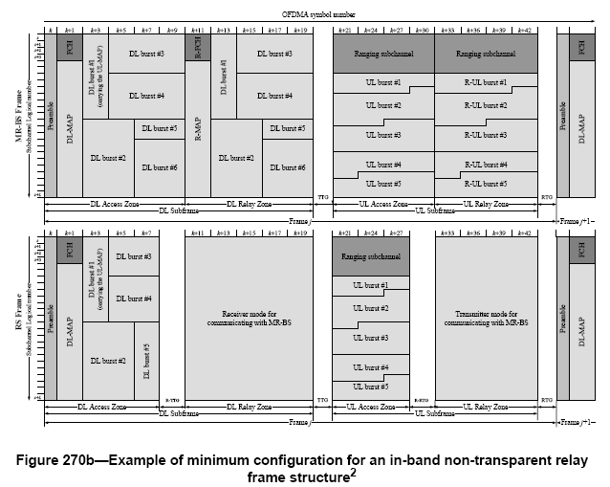

3.105 RS transmit/receive transition gap (RSTTG): The minimum transmit-to-receive turnaround gap required at an RS. RSTTG is measured from the time of the last sample of the transmitted burst to the first sample of the received burst at the antenna port of the RS.

3.106 RS receive/transmit transition gap (RSRTG): The minimum receive-to-transmit turnaround gap required at an RS. RSRTG is measured from the time of the last sample of the received burst to the first sample of the transmitted burst at the antenna port of the RS.

3.107 relay receive/transmit transition gap (R-RTG): Receive/transmit transition gap between a received mode access zone or relay zone and a transmit mode access or relay zone in an RS frame that provides for the required RSRTG. It shall be an integer number of OFDMA symbols. The R-RTG shall be calculated by following equation:
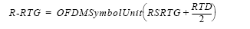

Where RTD is the round trip delay between the RS and its superordinate station and OFDMASymbolUnit is the integer number of OFDMA symbols, or.

3.108 relay transmit/receive transition gap (R-TTG): Transmit/receive transition gap between a transmit mode access or relay zone and a receive mode access or relay zone in an RS frame that provides for the required RSTTG. It shall be an integer number of OFDMA symbols. The R-TTG shall be calculated by following equation:

Where RTD is the round trip delay between the RS and its superordinate station and OFDMASymbolUnit is the integer number of OFDMA symbols, or

