Project | IEEE 802.16 Broadband Wireless Access Working Group <http://ieee802.org/16>
Title | Suggested remedy for ARQ state machine
Date Submitted | 2008-05-09
Source(s) | Tzu-Ming Lin, Fang-Ching Ren, Chie-Ming Chou  ITRI  ICL/M100, 195 Chung Hsing Rd., Sec.4 Chu Tung, Hsin Chu, Taiwan 310, R.O.C.  Wern-Ho Sheen  ITRI/NCTU  1001 Ta Hsueh Road, Hsinchu, Taiwan 300, ROC | Voice: +886-3-5916020  E-mail: tmlin@itri.org.tw  Voice: +886-3-5916020  E-mail: whsheen@itri.org.tw
Re: | IEEE P802.16j/D4: IEEE 802.16 Working Group Letter Ballot Recirc #28c
Abstract | This contribution provides the remedy of ARQ state machine.
Purpose | To incorporate the proposed text into the P802.16j/D5
Notice | This document does not represent the agreed views of the IEEE 802.16 Working Group or any of its subgroups. It represents only the views of the participants listed in the “Source(s)” field above. It is offered as a basis for discussion. It is not binding on the contributor(s), who reserve(s) the right to add, amend or withdraw material contained herein.
Release | The contributor grants a free, irrevocable license to the IEEE to incorporate material contained in this contribution, and any modifications thereof, in the creation of an IEEE Standards publication; to copyright in the IEEE’s name any IEEE Standards publication even though it may include portions of this contribution; and at the IEEE’s sole discretion to permit others to reproduce in whole or in part the resulting IEEE Standards publication. The contributor also acknowledges and accepts that this contribution may be made public by IEEE 802.16.
Patent Policy | The contributor is familiar with the IEEE-SA Patent Policy and Procedures:  <http://standards.ieee.org/guides/bylaws/sect6-7.html#6> and <http://standards.ieee.org/guides/opman/sect6.html#6.3>.  Further information is located at <http://standards.ieee.org/board/pat/pat-material.html> and <http://standards.ieee.org/board/pat>.
Suggested remedy for ARQ state machine
Tzu-Ming Lin, Fang-Ching Ren, Chie-Ming Chou, Wern-Ho Sheen
ITRI/NCTU

Problem Statement
The ARQ state machine in figure 54a is not consisting with that in P802.16Rev2/D3 (figure 51).
There shall be transition from "Discarded" state to "Done" state if ACK (MS-ACK or R-ACK) is received.

ARQ State Machine in P802.16Rev2/D3

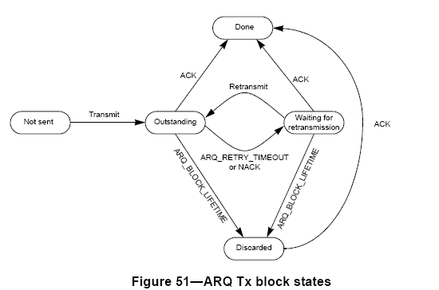

Suggested Modification

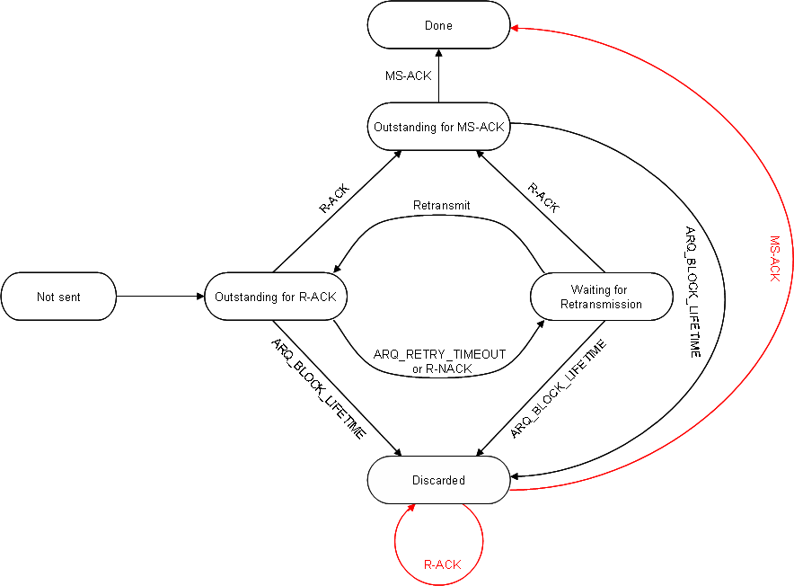
Figure : Suggest ARQ State Machine

Proposed Remedy
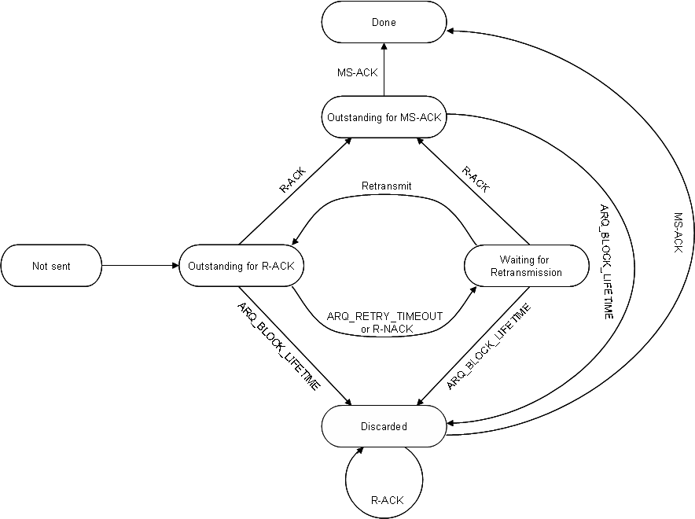
Figure 54a—ARQ Tx block state in MR-BS

