Project | IEEE 802.16 Broadband Wireless Access Working Group <http://ieee802.org/16>
Title | Suggested remedy for ARQ state machine
Date Submitted | 2008-05-14
Source(s) | Tzu-Ming Lin, Fang-Ching Ren, Chie-Ming Chou  ITRI  ICL/M100, 195 Chung Hsing Rd., Sec.4 Chu Tung, Hsin Chu, Taiwan 310, R.O.C.  Wern-Ho Sheen  ITRI/NCTU  1001 Ta Hsueh Road, Hsinchu, Taiwan 300, ROC  Youngbin Chang  Samsung Electronics | Voice: +886-3-5916020  E-mail: tmlin@itri.org.tw  Voice: +886-3-5916020  E-mail: whsheen@itri.org.tw  Email: yb.chang@samsung.com
Re: | IEEE P802.16j/D4: IEEE 802.16 Working Group Letter Ballot Recirc #28c
Abstract | This contribution provides the remedy of ARQ state machine.
Purpose | To incorporate the proposed text into the P802.16j/D5
Notice | This document does not represent the agreed views of the IEEE 802.16 Working Group or any of its subgroups. It represents only the views of the participants listed in the “Source(s)” field above. It is offered as a basis for discussion. It is not binding on the contributor(s), who reserve(s) the right to add, amend or withdraw material contained herein.
Release | The contributor grants a free, irrevocable license to the IEEE to incorporate material contained in this contribution, and any modifications thereof, in the creation of an IEEE Standards publication; to copyright in the IEEE’s name any IEEE Standards publication even though it may include portions of this contribution; and at the IEEE’s sole discretion to permit others to reproduce in whole or in part the resulting IEEE Standards publication. The contributor also acknowledges and accepts that this contribution may be made public by IEEE 802.16.
Patent Policy | The contributor is familiar with the IEEE-SA Patent Policy and Procedures:  <http://standards.ieee.org/guides/bylaws/sect6-7.html#6> and <http://standards.ieee.org/guides/opman/sect6.html#6.3>.  Further information is located at <http://standards.ieee.org/board/pat/pat-material.html> and <http://standards.ieee.org/board/pat>.
Suggested remedy for ARQ state machine
Tzu-Ming Lin, Fang-Ching Ren, Chie-Ming Chou, Wern-Ho Sheen
ITRI/NCTU
Youngbin Chang
Samsung Electronics

Problem Statement
- (Comment 4224) : The ARQ state machine in figure 54a is not consisting with that in P802.16Rev2/D3 (figure 51). There shall be transition from "Discarded" state to "Done" state if ACK (MS-ACK or R-ACK) is received.
- (Comment 4225) : Event of receiving MS-ACK in "Outstanding for R-ACK" state is not specified. In "Outstanding for R-ACK" state, MR-BS may receive MS-ACK if R-ACK is corrupted. In this case, the state should transit from "Outstanding for R-ACK" state to "Done" state.

ARQ State Machine in P802.16Rev2/D3

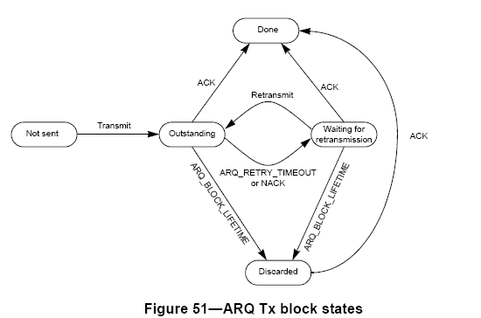

Suggested Modification

Figure : Suggest ARQ State Machine

Proposed Text change:

[Modify the text at line 6 on page 88 as following:]

The ARQ state machine operation in access RS and receiver in MR-BS is the same as described in 6.3.4.6.2 and 6.3.4.6.3. In case of transmitter state machine in MR-BS, an ARQ block or TDU may be in one of the following five states - not sent, outstanding for R-ACK, outstanding for MS-ACK, waiting for retransmission, and data discard. Outstanding for R-ACK is the state waiting for receiving acknowledged from access RS. When R-ACK received, the state transits outstanding for MS-ACK. In this state, MR-BS receives MS-NACK or after ARQ_BLOCK LIFE_TIME, the state transits to discard. If MR-BS receives MS-ACK in the state of outstanding for R-ACK or waiting for retransmission, the state transits to done. Other state transition descriptions are same as transmitter state machine defined in 6.4.4.6.2.

[Change the figure 54a on page 88 as following:]

Figure 54a—ARQ Tx block state in MR-BS

