Project | IEEE 802.16 Broadband Wireless Access Working Group <http://ieee802.org/16>
Title | Inter-cell Interference Mitigation based on IDMA
Date Submitted | 2007-06-13
Source(s) | Yunzhou Li, Wei Feng, Xiaofeng Zhong  Tsinghua Univ.  Research Institute of Information  Technology, Tsinghua University,  Beijing, P. R. China | Voice: 86-10-62773363  Fax: 86-10-62795871  mailto: liyunzhou@tsinghua.edu.cn  fengw@mails.tsinghua.edu.cn
Re: | Response to “Call for Comments and Contributions on Project 802.16m Requirements”
Abstract | IDMA (Interleave-Division Multiple-Access) is introduced as an inter-cell multiple access scheme in both downlink and uplink. A basic introduction is given, the principle and characteristics of IDMA is further clarified.
Purpose | For discussion and approval by TGm.
Notice
Release
Patent Policy and Procedures | The contributor is familiar with the IEEE 802.16 Patent Policy and Procedures <http://ieee802.org/16/ipr/patents/policy.html>, including the statement "IEEE standards may include the known use of patent(s), including patent applications, provided the IEEE receives assurance from the patent holder or applicant with respect to patents essential for compliance with both mandatory and optional portions of the standard." Early disclosure to the Working Group of patent information that might be relevant to the standard is essential to reduce the possibility for delays in the development process and increase the likelihood that the draft publication will be approved for publication. Please notify the Chair <mailto:chair@wirelessman.org> as early as possible, in written or electronic form, if patented technology (or technology under patent application) might be incorporated into a draft standard being developed within the IEEE 802.16 Working Group. The Chair will disclose this notification via the IEEE 802.16 web site <http://ieee802.org/16/ipr/patents/notices>.

Inter-cell Interference Mitigation based on IDMA
Yunzhou Li, Wei Feng, Xiaofeng Zhong
Tsinghua Univ.

Introduction
According to the requirements for IEEE 802.16m ^{[1]}, increasing “the average user-throughput in the downlink/uplink” is a key issue. Interleave Division Multiple Access (IDMA) ^{[2-5]} was introduced as an inter-cell multiple access scheme in both downlink and uplink. It can made a substantial performance gain in suppressing the inter-cell interference, following with the increasing of cell edge transmission rate and the increasing of average user-throughput further. So IDMA is presented to address the key issue of “average user-throughput”.
In this document, a basic introduction to IDMA is given, the principle and characteristics of IDMA is further clarified. Some useful conclusion will be drawn out.
We suggest that IDMA should be considered as a candidate for inter-cell interference mitigation in IEEE802.16m.

Principle of IDMA
The principle of IDMA is to employ distinct interleaving patterns in the neighbouring cells so that the UE (in downlink) or Node B (in uplink) can distinguish the signals from different cells by means of cell-specific interleavers.

How to use IDMA
Fig. 1 illustrates the use of IDMA in the downlink case, in which UE1 and UE2 are respectively served by NodeB1 and NodeB2 but allocated the same time-frequency resource (chunk). Suppose NodeB1 interleaves the signal for UE1 with interleaving pattern1, while NodeB2 interleaves the signal for UE2 with interleaving pattern2 (different from pattern1), then UE1 (UE2) may distinguish the signals from the two NodeBs by means of different interleavers. In case of using the single-cell receiver, the interference from the other NodeB will be whitened to a noise. In case of employing iterative multi-cell receiver, the interference could be effectively cancelled. Note that IDMA can be employed not only between neighboring NodeBs, but also potentially between neighboring sectors.
Similarly, IDMA can also be employed in uplink, as shown in Fig. 2. Two UEs from two neighboring cells can share the same chunk, but interleave their signals with distinct interleaving patterns.
Fig.1 using IDMA in downlink to suppress inter-cell interference
Fig.2 using IDMA in uplink to suppress inter-cell interference

Iterative multi-user detection
The principle of iterative multi-user (here “user” could be a NodeB, a sector or a UE) detection has been well introduced recently. In the single-user detection, the interference is treated as noise. However, the multi-user detection also demodulate the interfering signal, and improve the detection of the wanted signal. Especially, the iterative multi-user detection is regarded as an attractive technique because it can continuously improve the receiver performance with increasing number of iterations.
The structure of iterative multi-user receiver is showed in Fig. 3. The multi-user demodulators calculate and output the soft information based on the received signal, channel information and extrinsic information for each user. The user decoders calculate the decision information and the extrinsic information based on the signal delivered from the multi-user demodulator. Then the decision information and extrinsic information are fed back to the multi-user demodulator. The interleaver and de-interleaver in Fig.3 would be able to remove the correlation between the multi-user demodulator and the decoders, just like the role of the interleaver in Turbo codes.
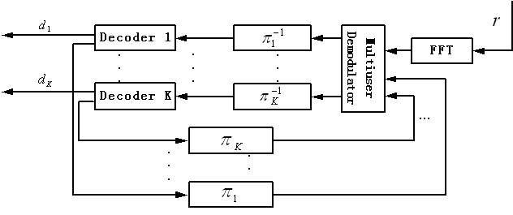
Fig. 3 Structure of iterative multi-user receiver
Fig.4 constellation of three-QPSK-user system with equal amplitude and equal phase space
In a multi-user system, each user’s amplitude, phase, and modulation may be different, therefore resulting in random constellation patterns. An example is shown in Fig.4, for constellations of a three-QPSK-user system with equal amplitude and equal phase space. In the random constellation patterns, some constellation points have relatively large distance from other constellation points, therefore are easy to be detected. On the other hand, the constellation points close to each other may be difficult to be detected. In this case, the extrinsic information from channel decoder can help the detection.
Some may be concerned about the complexity of implementing iterative multi-user detection. Fortunately, in the considered OFDM system, the number of neighbouring cells sharing the same chunk is limited to 2~3. Therefore even the algorithms with a complexity at a rate of exponential to user number, such as MCE algorithm, can also be considered.

How IDMA outperforms scrambling
In this section, the difference of IDMA and scrambling is interpreted by means of analysis and simulations.

Analysis of iterative process
Here we consider an iterative multi-user receiver based on the interference cancellation and iterative decoding. Here we consider a two-cell case. In the first iteration, the single-user decoding is performed for the Cell 1. Assuming after the decoding, a given information bit in the frame is relatively unreliable (log-likelihood ratio (LLR) is small), as shown in Fig.5 (a). Then the information bits will be re-encoded. Thus the unreliable information bit is converted to a number (in the sample, the number is 4) of unreliable code bits, as shown in Fig. 5 (b). As in Fig. 5 (c), the 4 unreliable code bits will be scrambled to distributed positions after re-interleaving for Cell 1. Then the Cell 2’s signal is obtained by subtracting the Cell 1’s from the received signal. After the interference subtraction, the 4 unreliable bits in the Cell 1’s frame will affect the corresponding bits in the Cell 2’s frame, as shown in Fig. 5 (d). Then the Cell 2’s signal will be fed to the de-interleaver of Cell 2. In the case of scrambling, since the two cells use the same interleaver pattern, the 4 unreliable bits will be re-assembled together, as shown in Fig.5 (e). However, if IDMA is used, the Cell 2 is employing a different interleaver pattern from Cell 1. Hence the 4 unreliable in the frame will be scrambled to another series of distributed positions, as shown in Fig. 5 (f). As well known, a number of adjacent bit errors (as in Fig. 5 (e)) are more difficult to be corrected than a number of distributed bit errors (as in Fig. 5 (f)). Hence in the second iteration, an IDMA system will have a better decoding performance than a scrambling system
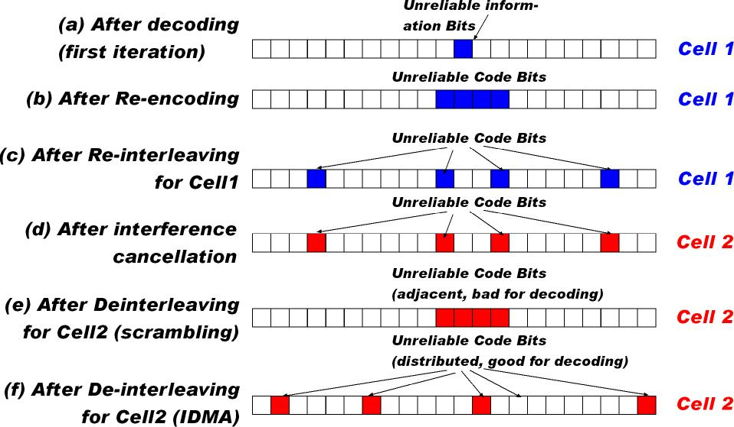
Fig. 5 How IDMA outperforms scrambling in iterative receiver

Impact of interleaving
The role of the interleaver and de-interleaver in iterative receiver are to remove the correlation between the multi-user demodulator and the decoders. This role cannot be replaced by user-specific scrambling. To explicitly demonstrate the impact of user-specific interleaving and user-specific scrambling during iterative detection, a direct comparison can be made as in Fig.6. The simulation is based on the following assumptions: Two multi-user systems respectively based on user-specific interleaving and user-specific scrambling; All users’ ${E_{b}}/{N_{0}}$= 8dB; Repeat coding (rate 1/64); Block length=256; BPSK modulation; SoIC detection; Random interleaving/scrambling, 10-iteration detection, AWGN channel.
Fig.6 user-specific interleaving vs. user-specific scrambling: User number- BER performance
The simulation results show that, in term of removing the relation between multi-user demodulator and all user decoders, IDMA-based system significantly outperform scrambling-based system。

References
[1] C80216m-07_010 Draft IEEE 802.16m Requirements
[2] Yunzhou Li, Shidong Zhou, Jing Wang, “Spectral efficiency of IDMA-OFDM systems”, Journal of Tsinghua University, Science and Technology, 2005-03, Vol.45, No.3 (in Chinese)
[3] M. Moher, “An iterative multiuser decoder for near-capacity communications,” IEEE Trans. Commun., vol. 46, pp. 870–880, July 1998.
[4] X.Wang and H. V. Poor, “Iterative (turbo) soft interference cancellation and decoding for coded CDMA,” IEEE Trans. Commun., vol. 47, pp. 1046–1061, July 1999.
[5] Li Ping; Lihai Liu; Leung, W.K., “A simple approach to near-optimal multiuser detection: interleave-division multiple-access”, Wireless Communications and Networking, 2003. WCNC 2003. 2003 IEEE, Volume 1, 16-20 March 2003 Page(s):391 - 396 vol.1

