Project | IEEE 802.16 Broadband Wireless Access Working Group <http://ieee802.org/16>
Title | Multi User MIMO with Downlink Adaptive Beamforming for TDD systems
Date Submitted | 2007-08-29
Source(s) | Howard Huang, Federico Boccardi  Alcatel-Lucent Bell Labs  Liu Ju  Alcatel Shanghai Bell | Voice:  E-mail: hchuang@alcatel-lucent.com,  fb@alcatel-lucent.com  jue.liu@alcatel-sbell.com.cn
Re: | IEEE 802.16m Requirements - Elaboration of MU-MIMO with DL BF for TDD Systems
Abstract | The contribution is on Multiuser (MU) MIMO with downlink adaptive beamforming. MU-MIMO aims at improving the overall system throughput by supporting multiple users in a cell over the same time-frequency resource. Adaptive beamforming using channel knowledge at the base station transmitter is suitable for time-division duplexed systems. This contribution highlights the performance gains of this technology compared to conventional single-user MIMO techniques.
Purpose | For 802.16m discussion and eventual adoption for standardization of MU-beamforming Schemes
Notice | This document does not represent the agreed views of the IEEE 802.16 Working Group or any of its subgroups. It represents only the views of the participants listed in the “Source(s)” field above. It is offered as a basis for discussion. It is not binding on the contributor(s), who reserve(s) the right to add, amend or withdraw material contained herein.
Release | The contributor grants a free, irrevocable license to the IEEE to incorporate material contained in this contribution, and any modifications thereof, in the creation of an IEEE Standards publication; to copyright in the IEEE’s name any IEEE Standards publication even though it may include portions of this contribution; and at the IEEE’s sole discretion to permit others to reproduce in whole or in part the resulting IEEE Standards publication. The contributor also acknowledges and accepts that this contribution may be made public by IEEE 802.16.
Patent Policy | The contributor is familiar with the IEEE-SA Patent Policy and Procedures:  <http://standards.ieee.org/guides/bylaws/sect6-7.html#6> and <http://standards.ieee.org/guides/opman/sect6.html#6.3>.  Further information is located at <http://standards.ieee.org/board/pat/pat-material.html> and <http://standards.ieee.org/board/pat>.

Multi User MIMO with Downlink Adaptive Beamforming for TDD systems
Howard Huang, Federico Boccardi
Alcatel-Lucent Bell Labs
Liu Ju
Alcatel Shanghai Bell

Introduction
In time-division duplexed (TDD) systems, uplink and downlink transmissions are time duplexed over the same frequency bandwidth. As a result, channel estimates on the uplink can be used by the base station on the donwlink to form beams that adapt to the users’ changing channel conditions. Multiple antennas at the base station can be used to create multiple simultaneous spatial channels over common frequency resources. Under single-user (SU) MIMO, the spatial channels are allocated to a single user. Per-antenna rate control (PARC) is a SU MIMO technique that does not require channel knowledge at the transmitter. Closed-loop (CL) MIMO is a SU MIMO technique that uses channel knowledge to provide improved performance. Under multiuser (MU) MIMO, the spatial channels are allocated to multiple users. We describe a generalized MU-MIMO technique known as multiuser eigenmode transmission (MET) that allocates spatial channels to multiple users in a near-optimum manner. Under MET, the channels could be allocated to a single user, making this technique a generalization of CL-MIMO. As such, the flexibility of MET results in improved performance compared to CL-MIMO.

Description of Multiuser Eigenmode Transmission (MET)
Downlink unicast MIMO transmission— where an array of M antennas transmits distinct information to K users, each with N antennas—is known in academia as the broadcast channel and has been of great theoretical interest recently. The capacity region for this channel has recently been shown to be achieved by an architecture based on dirty paper coding (DPC)[1], a nonlinear technique that unfortunately has very high complexity and is impractical to implement.
A class of linear architectures based on zero-forcing (ZF) beamforming have emerged as an attractive alternative for balancing complexity and performance [2][3][4]. The architecture is implemented using conventional coding (for example, turbo codes) and simple linear beamforming whose weights are computed with knowledge of the channel phase and amplitude at the transmitter. For the simplest case of single receive antennas (N = 1), multiple beams simultaneously transmit, each to a single user. Each beam is weighted so that nulls (zeros) are forced in the direction of the other users; therefore the users experience no interbeam interference. ZF (for N = 1) exhibits optimal performance asymptotically as K grows without bound [2], and it provides a significant fraction of DPC capacity for a large range of finite K.
We propose an architecture based on zero-forcing beamforming which we call multiuser eigenmode transmission (MET) where the base station transmits one or more spatially multiplexed data streams to one or more users. MET requires channel knowledge of each user’s MIMO channel. It is a generalization of the SU-MIMO technique known as closed-loop MIMO (BLAST) [5] where transmission occurs over a user’s eigenmodes.
For CL MIMO, since the transmitter knows the MIMO channel, it can compute its singular-value decomposition (SVD) and form a beam for each eigenmode using the right unitary matrix of the SVD. The receiver also knows the channel, computes the SVD, and uses the left unitary matrix for its receiver. Power allocation of the eigenmodes is performed at the transmitter using the conventional waterfilling algorithm. Because the eigenmodes are transmitted and received with unitary matrices, they are mutually orthogonal.
MET is similar to CL MIMO in that it transmits on a user’s eigenmodes. However, it is more general since it is not restricted to serve a single user at a time. In a sense, MET eliminates the distinction between single-user and multiuser MIMO techniques because it dynamically decides on each TTI how many users to serve. It could transmit multiple streams to a single user, a single stream to multiple users, or multiple streams to multiple users. Because the channels of all users are assumed to be known at the transmitter, the eigenmodes beamformed to different users are weighted using a zero-forcing criterion so they are mutually orthogonal. In other words, a given user receives no interference from any eigenmodes destined for other users. Groups of eigenmodes among users are mutually orthogonal due to zero-forcing; however, eigenmodes for a given user are mutually orthogonal due to the SVD. In general, the number of orthogonal beams that can be formed is no more than the number of transmit antennas M. On the other hand, the number of eigenmodes per user is no more than min(M, N). These limits are for a given band; therefore for the general multiband (OFDM) case with F bands (resource blocks), these limits become FM and min(FM, FN), respectively.
The zero-forcing effect applies only when the channels are known exactly. In practice, there will be residual interference, but more robust techniques could be developed that account for channel mismatch. Channel estimates at the base station could be obtained via uplink feedback in FDD systems or estimated directly in TDD systems. Because of the coupling among the users’ eigenmodes in order to achieve zero-forcing, a user’s MET receiver is a function not only of its MIMO channel, but of others too. Therefore additional overhead signaling is required to convey the receiver coefficients. The results throughout this contribution assume perfect channel knowledge.

Performance results: Theoretical comparison
As mentioned earlier, the class of zero-forcing beamforming systems has been shown to be asymptotically optimum for a given M and N, as the number of users per sector K increases without bound. For practical values of K, MET achieves a significant fraction of the capacity-achieving DPC performance. Figure 2 shows the average sum rate of DPC and MET for M = 4, K = 20, N = 4, F = 1. The average SNR of all K users is fixed, and the sum rate is averaged over IID realizations of the users’ MIMO channels. The MIMO channels are assumed to be spatially uncorrelated, and we have assumed perfect channel knowledge for both systems. To achieve the same average sum rate, MET requires only about 2dB higher SNR than DPC.
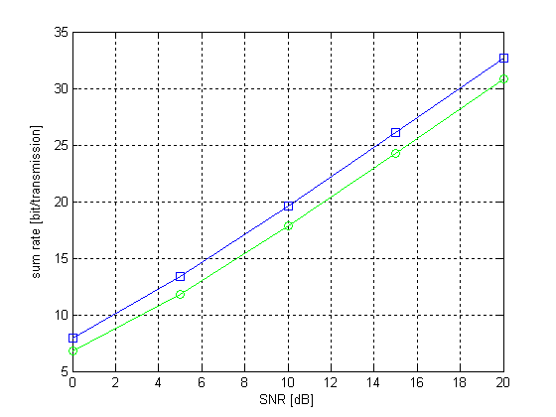
DPC
MET
Figure 2. Average sum rate of capacity-achieving DPC and MET, M = 4, K = 20, N = 4, F = 1.

Performance results: System simulations
Using system simulation parameters consistent with typical wideband cellular systems, we compare the performance of SU-MIMO with PARC, SU-MIMO with closed-loop MIMO, and MET. We assume there are K = 20 uniformly distributed users in the sector of the hexagonal cell considered, where each cell has 3 120-degree sectors. Surrounding base stations are assumed to transmit with full power at all times, and spatial interference is assumed to be white. We consider two antenna architectures: a baseline with M = 2 and N = 2, and an enhanced system with M = 4 and N = 4. All systems assume ideal channel knowledge at the transmitter and receivers. We assume a 5MHz bandwidth with F = 8 frequency resource blocks with localized subcarriers and 375KHz bandwidth per block. The simulation assumptions are summarized in Table 1.
For the SU-MIMO architectures, we assume that on each TTI, the base station transmits to a single user. For PARC, the best set of transmit antennas and MCS per antenna is chosen on each TTI, where the MCS are taken from Table 1. PARC does not require channel knowledge at the transmitter; it only requires CQI feedback per stream. On the other hand, CL-MIMO requires channel knowledge at the transmitter, and waterfilling is used to determine the ideal power allocation among the M eigenmodes. The received SINR per mode is then mapped to the highest achievable rate according to the MCSs in Table 1. This procedure is also used for obtaining the MET eigenmode rates.

Traffic and Mobility Models
User distribution | Uniform
Terminal speed | 3 km/h
Data generation | Full buffer
Radio Network Models
Distance dependent path loss | L = 15.3+20+37.6⋅log(d), d = distance in meters
Shadow fading | Log-normal, 8dB standard deviation
Multipath fading | SCM Suburban Macro
Cell layout | Hexagonal grid, 3-sector sites, 57 sectors in total
Inter-Site Distance | 1732m
General System Models
Spectrum allocation | 5MHz
Base station power | 20W
Max antenna gain | 14dBi
Modulation and coding schemes | QPSK, 16QAM, and 64QAM, turbo codes, rates 0.1, 0.14, 0.2, 0.25, 0.33, 0.4, 0.5, 0.6, 0.67, 0.75, 0.8, 0.89
Channel estimation | Ideal
Channel quality estimation | Instant, error-free feedback
Reuse | Uncoordinated reuse 1
Users per sector (K) | 20
E-UTRA Characteristics
Overhead | 2/7 = 29% (5 symbols from total 7 symbols per 0.5ms subframe available for data )
Transmission scheme | PARC SU-MIMO, Closed-loop SU-MIMO, Multiuser eigenmode transmission (MET) MU-MIMO
Receiver | Space-time MMSE for PARC, Linear receiver for CL and MET
Scheduler | Proportional fair for PARC and CL; Greedy algorithm for MET
Link adaptation | per TTI, no HARQ
Table 1: System simulation assumptions.

Figure 3 shows the CDF of the base station throughput for the three system architectures and two antenna options. Using the notation (M,N) for M transmit antennas and N receive antennas, we notice that for (2,2) the gains of the CL-MIMO over PARC are modest, indicating modest marginal gains due to channel knowledge at the transmitter. MET gains over CL-MIMO are likewise minimal indicating that the option of spatial multiplexing between users provides minimal gains when the degrees of freedom are few. On the other hand for (4,4), the performance gains from PARC to CL-MIMO and CL-MIMO to MET are more significant. We have observed that MET typically transmits only one eigenmode per user because with large K, there are likely to be M quasi-orthogonal modes among the users. Therefore with MET, high base station throughput can be achieved without implementing complex SU-MIMO receivers at the terminal. Figure 4 shows the CDF of the user rate averaged over the Rayleigh fading for a given drop. The relative performance among the systems is similar to that in Figure 3.
Using (2,2) PARC as a baseline, we give the gains of the (4,4) system for various performance metrics in Table 2.

 | (4,4)  CL-MIMO | (4,4) MET
Base throughput, mean | 2.4 | 2.7
Base throughput, peak | 2.2 | 2.2
Base throughput, edge | 2.7 | 3.0
User throughput, mean | 2.4 | 2.7
User throughput, peak | 2.2 | 2.4
User throughput, edge | 2.7 | 4.0

Table 2. Relative gains over (2,2) PARC

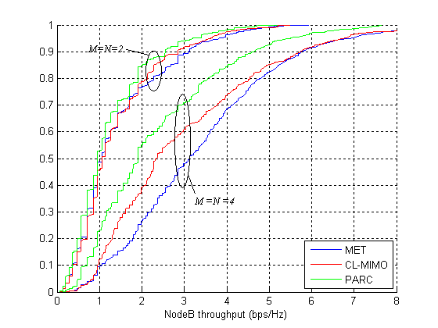
Figure 3. CDF of base station throughput, K = 20
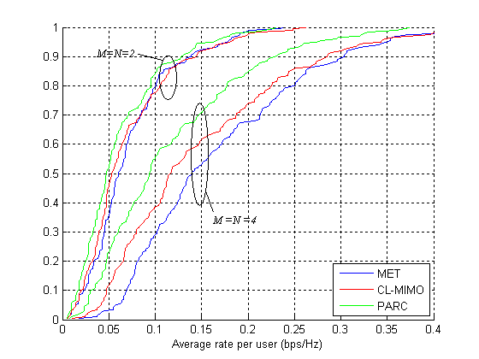
Figure 4. CDF of average rate per user, K = 20

Conclusions
MET is a member of the class of zero-forcing type beamformers which has been shown to achieve asymptotic optimality compared to the capacity-achieving technique based on dirty paper coding. It is shown to achieve a significant fraction of DPC sum rate under non-asymptotic conditions and is shown to provide additional performance gains over ideal CL-MIMO using system simulations. The suggested MET technique is particularly attractive for TDD systems where channel knowledge would be available at the transmitter due to channel reciprocity.

References
[1] H. Weingarten, Y. Steinberg and S. Shamai (Shitz), “Capacity region of the MIMO broadcast channel,” to appear in IEEE Trans. Information Theory.
[2] T. Yoo and A. Goldsmith, “On the optimality of multiantenna broadcast scheduling using zero-forcing beamforming,” IEEE J. Select. Areas Communun., vol. 24, no.3, pp. 528-541, Mar. 2006.
[3] H. Viswanathan, S. Venkatesan and H. Huang, “Downlink capacity evaluation of cellular networks with known-interference cancellation,” IEEE J. Select. Areas Communun., vol. 24, no. 5, pp. 802-811, June 2003.
[4] Q. H. Spencer, A. L. Swindlehurst and M. Haardt, “Zero-forcing methods for downlink spatial multiplexing in multiuser MIMO channels,” IEEE Trans. On Signal Processing, vol. 52, no. 2, pp. 461-471, Feb. 2004.
[5] E. Telatar, “Capacity of multiantenna Gaussian channels,” AT&T Tech. Memo., June 1995.
[6] G. Dimic and N. D. Sidiropoulos, “On downlink beamforming with greedy user selction: Performance analysis and a simple new algorithm,” IEEE Tans. Commun., vol. 53, no. 10, pp. 3857-3868, Oct. 2005.

Appendix: Detailed description of MET
We consider a multiband, multiantenna downlink channel model where each band f (f = 1,….,F) is modeled as a MIMO Gaussian broadcast channel. K users, each equipped with N receive antennas, request service from the transmitter which has M antennas. In the context of a wideband OFDM system, we assume that F is the number of frequency resource blocks so that in 5MHz bandwidth, there are F= 8 resource blocks of bandwidth 375KHz each. We assume each resource block is a contiguous cluster of 25 subcarriers.
A block diagram of the overall MET architecture is given in Figure 1. On each TTI, the scheduler determines a set S of users assigned to receive data, and for each user , it also determines the set of transmitted eigenmodes on each band f = 1,…,F . The scheduler chooses these sets, collectively represented by T, to maximize the weighted sum rate metric on each TTI, where weights are computed by a higher layer a function that considers quality of service metrics for each user such as minimum delay, average achieved rate, and data queue size. The scheduler consists of two nested loops where the inner loop computes the weighted sum rate for a given allocation T, and where the outer loop maximizes among choices of T. We first describe obtaining the transmitter and receiver structure for inner loop. Then we describe the greedy algorithm used in the outer loop.
We let denote the set of bands for user k on which at least one eigenmode is transmitted, and we let denote the cardinality of set X. For example, if , then . User 1 receives a total of 7 eigenmodes on 2 bands while user 2 receives only 1 eigenmode. With M antennas, similar to the SU-MIMO case, there are enough degrees of freedom to transmit at most min(M,N) eigenmodes per band, so for f = 1,…,F. The data for a chosen user is demultiplexed into substreams, each of which are coded, interleaved, and modulated (represented by CIM in Figure 1). The modulated symbol , is a -dimensional vector. This symbol vector is distributed across the M antennas by multiplying it with which is an M -by- beamforming matrix which is derived in the appendix. Note that in Figure 1, it is assumed that for both users, ==F. The transmitted signal on band f is
.
The complex baseband received signal by the kth user on band f is an N-dimensional vector
where is the kth user's MIMO channel matrix (where we have assumed flat fading over each band f), and is the complex additive white Gaussian noise at the kth user on band f which accounts for intercell and intersector interference. We assume that all of the user’s MIMO channels over all bands are known at the transmitter. The received signal is demodulated by multiplying with a -by-N matrix (derived in the appendix), resulting in an estimate of the symbol . The symbols are decoded and the streams are multiplexed together to yield the data stream for user k.
Figure 1. Multiuser Eigenmode Transmission block diagram
Because the transmit beamformer and receiver matrices operate in each band independently, we simplify the notation by dropping the subscript f from the transmitted signal x, the MIMO channel matrices H_{k}, and the eigenmode index set E_{k}. The derivation of the MET transmitter and receiver for a given choice of user and eigenmode assignments is described in [4]. We briefly describe it here for completeness. The channel of the kth user can be decomposed using the singular value decomposition (SVD) as , where the eigenvalues in are arranged so that the ones associated with the allocated set E_{k} appear in the leftmost columns. We denote these eigenvalues as . The kth user’s receiver is a linear detector given by the Hermitian transpose of the leftmost columns of which we denote as . Likewise, we denote the leftmost columns of the matrix as . The signal following the detector can be written as
where is the received signal given by , is the processed noise, and is a matrix. By defining
,
our zero-forcing constraint requires that lie in the null space of . Hence can be found by considering the SVD of :
where corresponds to the right eigenvectors associated with the null modes.
The kth user’s precoder matrix is given by where is determined later. Note that since for all , it follows that for and any choice of . Therefore from , the received signal for the kth user after combining contains no interference:
.
We perform an SVD
where is the diagonal matrix of eigenvalues, and we assign From , the resulting weighted rate for the kth user is , where is the jth diagonal element of (), is the diagonal matrix of powers allocated to the eigenmodes, and is the jth diagonal element. Therefore the total transmitted power for this user is . Letting T be a given selection of users S and eigenmodes (), the power allocation problem for maximizing the weighted sum rate given T and a = [a₁,…,a_{K} ]^{H} (the set of QoS weights for the K users) is
subject to

So finding the optimum transmit powers is a weighted waterfilling in dimensions. This completes the description of the scheduler’s inner loop.
For a given TTI, the scheduler’s outer loop must determine the scheduled set T for maximizing the overall weighted sum rate:
.
For a conventional single-band SISO system with proportional fair scheduling, the kth user’s QoS weight is the kth user’s reciprocal windowed average rate. Because a SISO system can transmit at most 1 eigenmode, the scheduler picks the user with the largest weighted rate. For the general MET case, finding the optimum set T for solving would require a brute force search over all possible allocations of 1, 2,…, min(M,KN) eigenmodes per band. Hence the total number of sets to consider is
.
For example, with M = 4, K = 10, N = 4, F = 8, the number of sets is on the order of . Because a brute force search would be infeasible, we propose a suboptimum but efficient greedy algorithm for determining T. This algorithm is an extension of the algorithm given in [6] for the special case of N = 1, F = 1. We start by picking the single best eigenmode among all users and bands and compute the resulting weighted rate. Keeping this eigenmode, we choose a second eigenmode from the remainder and find the best one which maximizes the weighted sum rate. If this rate is greater than the rate for only the first mode, then keep this second eigenmode and continue by looking for the next eigenmode. Otherwise, we revert back to a single eigenmode and stop the search algorithm.

