Project | IEEE 802.16 Broadband Wireless Access Working Group <http://ieee802.org/16>
Title | Self organizing mechanism (SRD)
Date Submitted | 2007-09-17
Source(s) | Jaehee Cho, Hyongoo Kang  Samsung Electronics | Voice: +82-31-279-5596  E-mail: jaehee1.cho@samsung.com
Re: | IEEE 802.16m-07/002r3: SRD
Abstract | Self organizing network will play a key role to reduce the operational cost and efficiency of future 802.16m networks. However, there is no requirements on self organizing networks in current SRD. In this contribution, the overview of the self organizing networks is provided and a text is proposed for SRD.
Purpose | Discuss this contribution and adopt the proposed text.
Notice | This document does not represent the agreed views of the IEEE 802.16 Working Group or any of its subgroups. It represents only the views of the participants listed in the “Source(s)” field above. It is offered as a basis for discussion. It is not binding on the contributor(s), who reserve(s) the right to add, amend or withdraw material contained herein.
Release | The contributor grants a free, irrevocable license to the IEEE to incorporate material contained in this contribution, and any modifications thereof, in the creation of an IEEE Standards publication; to copyright in the IEEE’s name any IEEE Standards publication even though it may include portions of this contribution; and at the IEEE’s sole discretion to permit others to reproduce in whole or in part the resulting IEEE Standards publication. The contributor also acknowledges and accepts that this contribution may be made public by IEEE 802.16.
Patent Policy | The contributor is familiar with the IEEE-SA Patent Policy and Procedures:  <http://standards.ieee.org/guides/bylaws/sect6-7.html#6> and <http://standards.ieee.org/guides/opman/sect6.html#6.3>.  Further information is located at <http://standards.ieee.org/board/pat/pat-material.html> and <http://standards.ieee.org/board/pat>.
Self organizing mechanism
Jaehee Cho, Hyongoo Kang
Samsung Electronics

Motivations
There is an increasing demand to reduce the cost of deployment and operation of future IMT-advanced access networks [1]. In conventional wireless access system, the deployment of network is complex and expensive tasks where human intervention is inevitably involved to install and configure BSs. In the operation of networks, efficiency and quality of network should be guaranteed through optimizing the network. In IMT-advanced access network, it is expected that more BSs will be deployed than the conventional access network and more complicated interaction between BSs will happen. These will complicate the configuration and optimization. The causes of such complication in IMT-advanced access system are, for example, higher throughput, indoor coverage and so on.
Higher density of BSs theoretically guarantees increase of system throughput, thus users can experience better throughput [2]. Fig. 1 shows conceptual diagram. The amount of user traffic that a geographical area can provide is larger in the dense BS environment than the conventional networks. Though the capacity can be limited due to more interference, it is a feasible scheme to increase the system capacity and improve user experience in IMT-advanced access network. However, the larger number of BSs burdens to increase the cost of deployment and optimization.
Fig 1. Increase of system capacity with higher BS density
There is an increasing demand on indoor coverage and it shall be incorporated into IMT-advanced access network. Such demand targets a seamless coverage of IMT-advanced system even in indoor environment like home and office [3][4]. Fig. 2 shows a conceptual diagram of an exemplary indoor network. In such environment, the same deployment and optimization problems occur even within the indoor network itself. Further, the situation is more complicated due to the fact that it is more probable to add or remove BSs more often. Also, the interaction between indoor BSs and conventional BSs should be carefully coordinated to build efficient access network.
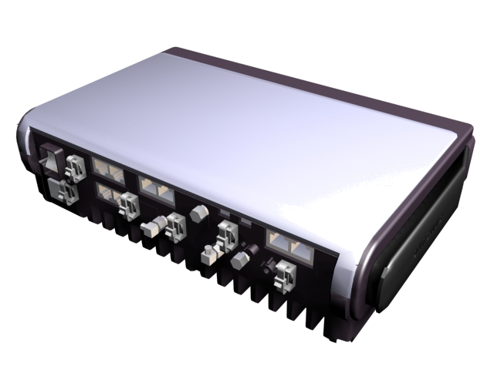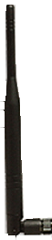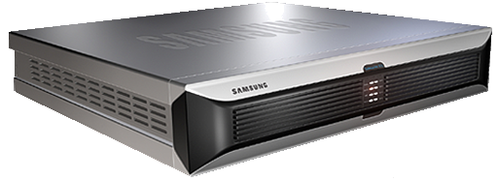
Access GW
(Micro)
IP Access Network
(Conventional)
In-building BSs
To IP Access Network
(Secure I/F)
Fig 2. Example of indoor networks [3]
These problems of configuration and optimization will be worsened in IMT-advanced access system thus feasible counter measures should be provided in 802.16m specifications. Self-configuration and self-optimization are intensively discussed for this purpose. They aim to automate to configure parameters of BSs to install into a network and to optimize its operational parameters like Tx power, neighbor list, handover parameters and so on. These functionalities can be named as self organizing mechanism.
Usually, such automation relies on some measurements from BSs and MSs. Especially, the measurements from MS can help a BS get information of other BSs those are hidden for the BS. The information may help BS to configure or optimize its relevant parameters more efficiently. This scenario makes it clear why the 802.16m TG should consider defining necessary functionalities for self organizing mechanism in the standards. The measurements and report schemes are examples of such standardization.
As a consequence, it is reasonable to include some appropriate text of the self organizing mechanism in SRD. In the following section, we propose the text for self organizing mechanism.

Proposed text
[Add following text at the end of 8.3]
8.4 Support of Self Organizing Mechanisms
IEEE 802.16m should support self organizing mechanisms including, but not limited to, the following:
Self-configuration: means allowing real plug and play installation of network nodes and cells, i.e. self-adaptation of the initial configuration, including the update of neighbor nodes and neighbor cells as well as means for fast reconfiguration and compensation in failure cases.
Self-optimization: means allowing automated or autonomous optimization of network performance w.r.t service availability, QoS, network efficiency and throughput.
The areas of expected standardization, relevant to the supported scenarios, include required MS and BS based measurements and performance indicators, as well as required interfaces for the support of multi-RAT and multi-vendor system operation aspects.

References
[1] Board of NGMN Limited: Next Generation Mobile Networks Beyond HSPA & EVDO White Paper, Ver. 3.0, Dec. 2006.
[2] Greenstein, L.J, et. al, “Microcells in personal communications systems,” IEEE Communications Magazine, Vol. 30, Issue 12, Dec. 1992, pp. 76 – 88.
[3] Jongsik Lee, “The technology development of indoor WiBro system,” Proceedings of JCCI, Seoul, Korea, May, 2007, pp. 141-155.
[4] Stuart Carlaw, “What is the Business Case for Femtocells,” Open Basestation Conference, Bath UK, April, 2007.
[5] Anton Ambrosy, et. Al, “Self-configuration and self-optimization of 4G Radio Access Networks,” C80216m-07_169.

