Project | IEEE 802.16 Broadband Wireless Access Working Group <http://ieee802.org/16>
Title | Proposed Text for Deriving PER of a Burst with Multiple FEC Blocks in Section 4
Date Submitted | 2007-09-10
Source(s) | Senjie ZHANG, Intel Corporation  May WU, Intel Corporation  Hongming ZHENG, Intel Corporation  Jinbao ZHANG, Intel Corporation  Yang-seok CHOI, Intel Corporation  Nageen HIMAYAT, Intel Corporation | senjie.zhang@intel.com  may.wu@intel.com  hongming.zhang@intel.com  jinbao.zhang@intel.com  yang-seok.choi@intel.com  nageen.himayat@intel.com
Re: | IEEE 802.16m-07/031 – Call for Comments on Draft 802.16m Evaluation Methodology Document
Abstract | This contribution proposes to add a subsection to the section 4.3.1, ‘Received Block Mutual Information (RBIR) ESM’ and provide additional text in section 4.6, ‘Deriving Packet Error Rate from Block Error Rate’ for supporting simulations with bursts containing multiple FEC blocks.
Purpose | For discussion and approval by TGm
Notice | This document does not represent the agreed views of the IEEE 802.16 Working Group or any of its subgroups. It represents only the views of the participants listed in the “Source(s)” field above. It is offered as a basis for discussion. It is not binding on the contributor(s), who reserve(s) the right to add, amend or withdraw material contained herein.
Release | The contributor grants a free, irrevocable license to the IEEE to incorporate material contained in this contribution, and any modifications thereof, in the creation of an IEEE Standards publication; to copyright in the IEEE’s name any IEEE Standards publication even though it may include portions of this contribution; and at the IEEE’s sole discretion to permit others to reproduce in whole or in part the resulting IEEE Standards publication. The contributor also acknowledges and accepts that this contribution may be made public by IEEE 802.16.
Patent Policy | The contributor is familiar with the IEEE-SA Patent Policy and Procedures:  <http://standards.ieee.org/guides/bylaws/sect6-7.html#6> and <http://standards.ieee.org/guides/opman/sect6.html#6.3>.  Further information is located at <http://standards.ieee.org/board/pat/pat-material.html> and <http://standards.ieee.org/board/pat>.
Proposed Text for Deriving PER of a Burst with Multiple FEC Blocks in Section 4
Senjie ZHANG, May WU, Hongming ZHENG, Jinbao ZHANG, Yang-seok CHOI, Nageen Himayat,
Intel Corporation

I. Introduction
This contribution is a text proposal for Section 4 in the evaluation methodology document IEEE C802.16m-07/080r3.
According to section 4.6, for a burst with N FEC blocks, the PER of this burst can be derived by each FEC block’s BLER as
(1)
In a WiMAX system, a burst can contain more than one FEC block and there is no interleaver across FEC blocks. In a fading channel, different FEC blocks suffer different fading. They have individual BLERs. In such a case equation (1) is not accurate because it is in terms of long-term average, while PER derivation is a short-term calculation.
Simulation results show the same conclusion.
In the simulation, burst’s size is chosen to be 96 sub-carriers by 6 symbols. Channel coding is CTC. This is a typical case for multiple FEC blocks as shown in Table 1.

Burst Size  MCS | 6 slots (96 subc x 6 sym)
CTC, QPSK 1/2 | 2 FEC blocks (3/3 slots)
CTC, QPSK 3/4 | 2 FEC blocks (3/3 slots)
CTC, QAM16 1/2 | 3 FEC blocks (2/2/2 slots)
CTC, QAM16 3/4 | 6 FEC blocks
CTC, QAM64 1/2 | 6 FEC blocks
CTC, QAM64 2/3 | 6 FEC blocks
CTC, QAM64 3/4 | 6 FEC blocks
CTC, QAM64 5/6 | 6 FEC blocks
Table-1 WiMAX FEC block partition in a 96x6 burst

The simulation scenario is a downlink transmission with a single interferer with SIR 30dB. The receiver is consistent with the section 4.5.1.
The simulation results are plotted in Figure-1 and 2. Figure-1 shows that RBIR works well for BLER (single FEC blocks). Figure-2 shows that PER derived from equation (1) is not accurate.

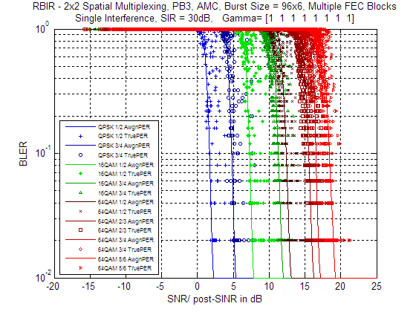
Figure-1 Performance of RBIR in BLER calculation

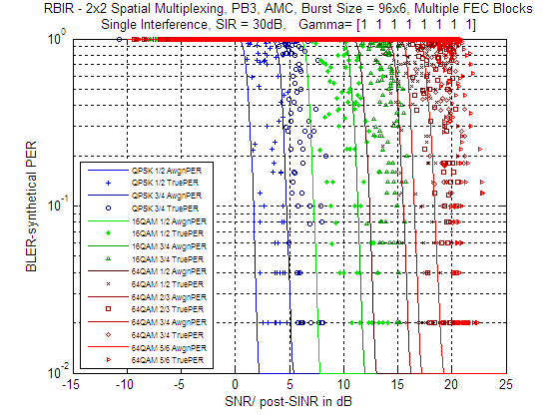
Figure-2 Performance of deriving PER from BLER

A modification on the RBIR mapping function can solve this issue. The modified RBIR mapping function is
(2)
In equation (2), is the mutual information for i-th symbol, is the modulation order and is an adjusting parameter.
Figure-3 shows that modified RBIR can be used to obtain accurate PER for a burst containing multiple FEC blocks.

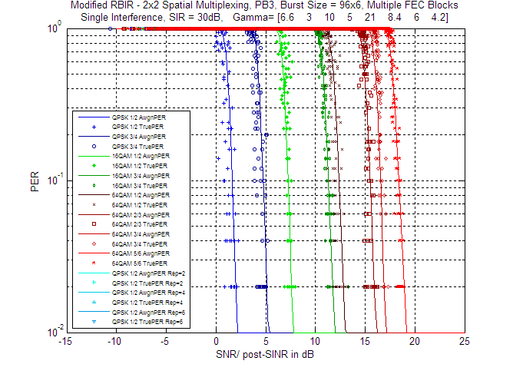
Figure-3 Performance of Modified RBIR in PER calculation

Based on the results above, we propose to insert a new subsection on the modified RBIR for multiple FEC blocks in subsection 4.3.1 and 4.6.

II. Proposed Text for Section on Deriving PER of Burst with Multiple FEC Blocks

-------------------------------------------------------Start of the text------------------------------------------------------------
[Add the following text after the line#21 of the page55 in C802.16m-07/080r3]

4.3.1.1 Modified RBIR
In order to obtain accurate PER for a burst containing multiple FEC blocks without a cross-block interleaver, RBIR can be calculated as
(x)
Where, is the mutual information for i-th symbol, is the modulation order and is an adjusting parameter.
Some optimized adjusting parameter values are listed below. More cases for different burst size are FFS.
Burst Size  MCS | 6 slots  (96 subc x 6 sym)
CTC, QPSK ½ | 6.6
CTC, QPSK ¾ | 3
CTC, QAM16 ½ | 10
CTC, QAM16 ¾ | 5
CTC, QAM64 ½ | 21
CTC, QAM64 2/3 | 8.4
CTC, QAM64 ¾ | 6
CTC, QAM64 5/6 | 4.2
Table (y): optimized Gamma value

[Replace the line#11~17 of the page64 in C802.16m-07/080r3 with the following text]
Consider a packet comprised of several FEC blocks. The packet error rate (PER) is the probability that an error occurs in at least one of FEC blocks comprising the packet. The PHY abstraction predicts the link performance, in terms of BLER for a coded FEC block. Here we need to extrapolate the PER given the predicted BLER.
If a packet is comprised of J blocks and the predicted BLERs are given by BLER₁, BLER₂, …, BLER_{J}, and, then the PER with a cross-block interleaver is derived as
(y)
For a packet consisting several individual FEC blocks (without cross-block interleaver), the packet error rate (PER) should be derived using Modified RBIR described in section 4.3.1.1.

-------------------------------------------------------End of the text------------------------------------------------------------

