Project | IEEE 802.16 Broadband Wireless Access Working Group <http://ieee802.org/16>
Title | Proposed Text Modification in Section 4.7: PHY Abstraction for H-ARQ
Date Submitted | 2007-09-10
Source(s) | Senjie ZHANG, Intel Corporation  May WU, Intel Corporation  Hongming ZHENG, Intel Corporation  Jinbao ZHANG, Intel Corporation  Shanshan ZHENG, Intel Corporation | senjie.zhang@intel.com  may.wu@intel.com  hongming.zhang@intel.com  jinbao.zhang@intel.com  shanshan.zheng@intel.com
Re: | IEEE 802.16m-07/xxx– Call for Comments on Draft 802.16m Evaluation Methodology Document
Abstract | This contribution proposes modifications to text in Section 4.7: ‘PHY Abstraction for H-ARQ’
Purpose | For discussion and approval by TGm
Notice | This document does not represent the agreed views of the IEEE 802.16 Working Group or any of its subgroups. It represents only the views of the participants listed in the “Source(s)” field above. It is offered as a basis for discussion. It is not binding on the contributor(s), who reserve(s) the right to add, amend or withdraw material contained herein.
Release | The contributor grants a free, irrevocable license to the IEEE to incorporate material contained in this contribution, and any modifications thereof, in the creation of an IEEE Standards publication; to copyright in the IEEE’s name any IEEE Standards publication even though it may include portions of this contribution; and at the IEEE’s sole discretion to permit others to reproduce in whole or in part the resulting IEEE Standards publication. The contributor also acknowledges and accepts that this contribution may be made public by IEEE 802.16.
Patent Policy | The contributor is familiar with the IEEE-SA Patent Policy and Procedures:  <http://standards.ieee.org/guides/bylaws/sect6-7.html#6> and <http://standards.ieee.org/guides/opman/sect6.html#6.3>.  Further information is located at <http://standards.ieee.org/board/pat/pat-material.html> and <http://standards.ieee.org/board/pat>.

Proposed Text Modification in Section 4.7: PHY Abstraction for H-ARQ
Senjie ZHANG, May WU, Hongming ZHENG, Jinbao ZHANG, Shanshan ZHENG
Intel Corporation

I. Introduction
In the EM document, sum of postSINR is recommended as the effective postSINR for repetition coding and HARQ transmission if Chase combining is utilized. This is not accurate in the MIMO case. If a burst is retransmitted, all streams are retransmitted. So the self interference between MIMO streams is repetitive instead of Gaussian. Retransmission and Chase combining can not improve the SIR corresponding to them effectively as Gaussian noise. So the total postSINR is not the sum of each transmission’s postSINR. Figure-1 shows the simulation result for MI and EESM.

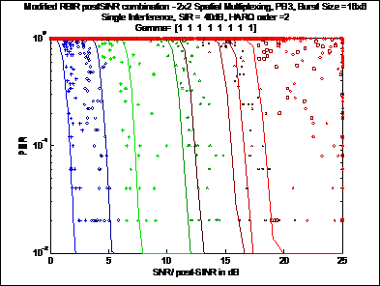
Figure-1

From figure-1, we can see that the combined sum postSINR is much higher than its realistic value. That proves the self interference between MIMO streams cannot be reduced by Chase combining.

Considering the self interference between MIMO streams and Gaussian noise separately when calculating combined postSINR can produce more accurate results. The impact of interference between cells is FFS because the characteristics of interfering signal are hard to be estimated. Currently we assume it to be Gaussian noise.

MIMO stream 1 in a 2x2 spatial multiplexing system is considered in the following example.

Considering$N$ transmissions (repetition coding is treated as multiple transmissions, the transmission order equals to the repetition rate), the simplified signal model is described as follows:
Here, $i$is the transmission number.
The non-interference-aware MMSE weights are specified as
where (.)* is the Hermitian operator.

Defining the following two expressions: which denotes the desired signal component and which is the self interference between MIMO streams.

The demodulated signal of i-th transmission is:

For Chase combining, the received signal is normalized as:

where is the data symbol with covariance; and is the equivalent Gaussian noise.

The Chase combined signal is
So the combined SINR should be

If LLR combination is used, a coefficient can be used to eliminate the impact of different LLR ranges of multiple-level modulation like 16QAM and 64QAM as:

The recommended value for different MCS is list in table-1
MCS | QPSK 1/2 | QPSK 3/4 | 16QAM 1/2 | 16QAM 3/4 | 64QAM 1/2 | 64QAM 2/3 | 64QAM 3/4 | 64QAM 5/6
Alpha | 1 | 1.5 | 1.2 | 1 | 1 | 0.6 | 0.5 | 0.4
Table-1

Simulation results are plotted in figures 2 and 3.

Figure-2 shows the result for bursts containing single FEC block.

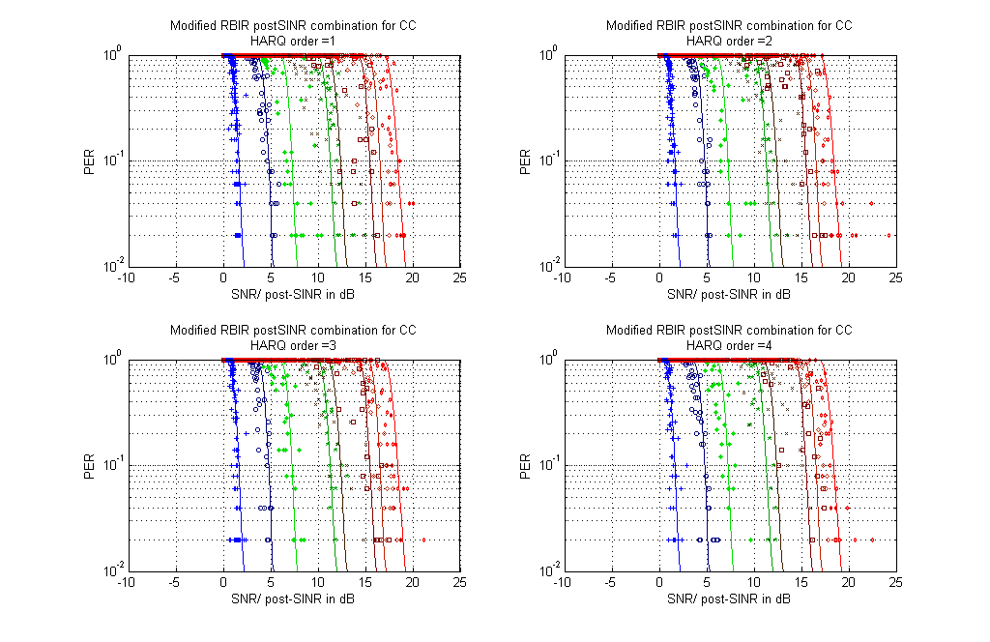
Figure-2

Figure-3 shows the result for bursts containing multiple FEC blocks jointly with modified RBIR.

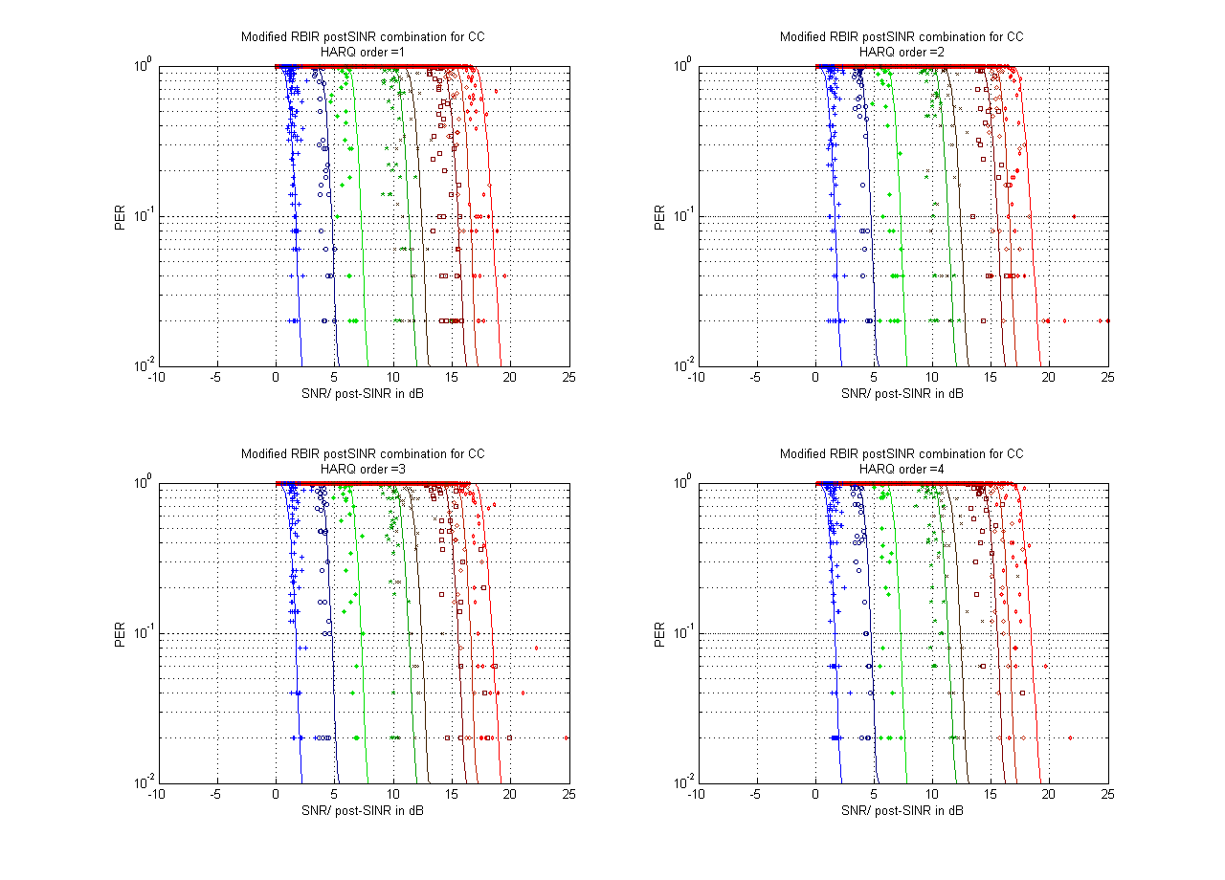
Figure-3

II. Proposed Text for Section on PHY Abstraction for H-ARQ
[Replace the line#31~33 of the page73 in C802.16m-07/080r3 with the following text]
For the SISO case, the post-processing SINR can be obtained as simple sum of the SINRs from the first transmission and subsequent retransmissions. For the MIMO case, the post-combining mutual information metric is given by …

[Add the following text after the line#3 of the page74 in C802.16m-07/080r2]
For MIMO case, the self interference between MIMO streams is repetitive instead of Gaussian. The total postSINR is not the sum of each transmission’s postSINR. The self interference between MIMO streams and Gaussian noise should be separately considered when calculating combined postSINR. For a 2x2 spatial multiplexing system, the combined SINR should be

-------------------------------------------------------End of the text------------------------------------------------------------

