Project | IEEE 802.16 Broadband Wireless Access Working Group <http://ieee802.org/16>
Title | Adaptive Frequency Reuse in IEEE 802.16m system
Date Submitted | 2007-11-12
Source(s) | I-Kang Fu, Pei-Kai Liao and Paul Cheng.  MediaTek Inc. No.1, Dusing Road 1, Science-Based Industrial Park, Hsinchu, Taiwan 300, R.O.C. | IKang.Fu@gmail.com  pk.liao@mediatek.com  Paul.Cheng@mediatek.com
Re: | IEEE 802.16m-07/040, “Call for Contributions on Project 802.16m System Description Document (SDD)”
Abstract | This contribution proposes to have a section “Adaptive Frequency Reuse” in P802.16m SDD and introduce how this mechanism can improve the capacity of IEEE 802.16m system.
Purpose | Propose TGm SDD to have a section “Adaptive Frequency Reuse”.
Notice | This document does not represent the agreed views of the IEEE 802.16 Working Group or any of its subgroups. It represents only the views of the participants listed in the “Source(s)” field above. It is offered as a basis for discussion. It is not binding on the contributor(s), who reserve(s) the right to add, amend or withdraw material contained herein.
Release | The contributor grants a free, irrevocable license to the IEEE to incorporate material contained in this contribution, and any modifications thereof, in the creation of an IEEE Standards publication; to copyright in the IEEE’s name any IEEE Standards publication even though it may include portions of this contribution; and at the IEEE’s sole discretion to permit others to reproduce in whole or in part the resulting IEEE Standards publication. The contributor also acknowledges and accepts that this contribution may be made public by IEEE 802.16.
Patent Policy | The contributor is familiar with the IEEE-SA Patent Policy and Procedures:  <http://standards.ieee.org/guides/bylaws/sect6-7.html#6> and <http://standards.ieee.org/guides/opman/sect6.html#6.3>.  Further information is located at <http://standards.ieee.org/board/pat/pat-material.html> and <http://standards.ieee.org/board/pat>.
Adaptive Frequency Reuse in IEEE 802.16m System

I-Kang Fu, Pei-Kai Liao and Paul Cheng
MediaTek Inc.

- Introduction
In mobile cellular systems, frequency reuse is an important technique to improve the overall system capacity by reusing the scarce spectrum resource and the cellular structure is the tool to facilitate the frequency planning. Few years ago, the idea of reuse partitioning was introduced in the literature [1] to apply different frequency reuse factors within the same cell. Recently, the IEEE 802.16 based mobile WiMAX system [2] has implemented this technique in the real system. In this contribution, the idea of reuse partitioning is further extended as a kind of adaptive frequency reuse and a simple example is given to introduce how to realize this technique in IEEE 802.16m system. Then, some text input for TGm SDD is proposed to consider the adaptive frequency reuse as a topic for further development in P802.16m.

- System Model
The system model begins from a typical cellular structure as shown in Figure 1. The reference base station () is denoted as, and the interfering BSs are denoted as, q = 1, 2 … Q, where Q is the number of the interfering BSs. Cell radius is the same for every BS, and the distance between adjacent interfering BSs is given by, where is the reuse factor (cluster size) [3]. is a key system parameter that balances link performance and system capacity.
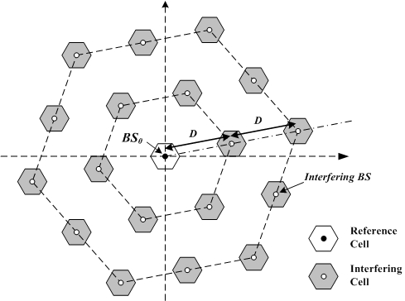
Fig. 1 Geometry of interfering cells () by given a frequency reuse factor (cluster size) K

- Adaptive Frequency Reuse
The typical reuse partitioning cell structure is given here as an example of adaptive frequency reuse, where a regular cell is divided (ideally) into two or more concentric cell-regions, each with a different frequency reuse factor () [2]. By allowing the inner cell-regions to use a smaller reuse factor leads to a higher system capacity, as compared to the regular cell structure where the same reuse factor is used for the entire cell. Note that the reuse factor, size of each frame zone and the user served by each zone may be adapted from time to time. In order to achieve this, some kind of measurement and inter-cell coordination mechanisms will be necessary to enable adaptive frequency reuse.
Figure 2 illustrates its concept with a TDD frame structure. In Figure 2(a), a regular cell is divided into Z cell-regions with the z-th region denoted by, where ,, , and . Then, the TDD frame is partitioned into resource-zones (or frame-zones), and within a resource-zone, the radio resource is further divided into resource-regions as shown in Figure 2(b), where is the reuse factor for z-th cell-region. Finally, each of the resource-region is allotted to BSs according to the designated reuse factor and cell regions.

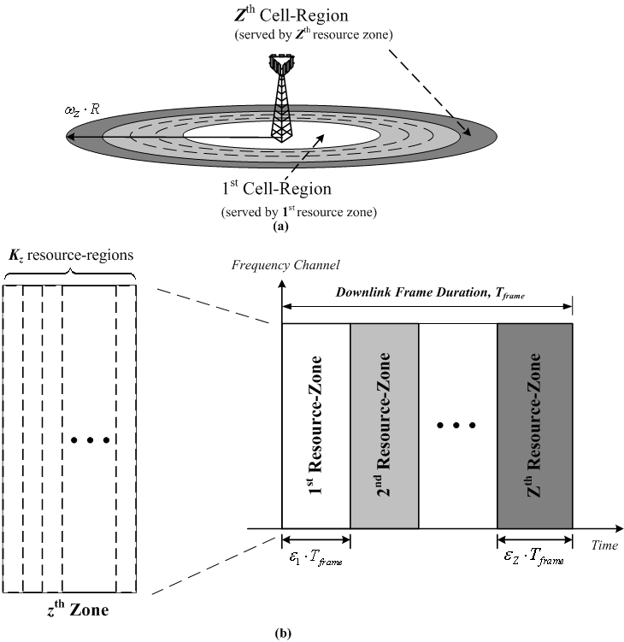
Fig. 2 An example [4] of adaptive frequency reuse: (a) divide the cell into Z concentric regions and (b) serve each region by corresponding frame zone with different

- Text Proposal

---------------------------------------------------------Start of the Text--------------------------------------------------------
x.y Adaptive Frequency Reuse
[In IEEE 802.16m system, the frequency reuse factor applied in each frame zone may be different. For the users in different location or under different interference level, system may serve them by appropriate frame zone with different frequency reuse factor. In order to enable the adaptive frequency reuse in IEEE 802.16m system, a measurement mechanism and a inter-cell coordination mechanism will be necessary.]
x.y.1 Measurement mechanism for adaptive frequency reuse
x.y.2 Inter-cell coordination for adaptive frequency reuse

---------------------------------------------------------End of the Text--------------------------------------------------------

References
[1] T-Po Chu and Stephen S. Rappaport, “Overlapping Coverage with Reuse Partitioning in Cellular Communication Systems,” IEEE Transactions on Vehicular Technology, Vol. 46, No. 1, pp.41-54, Feb. 1997.
[2] WiMAX White Paper, “Mobile WiMAX - Part I: A technical overview and performance evaluation,” http://www.wimaxforum.org/technology/downloads/, Feb. 2006.
[3] T. S. Rappaport, “Wireless communications: principles & practice,” ISBN: 0133755363, Prentice Hall, 1999.
[4] I-Kang Fu, “Performance Improvement Techniques for Cellular OFDMA Systems,” Ph.D Dissertation, National Chiao Tung University, Sep. 2007.

