Project | IEEE 802.16 Broadband Wireless Access Working Group <http://ieee802.org/16>
Title | 802.16m SDD Proposal
Date Submitted | 2007-11-14
Source(s) | Hokyu Choi, Jaeweon Cho, David Mazzarese, Jaehee Cho, Yungsoo Kim, DS Park  Samsung Electronics  #416, Maetan-3dong, Yeongtong-gu  Suwon-city, South Korea | Voice: +82-31-279-4660  E-mail: choihk@samsung.com
Re: | Response to IEEE 802.16m-07/040 “Call for Contributions on Project 802.16m System Description Document (SDD)”
Abstract | This contribution provides 802.16m SDD proposal for features in addition to IEEE 802.16m-07/297.
Purpose | For discussion and decision
Notice | This document does not represent the agreed views of the IEEE 802.16 Working Group or any of its subgroups. It represents only the views of the participants listed in the “Source(s)” field above. It is offered as a basis for discussion. It is not binding on the contributor(s), who reserve(s) the right to add, amend or withdraw material contained herein.
Release | The contributor grants a free, irrevocable license to the IEEE to incorporate material contained in this contribution, and any modifications thereof, in the creation of an IEEE Standards publication; to copyright in the IEEE’s name any IEEE Standards publication even though it may include portions of this contribution; and at the IEEE’s sole discretion to permit others to reproduce in whole or in part the resulting IEEE Standards publication. The contributor also acknowledges and accepts that this contribution may be made public by IEEE 802.16.
Patent Policy | The contributor is familiar with the IEEE-SA Patent Policy and Procedures:  <http://standards.ieee.org/guides/bylaws/sect6-7.html#6> and <http://standards.ieee.org/guides/opman/sect6.html#6.3>.  Further information is located at <http://standards.ieee.org/board/pat/pat-material.html> and <http://standards.ieee.org/board/pat>.
802.16m SDD Proposal
Hokyu Choi, Jaeweon Cho, David Mazzarese, Jaehee Cho, Yungsoo Kim, DS Park
Samsung Electronics

Introduction
In this contribution, several additional topics relevant to SDD system architecture, based on [1], are presented. They are:
- Further thought on legacy support
- Self organization network
- Multi-carrier support
- MIMO architecture

In [1], it is mentioned that 16e legacy operation zone and 16m operation zone can be divided in frequency or time domain, as an example of legacy supporting architecture. In this contribution, we explain a relevant issue which is believed to be inherently related to system architecture or frame structure.
In addition, MAC protocol architecture in [1] includes self organization function without having further explanation. More information on self organization function from system architecture point of view is explained in this contribution.
MAC protocol architecture in [1] also includes multi-carrier support function. It is possible to imagine many different scenarios even for a single carrier if scalable bandwidth is considered. Furthermore, legacy support requirement also adds up additional scenarios to multi-carrier scenario. In this contribution, we intend to show full range of possible scenarios in both single and multi-carrier scenarios so that discussion can focus on discriminating unrealistic and unnecessary scenarios before 802.16m have detail solution.
Finally, a generic DL MIMO architecture is provided to serve as a place-holder of many different kinds of proposals while keeping overall architecture maintained.

[1] IEEE 80216m-07/297 “Proposal for IEEE 802.16m System Architecture and Protocol Structure”

Further Thought on Legacy Support
In [1], DL and UL zone are divided for legacy (16e) and 16m zones in either time or frequency domain. There are total of 4 possible combinations in multiplexing legacy (16e) and 16m zones as shown in Figure 1. The proponent of the contribution recommends the TGm to take a careful investigation in choosing proper multiplexing scheme.

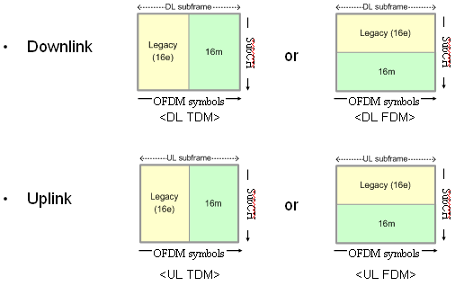
Figure 1. Possible Multiplexing of Legacy (16e) and 16m signal

Self Organization

Self organization network architecture
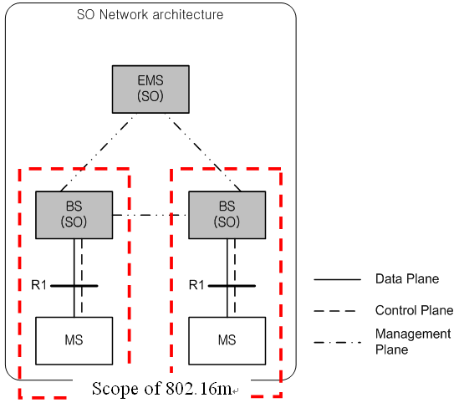

Figure 2. Self organization network architecture

Figure 2 shows the architecture of Self organization (SO) network. The SO functions mainly comprise of self configuration and self optimization mechanisms. EMS (Entity Management System) performs SO functions over base stations (BS) like managing system configuration parameters, radio resource managements to coordinate interference among BSs and etc. BS may perform SO functions in relation with neighboring BSs and mobile stations (MS) served by the BS. They may include transmission power control of BS, BS-to-BS synchronization, update of hand over parameters and etc. MS may measure SO related metrics in response to BS’s request and report the measurement to the BS. The measurements may include received signal strength of the other BSs, the location information of MS and etc. The SO scope of IEEE 802.16m is inside of the red dotted boxed.

Proposal
Figure 3. Protocol stack for SO support

Self Organization (SO) block performs functions to support self configuration and self optimization mechanisms. The functions include procedures to request MSs to report measurements for self configuration and self optimization and receive the measurements from the MSs. The specific request/response mechanisms are for further study (FFS). The types and definitions of the measurements are FFS. SO reference signals can be defined to enhance the self configuration and self optimization mechanisms. The block determines to send the reference signal and manages the control signal block to transmit the signal. The types and definitions of the SO reference signals are FFS.

MIMO Architecture

In this section, general MIMO architecture is described.

Architecture
Figure 4. MIMO architecture

Figure 4 shows the functional blocks that support MIMO operation. MIMO processing can be uniquely described as a block that takes as input codewords of modulated symbols, and that produces output in the form of a basic time-frequency resource block for each transmit antenna. The symbols in that resource block are uniquely processed and mapped to the resource block according to a specific MIMO mode. The specific MIMO mode is selected by an adaptation mechanism, and it only requires adapting the processing blocks within the MIMO encoding and mapping block.

Adaptation of the MIMO mode to operating conditions selects the specific processing and mapping for each block. The adaptation may rely among other things on Channel Quality Information (CQI) and on Channel State Information (CSI) feedback. This adaptation may be either long-term of short-term. CQI and CSI may be used as inputs to the adaptation mechanism (RRM, scheduler). CQI is also directly used for adapting the modulation and coding rate in the bit-level processing block. CSI is also directly used for signal processing within the MIMO encoding and mapping block.

MIMO Encoding and Mapping
Figure 5 shows the signal processing and mapping functions within the MIMO encoding and mapping block. A precoder supports closed-loop MIMO processing (beamforming with one or several beams to one or several users). The adaptation of the precoder may be either long-term or short-term or both. This structure supports single or multiple codewords MIMO, single-user or multiuser MIMO, open-loop or closed-loop MIMO, including spatial diversity, spatial multiplexing, and precoding. It is worth noting that boxes in the diagram inherently has an option of by-passing the signal.
Figure 5. MIMO Encoding and Mapping

