Project | IEEE 802.16 Broadband Wireless Access Working Group <http://ieee802.org/16>
Title | System Description of Inter-RAT Operation in IEEE 802.16m
Date Submitted | 2007-11-13
Source(s) | Chie Ming Chou, Richard Li, Fang-Ching (Frank) Ren, Ting-Chen (Tom) Song, ITRI  Wern-Ho Sheen, NCTU/ITRI | Voice:  E-mail: chieming@itri.org.tw  richard929@itri.org.tw
Re: | IEEE 802.16m-07/040 - Call for Contributions on Project 802.16m System Description Document (SDD)
Abstract | This contribution proposes two text proposals for 802.16m Inter-RAT operations. The first one is Table of Contents (ToC) for Inter-RAT operation section in 802.16m system description document (SDD). The other one describes a reference model and functionalities for 802.16m’s Inter-RAT operations. The second text proposal could also be treated as our reasons and explanation for the proposed ToC.
Purpose | For discussion and approval by TGm
Notice | This document does not represent the agreed views of the IEEE 802.16 Working Group or any of its subgroups. It represents only the views of the participants listed in the “Source(s)” field above. It is offered as a basis for discussion. It is not binding on the contributor(s), who reserve(s) the right to add, amend or withdraw material contained herein.
Release | The contributor grants a free, irrevocable license to the IEEE to incorporate material contained in this contribution, and any modifications thereof, in the creation of an IEEE Standards publication; to copyright in the IEEE’s name any IEEE Standards publication even though it may include portions of this contribution; and at the IEEE’s sole discretion to permit others to reproduce in whole or in part the resulting IEEE Standards publication. The contributor also acknowledges and accepts that this contribution may be made public by IEEE 802.16.
Patent Policy | The contributor is familiar with the IEEE-SA Patent Policy and Procedures:  <http://standards.ieee.org/guides/bylaws/sect6-7.html#6> and <http://standards.ieee.org/guides/opman/sect6.html#6.3>.  Further information is located at <http://standards.ieee.org/board/pat/pat-material.html> and <http://standards.ieee.org/board/pat>.
System Description of Inter-RAT Operation in IEEE 802.16m
Chie Ming Chou, Richard Li, Fang-Ching (Frank) Ren, Ting-Chen (Tom) Song, ITRI
Wern-Ho Sheen NCTU/ITRI

1. Introduction
According to IEEE 802.16m System Requirements [1], 802.16m shall support handover and internetworking functionalities with other radio access technologies (RATs). In addition, 802.16m should support IEEE 802.21 Media Independent Handover (MIH) Services and be fully compatible with IEEE 802.16g Network Control and Management Services (NCMS). This contribution proposes two text proposals for 802.16m Inter-RAT operations. The first one is Table of Contents (ToC) for Inter-RAT operation section in 802.16m system description document (SDD). The other one describes a reference model and functionalities for 802.16m’s Inter-RAT operations. The second text proposal could also be treated as our reasons and explanation for the proposed ToC.

2. Proposed Text
The following text is proposed to be adopted as ToC of Inter-RAT operations section in 802.16m SDD.
-------------------------------------------------------- Start of the text ------------------------------------------------------
- Inter-RAT Operations Reference Network Model
  - Legacy Network Model
  - 802.16m’s Inter-RAT Operations Reference Network Model

[Insert following contents into the section 10.1.2.3 proposed by [5]]
- Inter-RAT Functionalities
  - MS Capability Configuration
  - Mobility from IEEE 802.16m to other RATs
    - Network topology acquisition
      - Network topology advertisement
      - MS scanning of other RATs
        - Single-receiver MS scanning
        - Multi-receivers MS scanning

Inter-RAT handover process
      - Cell reselection
      - Handover decision and initiation
      - Handover execution
  - Mobility from other RATs to IEEE 802.16m
    - Mobility from IEEE 802.11 to IEEE 802.16m
    - Mobility from 3GPP network to IEEE 802.16m
    - Mobility from 3GPP2 network to IEEE 802.16m
-------------------------------------------------------- End of the text ------------------------------------------------------

The following text is proposed to be adopted as section contents of Inter-RAT operations in 802.16m SDD and also could be treated as our reasons and explanation for the above proposed ToC.
-------------------------------------------------------- Start of the text ------------------------------------------------------
- Reference Network Model
This section describes legacy network model and 802.16m’s Inter-RAT operations reference network model. A new entity and a new interface are added into the legacy one to construct 802.16m’s Inter-RAT operations reference network model.

1.1 Legacy Network Model
Figure 1 illustrates the legacy network model of IEEE 802.16 standard [2]. It comprises of three major functional aggregations: Mobile Station (MS), Access Service Network (ASN) and Connectivity Service Network (CSN). The ASN is a collection of functions described as Base Station and ASN Gateway (ASN-GW), which can be rendered in one or more ASNs’ configuration. The CSN comprises network elements such as, user databases, AAA proxy/servers and MIP HA.
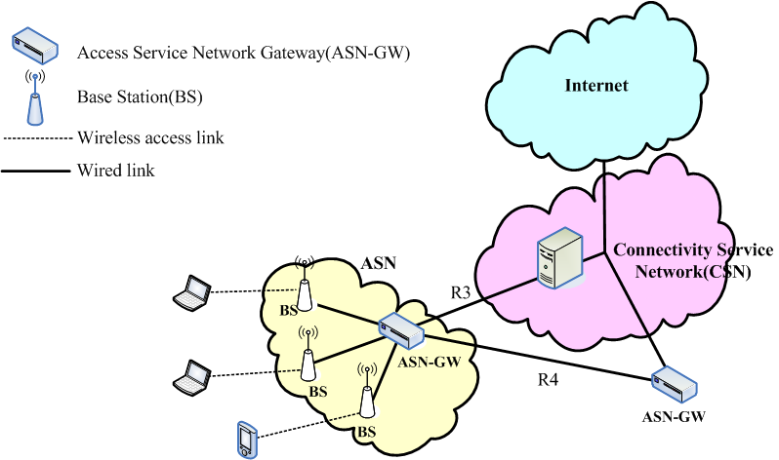
Figure 1. Legacy reference network model

R3 interface consists of a set of control plane protocols between the ASN and CSN to support AAA policy enforcement and mobility management capabilities. This also encompasses the bearer plane methods to transfer data between ASN and CSN. R4 interface consists of set of Control and Bearer plane protocols that co-ordinate UE mobility between ASNs. R4 encompasses the following functionality relating to mobility management:
- Handover Control and Anchoring: This function controls overall handover decision making and signaling procedures related to handover.
- Context Transfer: This function helps with the transfer of any state information between network elements.
- Bearer Path Setup: This function manages data path setup and procedures for data packet transmission between functional entities.

1.2 802.16m’s Inter-RAT Operations Reference Network Model
In order to support Inter-RAT operations, 802.16m messages need to be sent transparently to other RATs through IP network. Besides, network side should be able to provide sufficient information of neighboring RATs. Figure 2 shows an assumed 802.16m’s Inter-RAT operations reference network model. A new interface and a new entity, Enhanced R4 Interface and Internetworking Server, are added to facilitate Inter-RAT operations.

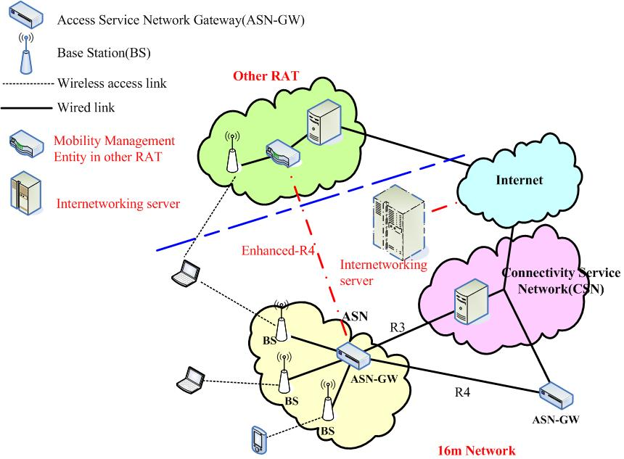
Figure 2. 802.16m’s Inter-RAT operations reference network model

- Enhanced R4 Interface
Enhanced R4 Interface is used for the negotiations between ASN-GWs and other RATs’ mobility management entities. In addition to R4 interface functions, Enhanced R4 Interface supports IEEE 802.21 protocol and Media Independent Handover (MIH) functions [3], which can tunnel associated management messages from 802.16m network to other RATs. Corresponding enhancements in IEEE 802.16m protocol architecture model are shown in Figure 3. Details of new layers are skipped in this document due to out of scope and can refer to WiMAX Forum NWG document [4] and IEEE P802.21 standard [3].
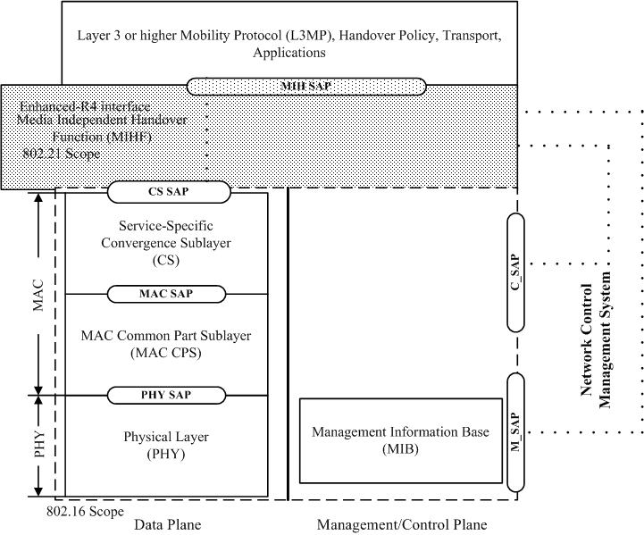
Figure 3. Enhanced 802.16m protocol architecture model

- Internetworking Server
Internetworking server is intended to provide 802.16m and other RATs a global view of available heterogeneous networks for seamless roaming. It is a media-independent network entity which is expected to be established by network services provider (NSP). ASN-GW can connect to the server through IP protocol and acquire information for internetworking. Then, BSs can periodically broadcast SII-ADV message or unicast to MSs [2]. The internetworking information includes:
  - List of available networks
－ NAP ID, NSP ID, BSID, etc.
  - Link layer information
－ MAC version, center carrier frequency, cell bandwidth, frame duration, etc.
  - List of support higher layer services
－ available services, QoS mapping, etc.

- Inter-RAT Functionalities
Essential Inter-RAT functionalities in PHY and MAC layers based on the 802.16m’s Inter-RAT operations reference network model are described in this section. All MSs and BSs in the following context are assumed to have 802.16m capability if no specific statement is made.

2.1 MS Capability Configuration
After an MS connects to a BS, it shall provide its Inter-RAT capabilities, such as supported RATs and number of transceivers, to the BS and network during network entry. It is helpful for the BS and network to control Inter-RAT operations.

2.2 Mobility from IEEE 802.16m to other RATs
Inter-RAT handover from 802.16m to other RATs can be used in a number of situations. For example:
－ When an MS moves out of 802.16m coverage, Inter-RAT handover is necessary to maintain its connectivity.
－ Higher QoS can be served from another RAT(s).
－ When 802.16m system has heavy capacity loading and other RAT services are available for some MSs. These MSs can handover to other RATs to reduce 802.16m system capacity loading.

In order to support mobility from 802.16m to other RATs and maintain service continuity, the following functionalities are necessary:
- Network topology acquisition: BSs shall be able to provide information regarding to network topology and schedule appropriate scanning period for MSs to acquire channel condition of other RATs.
- Inter-RAT handover process: Both BSs and MSs are able to trigger Inter-RAT handover process. Inter-RAT handover process consists of handover decision and initiation, PHY layer re-synchronization, network re-entry, and connection re-setup. The latter three steps depends on the specification of target RATs.

2.2.1 Network topology acquisition
BSs should acquire network topology from Internetworking Server and deliver the information to MSs. When specific metrics are met, either MSs or BSs can trigger Inter-RAT scanning process to acquire other RATs’ channel condition. MSs should be able to report their scanning results to BSs if needed.

2.2.1.1 Network topology advertisement
Inter-RAT network topology shall be broadcasted by BSs or unicasted to MSs. This information facilitates MSs to measure and synchronize with other RATs’ signals.

2.2.1.2 MS scanning of other RATs
Both BSs and MSs can originate the scanning process for other RATs. BSs could schedule and allocate time intervals for MSs to scan available RAT’s signals. The allocated time for scanning and search for available RAT cells is referred as scanning interval.
According to the number of receivers in MSs, allocation of scanning interval can be categorized into single-receiver and multi-receivers MS scanning.
The reporting of scanning results can be either periodic or event-triggered.

2.2.1.2.1 Single-receiver MS scanning
In case of single-receiver MS scanning, scanning interval and normal transmission should be well scheduled. Due to uncertainties of other RATs’ system, an adjustable scanning process should be employed to suit for various RATs.

2.2.1.2.2 Multi-receivers MS scanning
In this case, MSs are able to measure other RATs while communicating with 802.16m network. The schedule of scanning time can be easily allocated.

2.2.2 Inter-RAT handover process
In case of Inter-RAT handover from 802.16m to other RATs, three steps are needed: 1) cell reselection, 2) handover decision and initiation, and 3) handover execution.

2.2.2.1 Cell reselection
Cell reselection is an MS procedure to evaluate possible RATs for Inter-RAT handover.

2.2.2.2 Handover decision and initiation
Whether to initialize Inter-RAT handover can be decided by MSs, BSs, or networks. BSs should provide sufficient information to help MSs perform Inter-RAT handover. Networks may need to help on pre-negotiation between 802.16m and target RATs.

2.2.2.3 Handover execution
Once handover is initiated, MSs will synchronize with preferred target cell and perform authorization and registration to setup its connection. Details of these procedures vary with different RATs. In addition, BSs should temporarily dump original connections, and retrieve them if Inter-RAT handover is failed.

2.3 Mobility from other RATs to IEEE 802.16m
The interest of RATs includes IEEE 802.11, 3GPP GSM/EDGE, 3GPP UTRA FDD and TDD, 3GPP E-UTRA FDD and TDD, and 3GPP2 CDMA2000.

2.3.1 Mobility from IEEE 802.11 to IEEE 802.16m
This subsection specifies the 802.16m-side mobility mechanism/procedure when an MS handovers from IEEE 802.11 system.

2.3.2 Mobility from 3GPP network to IEEE 802.16m
This subsection specifies the 802.16m-side mobility mechanism/procedure when an MS handovers from 3GPP system.

2.3.3 Mobility from 3GPP2 network to IEEE 802.16m
This subsection specifies the 802.16m-side mobility mechanism/procedure when an MS handovers from 3GPP2 system.

------------------------------------------------------ End of the text ---------------------------------------------------------

References
[1] IEEE 802.16m-07/002r4, “IEEE 802.16m System Requirements”
[2] P802.16 Rev2/D1, “Part 16: Air Interface for Broadcast Wireless Access Systems”
[3] P802.21 D06, “Draft Standard for Local and Metropolitan Area Networks: Media Independent Handover Services”
[4] WiMAX Forum NWG Release 1.0.0
[5] C802.16m-07/283r1, “Table of Contents for IEEE 802.16m System Description Document”

