Project | IEEE 802.16 Broadband Wireless Access Working Group <http://ieee802.org/16>
Title | Modifying CTC symbol selection method to enhance CTC IR H-ARQ performance
Date Submitted | 2007-11-15
Source(s) | Yan-Xiu Zheng, Ren-Jr Chen, Chung-Lien Ho, Chang-Lan Tsai, Chang-Lung Hsiao,  Chi-Fang (Richard) Li, Ting-Chen (Tom) Song, ITRI  Wern-Ho Sheen, NCTU/ITRI | Voice:  E-mail: non2000.cm88g@nctu.edu.tw  richard929@itri.org.tw
Re: | IEEE 802.16m-07/040 - Responds to Call for Contributions on Project 802.16m System Description Document (SDD)
Abstract | Modifying CTC symbol selection method enhances CTC H-ARQ IR error rate performance. IR is one of the H-ARQ retransmission mechanisms. This mechanism retransmits pre-defined coded symbols by the symbol selection method. However the symbol selection method limits the types of the symbol selection. This contribution introduces a simple modification method on the symbol selection to increase more versions of selected symbols and enhance the associated performance.
Purpose | For 802.16m discussion and adoption
Notice | This document does not represent the agreed views of the IEEE 802.16 Working Group or any of its subgroups. It represents only the views of the participants listed in the “Source(s)” field above. It is offered as a basis for discussion. It is not binding on the contributor(s), who reserve(s) the right to add, amend or withdraw material contained herein.
Release | The contributor grants a free, irrevocable license to the IEEE to incorporate material contained in this contribution, and any modifications thereof, in the creation of an IEEE Standards publication; to copyright in the IEEE’s name any IEEE Standards publication even though it may include portions of this contribution; and at the IEEE’s sole discretion to permit others to reproduce in whole or in part the resulting IEEE Standards publication. The contributor also acknowledges and accepts that this contribution may be made public by IEEE 802.16.
Patent Policy | The contributor is familiar with the IEEE-SA Patent Policy and Procedures:  <http://standards.ieee.org/guides/bylaws/sect6-7.html#6> and <http://standards.ieee.org/guides/opman/sect6.html#6.3>.  Further information is located at <http://standards.ieee.org/board/pat/pat-material.html> and <http://standards.ieee.org/board/pat>.
Modifying CTC symbol selection method to enhance CTC IR H-ARQ performance

Zheng Yan-Xiu, Ren-Jr Chen, Chung-Lien Ho, Chang-Lan Tsai, Chang-Lung Hsiao, Chi-Fang (Richard) Li, Ting-Chen (Tom) Song,
ITRI
Wern-Ho Sheen
NCTU/ITRI

Summary

This contribution introduces a modified symbol selection method of the CTC IR H-ARQ. This new method provides more versions of selected symbols that improves error rate performance and our simulation results show the enhanced performance. This contribution is a text proposal of adopting a method of CTC symbol selection in the IEEE 802.16m SDD.

Proposed Text

-----------------------------Begin Proposed Text ----------------------------------------------------------------------

x.x.x CTC symbol selection

<Notes: Revisit the equation 174 in IEEE P802.16 section 8.4.9.2.3.4.4. Symbol Selection. Hereof to propose a modified equation; it changes the order of subpacket sequence of re-transmission symbol selection method>

---------------------------End of Text Proposal ---------------------------------------------------------------------

Introduction

This contribution introduces a modified symbol selection method of the CTC IR H-ARQ. This new method provides more versions of selected symbols that improves error rate performance and our simulation results show the enhanced performance. This contribution is a text proposal of adopting a method of CTC symbol selection in the IEEE 802.16m SDD.

Double binary turbo code encoder and subpackage generation method
IEEE 802.16 CTC [1] applies double binary circular recursive systematic convolutional code and Fig. 1 shows the CTC encoder. The input symbol of this code is composed of a bit pair (A_{i}, B_{i}), where A_{i} and B_{i} are the ith bits of the input sequences A and B. The output are A, B ,Y₁ ,Y₂ ,W₁ ,W₂.Y₁ andW₁ correspond to the input sequences A and B; Y₂ and W₂ correspond to the permuted input sequences A and B.
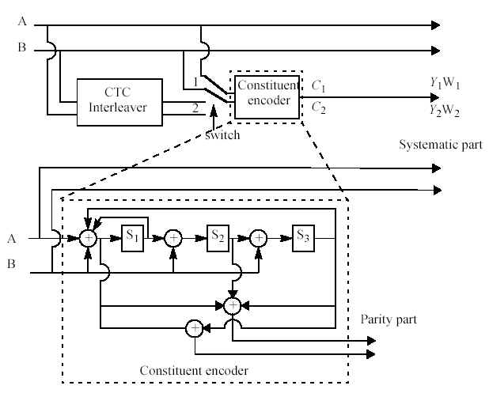
Fig. 1: Double binary turbo code.
Fig. 2 plots subpacket generation method. This method generates code sequence by the CTC encoder. Then the channel interleaver permutes the generated code sequence. After interleaving, the puncturing block selects the associated selected symbols. Fig. 3 shows the channel interleaving. This channel interleaving applies subblock interleaving on sequences A, B ,Y₁ ,Y₂ ,W₁ ,W₂, respectively. Then subblock interleaved sequences Y₁ and Y₂ are inter-block permuted into sequences Y₁’ and Y₂’ and subblock interleaved sequences W₁ and W₂ are inter-block permuted into sequences W₁’ and W₂’. Puncturing block selects symbols according to the sequence order A, B ,Y₁’ ,Y₂’ ,W₁’ ,W₂’, where Table 1 shows the parameters and Table 2 shows the selected symbols.
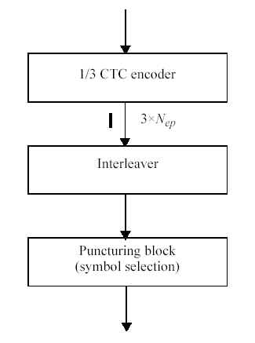
Fig. 2: Subpacket generation method.
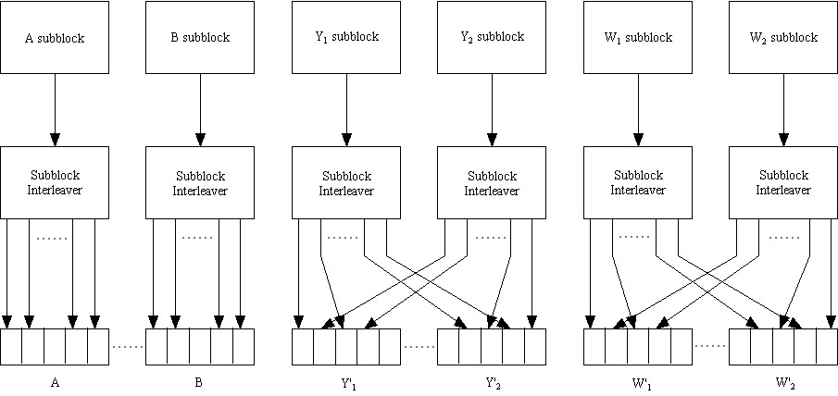
Fig. 3: Channel interleaver.
Table 1: Parameters for the H-ARQ CTC in IEEE 802.16 8.4.9.2.3.4.4 [1].
k | be the subpacket index when HARQ is enabled. k = 0 for the first transmission and increases by one for the next subpacket. k = 0 when HARQ is not used. When there are more than one FEC block in a burst, the subpacket index for each FEC block shall be the same.
N_{EP} | be the number of bits in the encoder packet (before encoding).
N_{SCHk} | be the number of the concatenated slots for the subpacket defined in Table 560 for the non-HARQ CTC scheme defined in 8.4.9.2.3.1 and be the same as the Nsch that is indicated in the Allocation IE for the HARQ CTC scheme defined in 8.4.9.2.3.5.
m_{k} | be the modulation order for the k-th subpacket (m_{k} = 2 for QPSK, 4 for 16-QAM, and 6 for 64-QAM).
SPID_{k} | be the subpacket ID for the k-th subpacket, (for the first subpacket, SPID_{k=0} = 0).

Table 2: The symbol selection in IEEE 802.16 8.4.9.2.3.4.4 [1].

$$\begin{aligned}S_{k,i}=(F_{k}+i)\text{mod}(3N_{\text{EP}}) \\ \text{where} \\ i=1,2,\text{.}\text{.}\text{.},L_{k}−1 \\ L_{k}=\text{48}⋅N_{\text{SCHk}}⋅m_{k} \\ F_{k}=({\text{SPID}}_{k}⋅L_{k})\text{mod}(3⋅N_{\text{EP}})\end{aligned}$$

Modification on the symbol selection method and symbol grouping
Table 2 shows the modified symbol selection method. This method shifts the selected symbol by X if complete codeword is selected, i.e. $S_{k,j}=\left(F_{k}+i+X\right)\text{mod}\left(3N_{\text{EP}}\right),F_{k}+i≥3N_{\text{EP}}$. In general X=N_{EP}. We also can set X=0.5N_{EP} or 1.5N_{EP}. When X=N_{EP}, this method firstly selects parity bits to enhance the distance property if a complete codeword is selected. Our simulation will show the error rate performance.

Table 3: The modified symbol selection method.
$$\begin{aligned}S_{k,i}=\left\{\begin{matrix}(F_{k}+i)\text{mod}(3N_{\text{EP}}) & F_{k}+i<3⋅N_{\text{EP}} \\ (F_{k}+i+X)\text{mod}(3N_{\text{EP}}) & F_{k}+i≥3⋅N_{\text{EP}}\end{matrix},\right.\text{ where} \\ i=1,2,\text{.}\text{.}\text{.},L_{k}−1 \\ L_{k}=\text{48}⋅N_{\text{SCHk}}⋅m_{k} \\ F_{k}=({\text{SPID}}_{k}⋅L_{k})\text{mod}(3⋅N_{\text{EP}})\end{aligned}$$
This method provides more flexibility comparing with IEEE 802.16 symbol selection method. If we consider the case L_{k}=1.5 N_{EP}, IEEE 802.16 symbol selection method only provides two kinds of versions of selected symbols but our method with X=N_{EP} can provide four kinds of versions of selection symbols. Our method give transmitter more degree of freedom in selecting retransmission symbols.
New channel interleaver is introduced for the case X<N_{EP}. We further inter-block permute subblock interleaved sequences A and B where this inter-block permutation is the same as the inter-block permutation for subblock interleaved sequences Y₁ and Y₂. This extra inter-block permutation prevent that only partial symbols of sequence B are selected for H-ARQ retransmission.
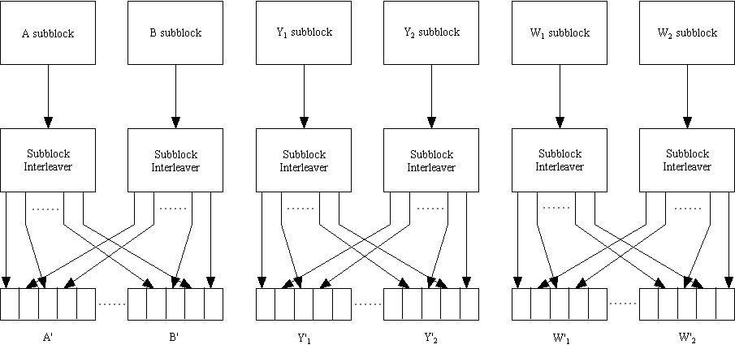
Fig. 4: Modified channel interleaver.

Simulation results
This part evaluates the error rate performance for both symbol selection methods. Denote by IR1 and IR2 the IEEE 802.16 [1] symbol selection method and our symbol selection method. We assume SPID_{k}=0,1,2,3 for k=0,1,2,3. The compared symbol lengths per transmission are 2N_{EP}, 1.5N_{EP} and 1.2N_{EP}, where the code rates for the first transmission are 1/2, 2/3 and 5/6. N_{EP}=480 and 2400 symbols which are equivalent to 960 and 4800 information bits are considered. We simulate the error rate performance of the 1st 2nd, for the cases 2N_{EP}, 1.5N_{EP}, respectively, and 2nd and 3rd retransmission for the cases 1.2N_{EP}. The H-ARQ IR mechanism chooses the selected symbols corresponding to the k^{th} transmission according to SPID_{k}. The simulation environment is AWGN channel. Log-MAP algorithm with 8 iterations is performed in our simulation.

Table 4: Simulation parameters.
Symbol length per transmission | Number of transmission | Mode | Equivalent rate
2N_{EP} | 2 | IR1 | 1/4
2N_{EP} | 2 | IR2 | 1/4
1.5N_{EP} | 3 | IR1 | 2/9
1.5N_{EP} | 3 | IR2 | 2/9
1.2N_{EP} | 3 | IR1 | 5/18
1.2N_{EP} | 3 | IR2 | 5/18
1.2N_{EP} | 4 | IR1 | 5/24
1.2N_{EP} | 4 | IR2 | 5/24

Fig. 5-12 shows the error rate performance. Blue curve denotes IEEE 802.16 symbol selection method and red cure denotes the new symbol selection method. Obviously, that new symbol selection method provides 0.2-0.3 performance gain to the IEEE 802.16 symbol selection method at frame error rate=10⁻⁴.

2N_{EP}, 1 retransmissions, 8 iterations
Fig. 5: N_{EP}=480 with two transmissions whose length is 2 N_{EP}.

2N_{EP}, 1 retransmissions, 8 iterations
Fig. 6: N_{EP}=2400 with two transmissions whose length is 2 N_{EP}.

1.5N_{EP}, 2 retransmissions, 8 iterations
Fig. 7: N_{EP}=480 with three transmissions whose length is 1.5 N_{EP}.

1.5N_{EP}, 2 retransmissions, 8 iterations
Fig. 8: N_{EP}=2400 with three transmissions whose length is 1.5 N_{EP}.

1.2NEP, 2 retransmissions, 8 iterations
Fig. 9: N_{EP}=480 with three transmissions whose length is 1.2 N_{EP}.

1.2N_{EP}, 2 retransmissions, 8 iterations
Fig. 10: N_{EP}=2400 with three transmissions whose length is 1.2 N_{EP}.

1.2N_{EP}, 3 retransmissions, 8 iterations
Fig. 11: N_{EP}=480 with four transmissions whose length is 1.2 N_{EP}.

1.2N_{EP}, 3 retransmissions, 8 iterations
Fig. 12: N_{EP}=2400 with four transmissions whose length is 1.2 N_{EP}.

Conclusions
This contribution provides new symbol selection method to enhance error rate performance. The modification is simple and mild. The performance gain is attractive. This new method also provides more flexibility in choosing retransmission symbols.

Table of contents
Channel coding
Encoding
Convolutional turbo codes (CTCs)
Subpacket generation
Symbol separation
Sybblock interleaving
Symbol grouping
Symbol selection

References
- IEEE DRAFT P802.16, "Part 16: Air interface for fixed broadband wireless access systems," March, 2007.

